1. Created VPC:

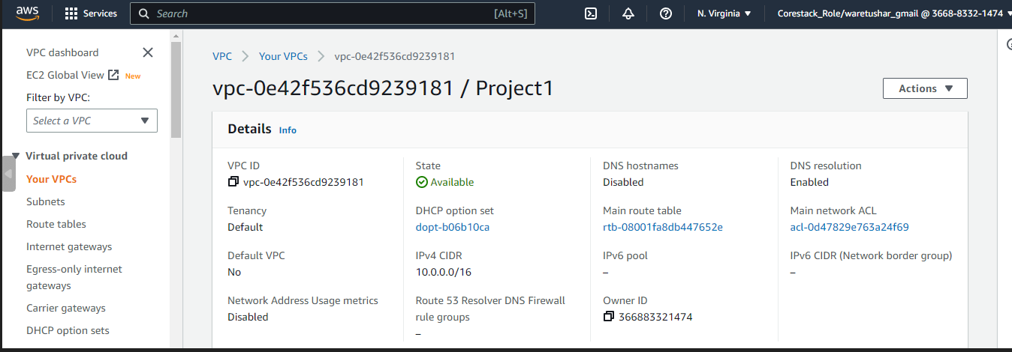

1. Created Subnet: 2 Subnet (Private & Public) & 1 more Private Subnet which is will be helpful for RDS

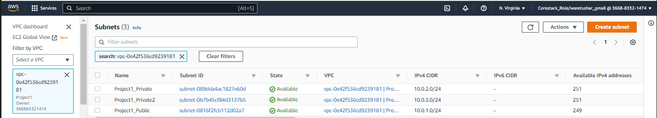

1. Created Route table & associated them from Subnet association

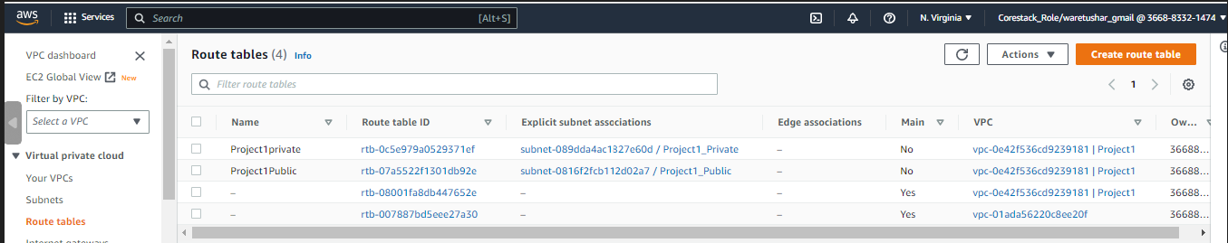

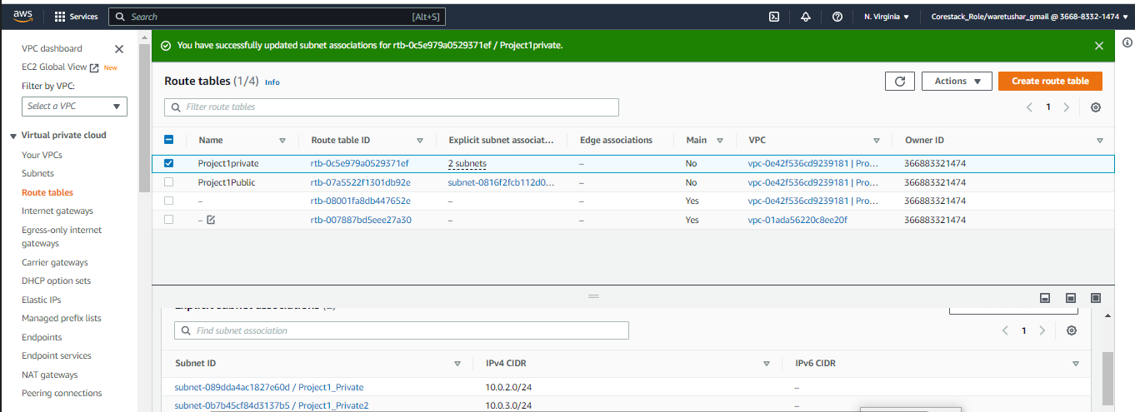

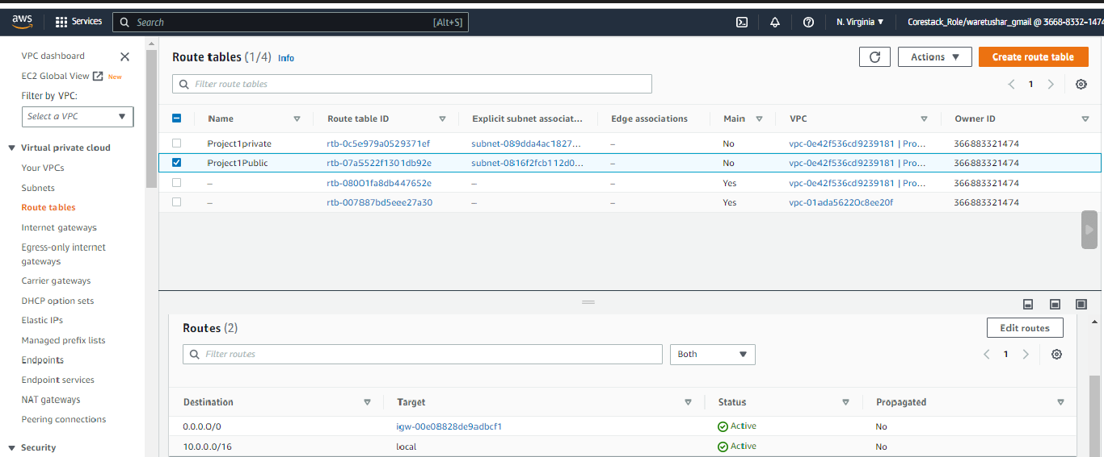

1. Created Internet Gateway

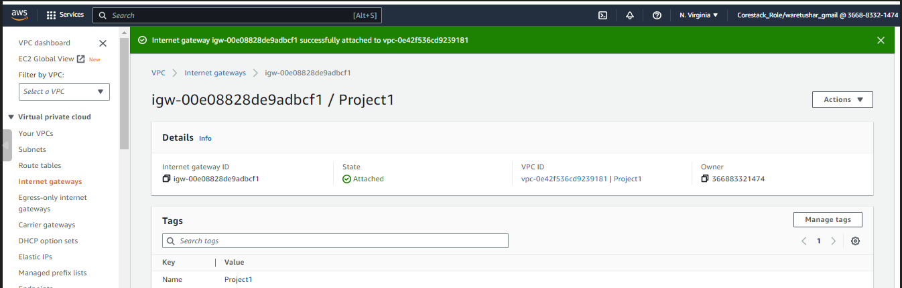

1. Created NAT Gateway

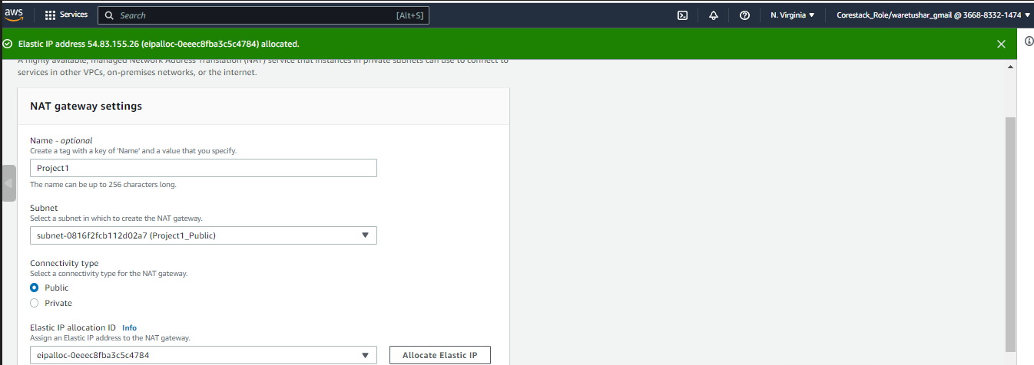

1. Enabled the DNS hostname from VPC

