**My review of Five Nights at Freddy's movie**

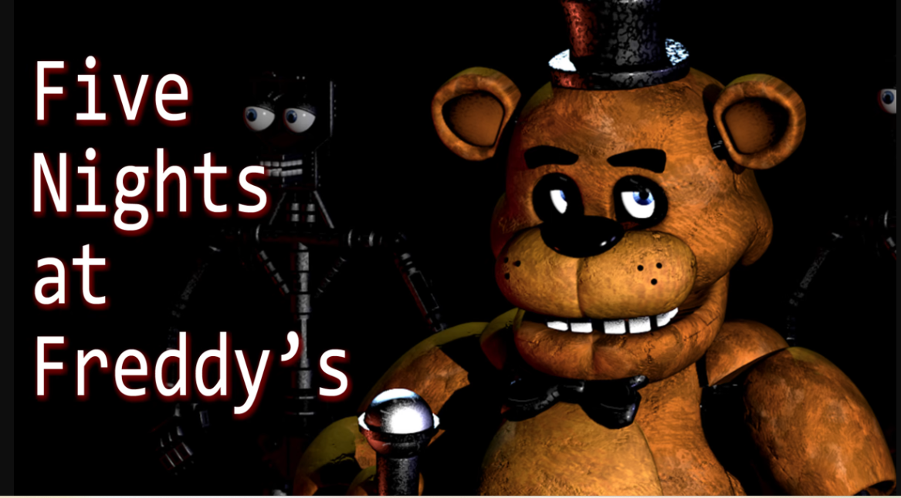

Well, here it goes. It’s kinda bad. Well, it is bad because one, it’s more for the fans. I did play the first FNAF, but wow, it’s like the Mario movie. It’s only a reference that hardcore fans can understand. But before I go to the negatives, let’s go to the positives.

**positives**

Let’s start with the positives first. The animatronics were cool and amazing, and of course, seeing.**CoryxKenshin** and **MatPat.**



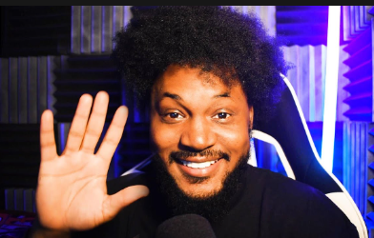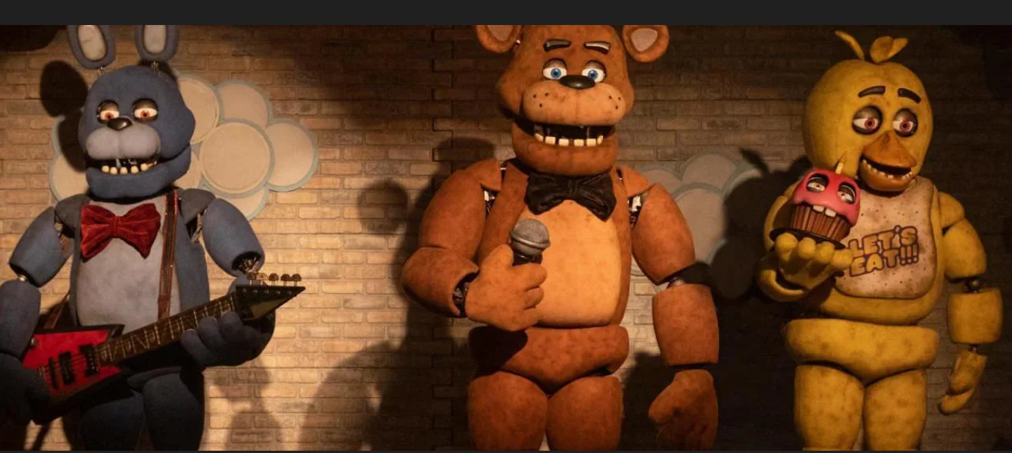

on the screen made me smile. That’s all the positive for me, which is kinda sad because I was kinda rooting for this movie.

Negatives aside, while the animatronics were super cool in their design, I feel like they were very underutilized in their own movie. The movie relied too much on the cupcake little guy because it was easy to use him and switch the CVI shots and have him flying around doing scary things. Most of the actual actions happen off camera and it’s pretty lame. I don’t think they were used well in this movie at all, despite being really cool and really well designed. They really could have used them a lot better, but they just didn’t.

And while I saidthe kid actress was good, she was given some pretty terrible dialogue to work with.

 So many times, the flow was just interrupted by the most awkwardly spliced together conversations. and while her acting was good, everyone else sucked total butt - even my goats! My legend Josh Hutcherson and Matthew Lillard

 was pretty bad in this movie; it was disappointing. This movie is genuinely ugly, and the lighting is terrible. For a movie that’s based on games where lighting is a key game mechanic, it has a very low budget. That’s usually how Blumhouse keeps their budgets small to maximize profits. For an IP as big as FNAF, it seems that they skimped out on everything except the altitude of the tangible animatronics. This movie is already projected to absolutely dominate the box office, so I just hope when they inevitably get a sequel, they don’t hold back. Then there’s the PG-13 rating, a controversial decision. While I understand why they did it, I can still recognize how they skimped out even in that department. They wanted this movie to appeal to kids and adult fans alike because while the majority of the fan base that grew up with FNAF is paying rent and depressed, there’s still a huge amount of kids getting into FNAF all of the time. But even for a PG-13 movie, this was incredibly tame. There are times when it wants to show blood and times where blood doesn’t even exist when it’s good, and it just takes you out of the movie. The gory, grossest scene is a closeup of a face for like 4 seconds, and everything other than that is just really boring. Most kills happen offscreen or when the camera cuts away. There’s no creativity in trying to get around the PG rating and showing it in a more fun and thoughtful way even happy death day a movie I don’t particularly like has some more fun kills than anything in this and that’s also rated PG- and from bloomhouse it makes the horror almost non-existent. because there’s no atmosphere here and since you don’t even have good kills There’s just nothing here in the horror. The department uses its rating. restriction as a crutch rather than a fun workaround, and that’s pretty boring. I mean, it’s a series about children. abductions and gross gear gore chomping and other bulls, and it just feels so sleeper, and then there’s the story now. Yes, FNAF has always been convoluted. confusing, downright insane, and I saw critics and people saying that this one is too much of that, and I couldn’t agree. This is one of the most basic stories you could ever make about five Nights at Freddy’s are the most boring and drawn out, you could possibly do with any of the lore, it’s like taking the secret sections of the purple man and stretching those out for nearly hours It’s not a fun movie plot to dive into a dream sequence times in the exact same manner and repetition, and have only One of them actually matters and does something different about the main character Michael is the most uninteresting. character to ever exist in this world You can only watch a man freak out about his brother being kidnapped the exact same way so many times before you just don’t care anymore, I mean for a series spanning games, books, and mat Pat videos were really only added, like one story element to really care about and boy is it drawn out. I just watched killers of the flower Moon a week before this, and despite it being double the length of FNAF FNAF felt longer I was counting the minutes and counting the seconds waiting for something to actually happen, even references or stupid fan service anything because it really just wastes you.used well in this movie at all despite

Being really cool and really well-designed, they really could have used them a lot better, and they just didn’t. And while I said the kid actress was great, she was given some pretty terrible dialogue to work with. So many times, the flow was just interrupted by the most awkward spliced-together conversations I’ve heard all year. And while her acting was good, everyone else sucked total butt, even my goats, my legends Josh Hutcherson and Matthew Lillard. They were pretty bad in this movie; it was disappointing. Also, this movie is genuinely ugly; the lighting is terrible. For a movie that’s based on games where lighting is a key game mechanic, this movie has a very low budget for what it is because that’s usually how Blumhouse operates: they keep their budgets small to maximize profits. For an IP as big as FNAF, it seems that they skimped out on everything except the allure of the tangible animatronics. This movie is already projected to absolutely dominate the box office, so I just hope when they inevitably get a sequel, they don’t hold back. Then there’s the PG-13 rating, a controversial decision. But while I understand why they did it, I can still recognize how they skimped out even in that department. They wanted this movie to appeal to kids and adult fans alike because while the majority of the fan base that grew up with FNAF is paying rent and depressed, there’s still a huge amount of kids getting into FNAF all of the time. But even for a PG-13 movie, this was incredibly tame. There are times when it wants to show blood and times where blood doesn’t even exist when it’s good, and it just takes you out of the movie. The gory grossest scene is a closeup of a face for like 4 seconds, and everything other than that is just really boring. Most kills happen offscreen or when the camera cuts away. There’s no creativity in trying to get around the PG rating and showing it in a more fun and thoughtful waybase that grew up with FNAF is paying

Even though the majority of the fan base that grew up with FNAF is paying rent and depressed, there are still a huge amount of kids getting into FNAF all of the time. But even for a PG-13 movie, this was incredibly tame. There are times when it wants to show blood and times where blood doesn’t even exist when it’s good, and it just takes you out of the movie. The grossest scene is a closeup of a face for like 4 seconds, and everything other than that is just really boring. Most kills happen offscreen or when the camera cuts away. There’s no creativity in trying to get around the PG-13 rating and showing it in a more fun and thoughtful way. I mean, even Happy Death Day, a movie I don’t particularly like, has some more fun kills than anything in this, and that’s also rated PG-13 and from Blumhouse. It makes the horror almost non-existent because there’s no atmosphere heresince you they don’t even have good kills. There’s just nothing here in the horror department. It uses its rating restriction as a crutch rather than a fun workaround, and that’s pretty boring. I mean, it’s a series about child abductions and gross gear gore chomping and other bull, and it just feels so sleeper. And then there’s the story. Now, yes, FNAF has always been convoluted, confusing, downright insane, and I saw critics and people saying that this one is too much of that, and I couldn’t agree

This is one of the most barebone stories you could ever make about Five Nights at Freddy’s. It’s the most boring and drawn-out you could possibly do with any of the lore. It’s like taking the secret sections of the Purple Man and stretching those out for nearly hours. It’s not a fun movie plot to dive into a dream sequence times in the exact same manner and repetition and have only one of them actually matter and do something different. The main character, Michael, is the most uninteresting character to ever exist in this world. You can only watch a man freak out about his brother being kidnapped the exact same way so many times before you just don’t care anymore. I mean, for a series spanning games, books, and MatPat videos, they really only added like one story element to really care about, and boy is it drawn out. I just watched Killers of the Flower Moon a week before this, and despite it being double the length of FNAF, FNAF felt longer. I was counting the minutes, counting the seconds, waiting for something to actually happen, even references or stupid fan service anything because it really just wastes your time. It would have been far more engrossing, far more engaging, far more entertaining to just put the security guard in the office for five whole nights and just sit there as he defends himself. People want to act like having a security guard in one location the whole movie would be bad when it is a clear sign that wow you should watch more movies. They could have made it way more creative and interesting just staying in the dang office.

Freddy’s Pizzeria, the whole movie. The best part about small-budget horror movies is being stuck in one single location, getting to know the ins and outs of everything in it, getting familiar with every wall and every crevice, and then by the end feeling absolutely amazing when you get to escape or leave. It makes a setting a character itself, and that would have benefited this movie immensely because

 This setting and location is unique, but somehow in a movie where that clearly should have happened, this location and…

setting just feels so unspecial because

They should have cut the boring human parts. I genuinely would have preferred a one-to-one recreation of the original games with some goofy elements here and there. If it means I didn’t have to fall asleep whenever the character fell asleep, it’s constantly repeating the same scene over and over again. It’s trying to be more cryptic and more mysterious than it has any right to be. It acts like withholding revelations and information until the end is smart and leading up to a big hurrah moment when it’s just more annoying than anything. You can see everything that’s going to happen from a mile away, and usually, I never fault the movie for that. I never fault a movie for being predictable, but when there is nothing else being put in its place, then how can I not complain about it? You could argue that this movie wasn’t really trying to be a full horror movie and much more of a dark story instead. I mean, children’s souls are getting trapped inside.

Having animatronics act like kids is a fun and dark idea. It really represents what draws people into the messed up nature of FNAF. However, that concept is really lost in this movie. It’s not a good adaptation and translation to the screen, and rather feels stupid and immersion-breaking. It feels like it has a total lack of confidence with an IP this huge and really holds back when you were told that it wouldn’t. It feels dumbed down, but not for newcomers, for everyone. It just doesn’t make sense. It’s very, very weak. The story is just bad, not fun, not entertaining. It does nothing to entice you more than the games ever did and just feels like a forced full-length movie. You could have done so many things with a movie like this for fans of FNAF and not of FNAF. The whole allure of theThe pizza place and the animatronics really lose their magic in minutes when the movie forgets about it. It’s an underbaked, uncooked mess. It did not want to lean in too hard with the horror but also didn’t want to lean in too hard with the amusing goofy stuff. It teeters on the line until the last minutes, and you just leave feeling unsatisfied that you waited years for this movie to come out, and the best you got were two YouTuber cameos. It’s crazy that the knockoff Five Nights at Freddy’s movie that came out a couple of years ago named Wily’s Wonderland is far more entertaining than this, and that movie sucks, like really sucks, but it’s actually fun and enjoys itself as a movie and does goofy things and has crazy scares and kills. It’s stupid, but it’s so much better than this crap. Overall, I’ll give the Five Nights at Freddy’s movie a two out of ten. Hopefully, the Minecraft movie will bring me some joy.”

