Dette er en test på en M-book i Microsoft Word.

a = magic(3)

a =
8 1 6
3 5 7
4 9 2

Her kaller vi GETVOCT.

[v]=getvoct('G#6')

The 1V/OCT value for key name G#6 (MIDI note 92) is 7.66666667 V.
The Hz/V value is 30.20397801 V.
The frequency is 1661.21879032 Hz.
The pitch is 92.

v =
notenumber: 92
voltoctave: 7.6667e+000
frequency: 1.6612e+003
pitch: 92
volthz: 3.0204e+001

f = plotnotefreq;

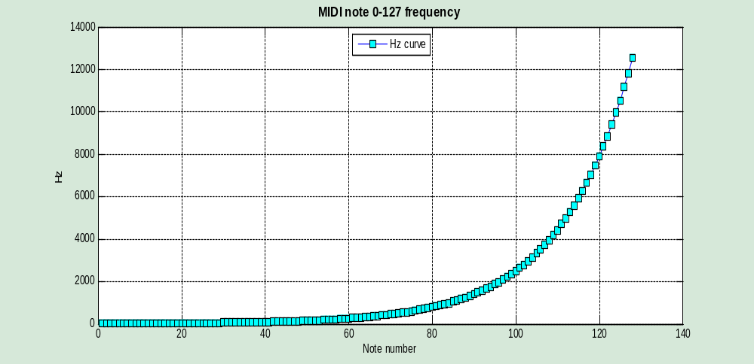
quantizer(0,2*pi,false);

Quantized output sent to GnuPlot!
