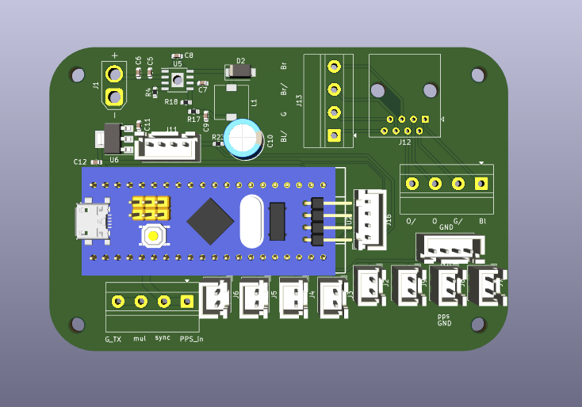
RJ45, ethernet cable
8 ethernet wire from lidar
e
2 wire from lidar
Power wire
Camera wire (PPS and GND)
GNSS
5V
3X GNDS

