**PART 2**

DATED 09/29/2015

Notes:

- No more MSR Names. Only Area Code and Area per District. Nawawala kasi Client's List pag Vacant ang MSR, kaya per area na lang to be sure.

- Yung Sales and Collection Performance **per Area** (w/ Area code) na din ang record. Example sa Sales:

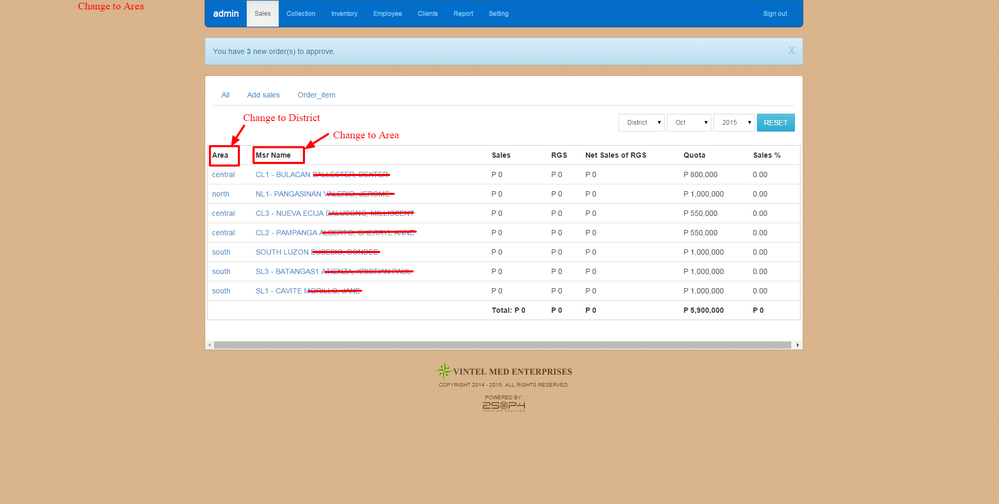

* History ng Sales and Collection Per Area din Example:

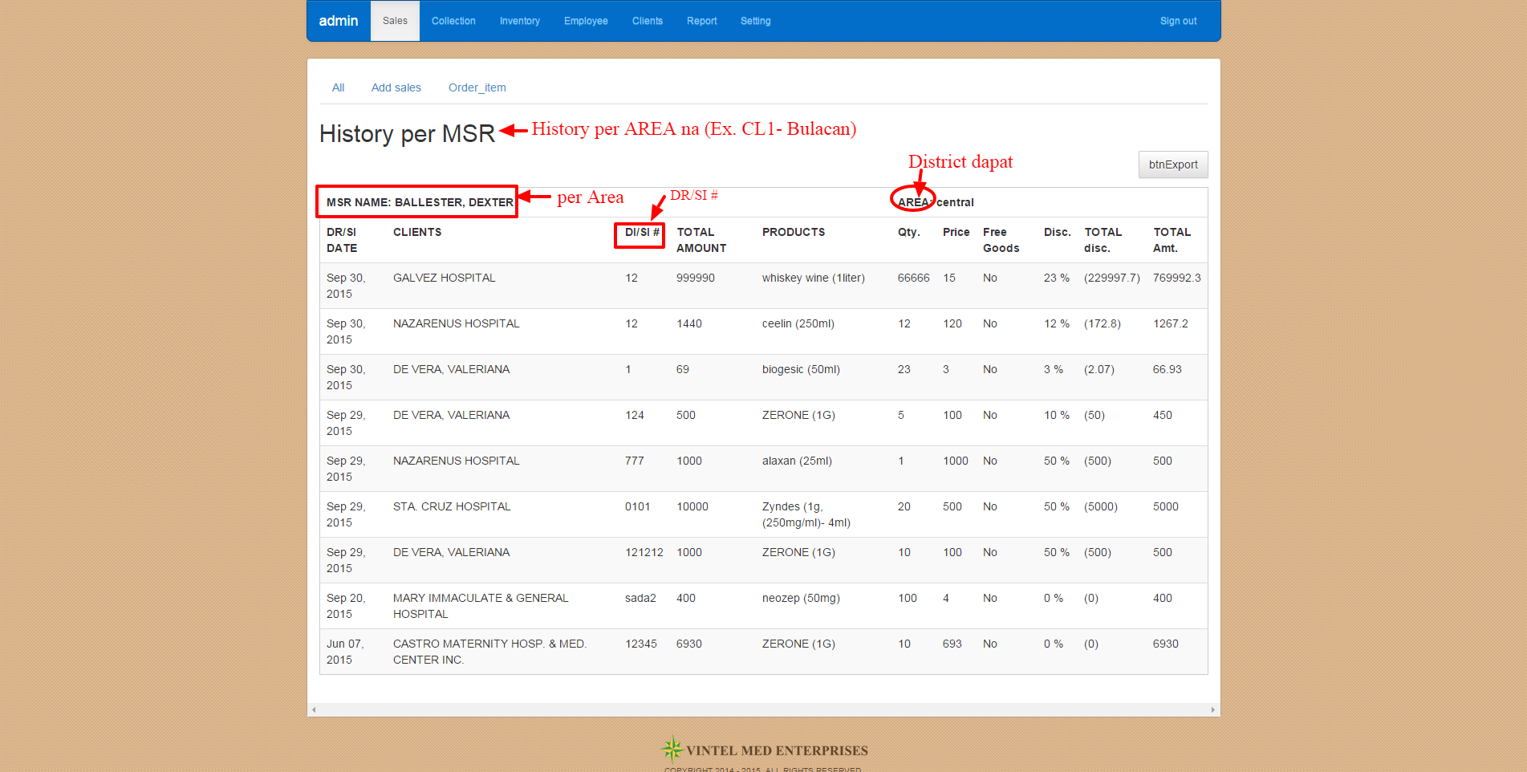

- Additional Area Codes and Area in the future. (ex. CL9, CL10, SL10,NL5, etc.)

- Additional Areas in the future. (ex.Bulacan II, Batangas II, Batanes etc.)

* Hindi ko lang alam saan nag-aadd. Please check:

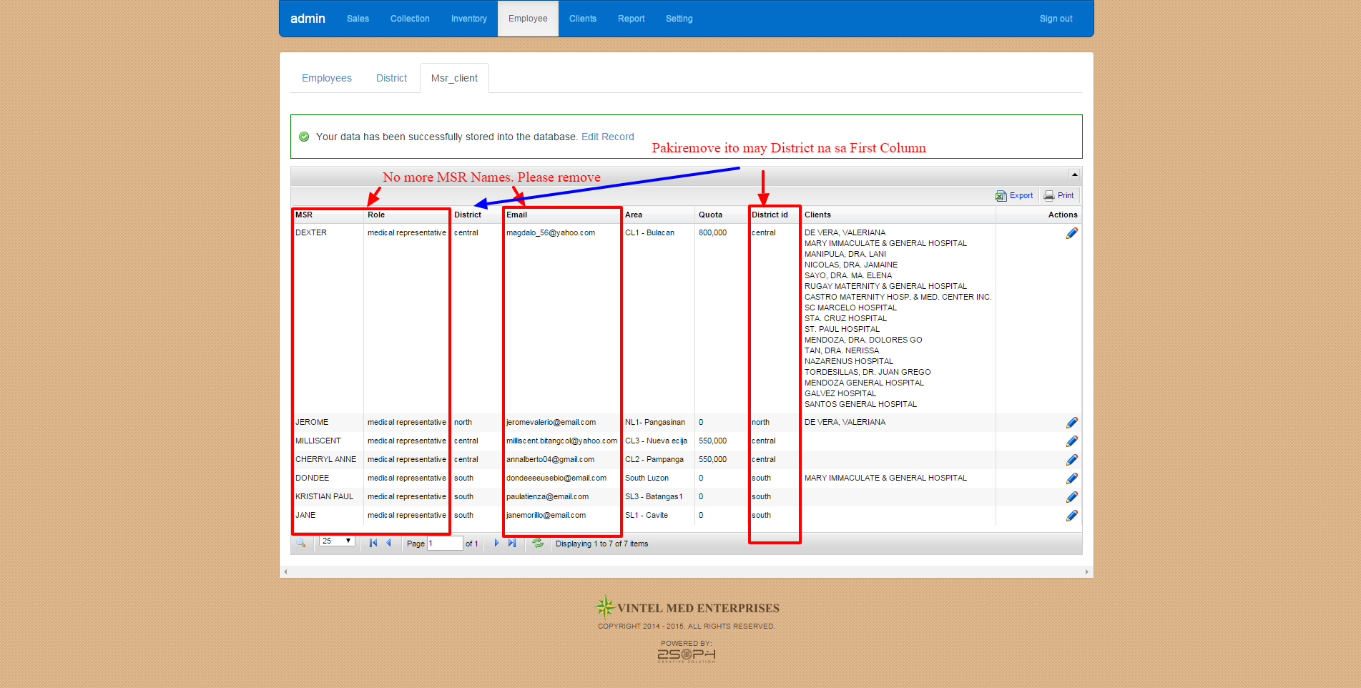

* **~~Under Sales~~**

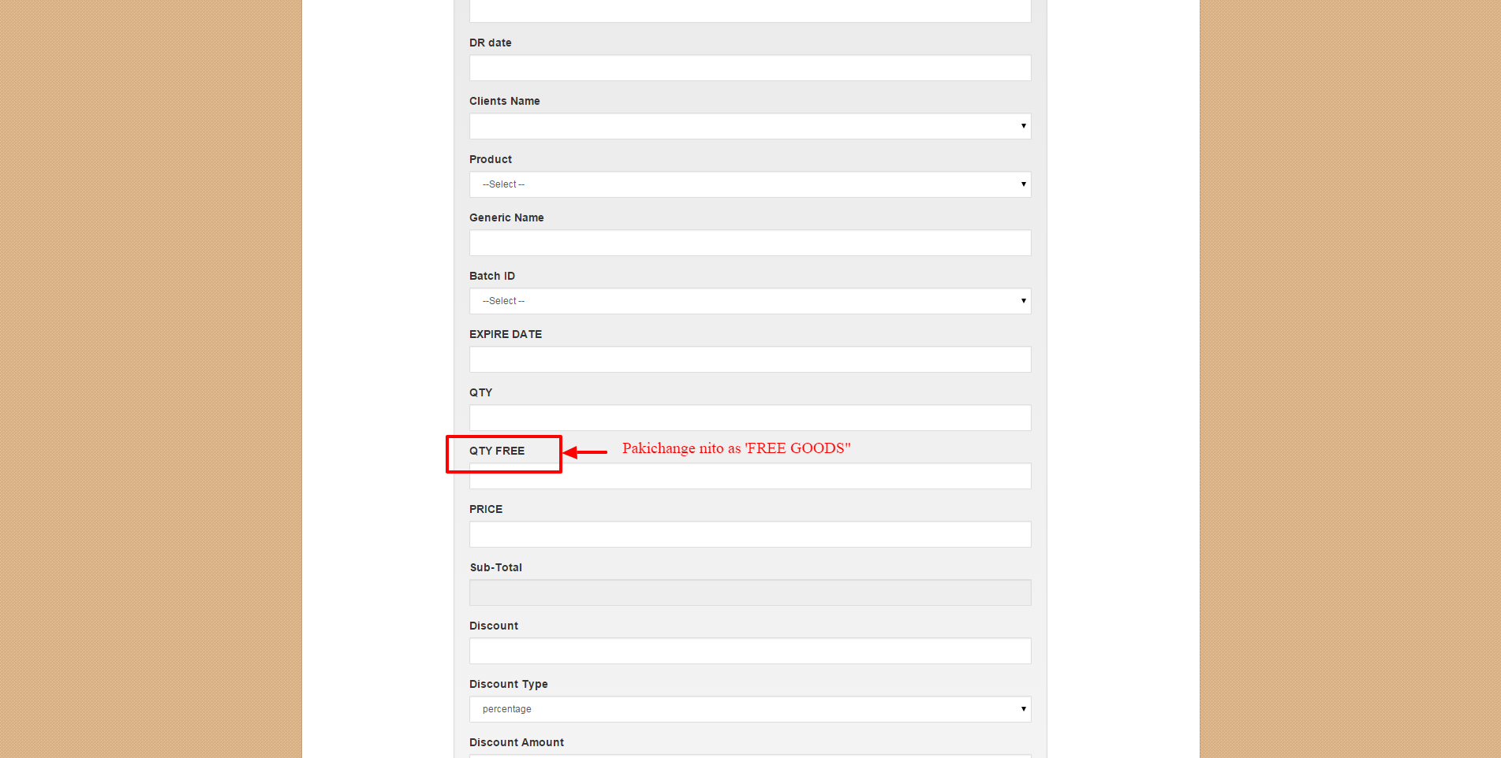

9. URL:

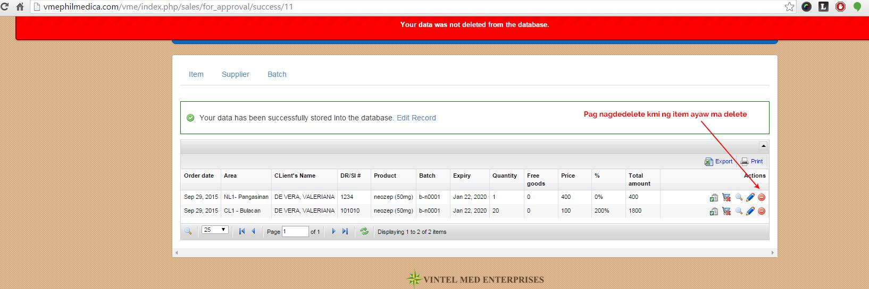  
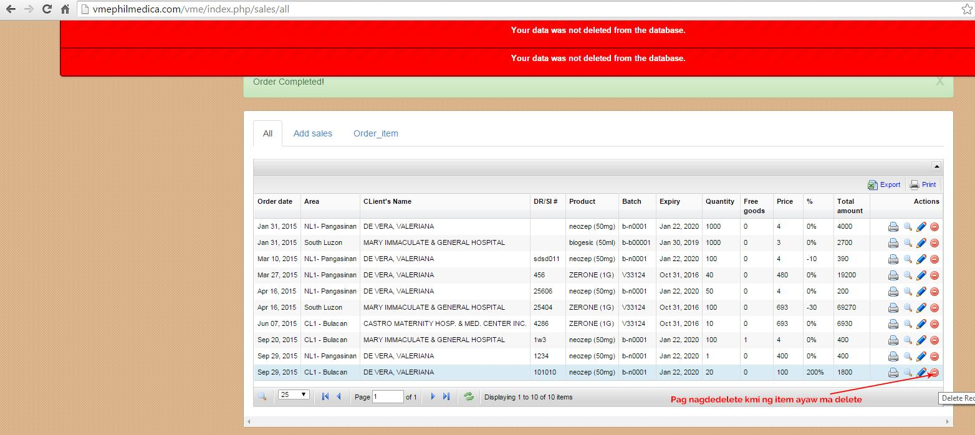

10. URL: <http://renanguillermo.com/clients/vintelmed/revisions/rsvn11.png>

**This is for All District:**   
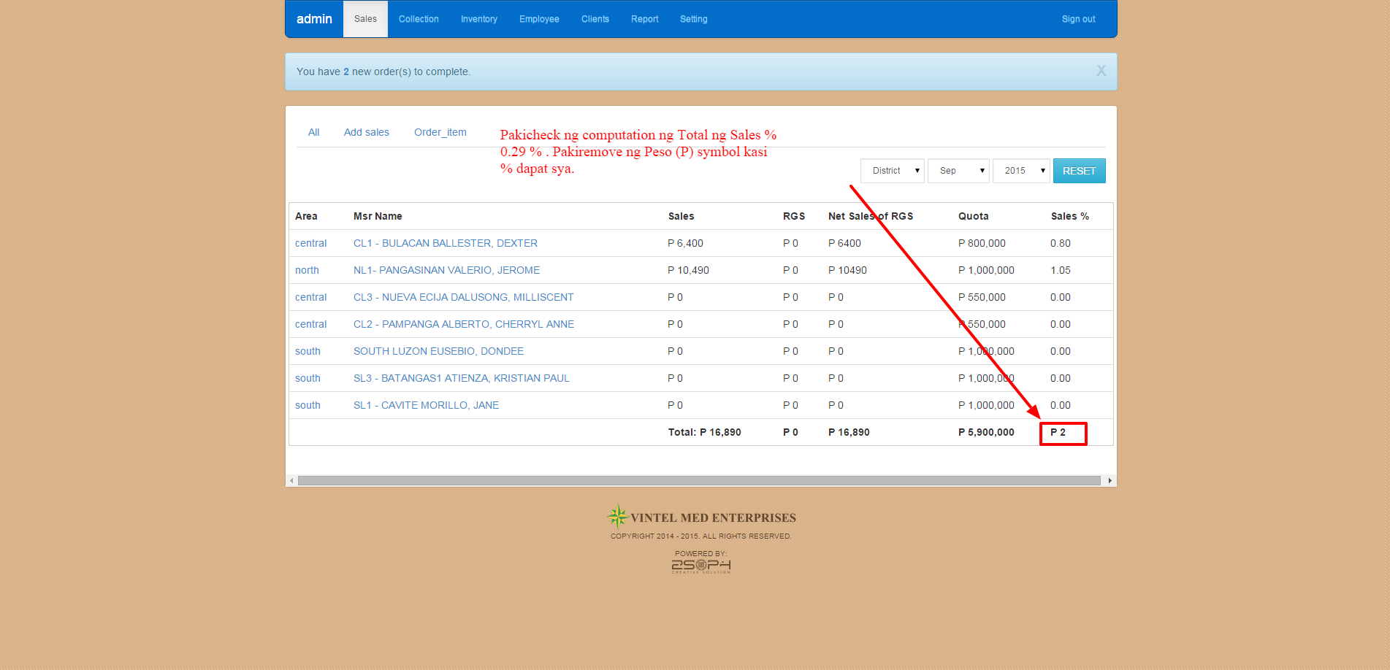

11. URL <http://renanguillermo.com/clients/vintelmed/revisions/rsvn12.png>

**This is Per District: ex. Central**

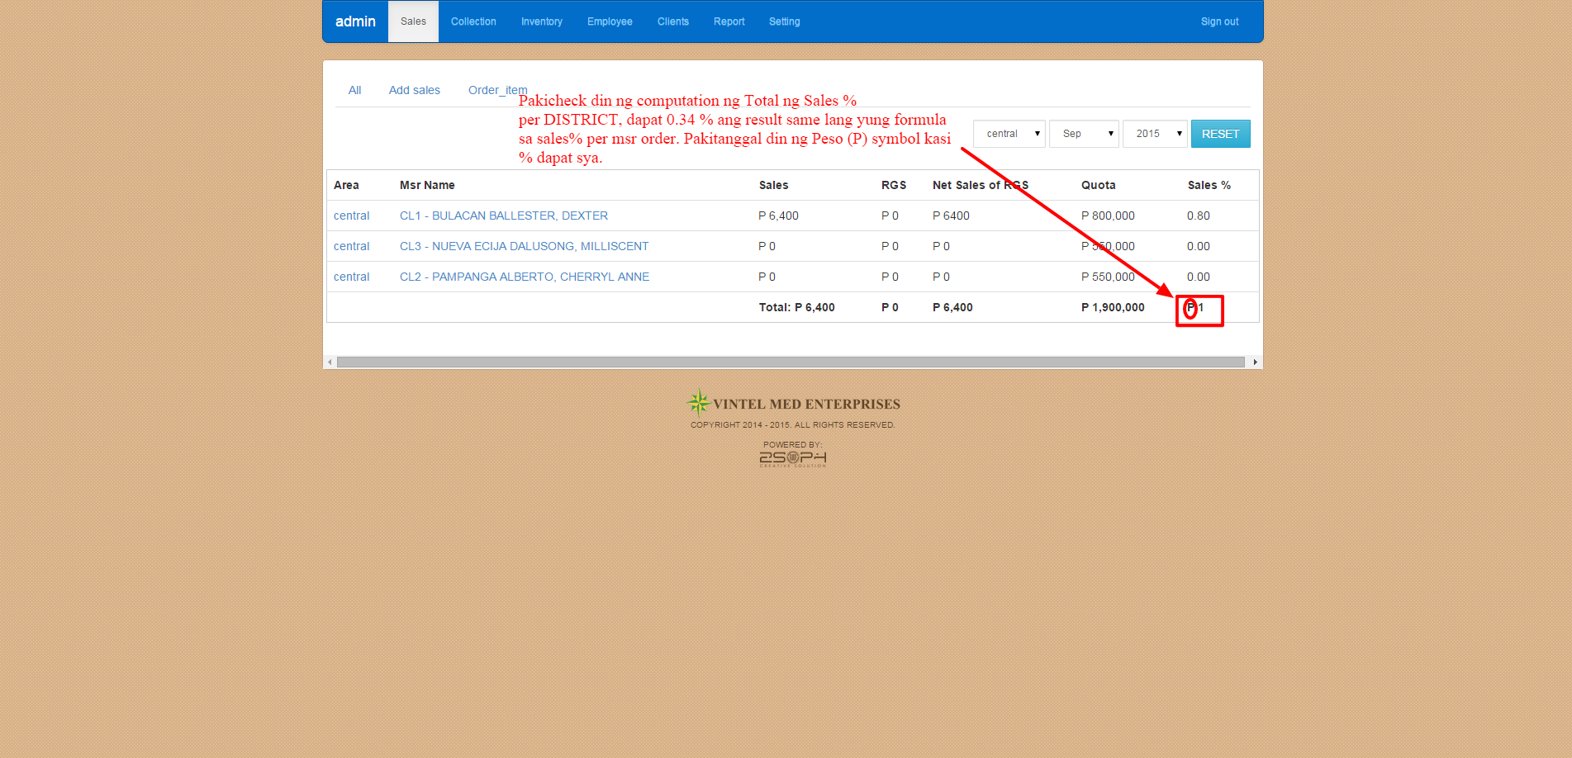

formula:sales-rgs=net of rgs/quota= 0.0033684210526316

0.34%

0.008=.80

12. URL: <http://renanguillermo.com/clients/vintelmed/revisions/rsvn13.png>

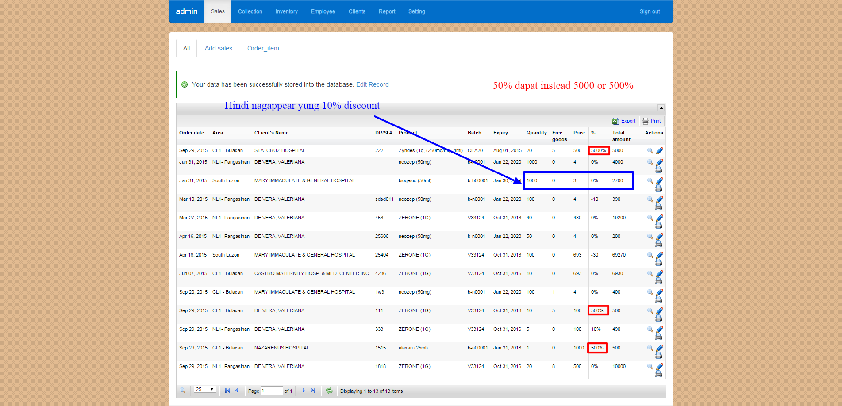

13.

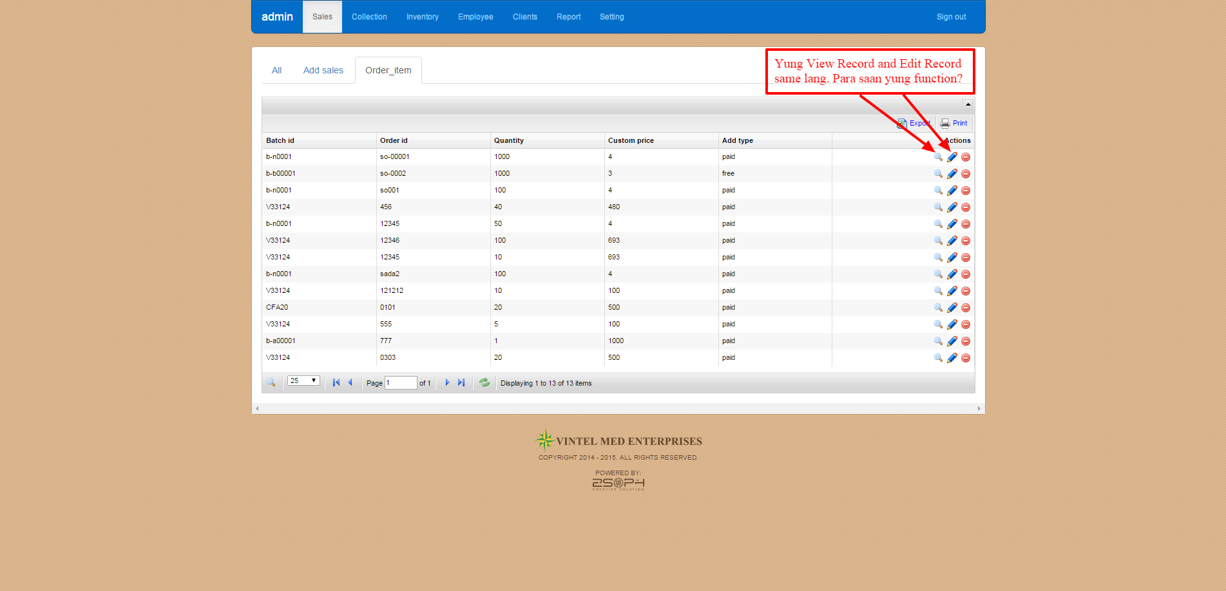

14.

**View Record:**

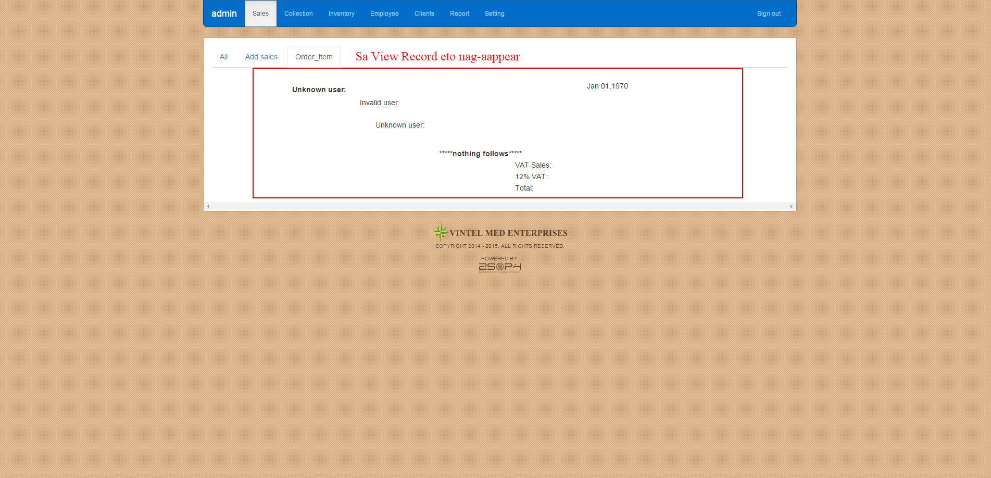

**Edit Record:**

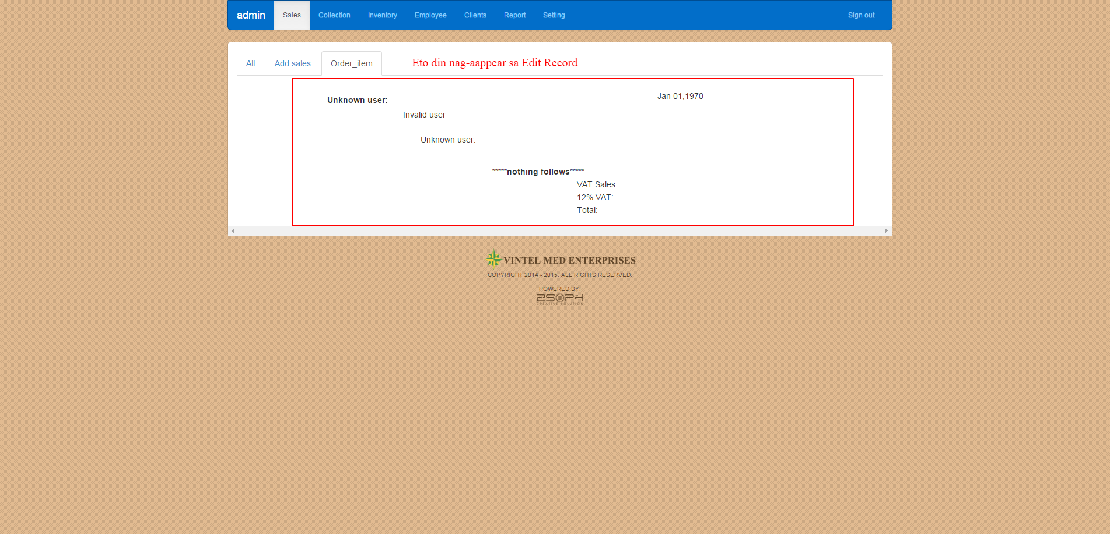

**COLLECTION:**

15 URL: http://renanguillermo.com/clients/vintelmed/revisions/rsvn14.png

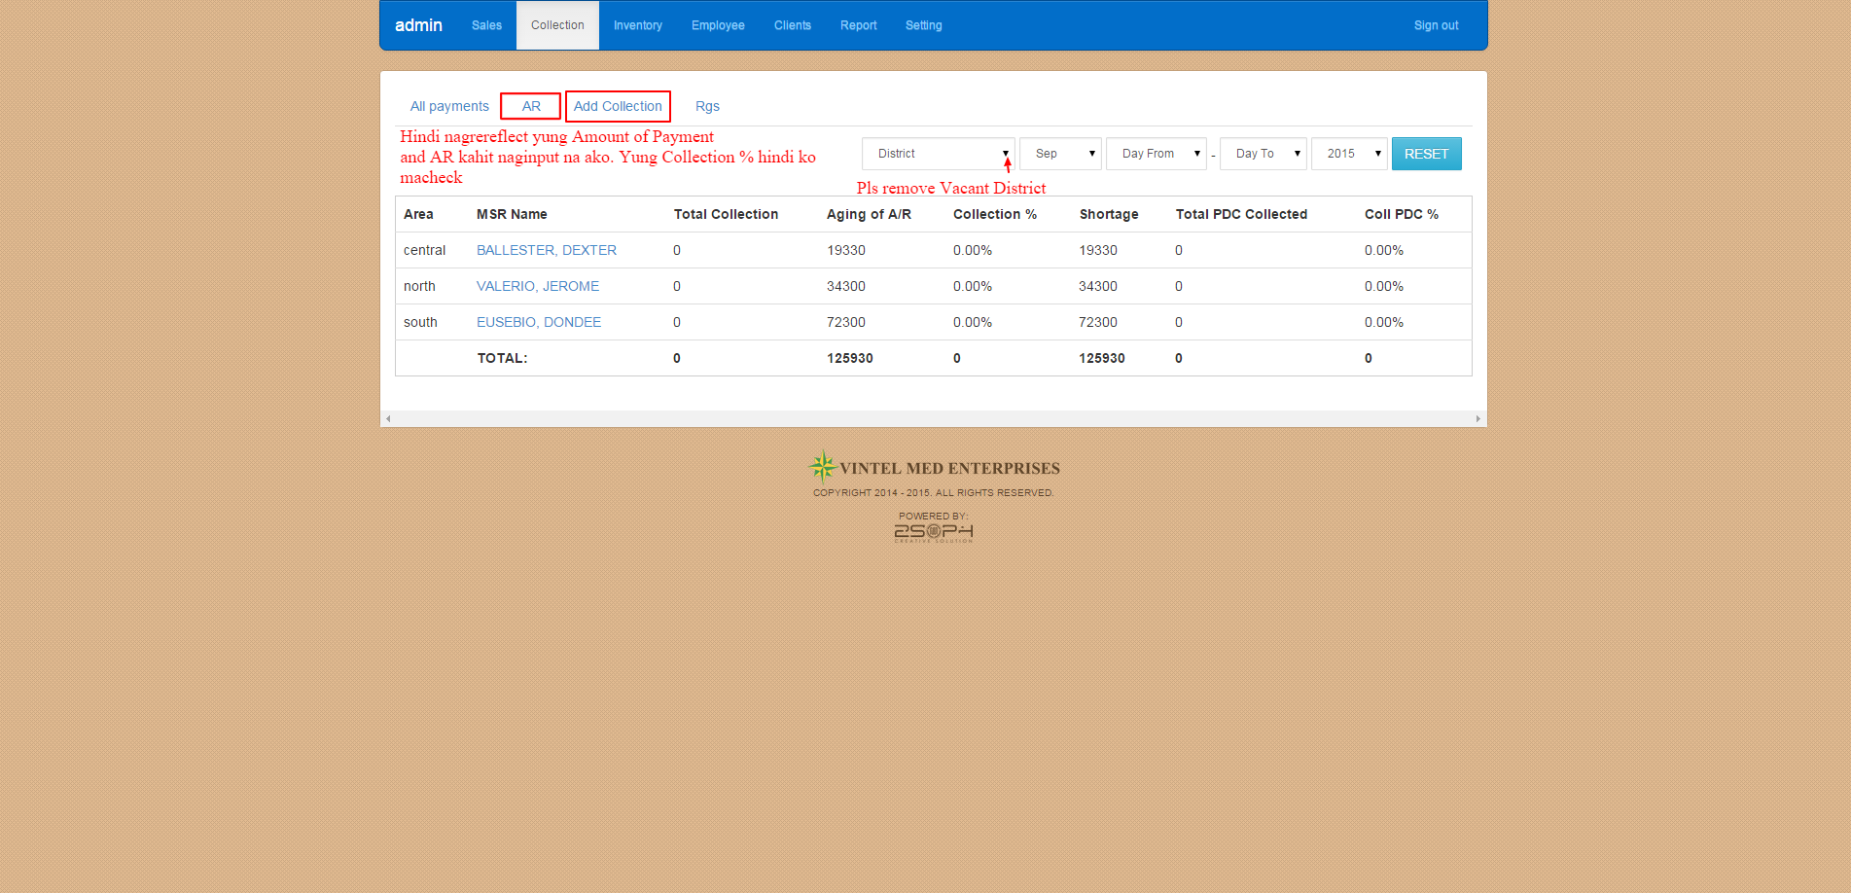

<http://awesomescreenshot.com/0c95age9e6>

16.

**Pakidisregard ng MSR Name sa attachment**

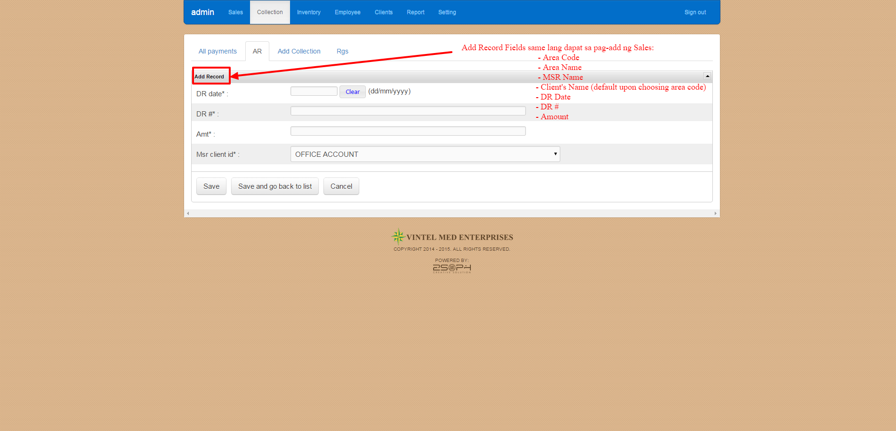

17.

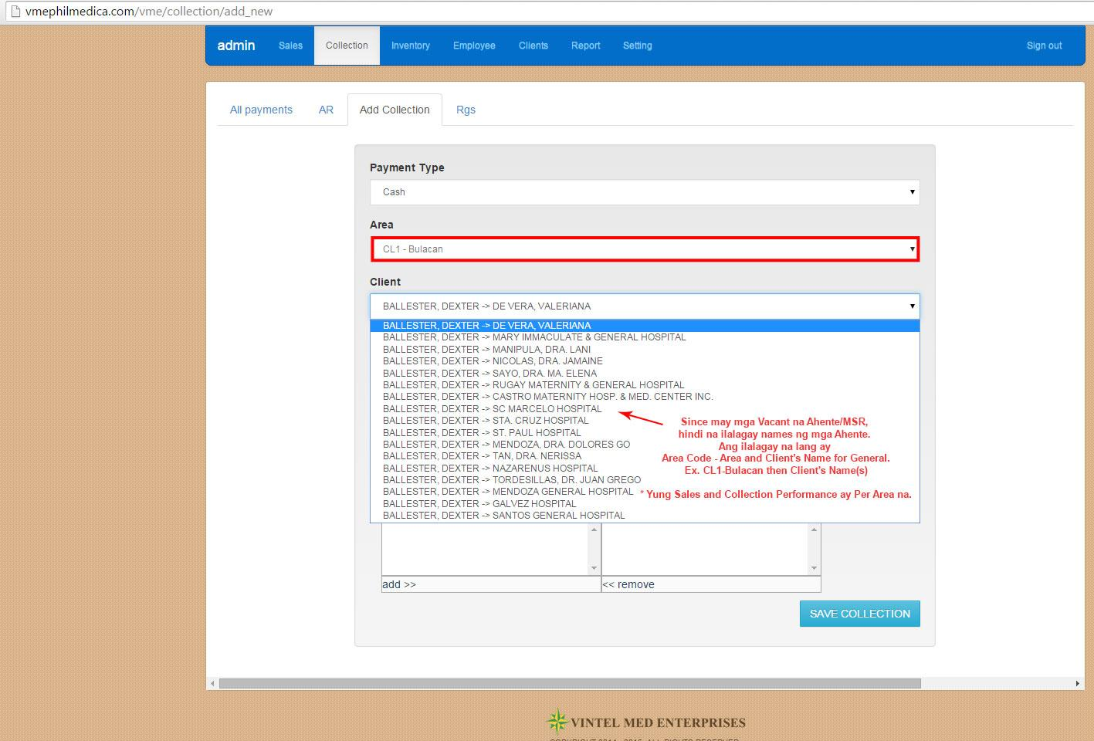

**Re: Post Dated Check (PDC)**

**Automatic ba nag-aadd na for the following month or ieencode pa manually.**

**Example. Every 30th of the month kasi ang cut-off ng sales and collection. Let’s say yung client nagbayad ng PDC Sept. 30 pero check dates for the following months (October 30, November 30, December 30, etc)., automatic ba magaadd sya sa PDC or manual ang paginput sa payment for next months.**

**18.**

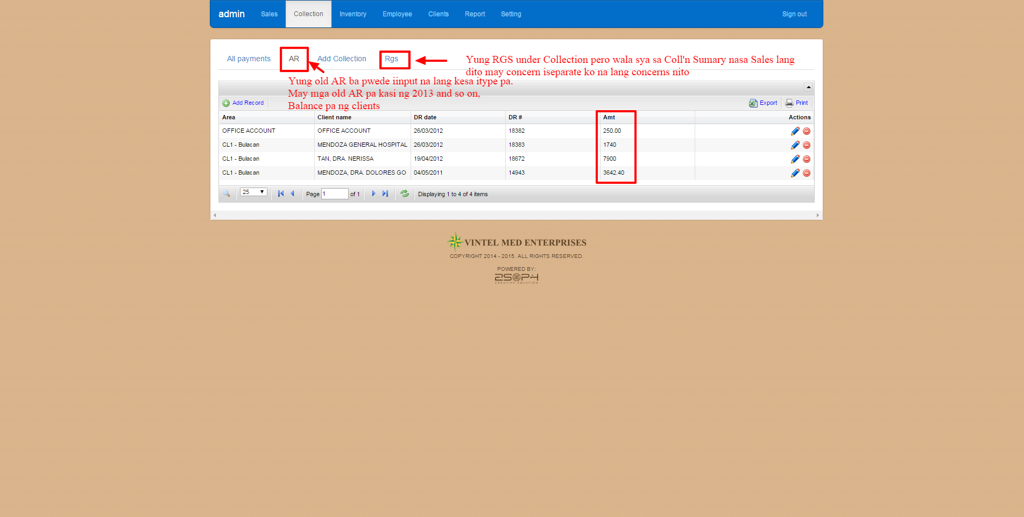

19.



20.

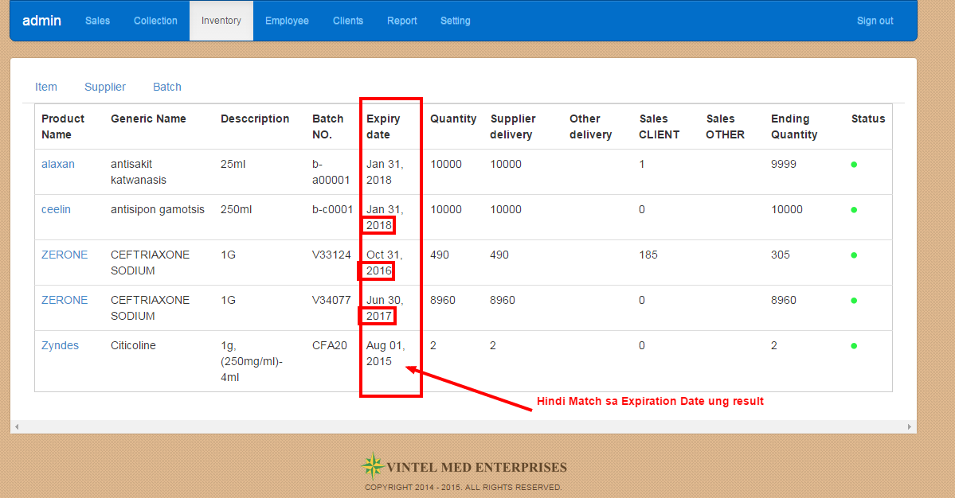

21. reference document: dr/si, reference = client

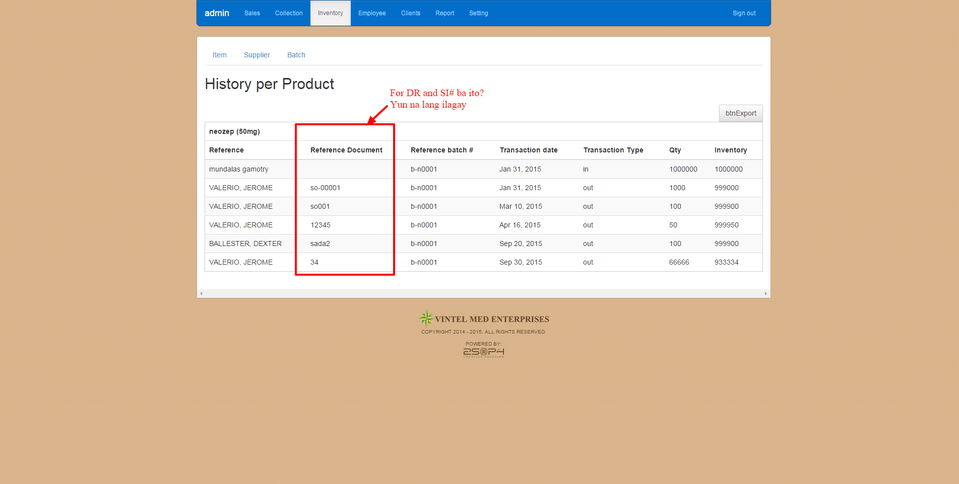

22. paid = order, free = free goods

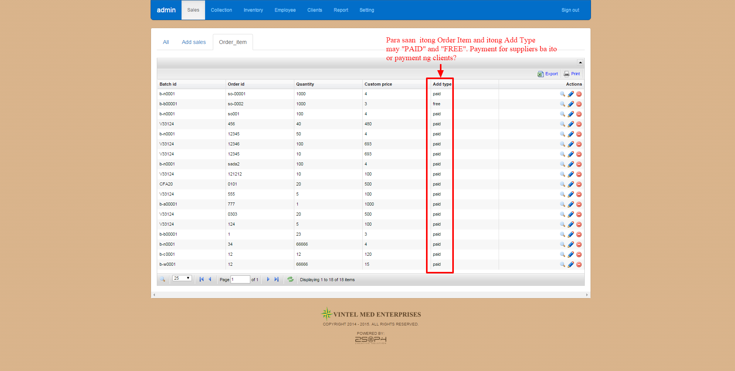

**RETURN GOODS (RGS):**

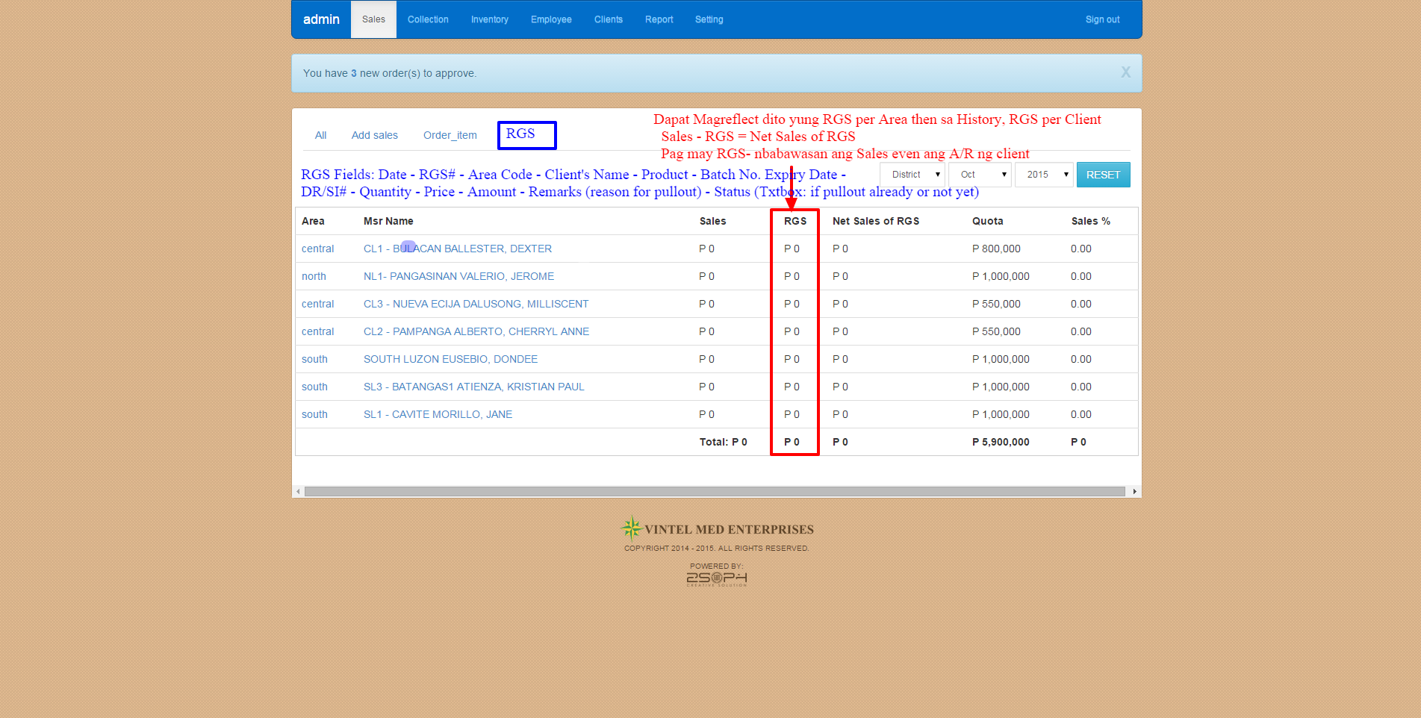

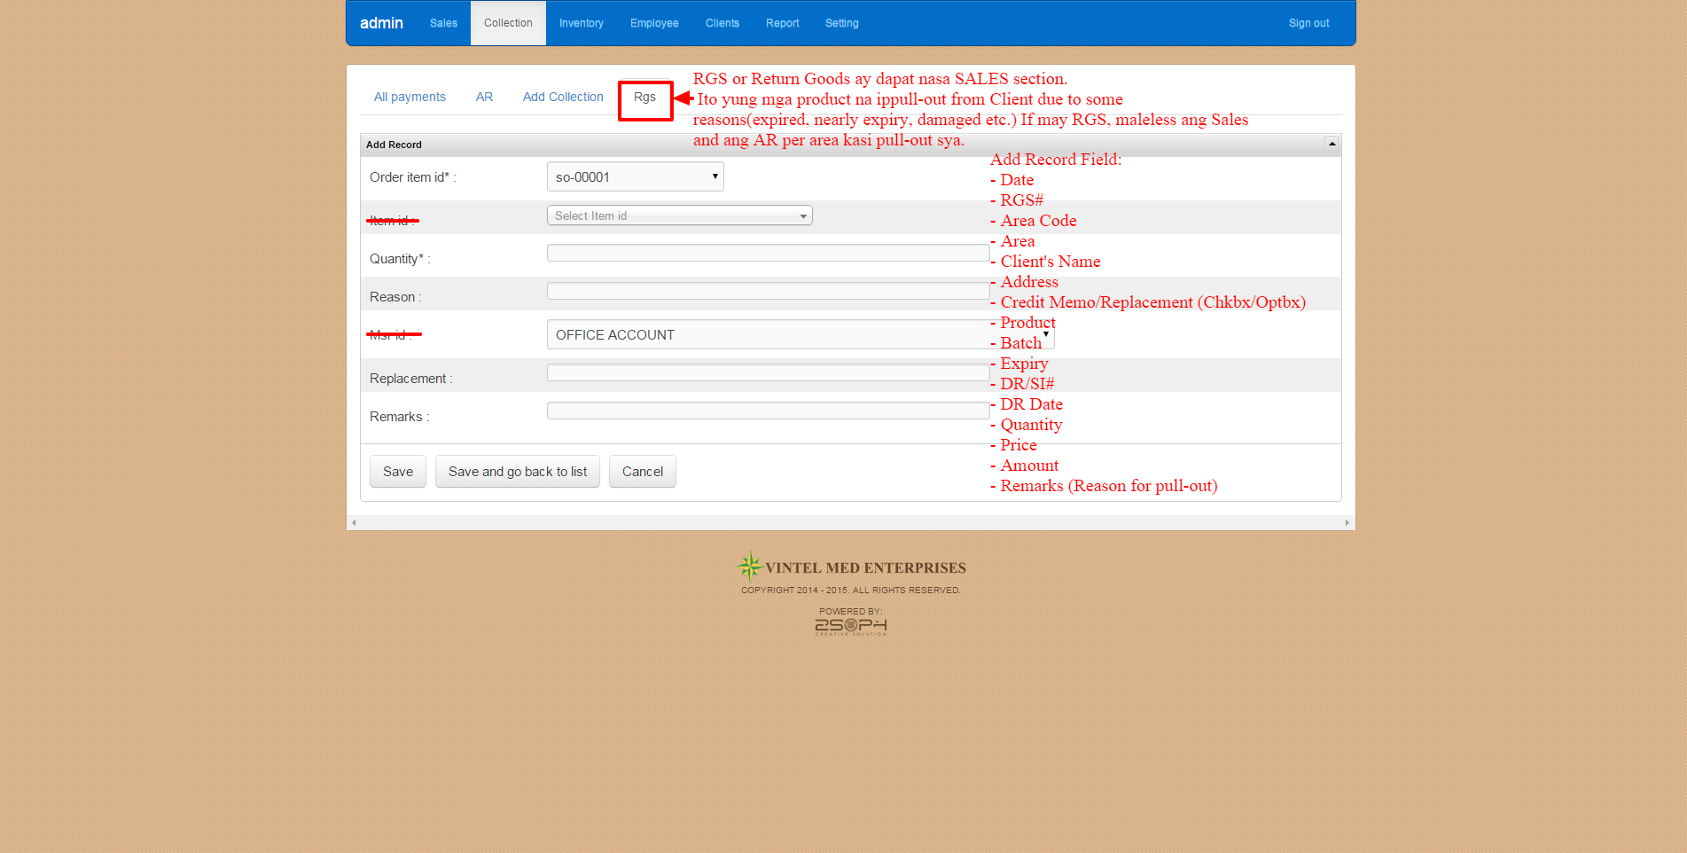

=============================================================

**PART 1 (Checked)**

1. URL: <http://renanguillermo.com/clients/vintelmed/revisions/rvsn1.jpg>

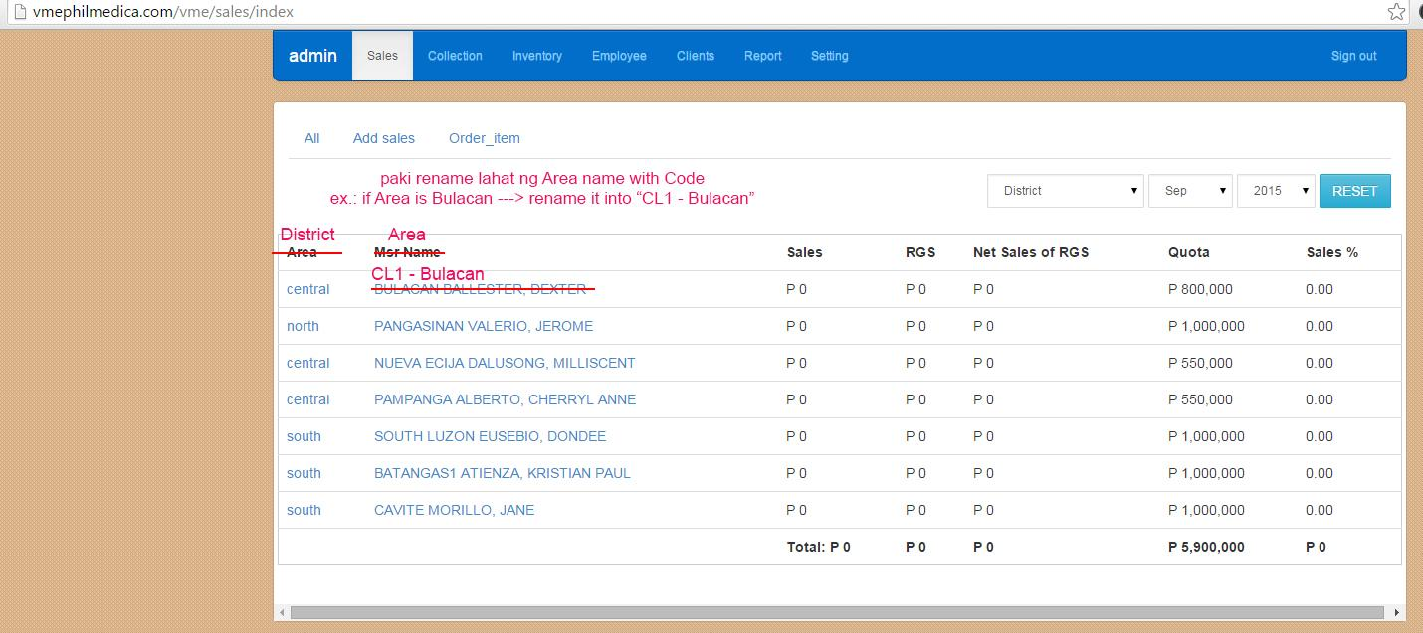

2. URL: <http://renanguillermo.com/clients/vintelmed/revisions/rvsn2.jpg>

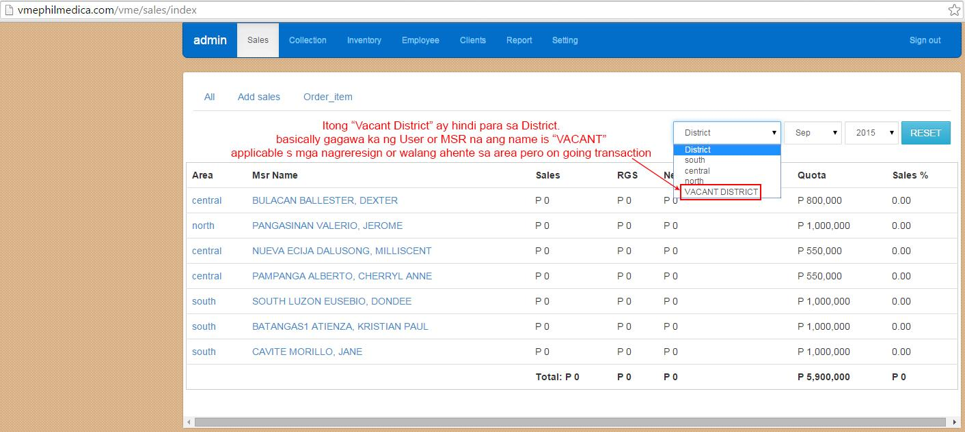

3. URL: <http://renanguillermo.com/clients/vintelmed/revisions/rvsn3.jpg>

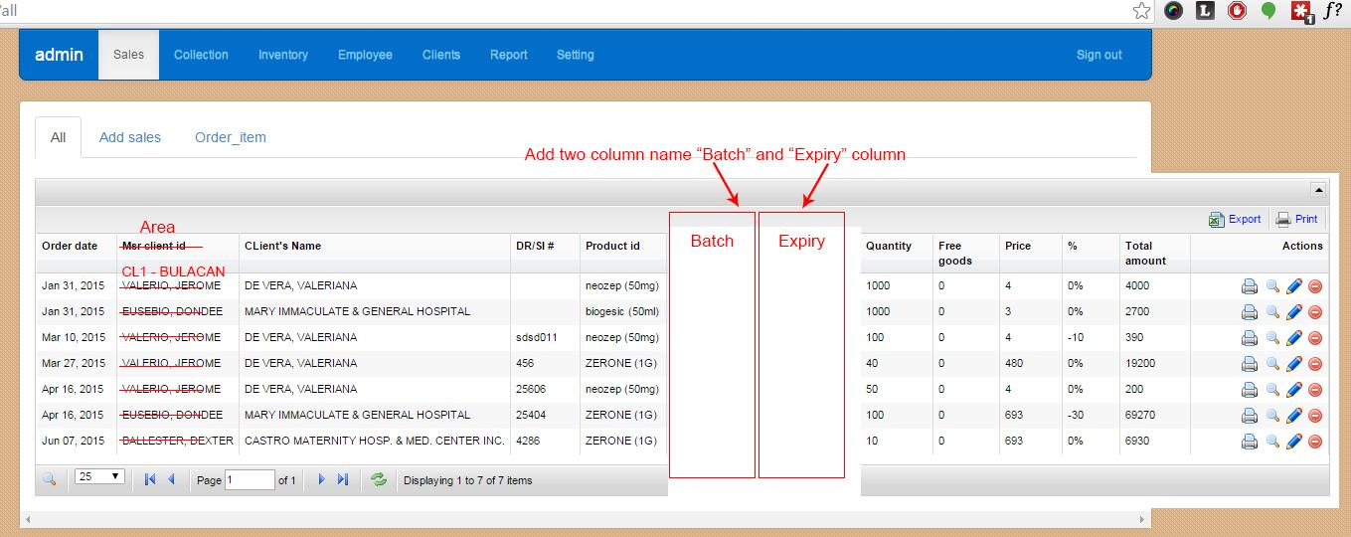

4. URL: <http://renanguillermo.com/clients/vintelmed/revisions/rvsn4.jpg>

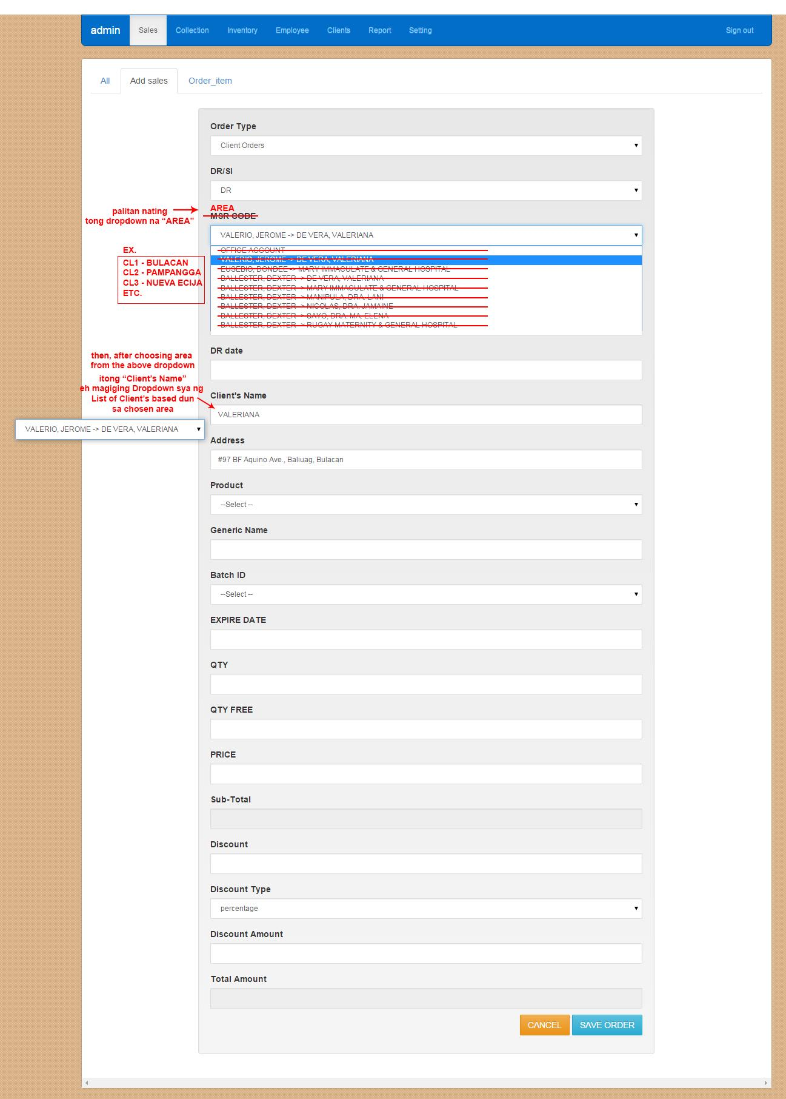

5. URL: <http://renanguillermo.com/clients/vintelmed/revisions/rvsn5.jpg>

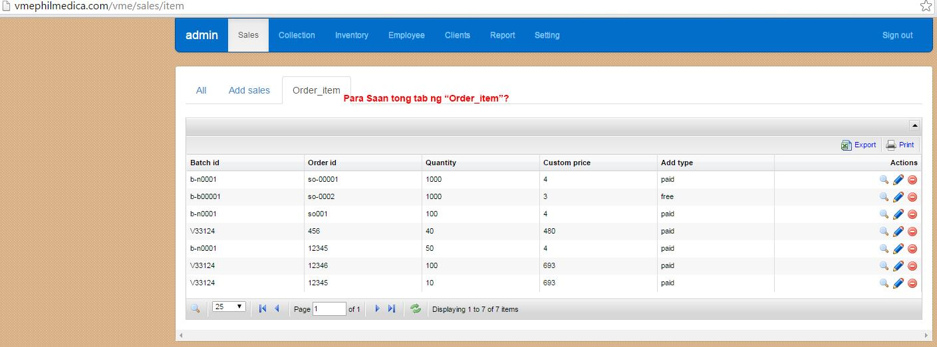

*old tab n naalis n. di lng nabura s live

6. URL: <http://renanguillermo.com/clients/vintelmed/revisions/rvsn6.jpg>

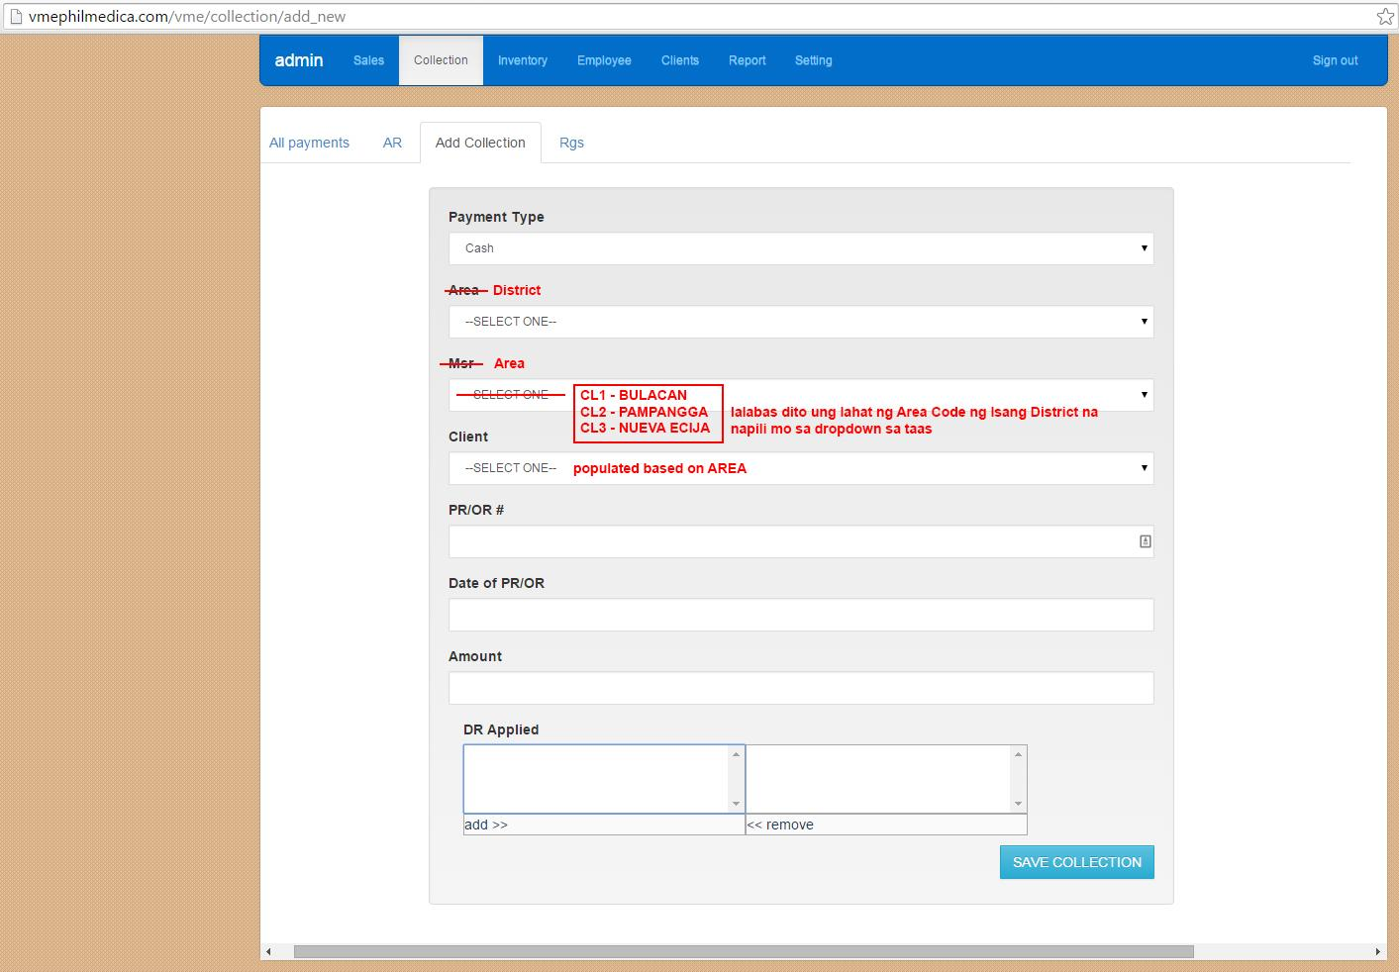

7. URL: <http://renanguillermo.com/clients/vintelmed/revisions/rvsn7.jpg>

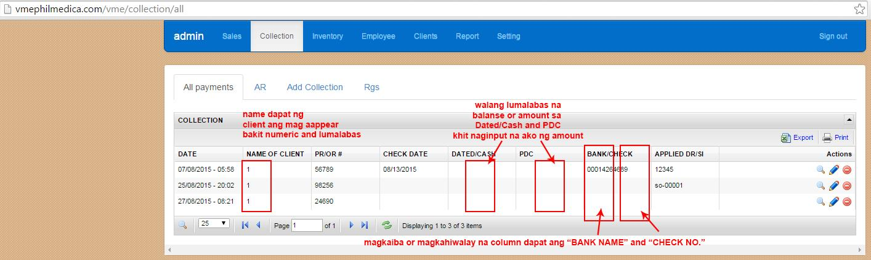

8. URL: <http://renanguillermo.com/clients/vintelmed/revisions/rvsn8.jpg>

