# VLSI Lab 4 – Inverters

Matthew Murray – 873525242

## Schematic

### Inverter 1/2

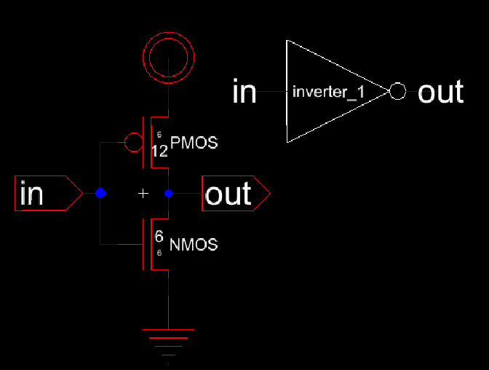

### Inverter Sim

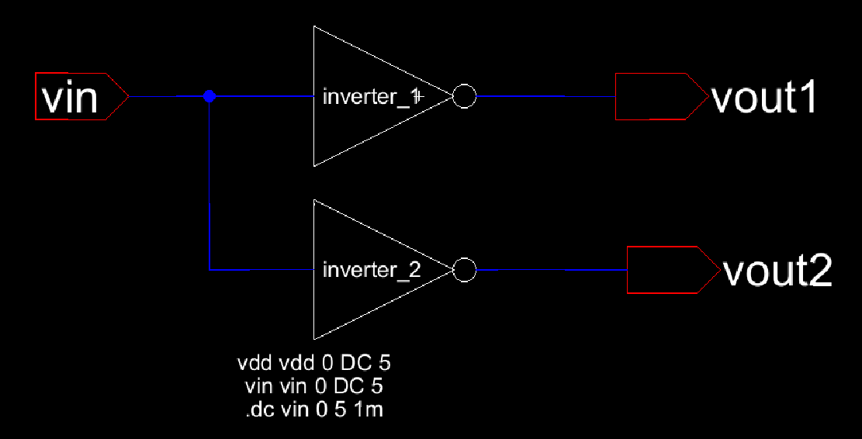

### Pulse Sim

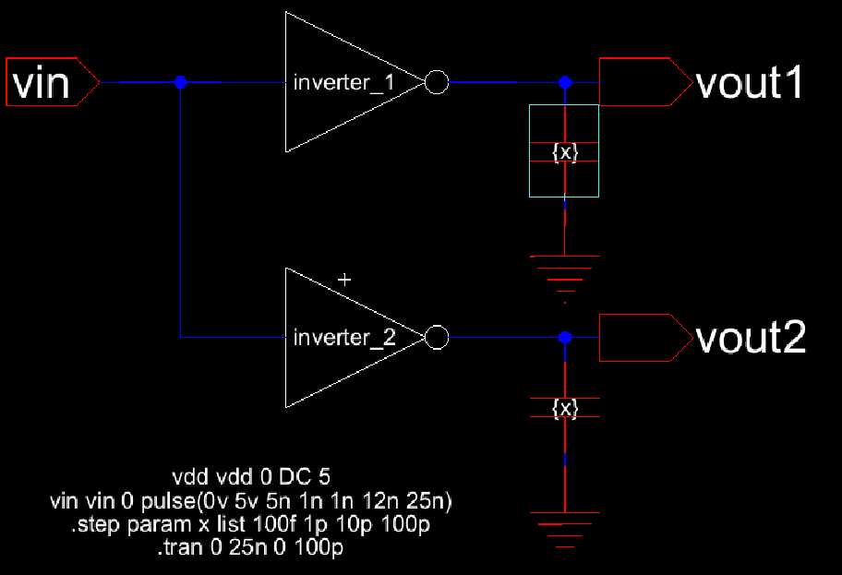

Inverter 2 appears to switch faster in both directions compared to inverter 1. Lower capacitances also appear to cause a little bit of “overshoot” during the transition where voltage goes slightly above 5V or below 0V.

## Layout

### Inverter ½

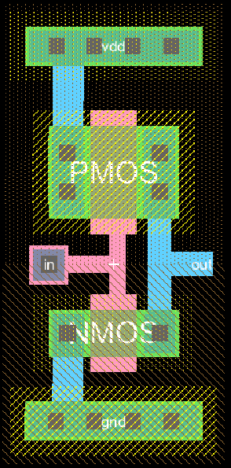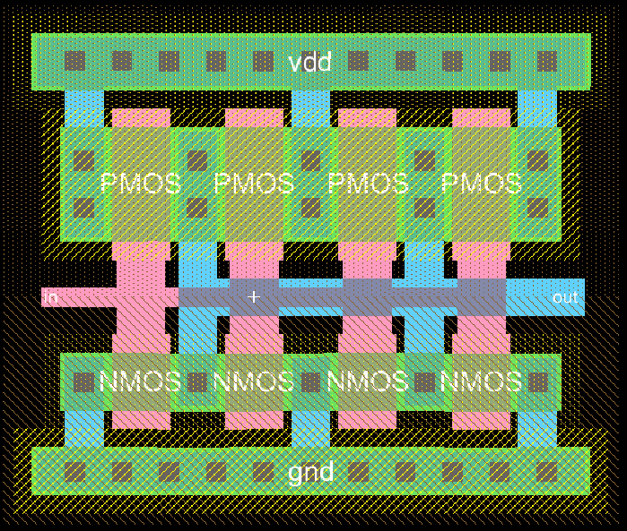

Metals and polysilicon wires were made as thick as DRC rules allow, but especially for inverter 1 it wont let it go any thicker than 2 for some reason.