# VLSI Lab 3 – NMOS ESD

Matthew Murray – 873525242

## Schematic

### pWell-nActive / nWell-pActive

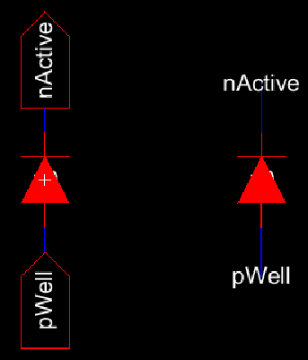 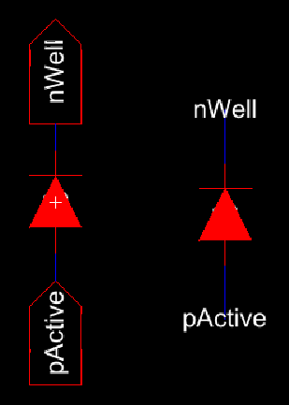

### Pad Cell w/ ESD

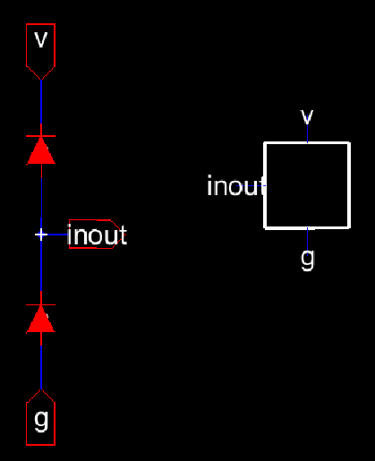

### Padframe

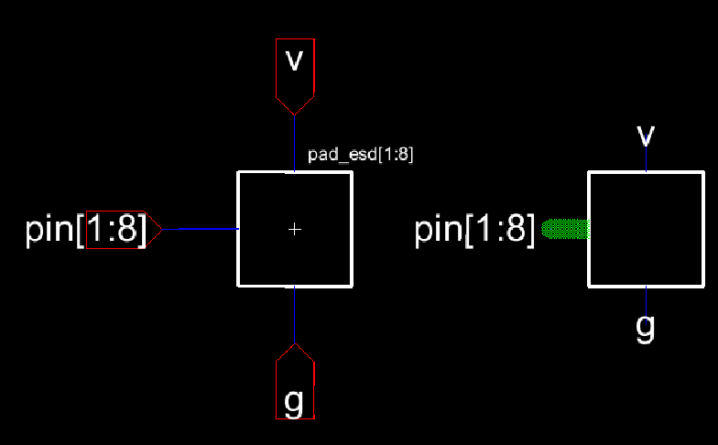

### Padframe w/ NMOS

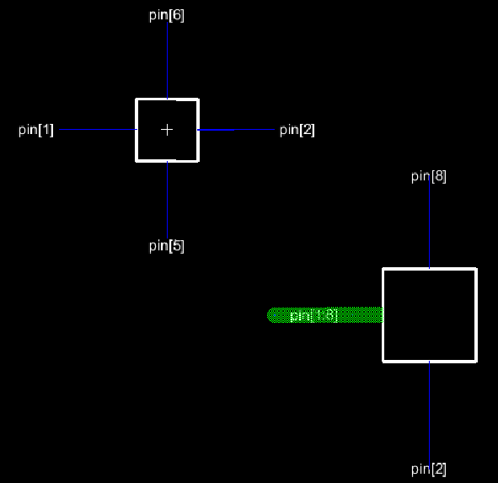

## Layout

### pWell-nActive / pActive-nWell

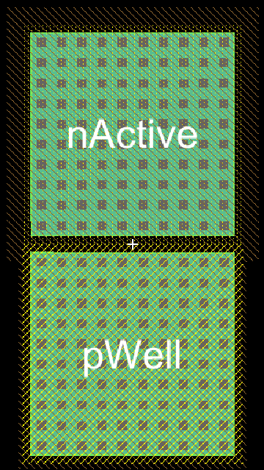 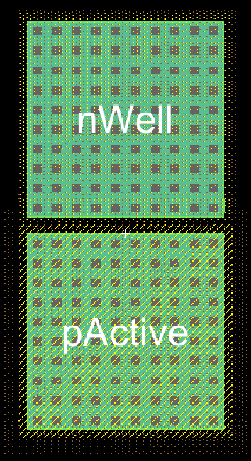

### Pad Cell w/ ESD

The horizontal busses were omitted in the individual pad cell to allow more compact placement in the padframe.

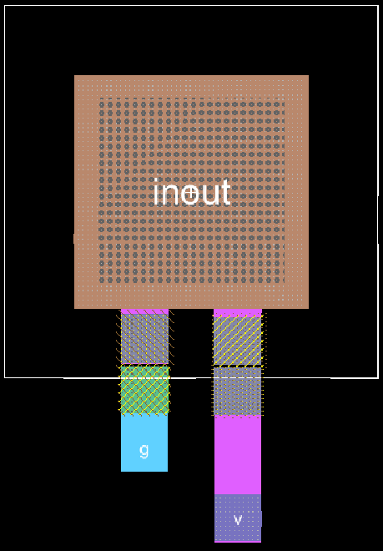

### Padframe w/ NMOS

