

**Netflix**

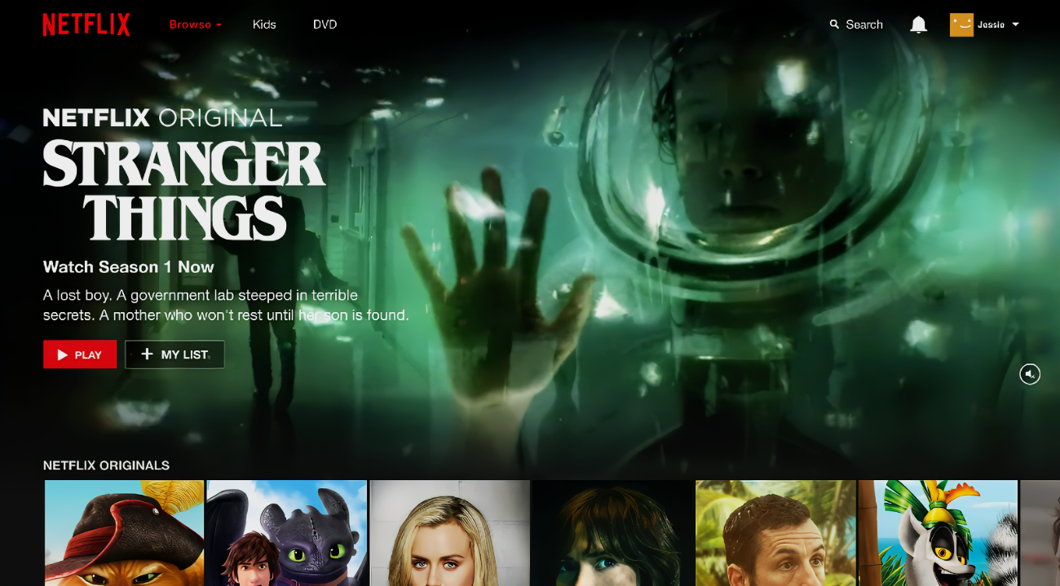

**MD WARISH RAAZ**

**Overview**

**Netflix is the most popular OTT platform globally. There are over 200 million subscribers from over 190 countries enjoying TV-Series, Documentaries, Feature films across a wide variety of genres and languages. Subscribers can watch as much as they want, anytime, from anywhere, on any internet connected device.**

**Goals**

* **Landing Page**
* **Login Page**
* **Home page**



**History**

**Netflix, in full Netflix, Inc., media-streaming and video-rental company founded in 1997 by American** [**entrepreneurs**](https://www.merriam-webster.com/dictionary/entrepreneurs)[**Reed Hastings**](https://www.britannica.com/biography/Reed-Hastings) **and Marc Randolph. It is also involved in the creation of original programming. Corporate headquarters are in Los Gatos,** [**California**](https://www.britannica.com/place/California-state)**.**

**In 1999 Netflix began offering an online subscription service through the** [**Internet**](https://www.britannica.com/technology/Internet)**. Subscribers chose** [**movie**](https://www.britannica.com/art/motion-picture) **and television titles from Netflix’s** [**Website**](https://www.britannica.com/technology/website)**; the shows were then mailed to customers in the form of** [**DVDs**](https://www.britannica.com/technology/DVD)**, along with prepaid return envelopes, from one of more than 100 distribution centres.**

**In 2007 Netflix began offering subscribers the option to stream some of its movies and television shows directly to their homes through the Internet. For most subscription plans, the** [**streaming**](https://www.britannica.com/topic/streaming-data-transmission) **service was unlimited.**

**Technologies Used In Netflix**

* **HTML**
* **CSS**
* **BOOTSTRAP**
* **JAVA SCRIPT**
* **FAV ICONS**

I will use Microsoft Visual Studio Code and I will use Github And Git Bash to make my codes online.

