Case Study | Exploration and Exploitation of Geospatial Data | HEC Montréal

Eritrea Digital Gateway 2030
A Country at the Edge of the Knowledge Network

Brian Marcon, MSc
Thierry Warin, Phd
Student version.

This teaching case is written for classroom discussion. It is not intended to serve as an endorsement, an investment memorandum, a diplomatic assessment, or an engineering design. Several organizations, characters, dates, and events in the decision narrative are fictionalized for pedagogical use; cited public data and references are identified in the exhibits.

The decision
In July 2025, Steve Gaye, director of strategic projects at ORIZON-Telecom, left a closed meeting in Geneva with three maps, a draft financing note, and a question that had become larger than any cable route on the table. Eritrea, long treated as a small country at the edge of the global system, wanted to become a digital gateway for the Horn of Africa. The government’s request was straightforward in language and difficult in practice: connect the country to the high-capacity Internet and make that connection sovereign, affordable, and credible to foreign investors.
Steve had been asked to prepare ORIZON’s position for a technical committee scheduled in Nairobi. The committee would include representatives from the United Nations Development Programme, the International Telecommunication Union, and ORIZON-Telecom, with observers from the European Union and regional institutions. By the time the group met, Steve needed to recommend a connectivity path, a governance model, and a first-stage implementation plan.
The choice had narrowed to three scenarios. Eritrea could connect through Sudan by terrestrial fiber. It could buy time through a low-earth-orbit satellite bridge. Or it could build a submarine-cable landing station on the Red Sea and connect it to a national fiber backbone. Each option solved one problem and created another. The Sudan route was cheaper but exposed. The satellite bridge was fast but thin. The submarine cable was transformative but expensive, slow, and politically delicate.
A fourth possibility had appeared outside the formal process: a turnkey offer from China Communications Construction Company to finance the infrastructure in exchange for a 25-year concession over the cable landing station. The offer was not on the Nairobi agenda. It was, however, in every conversation.

The issue beneath the infrastructure
The case was not only about telecommunications. It was about whether a country can build modern state capacity, firm productivity, human capital, and scientific exchange while standing outside the dense networks through which knowledge now moves. The Internet is often described as a service. For countries with weak connectivity, it functions more like a border: a line separating those who can reach cloud services, research databases, payment systems, digital trade platforms, medical information, and online education from those who cannot.
Submarine cables form the hidden architecture of that border. They carry the overwhelming majority of intercontinental data traffic because they provide scale, latency, and cost characteristics that satellite systems cannot match for national economic development. The policy question for Eritrea was therefore not whether the country should be connected. It was how to connect without exchanging one form of isolation for a new dependence on a foreign network, a private constellation, or a concessionaire that controlled the country’s main digital chokepoint.
Steve summarized the problem for his team in one sentence: ‘A country that cannot reach the Internet cannot fully reach the world’s knowledge; but a country that reaches it through the wrong gateway may never fully control its own development.’

ORIZON-Telecom
ORIZON-Telecom was a privately held European infrastructure company founded in the early 2010s by engineers who believed that African connectivity would increasingly depend on firms capable of building and operating cross-border networks rather than simply reselling international capacity. The company began by providing wholesale IP transit to African operators through interconnection points in Marseille, Lisbon, and Barcelona. Over time, it moved upstream into infrastructure: terrestrial fiber partnerships, landing-station services, data centers, and subsea-cable participation.
The company’s internal culture combined commercial discipline with a development narrative. Its executive board evaluated projects through expected return, political risk, and network fit. Its institutional-relations unit, however, argued that connectivity projects in fragile regions could not be reduced to discounted cash flows. The firm needed legitimacy with governments, lenders, regulators, and development agencies. Steve led that unit for Africa. He had been recruited because he spoke the language of engineers, diplomats, and public finance officials with equal fluency.
ORIZON’s regional network already included access points in Djibouti, Berbera, Mogadishu, and several North African corridors. Its proposed Octopus system, a high-capacity backbone connecting Europe, North Africa, the Middle East, and selected African coastal nodes, gave the company a plausible argument: Eritrea could become a branch point in a broader Red Sea architecture rather than a small isolated customer at the end of someone else’s network.

Eritrea: a strategic coastline with a weak digital gateway
Eritrea’s geography was the source of the paradox. The country had a long Red Sea coastline facing one of the world’s most strategic maritime corridors, near the Bab el-Mandeb passage. High-capacity cables crossed the broader region, linking Europe, the Middle East, Asia, and Africa. Yet Eritrea had no submarine-cable landing station. The country was close to the arteries of the digital economy but not plugged into them.
For decades, political isolation, weak institutions, sanctions, security concerns, and limited foreign investment had left the telecommunications system underdeveloped. Publicly available estimates showed some Internet use, but the country remained far from the global average and lacked the kind of affordable, high-capacity, redundant infrastructure that supports universities, digital firms, public services, and international investment. In Steve’s internal brief, the phrase ‘no meaningful broadband pathway’ mattered more than the precise penetration rate.
The new government in Asmara saw the digital question as a signal of political reopening. It wanted a cable landing in Massawa or Assab, an inland connection to Asmara, and a governance model that would not reproduce the closed practices of the former regime. It also wanted visible progress within eighteen months. That was the tension: development needed speed, but sovereignty required institutional design.
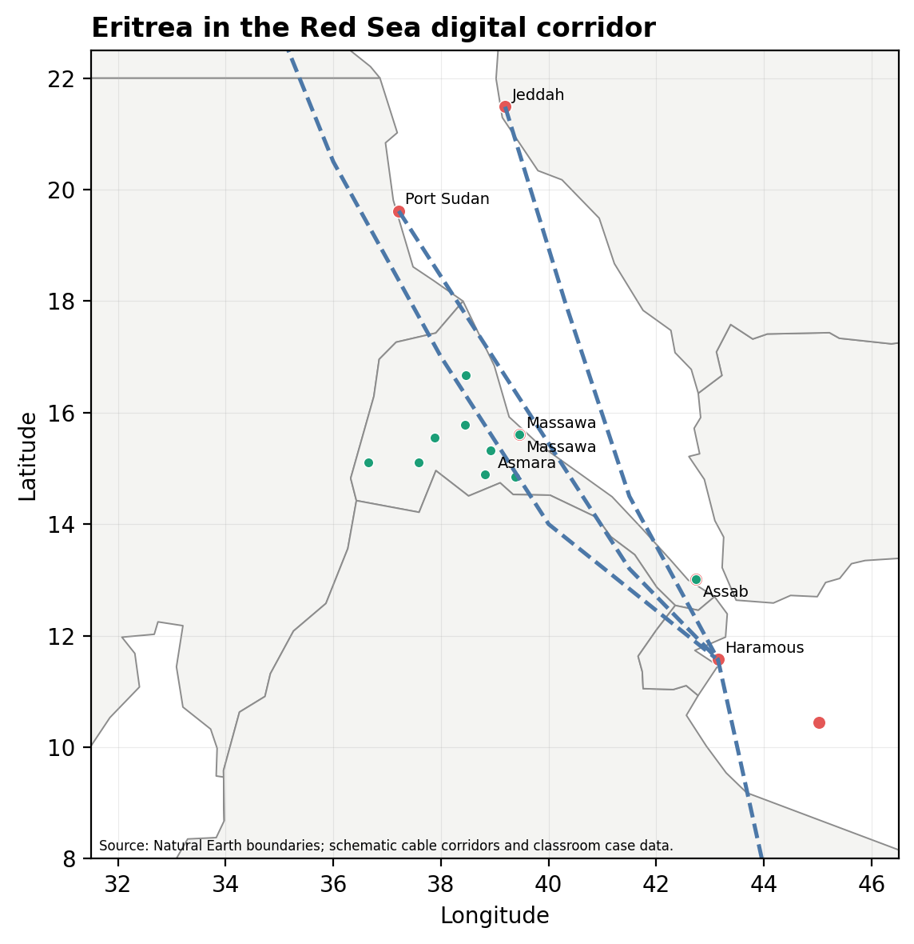
Figure 1. Red Sea context and stylized digital-corridor geography. Pedagogical map; not an engineering or nautical chart.

The development thesis
The argument for the project rested on a simple proposition: connectivity is a general-purpose infrastructure. Like ports, power grids, or roads, it does not create development automatically; but without it, many other development strategies remain trapped below scale. A country without reliable broadband cannot easily attract service exports, build cloud-based public administration, integrate hospitals into medical knowledge networks, connect universities to research communities, or lower the transaction costs faced by local firms.
The evidence Steve reviewed was suggestive rather than mechanical. Studies of broadband and growth associated higher broadband penetration with higher economic growth in developing economies. Empirical work on the arrival of fast Internet in Africa linked submarine-cable connection and terrestrial backhaul to employment shifts and firm outcomes. Other studies emphasized that infrastructure alone was insufficient: the gains depended on competition, skills, regulation, affordability, electricity, and local content. For Eritrea, the cable was therefore a necessary condition, not a development plan by itself.
That distinction shaped ORIZON’s message. The project could not be sold as a cable. It had to be sold as a knowledge gateway, a regulatory test, and a regional-integration mechanism. If the landing station was monopolized, the project could become another rent-seeking chokepoint. If it was governed as open-access infrastructure with transparent interconnection rules, it could become the backbone for a more competitive digital economy.

The multilateral path
ORIZON’s proposal moved through a multilateral channel. The government’s request was framed around resilient infrastructure, digital inclusion, and regional reintegration. A technical note was prepared with support from the International Telecommunication Union. The United Nations Development Programme was expected to coordinate capacity building and procurement discipline. The European Union indicated that the project might fit within the Global Gateway agenda if governance, transparency, and environmental safeguards were credible.
This path gave Steve legitimacy, but it also increased complexity. Multilateral finance demanded procurement rules, safeguards, and measurable development outcomes. The Eritrean presidency wanted speed and sovereign control. ORIZON wanted a commercially viable project and a protected role in the emerging regional network. Development agencies wanted openness, redundancy, and safeguards against digital authoritarianism. The same word—sovereignty—meant different things to each actor.

Scenario 1: terrestrial fiber through Sudan
The first option was a terrestrial fiber connection from Sudan into Eritrea, with a route that used five Sudanese nodes—Kassala, Gedaref, Medani, Khartoum, and Shendi—before extending toward Assab. On paper, the option was attractive. The capital expenditure was relatively low, estimated at USD 8 million to USD 11 million. Construction could begin quickly if permissions were secured. The system could be presented as regional integration rather than a high-profile marine project.
The weakness was exposure. The route crossed unstable territory, relied on the operating capacity of Sudanese institutions, and placed Eritrea’s first major digital opening at the end of a foreign transit corridor. Maintenance would be vulnerable to local conflict, cross-border politics, and recurring service interruptions. The very feature that made the option cheap—the ability to rent or extend someone else’s network—also made it difficult to defend as a sovereign development platform.
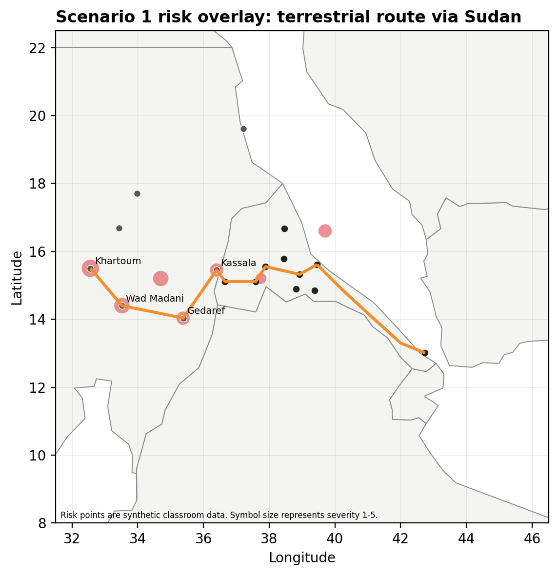
Figure 2. Scenario 1 risk overlay. Conflict and risk features are synthetic classroom layers for QGIS analysis.

Scenario 2: a low-earth-orbit satellite bridge
The second option was to lease capacity from low-earth-orbit satellite providers and install three national receiving stations around Asmara, Massawa, and Assab, each with an approximate service radius of 50 kilometers. The appeal was speed. No cable ship was needed. No trenching across unstable terrain was required. Within months, priority users—government offices, universities, hospitals, ports, and selected firms—could receive usable connectivity.
The limitations were strategic. A satellite bridge could provide a transitional layer, but it was not a national development backbone. Capacity would be narrower, recurring charges high, vendor dependence significant, and coverage concentrated around urban sites. For emergency public administration and early diplomatic signaling, the option had value. For a long-term knowledge economy, it was a bridge rather than a foundation.
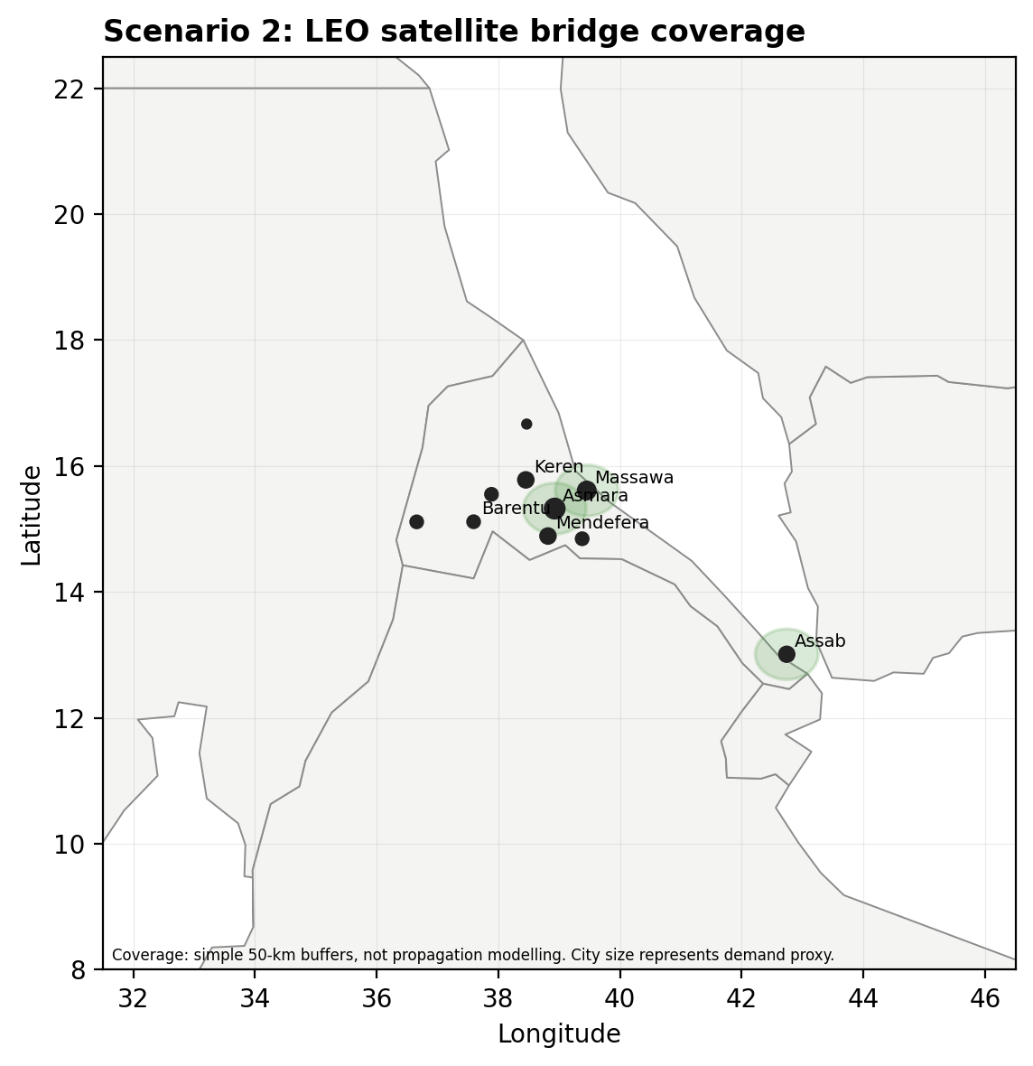
Figure 3. Scenario 2 satellite buffers around proposed national gateway sites. Pedagogical map.

Scenario 3: submarine cable and national backbone
The third option was the most ambitious. Eritrea would build a submarine-cable branch to a new landing station, most likely at Massawa, and connect that station to Asmara and other urban nodes through a domestic fiber backbone. The branch could integrate with ORIZON’s regional architecture and eventually connect Eritrea to Europe, the Middle East, and East Africa through diversified routes.
The estimated cost was USD 35 million to USD 50 million, with a likely deployment window of 18 to 24 months. The initial capacity assumption in ORIZON’s model was 400 to 600 Gbps, scalable to multiple terabits as demand rose and equipment was upgraded. This option offered the best long-run combination of capacity, latency, national autonomy, and investor credibility. It was also the hardest option to implement quickly.
The technical design was only half the issue. The landing station would have to be governed. Would it be owned by the state, ORIZON, a joint venture, a public utility, or an open-access wholesale entity? Would competing Internet service providers have non-discriminatory access? Would tariffs be regulated? Would the country build redundancy or create a single point of failure? Steve knew that a bad governance model could turn the best infrastructure into the worst political symbol.
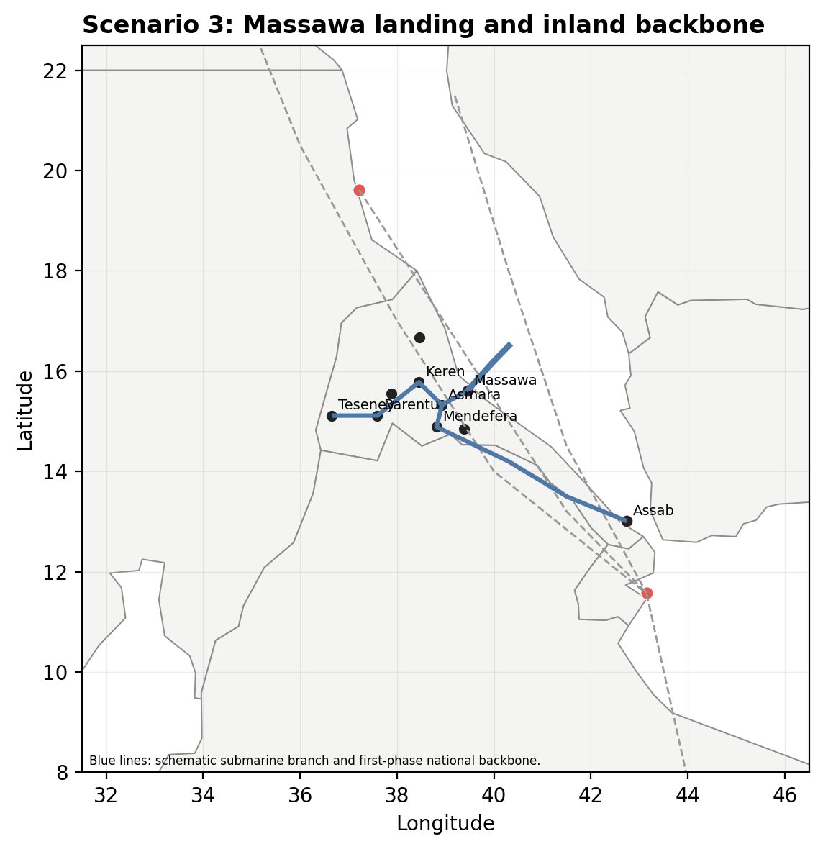
Figure 4. Scenario 3: stylized submarine branch and domestic backbone. Pedagogical map.

The shadow offer
Two weeks before the Nairobi committee, Steve received a message from a senior official in Asmara. China Communications Construction Company had presented a parallel proposal. The company would finance and deliver the full system, including the landing station, marine works, and first-stage terrestrial links. In return, it would receive exclusive operating rights over the landing station for 25 years.
The offer solved the budget problem by creating a sovereignty problem. It was attractive to officials who feared slow donor processes and wanted visible results. It worried those who saw the landing station as a national gateway to knowledge, commerce, diplomacy, and surveillance. A concession over such a chokepoint was not equivalent to a road toll. It potentially shaped who could interconnect, at what price, under which data-routing arrangements, and with what transparency.
The Eritrean president had not formally accepted the offer. Nor had he fully rejected it. Steve understood why. The multilateral path promised legitimacy but moved slowly. The concession path promised speed but might mortgage the digital future of the country.

Nairobi
The Nairobi meeting was designed as a technical committee, but no one believed it would be merely technical. The committee would compare route exposure, capacity, cost, environmental safeguards, institutional readiness, and financing. It would also read the maps. The QGIS layers showed country boundaries, principal cities, regional nodes, risk zones, satellite buffers, potential submarine branches, domestic backbone alternatives, and schematic Red Sea cable corridors. The map did not decide the answer. It disciplined the argument.
Steve had forty-eight hours to finalize ORIZON’s recommendation. He could advocate a single scenario or a phased approach. He could propose a purely public landing station, a regulated joint venture, or an open-access wholesale model. He could treat the CCCC offer as a threat to be rejected, a bargaining device, or a fallback if the multilateral process failed. Whatever he recommended, he needed to answer the central development question: how does a country move from isolation to knowledge access without losing control over the gateway that makes access possible?

Exhibits
The exhibits are designed for discussion and QGIS-based analysis. Figures and scenario layers are pedagogical and should not be treated as engineering plans.

Exhibit 1. Selected connectivity and development facts
Item | Relevance for the case
Submarine cables | Submarine cables carry the overwhelming majority of intercontinental Internet traffic and remain the principal high-capacity medium for global data exchange.
Global Internet use | In 2024, the ITU estimated that 68% of the world population was online; Africa’s average was materially lower.
Eritrea | Public estimates show some Internet use, but Eritrea lacks a submarine-cable landing station and remains constrained by limited scalable, affordable, high-capacity access.
Development mechanism | The cable creates the possibility of cheaper bandwidth, lower latency, cloud access, service exports, education access, and improved public administration. It does not automatically create those outcomes.
Institutional mechanism | Open access, credible regulation, redundancy, and procurement discipline determine whether connectivity becomes a public-development asset or a private chokepoint.

Exhibit 2. Connectivity options at a glance
Scenario | Strategic benefit | Primary risk | Indicative cost and timing
S1: Terrestrial fiber through Sudan | Lowest initial cost; can be framed as regional interconnection. | Foreign transit dependence; exposure to conflict and maintenance disruption. | USD 8–11 million; moderate implementation speed if permits and security hold.
S2: LEO satellite bridge | Fastest first-stage connectivity for government, universities, hospitals, and ports. | Recurring cost, vendor dependence, limited capacity, and concentrated coverage. | Approx. USD 0.6 million per station plus recurring monthly service costs; deployable within months.
S3: Submarine cable and national backbone | Best long-term capacity, latency, investor signal, and sovereignty if governance is open-access. | High capital cost, slow deployment, and complex landing-station governance. | USD 35–50 million; 18–24 months before full operational service.
Shadow option: CCCC concession | Solves short-term fiscal constraint and accelerates delivery. | 25-year control over national digital chokepoint; potential loss of policy flexibility. | Capital expenditure financed by concessionaire; economic cost embedded in concession terms.

Exhibit 3. Stakeholder map
Actor | Likely objective | Source of influence | Principal concern
Eritrean presidency | Visible reopening, sovereign control, national modernization. | Permits, public authority, domestic legitimacy. | Loss of control over a critical gateway; slow donor process.
ORIZON-Telecom | Commercially viable network extension and regional legitimacy. | Technical expertise, regional assets, institutional relationships. | Political risk, uncertain regulation, and return on investment.
UNDP and ITU | Inclusive and resilient infrastructure under credible standards. | Technical legitimacy, capacity building, coordination. | Procurement discipline, institutional capacity, safeguards.
European Union | Digital connectivity aligned with Global Gateway principles. | Blended finance, guarantees, diplomatic leverage. | Governance, transparency, and strategic competition.
CCCC | Turnkey infrastructure concession and long-run control of landing-station economics. | Financing speed and engineering capability. | Acceptance of exclusivity terms by the host state.
Citizens and firms | Affordable, reliable access to information, markets, and services. | Demand, legitimacy, future tax base. | Urban concentration, affordability, censorship, service quality.

Exhibit 4. Suggested QGIS layers in the student data package
Layer or file | Use in discussion
countries_context | Provides regional context for Eritrea, Sudan, Ethiopia, Djibouti, Somalia, Yemen, Egypt, and Saudi Arabia.
eritrea_cities | Provides principal demand nodes and allows students to reason about first-mile and middle-mile priorities.
scenario1_terrestrial_route | Allows spatial evaluation of the Sudan terrestrial option.
risk_zones_synthetic | Shows how security-risk assumptions can change the apparent cost of a route.
scenario2_satellite_sites and scenario2_satellite_buffers_50km | Allows students to assess rapid but geographically concentrated connectivity.
scenario3_submarine_branches and scenario3_domestic_backbone | Allows comparison of Massawa and Assab landing alternatives and inland backbone choices.
scenario_scorecard_seed.csv | Provides a starting decision matrix; students should revise weights and scores.

Exhibit 5. Discussion questions
1. What is the economic-development cost of remaining outside high-capacity Internet networks? Distinguish access, affordability, latency, redundancy, and knowledge use.
2. Which scenario should Steve recommend in Nairobi? Should the recommendation be a single option or a phased portfolio?
3. How should the landing station be governed if Eritrea chooses the submarine-cable option?
4. Should the CCCC concession be rejected, negotiated, or kept as leverage? What are the hidden costs of speed?
5. How do the QGIS maps change the argument? Which layers are decisive, and which assumptions should be challenged?
6. What complementary investments are required so that a cable becomes a development platform rather than a prestige project?

References
African Union. (2020). The Digital Transformation Strategy for Africa (2020–2030). African Union.
Cariolle, J. (2019). Telecommunication submarine-cable deployment and the digital divide in Sub-Saharan Africa. Fondation pour les études et recherches sur le développement international, Working Paper P241.
European Commission. (2025). EU-Africa: Global Gateway Investment Package. European Commission.
Hjort, J., & Poulsen, J. (2019). The arrival of fast Internet and employment in Africa. American Economic Review, 109(3), 1032–1079.
International Cable Protection Committee. (2024). Government best practices for protecting and promoting resilience of submarine telecommunications cables. ICPC.
International Telecommunication Union. (2024). Facts and figures 2024: Internet use. ITU.
Minges, M. (2015). Exploring the relationship between broadband and economic growth. World Bank.
Qiang, C. Z.-W., Rossotto, C. M., & Kimura, K. (2009). Economic impacts of broadband. In World Bank, Information and Communications for Development 2009: Extending reach and increasing impact (pp. 35–50). World Bank.
Raymond, M., & DeNardis, L. (2015). Multistakeholderism: Anatomy of an inchoate global institution. International Theory, 7(3), 572–616.
Starosielski, N. (2015). The undersea network. Duke University Press.
TeleGeography. (2025). Submarine Cable Map 2025. TeleGeography.
World Bank. (2025). Individuals using the Internet (% of population): Eritrea. World Development Indicators.

