Instructor Document | Exploration and Exploitation of Geospatial Data | HEC Montréal

Teaching Note: Eritrea Digital Gateway 2030
A Country at the Edge of the Knowledge Network

Brian Marcon
Thierry Warin, PhD
Instructor version. Do not distribute to students before class.

This teaching case is written for classroom discussion. It is not intended to serve as an endorsement, an investment memorandum, a diplomatic assessment, or an engineering design. Several organizations, characters, dates, and events in the decision narrative are fictionalized for pedagogical use; cited public data and references are identified in the exhibits.

Case synopsis
This case asks students to advise Steve Gaye, director of strategic projects at the fictional ORIZON-Telecom, as he prepares for a Nairobi technical committee on Eritrea’s proposed digital gateway. The country has limited scalable Internet infrastructure and no submarine-cable landing station, despite a strategic Red Sea coastline. Three formal scenarios are compared: a terrestrial fiber route through Sudan, a low-earth-orbit satellite bridge, and a submarine-cable landing station connected to a domestic fiber backbone. A fourth, informal alternative—a turnkey CCCC-financed concession—creates a sovereignty dilemma.
The teaching purpose is not to identify a single engineering solution. It is to force students to connect infrastructure, geography, state capacity, international political economy, development economics, and geospatial decision support. The central question is whether a country can build a modern knowledge economy if it lacks affordable, reliable, and sovereign access to the Internet and the knowledge stored, exchanged, and produced on it.

Courses and audiences
The case is designed for graduate courses in geospatial data science, international business, development economics, digital governance, infrastructure strategy, and political economy. It is particularly suitable for the HEC Montréal course Exploration and Exploitation of Geospatial Data because the substantive decision depends on reading maps, not merely producing them. Students should have enough familiarity with QGIS to load a GeoPackage, inspect layers, change symbology, create buffers or overlays, and export a simple map. No advanced geodesy or telecom-engineering background is required.

Learning objectives
Objective | Students should be able to
Digital infrastructure and development | Explain why high-capacity connectivity affects growth, firm productivity, education, public administration, health, trade, and investment.
Geospatial reasoning | Use QGIS layers to compare scenario routes, exposure to risk, coverage, urban demand, and regional interconnection.
Governance design | Compare multilateral, public, private, public–private, and concession models for critical infrastructure.
Sovereignty and dependency | Identify how a technical solution can create new forms of strategic dependency through routing, ownership, pricing, data access, or regulation.
Strategic recommendation | Produce a defensible, evidence-based recommendation under constraints of cost, speed, legitimacy, and institutional capacity.

Positioning in the course
The case works best after students have already completed an introductory QGIS lab on vector layers, basic symbology, projections, and spatial joins. It can be taught either as a 90-minute decision case with pre-prepared maps or as a 160-minute integrated GIS workshop in which students revise maps during class. The instructor should frame the map as a decision instrument: it makes assumptions visible, but it does not remove judgment.

Recommended preparation
Students should read the case and prepare the QGIS data package before class. They should open the GeoPackage, organize layers by scenario, and prepare at least one map export comparing the three options. They should also complete a one-page recommendation memo before the session. Recommended academic preparation includes Starosielski (2015), Hjort and Poulsen (2019), Minges (2015), and the African Union’s Digital Transformation Strategy for Africa (2020–2030).
Preparation item | Expected student output
Read the case narrative | A one-sentence statement of the decision Steve faces.
Open the QGIS package | A map showing Eritrea, principal cities, and at least two connectivity scenarios.
Review the scenario scorecard | A revised weighting of at least five criteria: capex, speed, scalability, sovereignty, and resilience.
Write a recommendation memo | A clear recommendation, two supporting arguments, one major risk, and one governance safeguard.

Assignment questions
1. What does it mean, economically and politically, for a country to lack meaningful access to the Internet and the knowledge available through it?
2. Which of the three formal scenarios should Eritrea pursue, and should it combine them in stages?
3. How should the landing station and backbone be governed if the submarine-cable option is selected?
4. What role should multilateral institutions play, and where should their authority stop?
5. How do QGIS maps change the recommendation? Which assumptions in the spatial layers are most important?
6. Should Steve treat the CCCC offer as unacceptable, negotiable, or useful leverage?

Teaching plan
The case can be taught in a short or extended format. The 90-minute version assumes students have completed the map work before class. The 160-minute version uses QGIS as an in-class workshop.
Segment | 90-minute class | 160-minute class | Teaching objective
Opening decision | 10 min | 15 min | Place students in Steve’s role and identify the decision criteria.
Development problem | 15 min | 20 min | Move from “Internet access” to the broader knowledge-economy problem.
QGIS and map reading | 15 min | 35 min | Use layers to reveal route exposure, coverage, and spatial inequality.
Scenario debate | 25 min | 45 min | Compare Sudan fiber, satellite bridge, submarine cable, and the concession offer.
Governance design | 15 min | 25 min | Design ownership, access, regulation, and financing safeguards.
Close | 10 min | 20 min | Synthesize the decision and draw general lessons for digital infrastructure.

Opening the class
Begin by asking students to write down Steve’s decision in one sentence. Good answers mention not merely the technology choice but the development and governance choice. Push students away from generic formulations such as ‘choose the best Internet option.’ A stronger formulation is: ‘Should ORIZON recommend that Eritrea build a submarine-cable landing station and national backbone, use satellites as a bridge, or accept a cheaper but more dependent route—while preserving sovereign control over the country’s main digital gateway?’
A useful board opening is a four-column frame: Map, Money, Sovereignty, Knowledge. Under Map, place routing, distance, population nodes, and risk. Under Money, place capex, recurring opex, financing, and returns. Under Sovereignty, place ownership, control, regulation, data routing, and concession duration. Under Knowledge, place universities, firms, health, public administration, and access to global information.

Analysis path

1. Why the absence of high-capacity Internet access matters
Students often begin with consumer Internet access. Redirect the discussion toward productive capacity. The most important consequences are not only that citizens cannot stream or communicate easily. Weak connectivity raises transaction costs for firms, limits cloud adoption, reduces access to research and online learning, makes government digitization fragile, discourages data-intensive investment, and isolates domestic professionals from global knowledge networks. The instructor can stress that the Internet is not development by itself; it is a platform on which many other forms of development increasingly depend.
A good discussion distinguishes five terms: access, affordability, latency, capacity, and redundancy. A country may have nominal access but still be unable to support knowledge-intensive development if the connection is slow, expensive, unreliable, or controlled through a single chokepoint. This distinction is crucial for correcting simplistic interpretations of Internet penetration rates.

2. Comparing the three formal scenarios
Scenario | Best argument for it | Best argument against it | Likely teaching judgment
Sudan terrestrial fiber | It is the cheapest formal option and may create regional interdependence. | It makes Eritrea dependent on a fragile foreign corridor and exposes the backbone to conflict and maintenance risk. | Useful only as redundancy or a temporary partial route; weak as the primary development platform.
LEO satellite bridge | It can be deployed rapidly and can connect priority institutions before a cable is ready. | It cannot provide a scalable national backbone and creates vendor dependence with high recurring costs. | Strong as a bridge and resilience layer; weak as the long-term core strategy.
Submarine cable and domestic backbone | It provides the strongest capacity, latency, sovereignty potential, and development signal if governed properly. | It is expensive, slow, and institutionally demanding. | Preferred long-term option, but should be staged and paired with governance safeguards and interim connectivity.

The expected high-quality recommendation is a phased portfolio: deploy a limited satellite bridge immediately for priority public institutions and port operations; begin the submarine-cable landing and domestic backbone as the strategic core; avoid dependence on Sudan as the primary route; and reject or radically renegotiate any concession that grants exclusive control over the landing station. This answer recognizes that development requires speed and durability. It also preserves the central teaching tension: the technically best option must still be made institutionally viable.

3. Governance of the landing station
The governance design should receive as much class time as the technology choice. Students should recognize that the landing station is a critical infrastructure chokepoint. A recommended model is a regulated open-access wholesale entity, structured as a joint venture or public utility with transparent interconnection rules, non-discriminatory access for licensed operators, tariff oversight, cybersecurity standards, data-protection rules, and an explicit capacity-building plan for the national regulator. Multilateral participation should be strongest during design, procurement, safeguards, and early capacity building, but the long-term model should avoid permanent external trusteeship.
Governance element | Recommended design
Ownership | Mixed public–private structure or public utility with ORIZON as technical operator under a time-limited contract.
Access | Open-access wholesale rules with published tariffs and non-discrimination among licensed service providers.
Regulation | Independent telecom regulator or interim regulatory board supported by ITU capacity building.
Revenue use | Ring-fence a share of landing-station revenues for backbone expansion, affordability programs, and cybersecurity.
Transparency | Publish service-level agreements, concession terms, environmental safeguards, and interconnection procedures.
Resilience | Plan for redundancy, cable-protection protocols, emergency repair agreements, and future second routes.

4. Handling the CCCC offer
The instructor should resist a purely geopolitical answer. The CCCC offer is useful because it forces students to price speed. It may reduce immediate fiscal burden and accelerate construction, but it shifts control to a concessionaire for 25 years. Students should ask what rights are granted, how tariffs are set, whether competitors can interconnect, where data are routed, what happens at the end of the concession, and whether the state has step-in rights. A sophisticated answer can say that Chinese participation is not inherently unacceptable; exclusivity over the national digital gateway is the problem.
The class can compare three positions. Reject: protects sovereignty but may delay the project. Negotiate: convert the offer into non-exclusive construction or equipment provision with open-access governance. Use as leverage: keep it on the table to improve financing terms from multilateral and European partners, while avoiding a final commitment. The teaching note’s recommended position is to negotiate only if exclusivity, tariff opacity, and unilateral operating control are removed.

QGIS teaching module
The QGIS package is deliberately small and classroom-oriented. Its purpose is not to provide official cable coordinates or conflict intelligence. It gives students enough spatial structure to see that each scenario has a different geometry of risk and benefit. The instructor should emphasize that every map is an argument made with assumptions.
QGIS layer | Instructor use | Possible prompt
countries_context | Orient students in the Red Sea and Horn of Africa geography. | What does Eritrea’s coastline make possible that its institutions may not yet be able to exploit?
eritrea_cities | Identify demand nodes and likely first-stage beneficiaries. | Which cities must be connected first for the project to have national-development credibility?
scenario1_terrestrial_route | Expose the hidden risk of a cheap option. | Where are the route’s vulnerabilities, and how would students price them?
risk_zones_synthetic | Introduce spatial uncertainty and security exposure. | How does the recommendation change as risk zones expand or move?
scenario2_satellite_buffers_50km | Show partial coverage and urban concentration. | Who is connected quickly, and who remains outside the first-stage network?
scenario3_submarine_branches | Compare landing alternatives and international integration. | Why might Massawa be preferable to Assab, or vice versa?
scenario_scorecard_seed.csv | Move from visual analysis to a decision matrix. | Which criterion deserves the highest weight: speed, sovereignty, scalability, or cost?

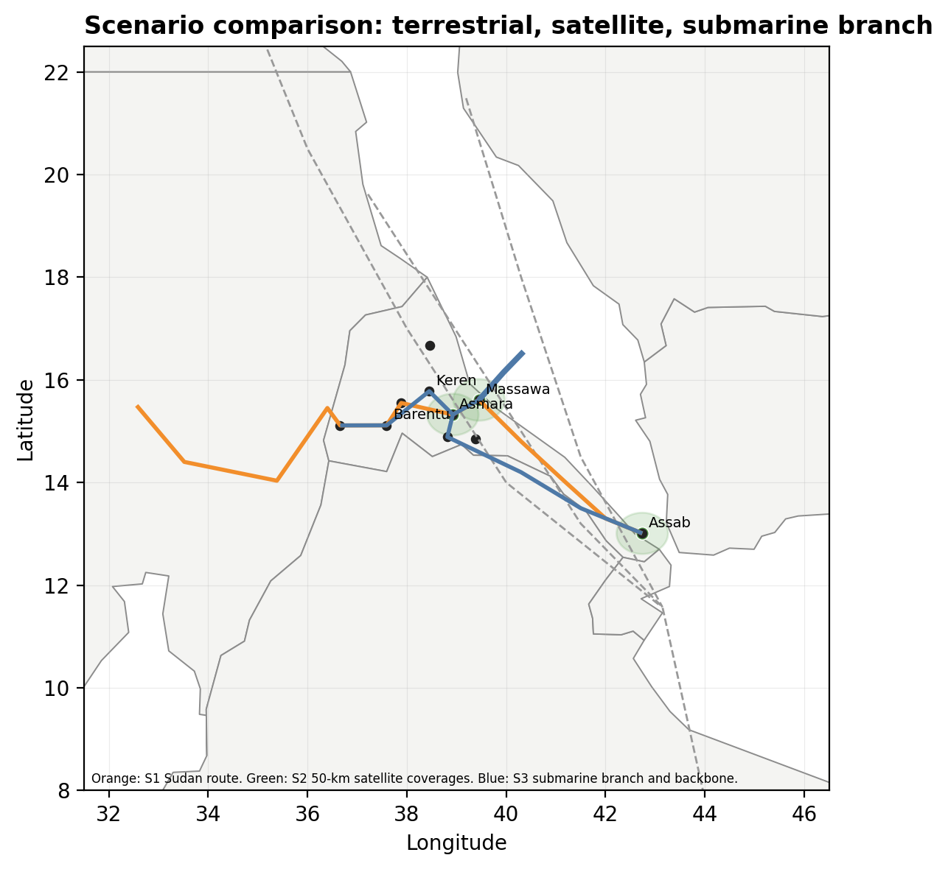
Figure TN-1. Scenario comparison map for classroom discussion. Pedagogical layers only.

Suggested board plan
Board column | What to write during discussion
Development problem | Knowledge access, firm productivity, education, public services, investment, integration.
Technical options | Sudan fiber; LEO bridge; submarine cable and backbone; CCCC concession.
Spatial evidence | Population nodes; route exposure; buffers; landing alternatives; regional corridors.
Governance risks | Monopoly, concession length, tariff opacity, data routing, weak regulator, urban bias.
Recommendation | Phased portfolio: LEO bridge now, submarine cable as strategic core, open-access governance, no exclusive landing-station concession.

Expected student errors and instructor responses
Common error | How to respond
Choosing the cheapest option by capex only. | Ask students to price outage risk, dependency, and lost development potential.
Treating satellite as equivalent to fiber. | Separate emergency connectivity from scalable backbone capacity.
Treating sovereignty as state ownership only. | Discuss open access, regulation, data routing, tariff setting, and control rights.
Assuming a cable automatically creates growth. | Ask what complementary investments are needed: competition, skills, electricity, local content, and institutions.
Rejecting all Chinese involvement as geopolitical reflex. | Focus on contract rights and governance rather than nationality of supplier.
Over-trusting the map. | Ask which layers are synthetic, which data are missing, and how uncertainty should be reported.

Assessment rubric
Criterion | Excellent answer | Weak answer
Problem framing | Connects Internet access to knowledge, development, sovereignty, and institutions. | Reduces the case to “which technology is fastest or cheapest.”
Use of evidence | Uses QGIS layers and facts to compare scenarios while noting uncertainty. | Mentions maps descriptively without using them in the recommendation.
Scenario logic | Recognizes trade-offs and proposes a phased portfolio. | Chooses one option without considering timing or complementarities.
Governance design | Specifies ownership, access, regulation, safeguards, and capacity building. | Says “public–private partnership” without design detail.
Strategic judgment | Balances speed, durability, sovereignty, and financing. | Overweights a single criterion and ignores second-order consequences.

Suggested closing
Close the class by returning to the sentence that opens the case: a country cannot fully reach the world’s knowledge if it lacks a reliable gateway to the Internet. Then add the second half of the lesson: the gateway must be governed, not merely built. For Eritrea, the best strategy is not a cable alone. It is an institutional bargain that uses a short-term bridge, builds a high-capacity backbone, protects open access, and turns geography into development rather than dependence.

References for instructors
African Union. (2020). The Digital Transformation Strategy for Africa (2020–2030). African Union.
Cariolle, J. (2019). Telecommunication submarine-cable deployment and the digital divide in Sub-Saharan Africa. Fondation pour les études et recherches sur le développement international, Working Paper P241.
European Commission. (2025). EU-Africa: Global Gateway Investment Package. European Commission.
Hjort, J., & Poulsen, J. (2019). The arrival of fast Internet and employment in Africa. American Economic Review, 109(3), 1032–1079.
International Cable Protection Committee. (2024). Government best practices for protecting and promoting resilience of submarine telecommunications cables. ICPC.
International Telecommunication Union. (2024). Facts and figures 2024: Internet use. ITU.
Minges, M. (2015). Exploring the relationship between broadband and economic growth. World Bank.
Qiang, C. Z.-W., Rossotto, C. M., & Kimura, K. (2009). Economic impacts of broadband. In World Bank, Information and Communications for Development 2009: Extending reach and increasing impact (pp. 35–50). World Bank.
Raymond, M., & DeNardis, L. (2015). Multistakeholderism: Anatomy of an inchoate global institution. International Theory, 7(3), 572–616.
Starosielski, N. (2015). The undersea network. Duke University Press.
TeleGeography. (2025). Submarine Cable Map 2025. TeleGeography.
World Bank. (2025). Individuals using the Internet (% of population): Eritrea. World Development Indicators.

