Supporting Information

**Theoretical estimation of dielectric loss of oxide glasses using non-equilibrium molecular dynamics simulations**

Shingo Urata1*, Hiroyuki Hijiya2, Kazuhiko Niwano2, Jun Matsui3

1 Planning Division, AGC Inc.

2 Materials Integration Laboratories, AGC Inc.

3 Department of Physics, Faculty of Sciences, Kyushu University

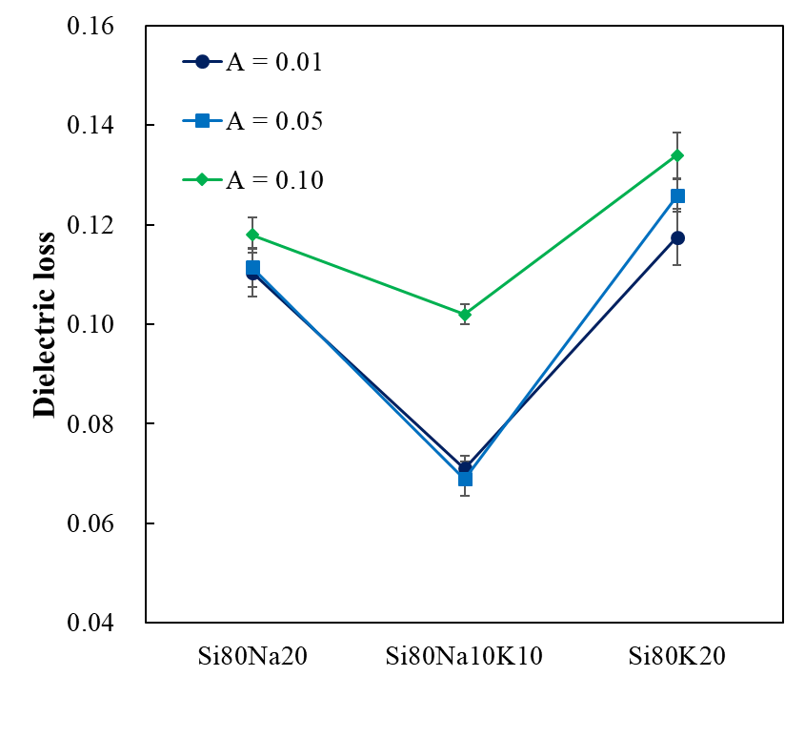

**Figure S1.** Effect of the amplitude (*A* in eV/Å) of an alternating electric field on the dielectric loss, which were evaluated at 40 GHz at 500K. Glass models are (SiO2)80(Na2O)20 (Si80Na20), (SiO2)80(K2O)20 (Si80K20), and (SiO2)80(Na2O)10(K2O)10 (Si80Na10K10). All cases demonstrate an evident mixed alkali effect on the dielectric loss.

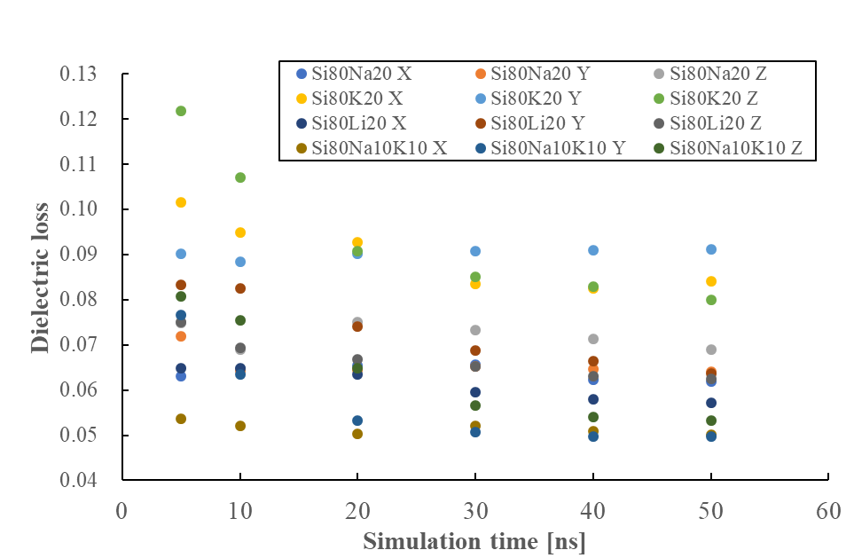

**Figure S2.** Time-dependence of the dielectric loss at 1 GHz for twelve cases. All MD simulations were conducted at 300 K. In the legend, Si80Na20, Si80K20, Si80Li20, and Si80Na10K10 indicate glass models of (SiO2)80(Na2O)20, (SiO2)80(K2O)20, (SiO2)80(Ki2O)20, and (SiO2)80(Na2O)10(K2O)10, respectively.

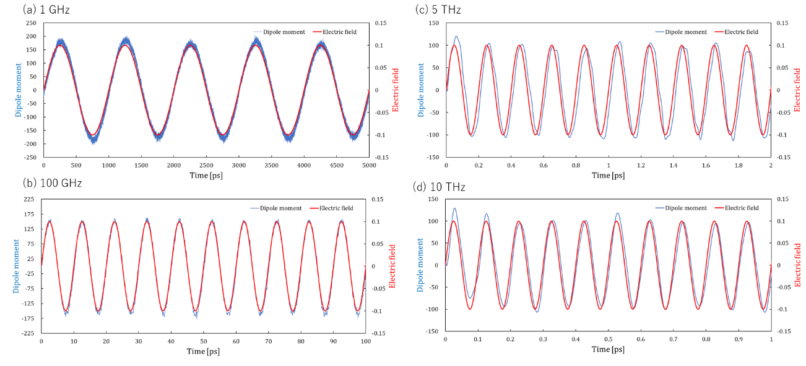

**Figure S3.** Comparisons between the external electric field applied to the glass models and the dipole moment induced along the electric field for (SiO2)80(Na2O)20 glass model. Temperature was 300 K.

**Table S1.** Glass models studied by MD simulations.



**Table S2.** MD simulation time for each frequency condition.



**An example of input file for LAMMPS to apply an alternating electric field**

# read restart file of the equilibrated slab model

read_restart Glass_slab.restart.300000

# Define interatomic interaction. Here Teter potential is defined using tables

pair_style hybrid/overlay coul/long 12.0 table spline 20000 pppm

kspace_style pppm 1.0e-5

pair_coeff * * coul/long

pair_coeff * * table "./Table_None.dat" None 12.0

pair_coeff 1 3 table "./Table_Teter_Si-O.dat" Teter_Si-O 12.0

pair_coeff 2 3 table "./Table_Teter_Na-O.dat" Teter_Na-O 12.0

pair_coeff 3 3 table "./Table_Teter_O-O.dat" Teter_O-O 12.0

# Define interatomic interaction. Here Teter potential is defined using tables

variable amp equal 0.10 # amplitude of the electric field

variable freq equal 1000.0 # frequency of the electric field

variable Eapply equal swiggle(0.0,v_amp,v_freq)

# Define MD simulation conditions

neighbor 1.0 bin

neigh_modify every 10 delay 10 check yes

timestep 0.001

reset_timestep 0

# Define calculation of dipole moment

compute call all chunk/atom bin/3d x upper 500 y upper 500 z upper 500

compute dip_all all dipole/chunk call

# Define ensemble (NVT)

fix 2 all nvt temp 300.0 300.0 1.0

# Define external electric field

fix 3 all efield 0.0 0.0 v_Eapply

# Define output of dipole moment

fix 5 all ave/time 100 1 100 c_dip_all[*] file dip_all.out mode vector

# Define trajectory file

dump 12 all custom 100000 SiNa8020_E.lammpstrj id type element x y z vx vy vz

thermo 100

thermo_style custom step lx v_Eapply press pxx pyy pzz pe evdwl ecoul elong temp

run 50000000

EOF