Assignment 1 :

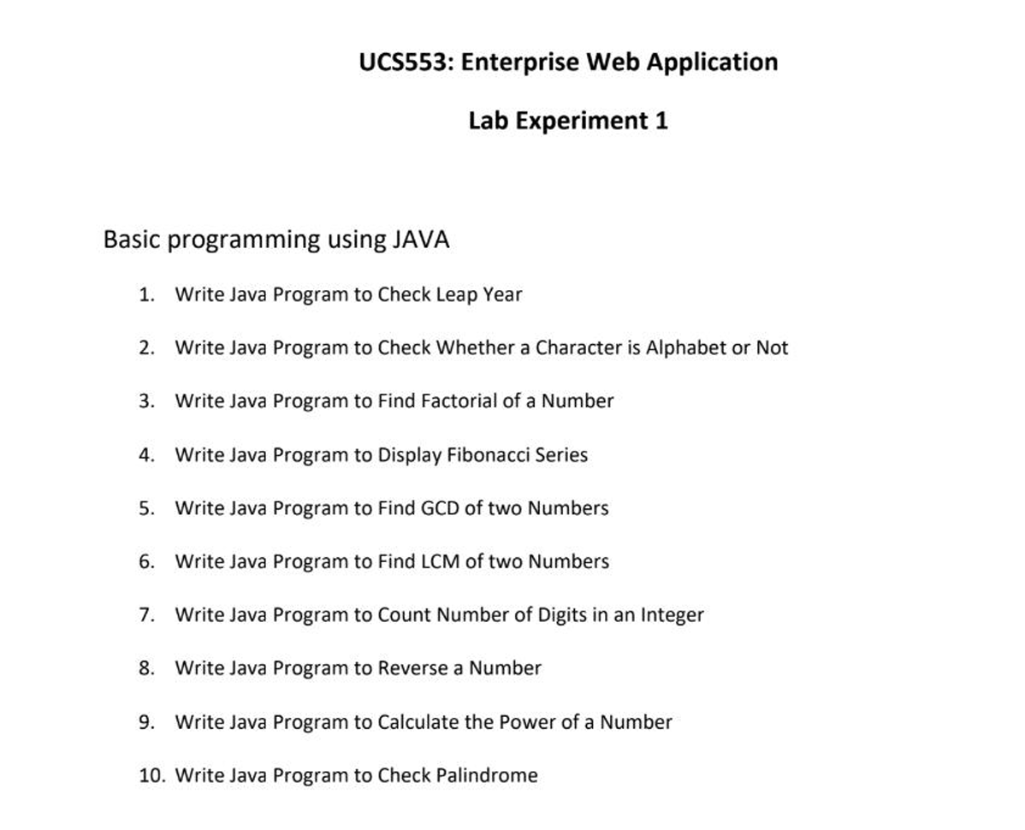

Q1. Write a program to check a leap year:

public class conditionals{
public static void main(String[] args){
Scanner leap_year=new Scanner(System.in);
System.out.println("Enter year :");
int year=leap_year.nextInt();
if(year % 400 == 0 || (year % 4 == 0 && year % 100 != 0)){
System.out.printf("%d is a leap year \n",year);
}
else{
System.out.printf("%d is not a leap year \n",year);
}
}
}

Output:
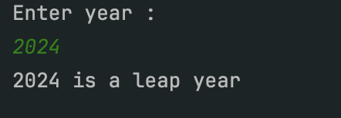

Q2. Write a program to check whether a character is an alphabet or not :

package increment;
import java.util.Scanner;
// Q2. Write a program to check whether a character is an alphabet or not
public class character_check{
public static void main(String[] args){
Scanner character=new Scanner(System.in);
System.out.println("Enter the character :");
char ch = character.next().charAt(0);
if((ch>='A' && ch<='Z') || (ch >= 'a' && ch<= 'z')){
System.out.printf("%c is an alphabet. \n",ch);
}
else{
System.out.printf("%c is not an alphabet. \n",ch);
}
}
}

Output:

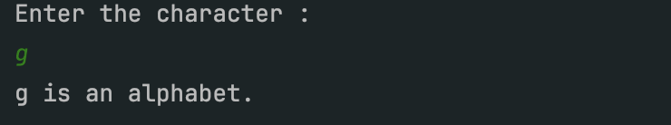

Q3. Write a program to find factorial of a number

// Q3. Write a program to find factorial of a number
public class factorial{
public static void main(String[] args){
Scanner factorial=new Scanner(System.in);
System.out.println("Enter the character :");
int num = factorial.nextInt();
int fact=1;
for(int i=1;i<=num;i++){
fact*=i;
}
System.out.printf("Factorial of %d is %d",num,fact);
}
}

Output:

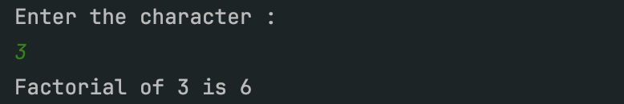

Q4. WAP to print Fibonacci Series:

package increment;
import java.util.Scanner;
// Q4. Write a program to print fibonacci series
public class fibonacci_series{
public static void main(String[] args){
Scanner sc=new Scanner(System.in);
System.out.println("Enter the character :");
int num = sc.nextInt();
int first=0;
int second=1;
System.out.print("Fibonacci Series: ");
for(int i=1;i<=num;i++){
System.out.print(first + " ");
int next = first + second;
first = second;
second = next;
}
}
}

Output:
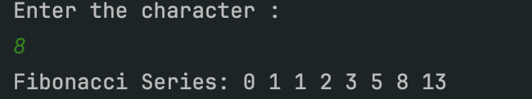
Q5.WAP to find GCD of two numbers

package increment;
import java.util.Scanner;
// Q5. Write a program to fid GCD of two numbers
public class GCD{
public static void main(String[] args){
Scanner sc=new Scanner(System.in);
System.out.println("Enter two numbers:");
int num1 = sc.nextInt();
int num2 = sc.nextInt();
int ans=1;
if(num2<num1){
for(int i=1;i<=num1;i++){
if(num2%i==0 && num1%i==0){
ans=i;
}
}
}
else{
for(int i=1;i<=num2;i++){
if(num2%i==0 && num1%i==0){
ans=i;
}
}
}
System.out.printf("GCD of %d ,%d id %d",num1,num2,ans);
}
}

Output:

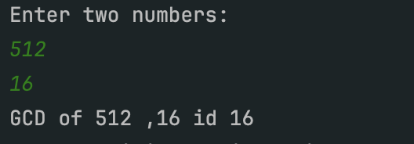

Q6. WAP to find LCM of two numbers

// Q6. Write a program to fid LCM of two numbers
public class LCM{
public static void main(String[] args){
Scanner sc=new Scanner(System.in);
System.out.println("Enter two numbers:");
int num1 = sc.nextInt();
int num2 = sc.nextInt();
int ans=1;
int lcm=Math.max(num1,num2);
while (true) {
if (lcm % num1 == 0 && lcm % num2 == 0) {
break;
}
lcm++;
}
System.out.printf("LCM of %d and %d is %d", num1, num2, lcm);
}
}

Output:

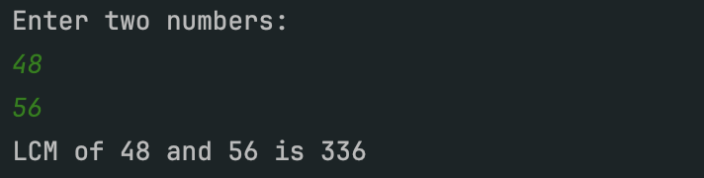

Q7. WAP to count digits in an integer

// Q7. Write a program to fid digits in an integer
public class digits_in_a_integer{
public static void main(String[] args){
Scanner sc=new Scanner(System.in);
System.out.println("Enter a number:");
int num1 = sc.nextInt();
int ans=0;
while (num1>0) {
num1/=10;
ans++;
}
System.out.printf("Ans %d", ans);
}
}

Output:

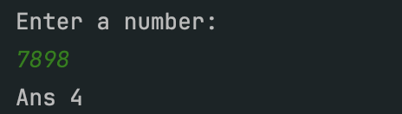

Q8. WAP to reverse a number

// Q8. Write a program to reverse a number
public class reverse_a_number{
public static void main(String[] args){
Scanner sc=new Scanner(System.in);
System.out.println("Enter a number:");
int num1 = sc.nextInt();
int ans=0;
while (num1>0) {
int rem=num1%10;
ans*=10;
ans+=rem;
num1/=10;
}
System.out.printf("Reverse number %d", ans);
}
}

Output:
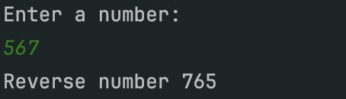

Q9.WAP to find power of a number

// Q9. Write a program to find power of a number
public class power{
public static void main(String[] args){
Scanner sc=new Scanner(System.in);
System.out.println("Enter a number, power");
int num1 = sc.nextInt();
int power = sc.nextInt();
int ans=1;
for(int i=1;i<=power;i++){
ans=ans*num1;
}
System.out.printf("Power of a number %d is %d", num1 ,ans);
}
}

Output:
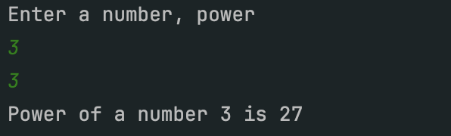
Q10.WAP to check whether a number is palindrome or not

// Q10. Write a program to find power of a number
public class pallindrome{
public static int pall(int num1){
int ans=0;
while (num1>0) {
int rem=num1%10;
ans*=10;
ans+=rem;
num1/=10;
}
return ans;
}
public static void main(String[] args){
Scanner sc=new Scanner(System.in);
System.out.println("Enter a number");
int num1 = sc.nextInt();
if(num1==pall(num1)){
System.out.println("Pallindrome ");
}
else{
System.out.println(" No Pallindrome ");
}
}
}

Output:
