INTRODUCTION TO JAVA :
Java is a high-level, object-oriented, class-based programming language. The primary creator of Java was: James Gosling
He worked at Sun Microsystems.
The original project was called Oak and was initially intended for interactive television and embedded devices.
Later, Oak was renamed Java.

“Write Once, Run Anywhere” (WORA)

- First program in JAVA:

// First program in JAVA to print Hello world
public class First_Program{ // The file name and the ClassName should be same
public static void main(String[] args){ // static keyword indicates method belongs to class only, no need to create object of class first
System.out.println("Hello world !!");
}
}

- Taking input from user:

import java.util.Scanner;
public class taking_input_from_user{
public static void main(String[] args){
Scanner sc=new Scanner(System.in);
System.out.println("Enter two numbers");
int a=sc.nextInt();
int b=sc.nextInt();
int sum=a+b;
System.out.print("Sum of two numbers: ");
System.out.println(sum);
sc.nextLine();
/* sc.nextLine(); consumes the leftover newline (\n) after nextInt(),
allowing the next nextLine() to correctly read the user's string input.
*/
System.out.println("Enter a string");
String str= sc.nextLine();
System.out.println(str);
}
}

Java Programming Exercise 1: CBSE Board Percentage Calculator

/* Write a program to calculate percentage of a given student in CBSE board exam.
His marks from 5 subjects must be taken as input from the keyboard. */
import java.util.Scanner;
public class exercise_CBSE_board_percentage{
public static void main(String[] args){
Scanner sc=new Scanner(System.in);
System.out.println("Enter marks of DSA");
int m1=sc.nextInt();
System.out.println("Enter marks of Discrete Mathematics");
int m2=sc.nextInt();
System.out.println("Enter marks of DBMS");
int m3=sc.nextInt();
System.out.println("Enter marks of Computer Networks");
int m4=sc.nextInt();
System.out.println("Enter marks of Operating System ");
int m5=sc.nextInt();
int total_marks=m1+m2+m3+m4+m5;
float percentage= (float) (total_marks*100 /500);
System.out.println("Percentage of student:"+percentage);
}
}

- Increment-Decrement operators:

public class increment_decrement {
public static void main(String[] args) {
int a = 6;
System.out.println(a); //6
System.out.println(a++); //6
System.out.println(++a); //8
System.out.println(a); //8
}
}
a++ : Use first, increment later
++a: Increment first, use later

- Operators precedence and associativity :

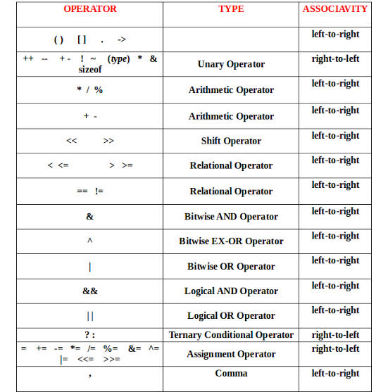

- Strings:
- A string instantiated as-

Java Strings are immutable, meaning once a String object is created, its actual content cannot be changed.
/*
A string is a class and can be used as a datatype of
sequence of characters.
*/
public class basics_of_strings {
public static void main(String[] args) {
String name=new String(" Waris Mittal");
System.out.println(name);
System.out.println(" String.length " + name.length());
System.out.println(" String.toLowerCase " + name.toLowerCase());
System.out.println(" String.toUpperCase " + name.toUpperCase());
System.out.println(" String.trim " + name.trim());
System.out.println(" String.substring from starting 3rd place " + name.substring(3));
System.out.println(" String.substring from starting 3rd place and ending at 10th place " + name.substring(3,10));
System.out.println(" String.replace w with m " + name.replace('W','M'));
System.out.println(" String.replace w with mit " + name.replace("W","Mit"));
System.out.println(" String.startsWith W " + name.startsWith(" War"));
System.out.println(" String.endsWith l " + name.endsWith("al"));
System.out.println(" String.charAt 3 " + name.charAt(3));
System.out.println(" String.indexOf M " + name.indexOf('M'));
int a=5;
int b=6;
/* we have to use \\ to get \ */
System.out.printf(" Number a :%d \\\n number b: %d \\\n string is: %s ",a,b,name);
}
}

- Escape Sequences
