Waristha Simsiripon (Job)
Account Value Partner | Roche Diagnostics Thailand

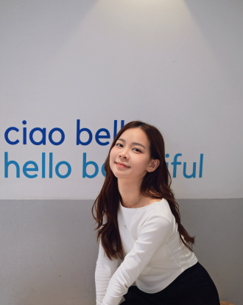  📍 Bangkok, Thailand  🏢 Roche Diagnostics Thailand | About Me  Hi everyone, my name is Waristha Simsiripon — but please call me Job.  I am excited to join Roche Diagnostics Thailand as an Account Value Partner and look forward to contributing to the team.  I hold a Bachelor's degree from Chulalongkorn University and have spent the past 3 years as a Sales Representative at Meditop Co., Ltd., managing hospital laboratory accounts across Bangkok. My experience centres on hematology and urinalysis analyzers, lab workflow optimization, tender specification, and value-based proposals for both public and private hospital customers.  I have developed a strong understanding of hospital procurement processes and laboratory operations — and I believe that the right diagnostic partnership, built on trust and data, can meaningfully improve patient care.  Joining Roche means stepping into a global leader in IVD innovation, and I am genuinely excited to grow from product-focused sales into strategic healthcare partnership.  What motivates you to come to work every day?  Every test result is connected to a real clinical decision. When I help a lab team improve turnaround time or adopt a better workflow, that improvement flows directly to the patient — and that connection is what drives me each day.  I also enjoy the challenge of truly understanding a customer's pain points and finding creative, evidence-based solutions. No two accounts are the same, and I find that variety energizing.  A fun fact most people would not know about you  I tend to over-prepare for almost everything — and I mean almost everything. Colleagues have noted that I bring the same level of attention to detail to a client presentation as I do to selecting a proper cup of matcha. What I have learned from both is that precision in small things builds trust in large ones — and in diagnostics, I believe that principle matters more than most.

