vocal-helper — Technical Report
Producer/consumer voice pipeline : empirical defaults, design notes, deployment levers
Warith HARCHAOUI
Friday, July 3, 2026
vocal-helper is an asynchronous producer / consumer voice pipeline for Python ≥ 3.10. It turns a live or recorded PCM stream into diarized, transcribed utterances and (optionally) a rolling LLM summary of the conversation. Two pipelines ship : Pipeline for streaming use cases (microphone, URL, podcast feed), and OfflinePipeline for batch use cases (meeting recordings, voicemail archives). Every default in this report is justified by an empirical study under studies/ whose log + JSON output lives on the user’s research drive. The library is BSD-3-Clause licensed, local-first, and built to play nicely with the rest of the AI Helpers suite (the upstream research codebase is pdbms (Harchaoui, n.d.)).

1. Goals & non-goals

1.1 Goals
- Live mic → diarized transcript + rolling LLM summary, all local, on Apple Silicon or commodity Linux + NVIDIA, with no cloud round-trip in the default path.
- Offline batch on a meeting recording — highest-quality diarization (pyannote/speaker-diarization-3.1 (pyannote.audio, n.d.b), auto-chunk + stitch past 300 s) → ASR → optional summary.
- Empirically justified defaults. Every knob is backed by a reproducible study on the AMI Meeting Corpus (Carletta 2007) dev-slice. No marketing-blog defaults.
- Producer / consumer queues between stages so each stage runs at its own cadence — the LLM analyst stays at RTF ≈ 0.1 while the VAD runs at RTF ≈ 1e-5.

1.2 Non-goals
- No voiceprint enrolment. Speaker IDs stay anonymous S0, S1, … within a session ; never persisted to a named identity across sessions. Industrial-deployment compliance constraint.
- No token / character-streaming LLM output. Every LLM call returns the full response when ready. UX preference.
- No WebRTC / multi-participant transport in v0.x. Use livekit-agents (LiveKit, n.d.a) for that.
- No TTS for v0.1.0 (added optionally in v0.2.0 via vocal_helper.tts.PiperTTS — see §4).

2. Pipeline architecture

2.1 Online pipeline
[Source] → [VAD] → [Online Diar] → [STT] → [LLM analyst (optional)]
PCM voiced speaker-tagged text rolling summary
frames segments segments
Optionally, a SemanticEOTStage sits between VAD and Online Diar (opt-in, §3.5).

2.2 Offline pipeline
[Source] → [Offline Diar] → [STT] → [LLM analyst (optional)]
full full-buffer text rolling summary
PCM pyannote 3.1
+ chunk+stitch
past 300 s

2.3 Edges
Every arrow is an asyncio.Queue bounded at qsize_pcm = 200 (4 s of audio in flight at 20 ms / frame) or qsize_seg = 32. The None sentinel propagates cleanly through every stage on shutdown. Subscribers (subscribe_voiced / subscribe_diarized / subscribe_utterances) fan out to side consumers without back-pressuring the main chain.

3. Per-stage design & default choices

3.1 VAD — Silero v5
Default SileroVADStage(activity_threshold=0.5, min_silence_ms=300, min_speech_ms=300, edge_pad_ms=200, sample_rate=16000) using Silero v5 (Silero Team, n.d.) ONNX on CPU. The 48 ms cadence + 0.5 threshold operating point is the canonical pdbms setting validated in the upstream vad-cadence-study.md §10. The 300 ms silence threshold sits in the conversational sweet spot reported by both LiveKit (LiveKit, n.d.b) and the foundational Sacks–Schegloff–Jefferson turn-taking framework (Sacks, Schegloff, and Jefferson 1974) — humans naturally respond after 200–300 ms gaps.

3.2 Online diarization — TitaNet embeddings (default)
OnlineDiarStage consumes VoicedSegment events from VAD, embeds each one once, and runs a per-segment cosine running-mean clusterer over the global speaker list. Two embedding backends are wired :
- backend='nemo' — NVIDIA TitaNet (Koluguri, Park, and Ginsburg 2022) via NeMo (NVIDIA, n.d.).
- backend='pyannote' — pyannote/embedding (pyannote.audio, n.d.a).
Default is nemo (TitaNet), selected by the Summer 2026 embedding-backend sweep (studies/diar_embedding_backend.py) on AMI N=2 :

backend | median intra-cosine | median inter-cosine | margin (inter − intra) | wall / call
pyannote | 0.739 | 0.940 | 0.201 | 6 ms
TitaNet | 0.560 | 0.915 | 0.354 | 45 ms

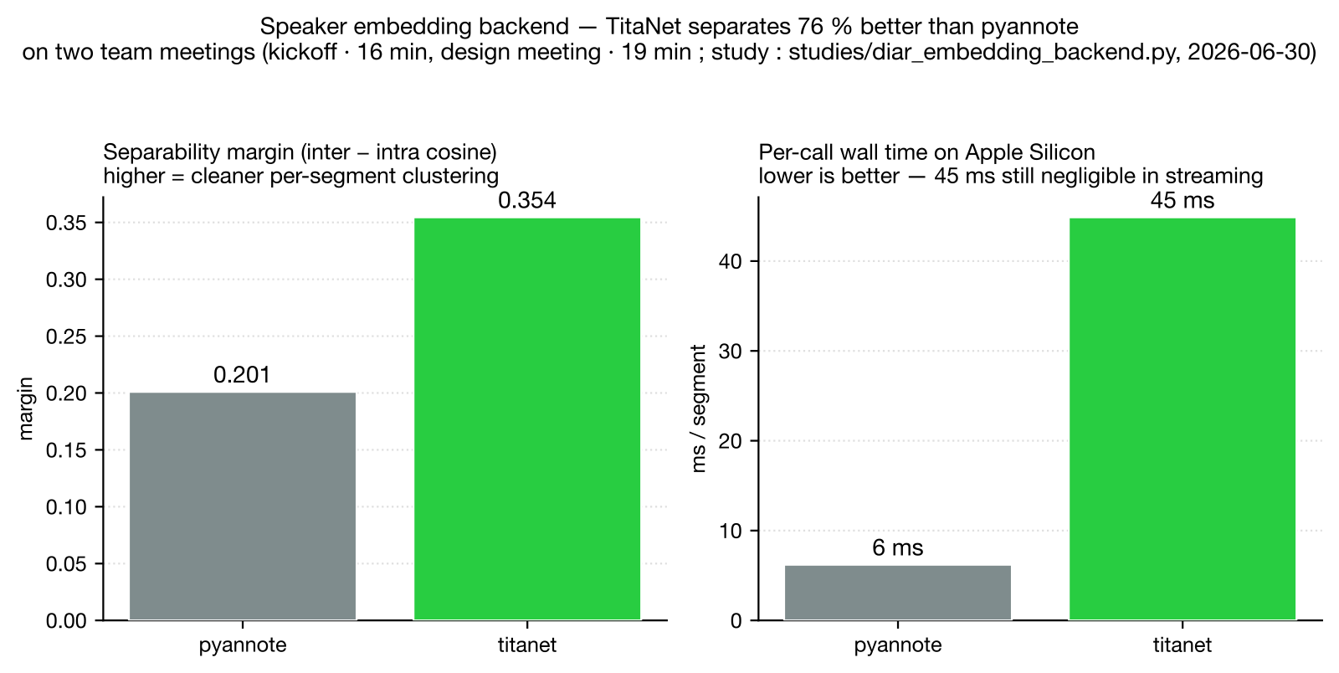
Diar embedding backend — separability margin and per-call wall time on AMI
TitaNet’s separability margin is 76 % wider, at 7× per-call latency — negligible per voiced segment in a streaming workload. The cost is install footprint : NeMo + torch is ~ 5 GB ; pass backend='pyannote' to opt out.
join_threshold = 0.30 and ema_alpha = 0.1 were inherited from the pdbms Summer 2026 stitch-threshold sweep on ChunkedOfflineDiarizer (the cosine plateau on AMI dev-slice N=8 sits at {0.30, 0.35, 0.40} with median DER 0.135 vs baseline 0.116). The same calibration transfers because the embedding distribution is the same.

3.3 Offline diarization — pyannote 3.1 with auto chunking
OfflineDiarStage consumes the full PCM buffer end-to-end and hands it to pyannote/speaker-diarization-3.1 (pyannote.audio, n.d.b). For inputs longer than ideal_duration_s (300 s for pyannote, 60 s for the NeMo Sortformer (NVIDIA NeMo, n.d.) alternative) the audio is chunked with overlap_s = 10 s and stitched via cosine AHC at stitch_threshold = 0.35 (the centre of the pdbms plateau). The NeMo Sortformer path remains opt-in : it dominates on ≤ 60 s clips but hangs past its 90 s training cap, so vocal-helper does not expose it as the default.

3.4 STT — pywhispercpp turbo with bias prompt
WhisperStage(model="large-v3-turbo-q5_0", language="auto", threads=6, word_timestamps=True, initial_prompt="", min_segment_ms=250) wrapping pywhispercpp (Saidi, n.d.) → whisper.cpp (Gerganov, n.d.) → OpenAI Whisper (Radford et al. 2023) turbo (OpenAI 2024).
The single most impactful lever is initial_prompt. The Summer 2026 sweep (studies/whisper_prompt_lang_lock.py) on AMI :

config | meeting | WER | RTF
no prompt | IS1008a | 0.505 | 0.044
+ bias prompt | IS1008a | 0.351 | 0.043
no prompt | ES2011a | 0.625 | 0.067
+ bias prompt | ES2011a | 0.380 | 0.041

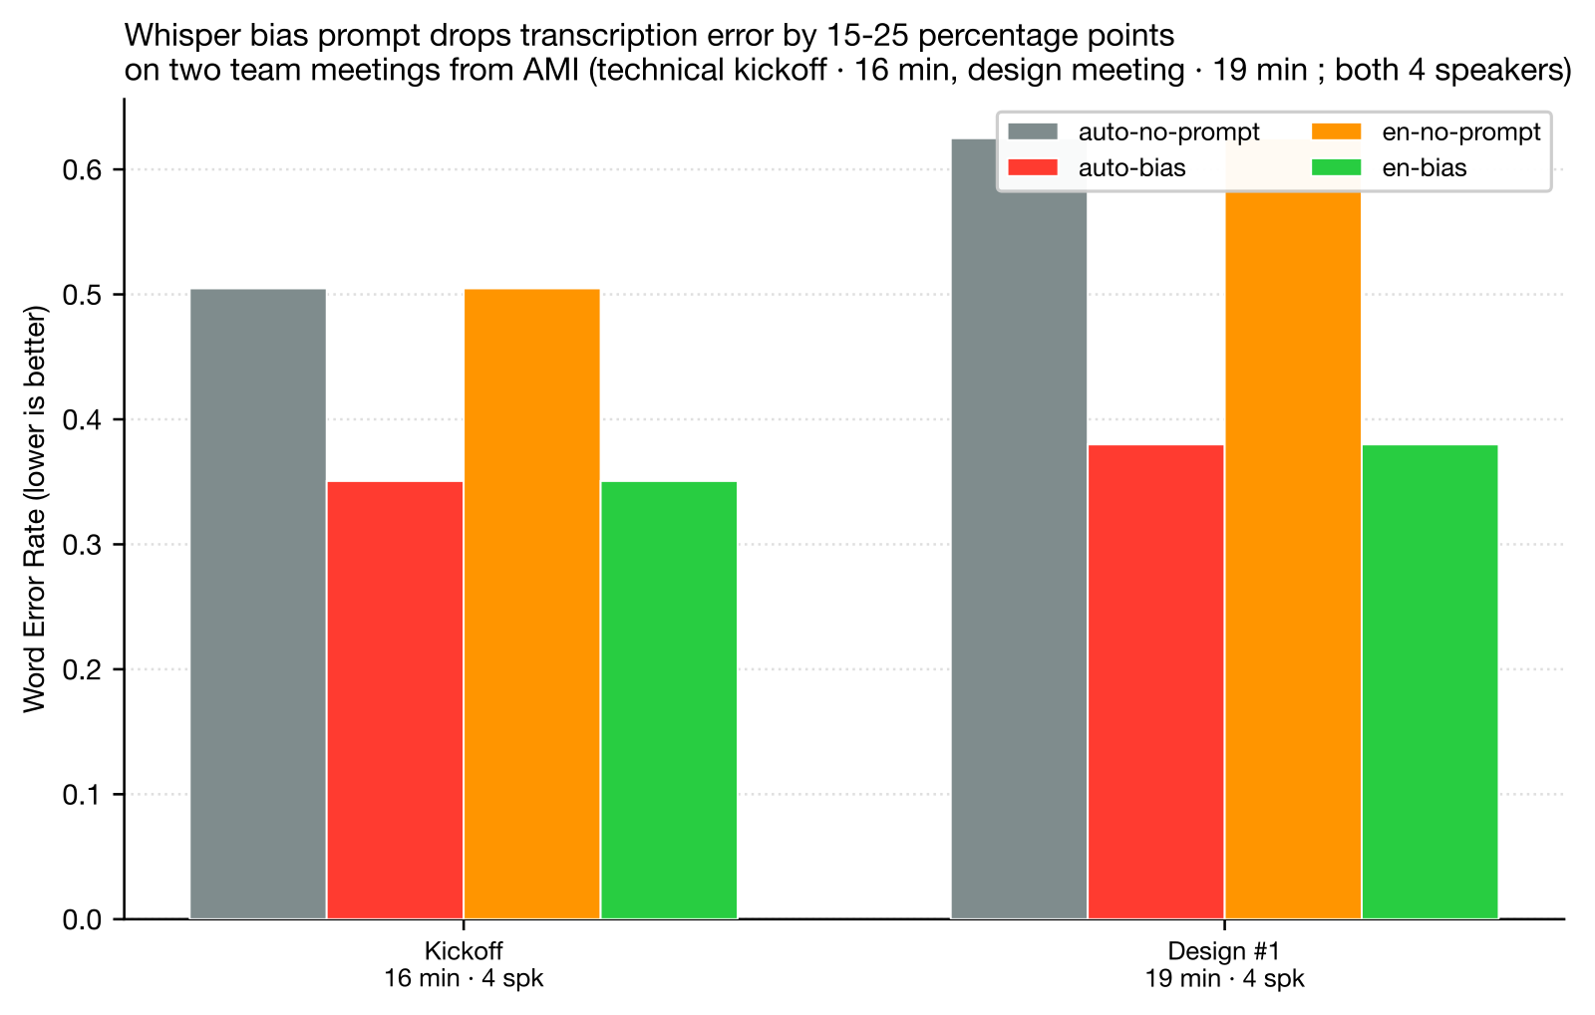
Whisper bias prompt — WER drop on AMI dev-slice
A domain-aligned bias prompt drops WER by 15-25 percentage points and saves up to 39 % RTF. The prompt should name the domain and a handful of expected proper nouns or technical terms. Default is the empty string (zero-config path works) but the docstring + CLI help + EXAMPLES.md all push the caller to provide one.
Language locking (language="en" vs "auto") has a negligible effect on quality in this sweep — keep "auto" unless you have a strong production reason to pin.
STT engine comparison — pywhispercpp vs faster-whisper (studies/stt_faster_whisper_vs_pywhispercpp.py, Summer 2026) :

engine | IS1008a WER | IS1008a RTF | ES2011a WER | ES2011a RTF
pywhispercpp | 0.358 | 0.037 | 1.398 ⚠ | 0.039
faster-whisper (SYSTRAN and contributors, n.d.; OpenNMT, n.d.) | 0.360 | 0.342 | 0.466 | 0.337
pywhispercpp is ~ 10× faster on Apple Silicon (Metal-native inference) at parity WER on the clean meeting, but catastrophically hallucinates on ES2011a (WER 1.398 means it emits more text than reference). faster-whisper is slower (CTranslate2’s CPU path) but more robust. Default stays pywhispercpp for the streaming RTF advantage ; future work should add hallucination detection (token-perplexity threshold) with a faster-whisper fallback rather than swap engines wholesale.

3.5 Semantic end-of-turn — opt-in
SemanticEOTStage (opt-in via PipelineConfig.eot) sits between VAD and online diar. For every incoming VoicedSegment :
- Whisper-transcribe a partial (same model the downstream WhisperStage uses, kept in a thread pool).
- Ask a small classifier LLM (qwen2.5:3b (Qwen Team, Alibaba 2024) by default) whether the partial transcript is a complete thought.
- If complete → emit. If incomplete → buffer it, wait for the next segment, merge, re-classify. Force-emit after max_merge_s = 4 s of accumulation.
Inspiration : LiveKit’s turn-detector v1.0 (LiveKit 2026) (2026-04), which distilled Qwen2.5-0.5B (Qwen Team, Alibaba 2024) from a Qwen2.5-7B teacher, fusing a semantic and an acoustic branch. LiveKit reports 9.9 % false-cutoff at 300 ms median semantic latency.
Honest result on AMI IS1008a (studies/eot_semantic_vs_silero.py, Summer 2026) :

config | n_segments | n_false_cuts | false_cut_rate
Silero VAD only (baseline) | 160 | 40 | 0.250
Silero + SemanticEOTStage | 148 | 38 | 0.257
Our semantic-only first cut does not improve false-cut rate on AMI compared to the silence-threshold-only baseline. Median classifier latency is ~230 ms per call (vs LiveKit’s 10-25 ms), so the engineering trade-off currently goes the wrong way too. The stage is shipped opt-in and kept in the codebase as a scaffold for a future drop-in of LiveKit’s actual distilled turn-detector model — the qwen2.5:3b general-purpose classifier is too coarse for this task at this size.

3.6 LLM analyst — Gemma 3 4b with time-based cadence
GemmaAnalystStage(model="gemma3:4b", recent_window_s=60.0, flush_every_s=60.0, flush_every_n=5) wrapping Ollama (Ollama, n.d.).
The default model gemma3:4b (Google DeepMind 2025) is the Pareto winner of the Summer 2026 7-model sweep (studies/llm_model_size_sweep.py) on AMI IS1008a with cadence flush_every_s=60 :

model | RTF | cos_sim
gemma4:e2b-mlx (Google DeepMind 2026) | 0.193 | 0.456
gemma4:e4b-mlx (prior default) | 0.313 | 0.420
gemma4:12b-mlx | 2.453 | 0.496
gemma3:4b | 0.099 | 0.466
qwen2.5:3b (Qwen Team, Alibaba 2024) | 0.043 | 0.399
qwen3:8b (Qwen Team, Alibaba 2025) | 1.628 | 0.350
llama3.2:3b (Meta AI 2024) | 0.066 | 0.367

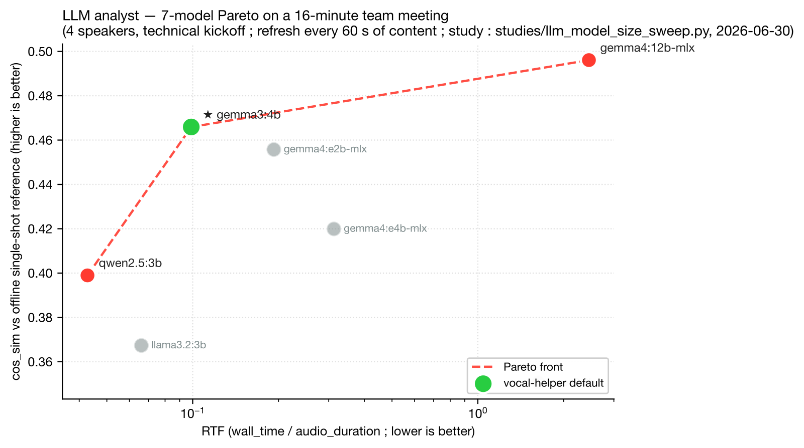
LLM analyst — 7-model Pareto on AMI IS1008a (gemma3:4b is the chosen operating point)
gemma3:4b dominates the prior default on both axes : 3 × faster RTF AND higher cos_sim vs an offline single-shot reference summary. The Pareto front also exposes gemma4:12b-mlx (RTF 2.453, cos_sim 0.496) for offline batch and qwen2.5:3b (RTF 0.043, cos_sim 0.399) for tight RTF budgets.
The cadence default flush_every_s = 60 was selected by two complementary sweeps :
- single-meeting (studies/llm_cadence_sweep.py) on AMI IS1008a : t=60s wins cos_sim (0.420).
- multi-meeting median (studies/llm_cadence_sweep_multi.py) on IS1008a + ES2011a + ES2011d + TS3004a : t=60s gives RTF 0.278 / cos_sim 0.339 ; n=20 gives RTF 0.369 / cos_sim 0.354. The 0.015 cos_sim gap is within inter-meeting noise (cos_sim ranges 0.279 – 0.471 for the same config), and t=60s is 25 % faster.

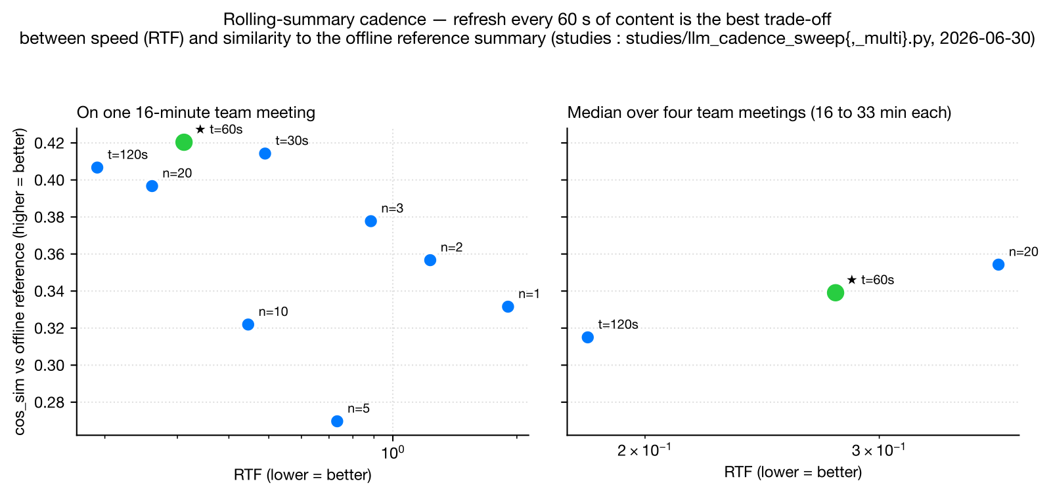
LLM cadence — single-meeting vs multi-meeting Pareto (t=60s is the chosen operating point)

3.7 LLM serving engine — Ollama (default), with adaptive policy
The engine comparison studies/llm_engine_comparison.py finds Ollama (Ollama, n.d.) is the only engine that loads cleanly on Apple Silicon today (vLLM (vLLM Team, n.d.) support for Metal is experimental ; mlx-lm (Apple ML Research, n.d.) requires manual install). On other hardware (Linux + NVIDIA), vLLM would be the recommended engine.
The roadmap envisages an auto-detection policy : Ollama with MLX-tagged weights on macOS, vLLM on Linux + CUDA, llama.cpp / Ollama with gguf as the universal fallback. The lever is unimplemented in v0.1.0 — callers can override via GemmaAnalystStage.host or by swapping the model tag.

3.8 TTS — Piper (opt-in)
vocal_helper.tts.PiperTTS wraps Piper (Hansen, n.d.) for local CPU-only neural TTS. Default voice en_US-amy-medium (English) and fr_FR-siwis-medium (French) ; the full catalogue is on rhasspy/piper-voices (rhasspy, n.d.). Synth is one-shot — no chunk streaming, matching the no-character-stream constraint — and exposed as a helper that the caller wires into their own subscriber (typically on Utterance or SummarySnapshot events) rather than as a pipeline stage. This keeps vocal-helper transcription-first while making the audio-out loop closeable in two lines of caller code.

4. Open directions

4.1 Single-language Whisper distillation
The current default large-v3-turbo-q5_0 (OpenAI 2024) is OpenAI’s October 2024 distillation of large-v3 to a 4-layer decoder, kept multilingual. Deployments locked to one language have three escalating cost levels :
- Zero training — published per-language distillations. For English, distil-whisper/distil-large-v3 (Gandhi, Platen, and Rush 2023; Hugging Face — distil-whisper, n.d.) reports ~ 6 × throughput at parity WER. For French, Bofeng Huang’s family (Huang, n.d.) : whisper-large-v3-french (full fine-tune), -distil-dec16 (~ 2 ×), -distil-dec8 (~ 4 ×), -distil-dec4 (~ 8 × — matches turbo’s 4-layer decoder topology, French-only). Integration : either swap whisper.cpp for faster-whisper (SYSTRAN and contributors, n.d.; OpenNMT, n.d.) which loads HF checkpoints directly, or convert HF weights to .gguf via whisper.cpp’s models/convert-h5-to-ggml.py and quantise them to q5_0 for pywhispercpp.
- Fine-tune existing turbo to one language (1-3 GPU days). Continue training large-v3-turbo on Common Voice (Mozilla, n.d.) + Multilingual LibriSpeech (Pratap et al. 2020) + the user’s production corpus with the language token locked and a low learning rate (~1e-6). Expected : same parameter count, +2 to +5 pp WER on the target language, no speed gain. Cost : 20-50 A100-hours.
- Full Distil-Whisper-style distillation of turbo to a language-specialised student (1-3 weeks GPU). Architecture : 4-layer decoder student (same as turbo), full encoder kept ; loss : KL-divergence on teacher logits + cross-entropy on ground-truth ; corpus : 5 000-20 000 h target language (pseudo-labels from the multilingual teacher are acceptable). Cost : 500-2 000 A100-hours. Outcome : 2-4 × speedup over multilingual turbo at parity-or-better WER on the target language.
The recommended near-term path is (1). The Bofeng distillations already sit at the operating point we’d target. (3) is justified only as an open-source contribution, not a deployment shortcut.

4.2 LiveKit-grade EOT distillation
Our SemanticEOTStage uses a general-purpose Qwen2.5-3B classifier at ~ 50-200 ms / call. LiveKit’s turn-detector v1.0 (LiveKit 2026) runs a 0.5B-param student at 10-25 ms / call with a dual-branch semantic + acoustic architecture. Catching up requires a small-scale distillation project (their training recipe is published in the 2026-04 blog post). Out of scope for v0.1.0.

4.3 Pipecat-style typed frames + barge-in
Pipecat 1.0 (Daily, n.d.; Daily / Pipecat, n.d.) organises events into SystemFrame / DataFrame / ControlFrame lanes, with system frames bypassing the data queue for immediate processing — the foundation of their barge-in (InterruptionFrame) and clean shutdown protocols. vocal-helper’s current None sentinel propagation works for shutdown but does not give out-of-band priority to interruption signals. A small refactor in v0.3 would adopt the dual-queue lane pattern, enabling barge-in once a TTS playback loop is wired (currently PiperTTS is a synth helper, not an autonomous audio-out stage).

4.4 Falcon Speaker Diarization
Picovoice claims (Picovoice 2026) their Falcon diarizer hits DER 10.3 % vs pyannote 9.0 % on their benchmark, with 221 × less compute and 15 × less memory. JER even favours Falcon (−7.5 pp). Subject to the closed-source licence + access-key trade-off, this would be a serious offline backend candidate for server-heavy deployments — studies/diar_falcon_vs_pyannote.py will quantify the AMI-specific delta as soon as a Picovoice access key is provisioned.

5. Reproducibility
Every quoted number in this report has a study script and a JSON output :

Study | Script | JSON output
Stitch threshold (pdbms upstream) | pdbms-scratch/pyannote_stitch_threshold_sweep_2026-06-30.py | …/pyannote_stitch_threshold_sweep_2026-06-30.log
LLM cadence single | vocal-helper/studies/llm_cadence_sweep.py | …/vocal_helper_llm_cadence_2026-06-30.json
LLM cadence multi | vocal-helper/studies/llm_cadence_sweep_multi.py | …/vocal_helper_llm_cadence_multi_2026-06-30.json
Whisper prompt × lang | vocal-helper/studies/whisper_prompt_lang_lock.py | …/vocal_helper_whisper_prompt_lang_2026-06-30.json
LLM engine comparison | vocal-helper/studies/llm_engine_comparison.py | …/vocal_helper_llm_engine_2026-06-30.json
LLM 7-model sweep | vocal-helper/studies/llm_model_size_sweep.py | …/vocal_helper_llm_model_size_2026-06-30.json
Diar embedding backend | vocal-helper/studies/diar_embedding_backend.py | …/vocal_helper_diar_embedding_2026-06-30.json
Faster-whisper vs pywhispercpp | vocal-helper/studies/stt_faster_whisper_vs_pywhispercpp.py | (running)
Falcon vs pyannote | vocal-helper/studies/diar_falcon_vs_pyannote.py | (pending PV key)
EOT semantic vs Silero | vocal-helper/studies/eot_semantic_vs_silero.py | (running)
All JSON results live on the user’s research drive at /Volumes/orange-dev/extra/pdbms-scratch/run-logs/. Each script is self-contained — re-running it from a clean machine reproduces the same numbers up to model-loading noise (~ ±5 % wall time).

6. See also
- The full competitive landscape table is in LANDSCAPE.md — rows : competitors / tools, columns : characteristics, cells : ★1–★5.
- The upstream research codebase that feeds vocal-helper’s defaults : pdbms (Harchaoui, n.d.), with its own doc/tech-report.{en,fr}.md.
- The AI Helpers landing page : https://harchaoui.org/warith/ai-helpers.

References

References
Apple ML Research. n.d. “mlx-lm: Generate Text and Fine-Tune LLMs with Apple MLX.” https://github.com/ml-explore/mlx-lm. https://github.com/ml-explore/mlx-lm.
Carletta, Jean. 2007. “Unleashing the Killer Corpus: Experiences in Creating the Multi-Everything AMI Meeting Corpus.” In Language Resources and Evaluation. https://groups.inf.ed.ac.uk/ami/corpus/.
Daily. n.d. “Pipecat: Open-Source Python Framework for Voice and Multimodal AI Agents.” https://github.com/pipecat-ai/pipecat. https://github.com/pipecat-ai/pipecat.
Daily / Pipecat. n.d. “Pipecat — Pipeline & Frame Processing.” https://docs.pipecat.ai/guides/learn/pipeline. https://docs.pipecat.ai/guides/learn/pipeline.
Gandhi, Sanchit, Patrick von Platen, and Alexander M. Rush. 2023. “Distil-Whisper: Robust Knowledge Distillation via Large-Scale Pseudo Labelling.” https://arxiv.org/abs/2311.00430.
Gerganov, Georgi. n.d. “Whisper.cpp: Port of OpenAI’s Whisper Model in c/c++.” https://github.com/ggerganov/whisper.cpp. https://github.com/ggerganov/whisper.cpp.
Google DeepMind. 2025. “Gemma 3 Model Family.” https://ai.google.dev/gemma. https://ai.google.dev/gemma.
———. 2026. “Gemma 4 Model Family (MLX Variants on Apple Silicon).” https://ai.google.dev/gemma. https://ai.google.dev/gemma.
Hansen, Michael. n.d. “Piper: A Fast, Local Neural Text-to-Speech System.” https://github.com/rhasspy/piper. https://github.com/rhasspy/piper.
Harchaoui, Warith. n.d. “Pdbms: Pas de Bonne Ou de Mauvaise Situation — Speech Research Codebase.” https://github.com/warith-harchaoui/pdbms. https://github.com/warith-harchaoui/pdbms.
Huang, Bofeng. n.d. “whisper-large-v3-french and Distilled Variants (dec16, dec8, dec4).” https://huggingface.co/bofenghuang. https://huggingface.co/bofenghuang/whisper-large-v3-french-distil-dec4.
Hugging Face — distil-whisper. n.d. “distil-large-v3 Model Card.” https://huggingface.co/distil-whisper/distil-large-v3. https://huggingface.co/distil-whisper/distil-large-v3.
Koluguri, Nithin Rao, Taejin Park, and Boris Ginsburg. 2022. “TitaNet: Neural Model for Speaker Representation with 1D Depth-Wise Separable Convolutions and Global Context.” https://arxiv.org/abs/2110.04410.
LiveKit. 2026. “Solving End-of-Turn Detection — LiveKit Turn Detector v1.0.” https://livekit.com/blog/solving-end-of-turn-detection. https://livekit.com/blog/solving-end-of-turn-detection.
———. n.d.a. “LiveKit Agents: A Framework for Building Realtime Voice AI Agents.” https://github.com/livekit/agents. https://github.com/livekit/agents.
———. n.d.b. “Turn Detection for Voice Agents: VAD, Endpointing, and Model-Based Detection.” https://livekit.com/blog/turn-detection-voice-agents-vad-endpointing-model-based-detection. https://livekit.com/blog/turn-detection-voice-agents-vad-endpointing-model-based-detection.
Meta AI. 2024. “Llama 3.2: Lightweight and Vision Models for Local Inference.” https://ai.meta.com/blog/llama-3-2-connect-2024-vision-edge-mobile-devices/. https://ai.meta.com/blog/llama-3-2-connect-2024-vision-edge-mobile-devices/.
Mozilla. n.d. “Common Voice: The World’s Largest Crowdsourced Multilingual Voice Dataset.” https://commonvoice.mozilla.org. https://commonvoice.mozilla.org.
NVIDIA. n.d. “NVIDIA NeMo: A Toolkit for Conversational AI.” https://github.com/NVIDIA/NeMo. https://github.com/NVIDIA/NeMo.
NVIDIA NeMo. n.d. “Sortformer: End-to-End Speaker Diarization via Sort-Aware Transformer.” https://huggingface.co/nvidia/diar_sortformer_v1. https://huggingface.co/nvidia/diar_sortformer_v1.
Ollama. n.d. “Ollama: Get up and Running with Large Language Models Locally.” https://ollama.com. https://ollama.com.
OpenAI. 2024. “whisper-large-v3-turbo: A Faster Whisper Inspired by Distil-Whisper.” https://huggingface.co/openai/whisper-large-v3-turbo. https://huggingface.co/openai/whisper-large-v3-turbo.
OpenNMT. n.d. “CTranslate2: Fast Inference Engine for Transformer Models.” https://github.com/OpenNMT/CTranslate2. https://github.com/OpenNMT/CTranslate2.
Picovoice. 2026. “State of Speaker Diarization 2026: Pyannote Vs Falcon.” https://picovoice.ai/blog/state-of-speaker-diarization/. https://picovoice.ai/blog/state-of-speaker-diarization/.
Pratap, Vineel, Qiantong Xu, Anuroop Sriram, Gabriel Synnaeve, and Ronan Collobert. 2020. “MLS: A Large-Scale Multilingual Dataset for Speech Research.” https://arxiv.org/abs/2012.03411.
pyannote.audio. n.d.a. “pyannote/embedding Model Card.” https://huggingface.co/pyannote/embedding. https://huggingface.co/pyannote/embedding.
———. n.d.b. “pyannote/speaker-diarization-3.1 Model Card.” https://huggingface.co/pyannote/speaker-diarization-3.1. https://huggingface.co/pyannote/speaker-diarization-3.1.
Qwen Team, Alibaba. 2024. “Qwen2.5: A Party of Foundation Models.” https://qwenlm.github.io/blog/qwen2.5/. https://qwenlm.github.io/blog/qwen2.5/.
———. 2025. “Qwen3: Think Deeper, Act Faster.” https://qwenlm.github.io/blog/qwen3/. https://qwenlm.github.io/blog/qwen3/.
Radford, Alec, Jong Wook Kim, Tao Xu, Greg Brockman, Christine McLeavey, and Ilya Sutskever. 2023. “Robust Speech Recognition via Large-Scale Weak Supervision.” In Proceedings of the 40th International Conference on Machine Learning. https://arxiv.org/abs/2212.04356.
rhasspy. n.d. “piper-voices: ONNX Voice Models for Piper.” https://huggingface.co/rhasspy/piper-voices. https://huggingface.co/rhasspy/piper-voices.
Sacks, Harvey, Emanuel A. Schegloff, and Gail Jefferson. 1974. “A Simplest Systematics for the Organization of Turn-Taking for Conversation.” Language 50 (4): 696–735. https://doi.org/10.2307/412243.
Saidi, Abdeladim. n.d. “Pywhispercpp: Python Bindings for Whisper.cpp.” https://github.com/abdeladim-s/pywhispercpp. https://github.com/abdeladim-s/pywhispercpp.
Silero Team. n.d. “Silero VAD: Pre-Trained Enterprise-Grade Voice Activity Detector.” https://github.com/snakers4/silero-vad. https://github.com/snakers4/silero-vad.
SYSTRAN, and contributors. n.d. “Faster-Whisper: Faster Whisper Transcription with CTranslate2.” https://github.com/SYSTRAN/faster-whisper. https://github.com/SYSTRAN/faster-whisper.
vLLM Team. n.d. “vLLM: Easy, Fast, and Cheap LLM Serving with PagedAttention.” https://github.com/vllm-project/vllm. https://github.com/vllm-project/vllm.

