I T C S 1 5 9  
Lab1: Basic Python Programming

1.



It prints: Hello world

`print()` is a function in Python that displays texts, which can be Strings like in this case “Hello world” that specified inside () to the terminal screen.

2.

2.1

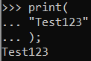

It prints: Test123

Assume that what I wanted to do is to display:



This is not possible because pressing <enter> doesn’t have the effect of going to a new line in Python. To go to new line in Python, we need to find other ways. One way is to use `\n` every time we want to go to new line. In this case, we could do this ‘print(“\nTest123\n”);` instead.

2.2

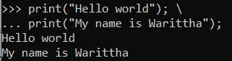

\ does the effect of combining scripts so that all the scripts combined will be displayed together after no more ‘\’ is added and each script results will be separated by a new line.

3.



We should add a space “ “ at the end of “Hello world” String or at the beginning of “This is python class” String or between the two Strings.

Ex. A space is added at the end of “Hello world”



4.

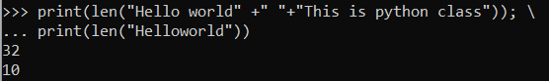

The output:

32

10

`len()` counts all characters in all Strings inside ()

5.

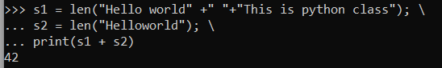

The result is 42. This indicates that the value return from len() is an integer.

6.

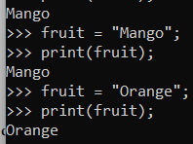

The output: Orange

This shows that we can update a variable to new value.

7.

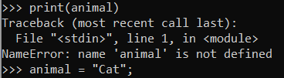

We can’t do the following commands because animal variable doesn’t exist until we define it (declare and assign value to it).

This shows that the order of operation is important.

8.

This shows that print() function take in as input more than just String type; it also takes int, float, and bool data types.

9.

The result is 100250.

It is not correct mathematically because x and y are str; that’s why they are concatenated instead of added to each other.

Edited code:

10.

The output: The faculty of ICT year 2018

When `f` is placed immediately at the beginning of the str, it becomes formatted str. Formatted str has special functionality in that it can take a placeholder, which is represented by {variable_name}.

11.

Line 1: x = 10.25 # x is a float

Line 2: y = “15” # y is a str

Line 3: print x and y in integer; In float, the value after the decimal point gets truncated.

Line 4: Update y to int(x)

Line 5: Update x to int(y) [that has already been updated on Line 4; hence it is not swapped]

Line 6: Display 10 10 # Both displays the value of int(x)

Line 7: x = 5

Line 8: Display 5 10

12.

The outputs are 0, 22, 14, 16, 17, and 17.

`open()` will open the file with specified file path or will create a new file with the specified file path if it doesn’t already exist. The second argument specifies the mode, which, in this case, is in write mode.

‘file.write()` will write the text in the argument into a file (in this case called file)

The number after typing file.write command are the length of String inputted to the `file.write()` argument.

13.

The output:

`file.read()` will read everything until the end of file.

`file.read(n)` will read the file until the nth character.

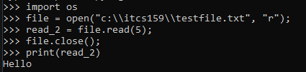

`file.readline()` will read the file until found \n or reached the end of file.

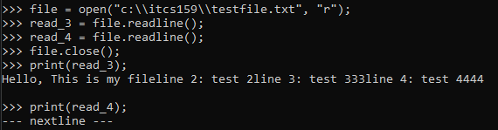

14.

Use print() command to display the file information:

The difference between ‘w’, ‘r’, ‘a’:

‘w’ will write to file or overwrite the file if it has some content.

‘r’ mode makes the file readable.

‘a’ will append the new text in the new line to file.

15.

The output is as expected.

Exercise objective: to practice using basic command line like cd (change directory) and running a Python program from the command prompt.

> cd c:\itcs159

= to change folder to folder c:\itcs159

> python c:\itcs159\firstProg.py

= runs Python interpreter on Python program c:\itcs159\firstProg.py

16.



Exercise objective: to practice creating a basic python program and utilizing what we have learned in this lab.

Line 1: Prompt the user with “Enter temperature in Fahrenheit: “. User’s input will be store in variable ftemp.

Line 2: conversion formula

`ftemp` needs to be converted into float because `input()` will return data type str.

Line 3: Display the results

6488130 Warittha Tarntong

Section 3