

Project Bulgaria
IoT Weather Station with ESP32

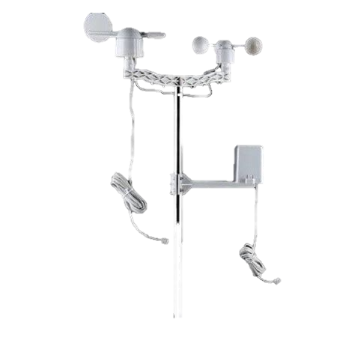

18-Feb-2026
Burgas, Bulgaria

Table of Contents
Team 2
Summary 2
1. Objectives 2
2. Main Development Stages 3
3. Scrum Methodology 3
4. Implementation 4
Conclusion 4

Team
Developers
Marcos Costa, Rodrigo Costa, Boris Milev, Plamen Petkov
Designer
Plamen Petkov

Summary
The IoT Weather Station with ESP32 project focuses on the development of a system capable of collecting real-time meteorological data using physical sensors and displaying it on a web-based platform. The system was designed to allow remote monitoring of environmental conditions such as temperature, humidity, atmospheric pressure, and other relevant parameters.

1. Objectives
The main objective of this project is to develop a functional IoT solution that is able to:
- Collect weather data using sensors connected to an ESP32 microcontroller;
- Transmit the collected data over the internet to a server;
- Store and process the data efficiently;
- Display the data on a clear, intuitive, and user-friendly web interface;
- Allow real-time and historical data visualization.

2. Main Development Stages
Problem Analysis
In the initial phase, a detailed analysis of the project requirements was carried out. This included identifying which meteorological data would be collected, selecting appropriate sensors, and defining how the information would be presented to the end user.
Design
The web interface was designed to be simple and functional. Initial wireframes and layouts were created to define charts, tables, and visual indicators that help users easily interpret the collected data.
Development
The development process was divided into two main components:
- Hardware: configuration of the ESP32, sensor connections, and data acquisition;
- Software: microcontroller programming, backend development for data reception and storage, and frontend development for data visualization.
Testing
Continuous testing was carried out to ensure data reliability, stable internet connectivity, and correct operation of the web platform.

3. Scrum Methodology
Planning
At the beginning of the project, tasks and weekly goals were defined and distributed among team members according to their skills and availability.
Team Meetings
The team held regular meetings to monitor progress, discuss challenges, and adjust solutions whenever necessary.
Task Distribution
Tasks were assigned in a balanced way to ensure that all team members contributed to both the technical development and the project documentation.
Communication
Effective and continuous communication throughout the project allowed problems to be solved quickly and ensured consistency between hardware, software, and the web interface.

4. Implementation
Hardware

- ESP32 microcontroller

- Weather sensors (temperature, humidity, pressure, etc.)

- Breadboard and connecting wires
Software and Tools

- Microcontroller programming: Arduino IDE / Visual Studio Code

- Backend: server for data reception and storage

- Frontend: website for data visualization

- Design: Figma

- Version control: Git and GitHub

- Documentation: Microsoft Word and Microsoft PowerPoint

Conclusion
The IoT Weather Station with ESP32 demonstrates the practical application of IoT technologies in environmental data collection and visualization. This project helped consolidate knowledge in microcontroller programming, network communication, web development, and teamwork. The final result is a functional and scalable solution with strong potential for future improvements, such as the integration of additional sensors or advanced data analysis features.

