**An online/dynamic variable guiding lane and traffic signal control optimization model based on long term and short term connected vehicle data**

Stage 0. Real-time traffic state estimate (sparse GPS data + different arrival rate of vehicles)

TSE paper

Stage 1. Base lane setting and signal setting optimization (Historical sparse GPS data + lane based model). (代码 M4-Lane.py)

To meet the long-term traffic arrival pattern, this research builds a base model to optimize lane settings and signal settings for each intersection based on the estimated traffic arrival rate. As the delay function for each intersection is nonlinear, we utilize the Cell Transmission Model (CTM) to discretize the delay function. Therefore, we model the intersection links as cells and a classical four arm intersection is as below.

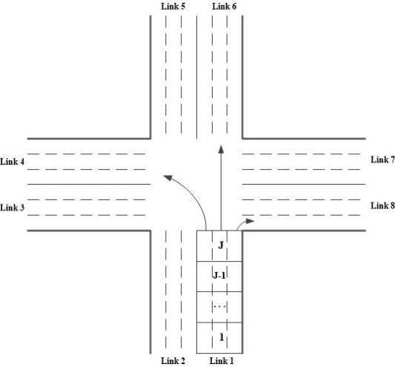

Figure x. Intersection configuration

In this figure, the links are categorized into approach link set $ψ_{A}$ and exit link $ψ_{E}$, each link is divided into cells and cell(i,j) is the jth cell on link i. Therefore, the delay function for cell(i,j) is as below.

$d_{i,j}\left(t\right)=n_{i,j}\left(t\right)-f_{i,j+1}(t)$ (15)

Where $n_{i,j}\left(t\right)$ and $f_{i,j+1}(t)$ are the accumulation and outflow of cell(i,j), and the outflow of cell(i,j) is calculated based on CTM as below.

$f_{i,j+1}\left(t\right)=min⁡\{n_{i,j}\left(t\right), Q,\frac{w}{v}(N-n_{i,j+1}\left(t\right))\}$ (16)

Where *Q* is the cell capacity, *N* is the cell jam accumulation, *w* and *v* are shockwave and free flow speed, respectively.

For the first cell of each approach link, the upstream cell accumulation can be set as the traffic arrival rate at time t, as below.

$n_{i,0}\left(t\right)=q_{i}\left(t\right)=Poisson(λ_{i})$ (17)

Where we generate the traffic demand based on Poisson distribution to simulate the fluctuation of traffic flow. Then, we model the green timing and red timings as the on and off of a valve. A binary variable $y_{i,i}(t)$ is depicted as below.

$y_{i,i^{'}}(t)=\left\{\begin{aligned}1, & if the signal is in green \\ 0, & if the signal is in red\end{aligned}\right.$

We use cycle length *C*, the normalized start ($θ_{i,i^{'}}$) and duration ($ϕ_{i,i'}$) of green timings for traffic flow from approach link i to exit link i’ to represents signal settings at an intersection. The above equation can be rewritten as below.

$y_{i,i^{'}}(t)=\left\{\begin{aligned}1, & Cθ_{i,i^{'}}≤ t≤C(θ_{i,i^{'}}+ϕ_{i,i'}) \\ 0, & otherwise\end{aligned}\right.$ (18)

And the signal cycle length, the normalized start ($θ_{i,i^{'}}$) and duration ($ϕ_{i,i'}$) of green timings follows the constraints as below.

$C_{min}≤C≤C_{max}$ (19)

${0≤θ}_{i,i^{'}}≤1$ (20)

$g_{min}≤ϕ_{i,i'}≤g_{max}$ (21)

The traffic flow from arm *i* to *i’* (${FI}_{i,i^{'}}(t)$) is therefore constrained by the cell accumulatio ($n_{i,J}\left(t\right)∙α_{i,i^{'}}$, $α_{i,i^{'}}$ is the turning ratio), the permitted traffic saturation rate ( $s∙y_{i,i^{'}}(t)∙k_{i,i^{'}})$ and downstream available space $\frac{w}{v}(N-n_{i^{'},1}(t))$, as below.

${FI}_{i,i^{'}}\left(t\right)=min⁡\{n_{i,J}\left(t\right)∙α_{i,i^{'}}, s∙y_{i,i^{'}}(t)∙k_{i,i^{'}}, \frac{w}{v}(N-n_{i^{'},1}(t))\}$ (22)

Where $k_{i,i^{'}}$ is the number of lanes for movement(i,i’) and it is constrained by the total number of lanes, as below.

$\sum_{i'ϵψ_{E}}{k_{i,i'}=K_{i}}$ (23)

It is worth noting that we do not consider the lane share scenario. Therefore, the last cell outflow on link i is calculated as the summation of traffic flow to all the other exit links, as below.

$f_{i,J+1}(t)=\sum_{i'∈ψ_{E}}{{FI}_{i,i^{'}}(t)}$ (24)

The integrated lane setting and signal setting optimization model is as below.

$MinD=Min\sum_{t=1,…,T}{\sum_{i∈ψ}{\sum_{j=1,…,J}{d_{i,j}}}}(t)$

St. (15) to (24)

It is worth noting that even constraints (16), (18), (22) are not linear, these constraints can be easily linearized in s similar way, please refer to Appendix A for more details. The integrated optimization mode with the objective of minimizing intersection delay is a standard Binary Mixed Integer Linear Program (BMILP) and can be solved by the branch and bound algorithm. The solution for each intersection is the optimized signal cycle length, the lane settings and the start and duration of green timings for all the movements. The solution for each intersection will set as the base lane setting and signal settings.

Stage 2. Dynamic variable guiding lane and signal control optimization model (CTM + lane setting) (M3-VGL.py)

The objective function is to minimize the intersection delay as depicted below.

 (1a)

Or maximize the throughput of the intersection

 (1b)

The constraints of the model are as below.

**Flow constraint**

***Inflow for the source cell***

 (1)

Where  is the dynamic traffic demand for link I, .

***Approach link normal cell inflow***

  （2）

***Intersection cell inflow***

 

where m=1,2,3, represents the left, through and right turn cell, respectively.

***Intersection cell outflow***









**Variable guiding lane setting**





**Signal constraint**









**Cell accumulation update**

 j=1,2,…,J-1.



Stage 3. Assessment. MFD + emission + delay + capacity

Case study. 合肥单交叉口