By Liusongsen(Woody) Yang

This web application is implemented by using Node.JS and Mongodb.

The source code is in GitHub: <https://github.com/warmachine64/yangtest/tree/master>

P1: This is the Home page of the app.

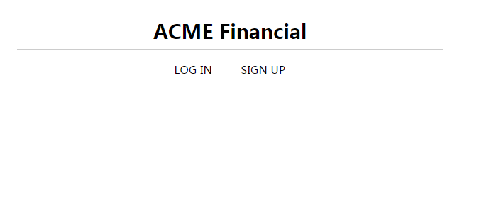

P2: This the register page, which you sign up for a new account and it will determine whether the email is already existed.

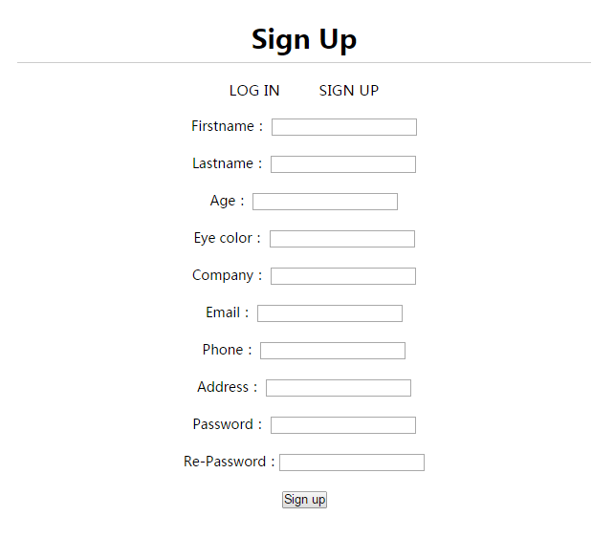

P3: This is the log in page, will restrict access to valid a User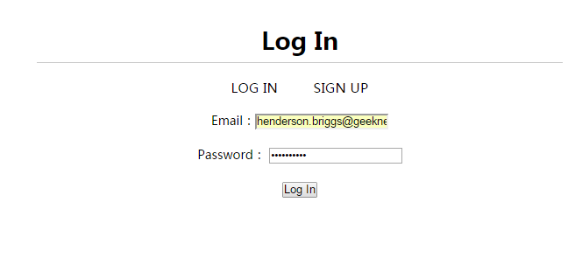

P4: Shows the account information. Use edit button to edit the account.

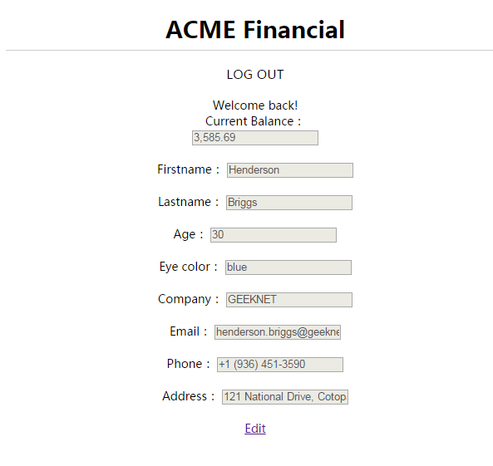

P5: Edit the account information. For example, I changed the first name and saved.

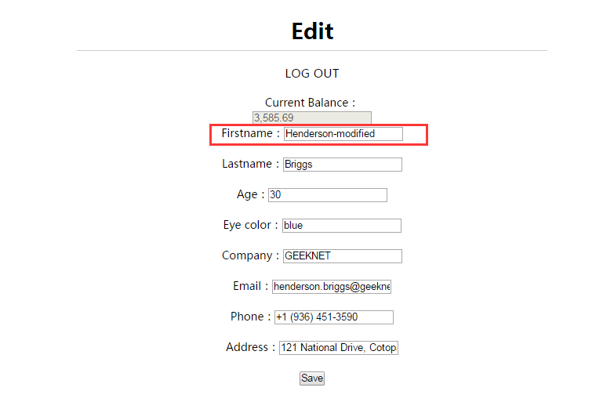

P6: The account information has been changed.

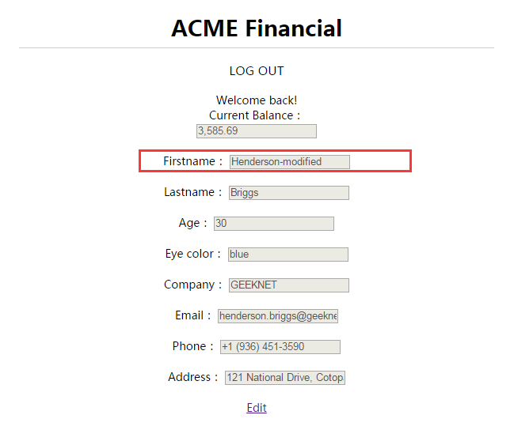

P7: The data in database has been changed.

