Appendix A: Instructions
Instructions are translated from French. The instruction set presented here corresponds to the Heterogeneous Ranking treatment, which is the most complete treatment of our experiment. Sets of instructions for other treatments are available upon request.
General instructions
You are now taking part in an economic experiment. You will take several decisions which are described in this instruction sheet. The instructions are simple. Following them carefully will allow you to earn a considerable amount of money.
Your earnings depend on your own decisions and in some case on the decisions of other participants. It is very important that you read these instructions carefully. Your final earnings will be the sum of what you earn in each game. During the experiment your entire earnings will be calculated in ECU (Experimental Currency Units). At the end of the experiment the total amount of ECU you have earned will be converted to euro at the following rate: 5 ECU = €1. Note that you receive a show-up fee of €5 for your participation to the experiment. We guarantee anonymity for every decision you make.

Game 1
Game 1 includes two steps.

Step 1.
You are randomly matched with another participant in the room. You will receive an endowment of 20 ECU. You must choose how to distribute this endowment between yourself and the other participant. More specifically, you can decide an amount (integer number) to offer to the participant you are matched with.
Please note that in the second step, the participant you are matched with will choose whether to accept or to reject the amount you offer. If the other participant accepts your offer, you will both receive the selected earnings. If the other participant declines your offer, you will both earn nothing in game 1.

Step 2.
A new random draw will match you with a participant in the room. Just like you, this participant made a decision in the first step. He received an endowment of 20 ECU and chose an amount to offer you. You are not informed of this decision. In step 2, you have to declare, for each amount that could have been offered to you, whether to accept or reject the offer. The decision screen will be presented as follows:

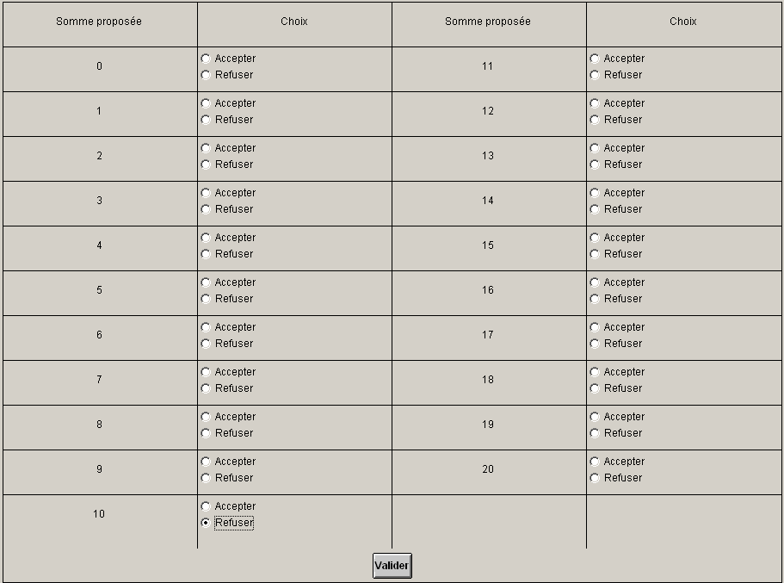
- If you accept the offer, you will both receive the selected earnings.
- If you decline the offer, you will both earn nothing in game 1.
Your earnings in game 1 are the sum of the amount you kept in the first step (if your offer was accepted) and the amount you were offered in the second step (if you accepted the offer).

Game 2
In game 2, you are randomly matched with a participant in the room. You must select a payoff distribution that will apply to this participant and yourself. At the same time, another participant selects a payoff distribution that will apply to you and him/her.
You must make a decision for each line of the following table. All lines represent a different choice between a payoff distribution A and a payoff distribution B. You must indicate for each line which payoff distribution you would like to see implemented. The decision screen will appear as follows:

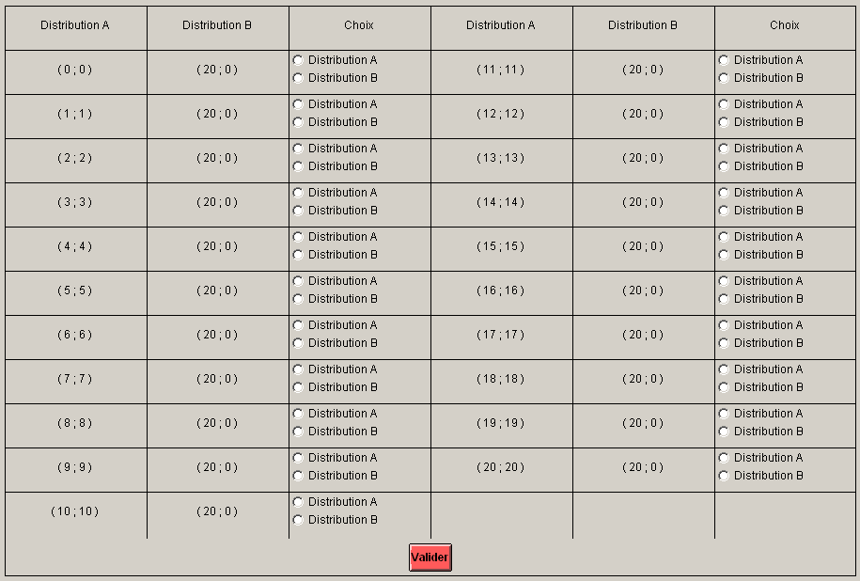
The payoff distribution is represented in brackets. The first figure corresponds to your own payoff, as a decision maker. The second figure corresponds to the payoff of the player with whom you are matched. For instance, the distribution (20 ; 0) means “you earn 20 ECU and the other participant earns 0 ECU”. The distribution (6 ; 6) means “you earn 6 ECU and the other participant earns 6 ECU”.
Once your decision is made, the computer will randomly select a line. It is your decision on that specific line that will be used to compute your earnings.
Your earnings in game 2 are the sum of the amount you decided to attribute to yourself, and the amount you received from another participant who played game 2 at the same time and was matched with you. You will receive information of your payoff at the end of the experiment only.
Game 3
A questionnaire will appear on your screen. You have to honestly answer to the questions. Your answers to those questions will not affect your earnings, nor will they affect the actions you will undertake in the following games of the experiment. Furthermore, please recall that your answers are anonymous and will not be associated with your name. Once the questionnaire is over; we will hand you new instructions.

Game 4
The answers you provided to the previous questionnaire have been used to match you with three other participants in the room. Together you form a group of four participants. Over the course of the experiment, you will stay in this four-persons group. The three participants you have been matched with are the ones whose answers to the questionnaire are the most similar to yours. In other words, you are matched in the group of four participants that corresponds to you the most, based on the questions that have been asked to you previously. Over the course of the experiment, you will interact with the participants of your own group, but also with the participants of another group that has been created according to the same process. Therefore, all interactions you will undertake during the rest of the experiment will always be with the same seven participants (three from your own group and four from the other group).
In game 4, you collectively choose a name for your group. This name will be used until the end of the experiment to designate your group. The choice of this name does not affect your future earnings nor the choices you will make in the future. The name of your group will be chosen via majority voting, from among a predefined list of five names which will be displayed on your screen. The discussion process will be as follows:
In a first step, you will receive information on the five group names you can choose from. Then, you will have 180 seconds in a chat room discussion to reach an agreement on the name to choose. It is strictly forbidden to reveal or give any clue on your real identity in the chat room. If you do not respect this restriction, you will be excluded from the experiment and its payments. Following this discussion, each member of the group votes individually. If the majority of participants voted for the same name, this name will be assigned to your group for the rest of the experiment. If no majority is reached, members of your group will vote a second time. If no majority is reached from this second vote, a random name will be assigned to your group.
Game 5
Game 5 includes two steps.
Step 1
In the first step, you rank by order of preference the seven other participants with whom you interact. This ranking can later be used to form teams. At the end of the first step, a role will randomly be assigned to you. You can be either employer, worker, or unemployed.
In game 5, all participant will randomly be assigned a characteristic: high cost of effort or low cost of effort. This characteristic will affect the participants in the role of worker in step 2 of the game.
Your first decision in game 5 will be taken as a potential employer. You will rank the seven other participants by order of preferences. This ranking will be used to define which workers you would want to recruit in the following of the game. Your chance to hire the participant is the highest for the participant you rank at the first position and the lowest for the participant you rank at the seventh position.
A screenshot of your decision screen is provided in the next page of these instructions.

Information regarding participant’s group and participant’s cost of effort will be displayed on the decision screen. Participants can be members of your own group, or members of the other group. To attribute a rank, you have to type the letter corresponding to the participant on the right panel of the screen. You cannot enter the same letter twice. The ranking must be complete. If you make any mistake in the ranking, you will be alerted and you will have to enter the ranking anew.

Once every participant has declared his/her preference ranking, the computer will assign roles according to the following rule:
- A first participant is randomly selected and is assigned the role of employer.
- The two participants at the top of the ranking of this employer will join his/her team, and be assigned the role of worker.
- A new participant, among the remaining ones, will be randomly selected and assigned the role of employer.
- The two participants at the top of the ranking of this employer (among remaining participants) will join his/her team, and assigned the role of worker.
- The two participants who have not been assigned the role of employer or worker will be unemployed for the rest of the experiment.

Important: If you are assigned the role of employer, your ranking will be used to match two workers in your team. You should therefore pay attention when declaring this ranking.

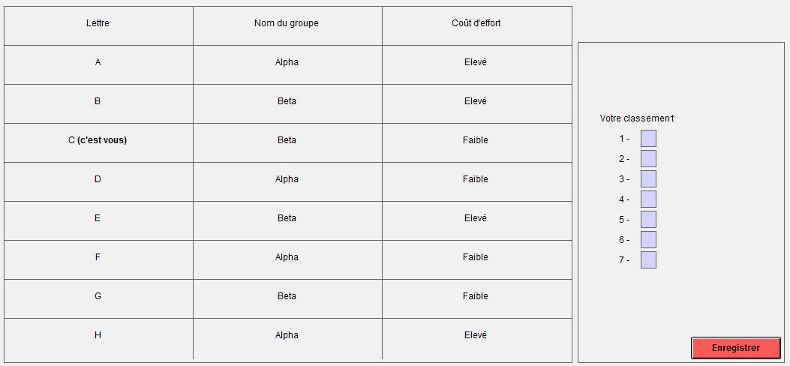
Step 2
Step 2 begins when roles have been assigned to every participant in the room. Your role (employer, worker or unemployed) will determine the actions you can undertake in step 2. Here is a summary of the actions that will be undertaken (further detail are given in the following of the instructions).
- Employers will decide a wage (16 ECU or 32 ECU) to offer each worker with whom he/she is matched.
- Workers will decide on a level of effort (1, 2, 3 or 4). This level of effort affects both workers’ and employer’s earnings.
- Participants in the role of unemployed do not make any decision in this game.

If you are an employer

You have been matched with two workers. You have to decide a wage to offer each of these workers. This wage can be 16 ECU or 32 ECU. The sum of the wages you assign will be withdrawn from your final profits.
When making this decision, you will not be informed of the exact identity of the workers you have been matched with. For that reason, you must assign wages for every possible situation. Your decisions will be made in a simple table. All lines correspond to a different situation, described in the first column. At every line, you must make two decisions: what wage to pay worker 1, and what wage to pay worker 2.
First, you must click on the button “choose”, available at every line of the table (see screenshot below).
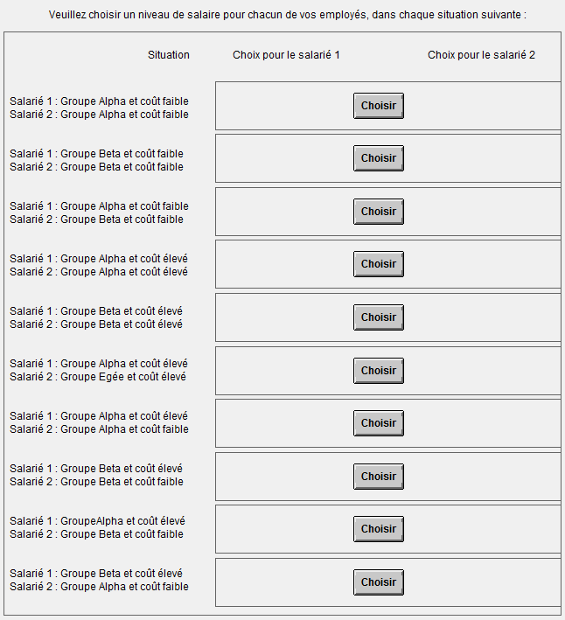
A new screen will then pop up, describing in detail the situation considered (group and effort cost of both workers 1 and 2). On this screen, you will assign a wage for each of these workers. By clicking on OK, you will validate your choice and then be returned to the previous screen, which will now display the wage choices you have made for each situation. Please note that you can come back to your choice whenever you want.

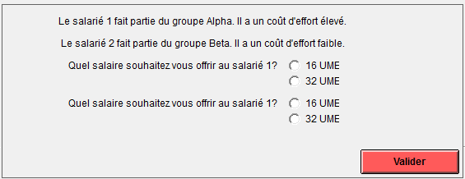

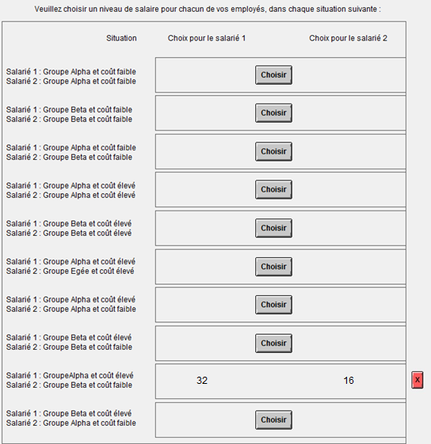
You must make a decision for every single line of the table. By clicking on the red button next to a line, you can modify your decision. Once all decisions are made, you can permanently validate your choices by clicking on the “end” button.

Following your decisions, both of your workers will decide on a level of effort to provide. You will earn 32 ECU for each unit of effort provided by you workers.

Your payoff for game 5 as an employer is defined as:
$$earnings in game 5=32×\left(effort from 1st worker\right)+32×\left(effort from 2nd worker\right)$$
$$-(wage assigned to worker 1)-(wage assigned to worker 2)$$

If you are a worker

The employer you have been matched with has decided on a wage to offer you and the other worker in your team. As a worker, you will choose a level of effort (1, 2, 3 or 4) to provide. When making this decision, you are not yet informed of the specific wage offered by the employer. You are also not informed of the group to which your employer and your coworker belong. Therefore, you must make an effort decision for every possible situation.
In total, you will have 16 decisions to make. The screen you face will be divided into two panels. The left panel describes all different situations in the event that your employer is from your own group. The right panel describes the exact same situation in the event your employer belongs to the other group. Each panel includes two lines. The first line corresponds to situations where your coworker belongs to one group. The second line corresponds to situations where your coworker belongs to another group. Finally, within each line, you have to make four decisions. These decisions correspond to the different payoff distributions that your employer could have chosen. This screen is displayed in the following screenshot.

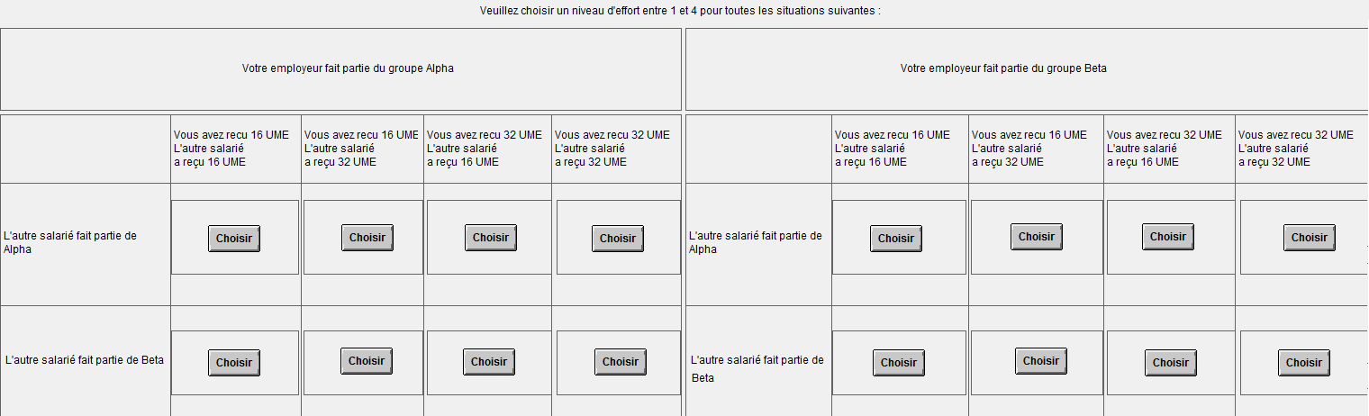
To declare the effort that you want to provide in a particular situation, please click on the corresponding button “choose”. A pop-up screen will appear. This new screen will describe the situation in details, and will allow you to select a level of effort.

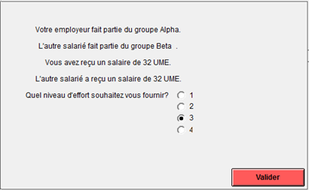
You can confirm your choice by clicking on “validate”. Note that you will be able to modify your choice, as long as you have not yet made decisions for every situation.

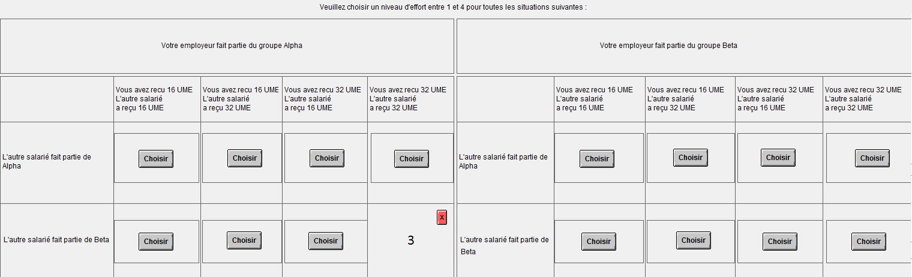

Each level of effort is associated with a cost. This cost will be withdrawn from your final earning in game 5. The cost of an effort choice depends on your characteristic: high cost of effort or low cost of effort.

If you have a high cost of effort, the cost you incur for each level of effort will be as follows :
Level of effort | 1 | 2 | 3 | 4
Associated cost | 0 | 5 | 10 | 15

If you have a low cost of effort, the cost you incur for each level of effort will be as follows :
Level of effort | 1 | 2 | 3 | 4
Associated cost | 0 | 3 | 6 | 9
Your payoff for game 5 as a worker is defined as:
$$earnings in game 5=\left(wage received from employer\right)-(cost of the selected level of effort)$$
If you are unemployed

You are unemployed, because you have not been selected by an employer in the first step of game 5. You earn a fixed amount of 5 ECU in this game.

Game 6
Only the participants in the role of unemployed will take part in game 6. As an unemployed participant, you can decide whether you want to spend a part of the fixed remuneration of 5 ECU you have received in game 5 to reduce the earning of other participants. To make that decision, you will observe the earnings, the group, and the role (employer or worker) of all other participants who were not unemployed.
Five actions that you may choose from will be displayed on your decision screen. You may reduce the earnings of one participant that you target by 5 ECU. This action will cost you 1 ECU. You can also choose to reduce the earnings by 2 ECU of all participants who have the role of employer or workers. This action would cost you 1 ECU.
Please note that if you decide to reduce the earnings of all participants, you cannot additionally target a particular participant. However, if you decide not to reduce the amount of all other participants, you can choose several participants to target individually. Each action would cost you 1 ECU. The decision screen will appear as follows:

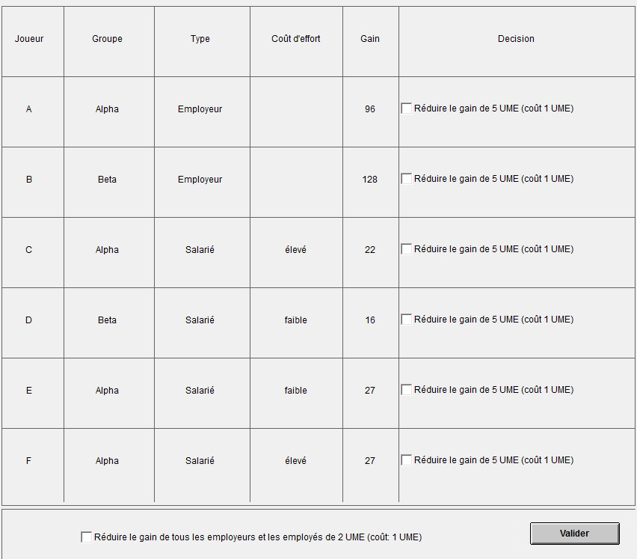

Please recall that all the actions you undertake are anonymous, and are your decisions only. You may choose to not reduce the earnings of any other participant if that is your choice.

The participants who have been in the role of employer or of worker in game 5 do not have any action to undertake in game 6.

