This cover sheet must be completed, signed and firmly attached to the front of the submission. All work must be submitted by the due date. If an extension of work is granted, an assignment extension acknowledgement slip must be signed by the lecturer/tutor and attached to assignment. Please note that is your responsibility to retain copies of your assignmentt.

|  |  |  |
| --- | --- | --- |
| **Student Name** | **Student Id Number** | **Signature** |
| Mohamed Adzhar bin Zaidi | 64868 |  |
| Sh. Nur Aini Wafa binti Wan Ahmadi | 67655 |  |
| Nur Syarwarni binti Berjaya | 67241 |  |
| Sarah Elena binti Zamizan | 71486 |  |
| Muhammad Iz’aan Fahmi bin Badrusam | 64952 |  |
| Syed Mohd Asyraf bin Wan Hashim | 65245 |  |

|  |  |  |  |  |  |
| --- | --- | --- | --- | --- | --- |
| Subject  Code/Name : | **TME3413 SOFTWARE ENGINEERING LAB** | | | GROUP # : | **19** |
| Assignment Title : | | **Project Proposal** | Lecturer : | **Mdm. Nurfauza binti Jali** | |
| Project Title : **Abella Scent’z Web Application** | | | | | |

***Plagiarism and Collusion are methods of cheating that falls under Peraturan Akademik Universiti Malaysia Sarawak para 11: Etika Akademik***

**Plagiarism**

Plagiarism is the presentation of work which has been copied in whole or in part from another person’s work, or from any other source such as the internet, published books or periodicals without due acknowledgement given in the text.

**Collusion**

Collusion is the presentation of work that is the result in whole or in part of unauthorised collaboration with another person or persons.

Where there are reasonable grounds for believing that cheating has occurred, the only action that may be taken when plagiarism or collusion is detected is for the staff member not to mark the item of work and to report or refer the matter to the Dean. This may result in work being disallowed and given a fail grade or if the circumstances warrant, the matter may be referred to a Committee of inquiry for investigation. Such investigation may result in the matter being referred to the University Discipline Committee, **which** has the power to exclude a student.

|  |
| --- |
| **Upon placing signature above, I certify that I have not plagiarised the work of others or participated in unauthorised collusion when preparing this assignment.**  **I also certify that I have taken proper case in safeguarding my work and have made all reasonable efforts to ensure that may work not be able to be copied.** |

|  |
| --- |
| **MARK :** |

**Abella Scent’z web application**

****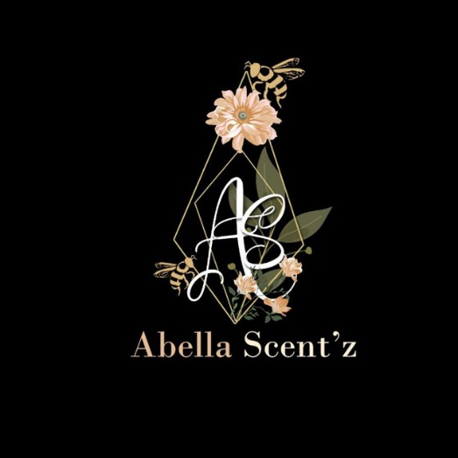

**Customers/ agents/ retailers**

**Management staff/ perfume warehouse**

**Table of Content**

Abstract 7

1. Introduction 8

1.1. Company Background 9

1.2. Team Background 10

2. Problem statement 11

3. Project Objectives 12

4. Project Perspective 13

5. Project Scope 14

6. Software Methodology 18

7. Task Allocation & contribution 20

8. Team Goals 21

9. Expected Result / Deliverables 22

9.1. Working System 22

9.2. System Artefacts/Documentation 23

10. Project Planning 24

11. References 27

12. Appendices 28

12.1. Appendix A: Details of Scrum Method Roles in the Scrum Method. 28

12.2. Appendix B: Task Allocation, Responsibilities and Contribution 31

**List of Figure**

Figure 1 : Abella Scent'z Logo 8

Figure 2 : Group Charmander Logo 9

Figure 3 : Logical Architecture of Abella Scent'z Web Application 12

Figure 4 : System Modules for the Abella Scent’z Web Application 14

Figure 5 : The Scrum - An Agile Software Methodology Framework 18

Figure 6 : The Expected Results of system and user 21

Figure 7 : Gantt Chart for Sprint #1 - Planning 23

Figure 8 : Gantt Chart for Sprint #2 - First Iteration 24

Figure 9 : Gantt Chart for Sprint #3 - Second Iteration 25

**List of Table**

Table 1 : System Environment for the Abella Scent'z Website 13

Table 2 : Explanation of System Modules for the Abella Scent’z Web Application 14

Table 3 : Description of System Artefacts/Documentation Involved 22

Table 4 : Task Allocation, Responsibilities and Contribution 30

# Abstract

Having an online business and using multiple platforms is not an efficient way to sell products as it is always better to have an individual website to sell their products. Online shopping is a process where customers directly buy goods and service and, in this pandemic, happening in 2020 online shopping is the way to go. Our client, Abella Trigona has been selling their products through social media such as Facebook, Tiktok, Instagram and WhatsApp. This main objective for this project is to solve Abella Trigona daily business operations which is by developing a web application. To come with a solution, our team has been discussing with our client, Abella Trigona regarding on how to ease the process of buying and selling of Abella Scent’z perfume. The requirements and specifications of the project has been laid out by our client and an agreement was made to develop a web application called Abella Scent’z Web Application. As a team, we interviewed and sent a survey to our client to get further understanding and information about our clients’ company. This process is very important to make sure that we develop a web application that is up to our clients’ expectation. After discussing with them, we have a rough idea on the development of the proposed web application’s development. Through the discussion we concluded that the web application should contain three main users and other features. Our team hopes that we will not encounter any problems that will interfere with the progress of the development of the web application for our client, Abella Trigona and it is hoped that the web application will ease Abella Scent’z business and customers.

# Introduction

Online shopping has become a regular activity for customers in this modern age of time. Online shops such as Shopee and Lazada is not an alien name for most of Malaysian’s nowadays. It provides an easier way to buy things that people want without ever setting foot outside of their living comfort. This shopping method is even more significant after what is happening now with the Restricted Movement Control Order (RMCO) that has been going on since March 2020. Our client, Abella Scent’z is using Facebook as a medium to promote and display their business products. To help Abella Scent’z to sell their products easier, we proposed to make a web application that is going to be called Abella Scent’z Perfume Shop. Our client has been handling the sales manually since 15th January 2020 by using social media such as Facebook, Tiktok, Instagram, and WhatsApp and this web application will certainly make their part of the work easier and more efficient. Our team will develop Abella Scent’z Perfume Shop according to the specifications and requirements of our client.

## Company Background

The founder of Abella Scent’z, Madam Linda Jantin originally was involved in the production of honey or locally known as “madu kelulut” and the idea of making a perfume product based on honey which is Abella Scent’z was born because of the uniqueness of using honey extract as one of the perfume ingredients. Madam Linda Jantin started beekeeping in 2017 to produce honey and after researching the properties of honeys, she decided to create a fragrance product based on honey on 15th January 2020. As this business is still growing, she started promoting her business on social medias, from Multi-Level Marketing and selling at physical stores at kiosk and stores. It is certainly an interesting product as not many local fragrance products have the creativity to incorporate honey extract to be one of the ingredients. Besides that, the honey is self-manufactured and is ensured to be at high quality as it is handled with care and patience.

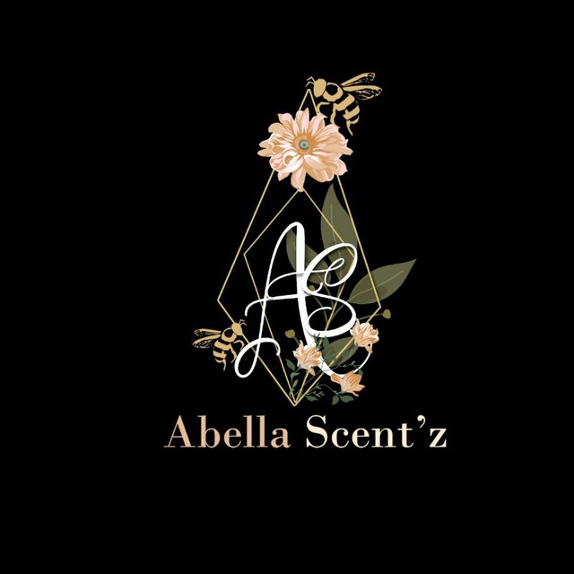

Figure 1 : Abella Scent'z Logo

## Team Background

The individuals that hold responsibility for the creation of the web application project comprises of six members. The members are Mohamed Adzhar bin Zaidi, Sh. Nur Aini Wafa binti Wan Ahmadi, Nur Syarwarni binti Berjaya, Sarah Elena Binti Zamizan, Muhammad Iz’aan Fahmi bin Badrusam, Syed Mohd Asyraf bin Wan Hashim. We are called Charmander because Charmander is a fire type Pokémon which depicted our burning flames of passion when we came up with this web application. This group is formed in the middle of October 2020 after the start of the new 20/21 semester. Even though it is a little difficult to discuss during this global pandemic that is going on right now, the roles and specific tasks are divided and allocated by Sarah Elena a week after the group is formed in a meeting we conduct so the project can start as soon as possible. Charmander was created to develop the Abella Scent’z Perfume Shop web application. This project is guided by Madam Nurfauza Binti Jali for the subject TME 3413 - Software Engineering Laboratory. The web application will certainly help ease the business of Abella Scent’z and hopefully increasing their sales revenue. Our group collaborated with Abella Scent’z in October 2020. We are honoured to be the ones responsible for the development of the web application for Abella Scent’z Perfume Shop and to have Abella Scent’z as our client. Therefore, we will do our best in terms of hard work and time to cater to our client’s requirement and specification.



Figure 2 : Group Charmander Logo

# Problem statement

Based on our questionnaire and interview with the company’s representative, Madam Adibah, we learn that an advertising strategy currently used by our client, Abella Trigona is by placing their products, Abella Scent’z perfume in stores and supermarkets. Apart from that, our client uses social media as their current platform to showcase their products such as Facebook, Instagram, TikTok, YouTube and WhatsApp. Social media also acts as a medium for Abella Trigona’s customers to place their orders. The daily business operation between the management staff and the selling team which comprises the dropship agents, agents and stockist is done through calls and WhatsApp. As of now, Abella Trigona has no official website to advertise their products. Although social media has been useful in promoting their products and their daily business operation, there are drawbacks to it too. Not all customers own social media accounts. With the current platform, customers are less likely to keep up with Abella's latest updates and info. Also, social media contains a variety of things and does not revolve around business-related info only, let alone, Abella Trigona’s products. This will only further deviate customers' attention on the products. Plus, if there are many messages received in WhatsApp, it is harder to keep track of customers’' messages which will result in some orders being overlooked.

The solution to resolve the problems previously stated is through the use of a web application which will act as a medium to showcase Abella Scent’z. The web application will make it easier for customers and the selling team because they can access the web app without the need to own any social media account and can directly purchase the products. Besides that, the proposed web application will also help smoothen the daily business operation for the management staff in handling the orders received and also for the selling team in regards of their commission. A web application is believed to be the best solution to expand our client's business.

# Project Objectives

* 1. **To identify and analyse the current problems faced by Abella Trigona and propose the best solution to resolve the problems**

We have provided ourclient with a questionnaire and conducted an online interview with the company’s representative to gather and analyse the problems faced by the client. From that, we managed to gain an insight of the client’s daily business operation in which with this information, we were able to extract, analyse the problems and come up with a solution for problems they faced and the areas that needs improvement

* 1. **To design and develop a web application that fulfils all of client's requirements**

From the interview and questionnaire, we gathered information on what the client wants in the web application. The requirements stated by our client are essential in the development of the web application as it guides our group to design and build the desired web application that is useful and serves the users including the client excellently.

* 1. **To test the built web application and evaluate whether it meets client's expectations by making client's requirements as the benchmark**

In order todetermine whether our group has build the web application exactly as what the client has expected, the web application is tested thoroughly based on client's requirements. The web application is ready to be handed to the client if it meets all of the requirements.

* 1. **To deploy a web application that performs all the functionalities expected by the client with excellence**

The built web application is expected to solve the problemscurrently faced by the client and help elevate the client’s business and most importantly, satisfies and serves the client and other users for a long period of time.

# Project Perspective

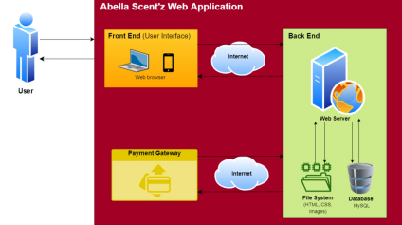

Figure 3 : Logical Architecture of Abella Scent'z Web Application

As illustrated in the logical architecture of Abella Scent'z Web Application above, the users (customers, the selling team and the management) will access the web application via web browsers. By using this web application,

1. Users can view the pictures of all the products (i.e.: Abella Scent'z perfume) with their respective details. It will no longer be a necessity for customers to contact the client on every purchase they would like to make and it will also reduce the possibility of any customer orders from being overlooked due to many messages received through WhatsApp and another social messaging app.
2. Users can also view the information regarding the company itself.
3. Users can easily purchase the products directly through the payment gateway.
4. The selling team will be able to view their sales commission, performance sales and team hierarchy.
5. The management staff is able to view the orders received, manage the sales commission of the selling team and handle the web application (e.g.: Adding event programs, updating promotion and editing the information displayed in the web app). Simply said, the web app will simplify the daily business operation of the management and the selling team.
6. Our client can grow their business online because it adds credibility to the company as a legitimate business. The business must be able to instil trust in customers to purchase their products.

That being said, the web application satisfies all users, including customers, the selling team and the management staff.

# Project Scope

This project involves developing a web-based business application (e-commerce web application) for a company named Abella Scent’z. This web application consists of products such as perfumes (a mixture of fragrant, essential oils and aroma compounds). The web application that will be built will contain information on the company’s background, history and overview of their establishment and business originality. Other than that, the information on the products will also be included in the web application such as the description of each products, the pricings, and what the product does and its functionality. The web application will contain any social media pages that links to Abella Scent’z business whereabouts and information as they need to keep updating their customers on new promotions and events. For the customers and users of the Abella Scent’z web application, they will be able to choose the desired products and then proceed to the check-out page. Then, the customer will need to include details such as home address, phone numbers, and e-mail. In the check-out page, customers will be able to select an option whether to self-collect or to proceed with deliveries to receive their orders. This should be done within the operation hours of the Abella Scent’z business. Once an order has been placed, the customers will send a transfer receipt as a proof of payment so that the company can proceed with the orders.

**5.1 System Environment**

A detailed information on the system environment involved in Abella Scent’z businesses through web application will be shown in the table below. The software, hardware and system requirements mentioned should satisfy the need of every project team members during the development phase, and during the deployment for both the users’(customers) end and the clients’(employees) end.

Table 1 : System Environment for the Abella Scent'z Website

|  |  |  |  |
| --- | --- | --- | --- |
| Environment | Software | Hardware | System Requirements |
| Development | Operating System – MacOS  Operating System – Windows  Web Browser – Google Chrome  Web Host – 000webhost.com  Local Hosting –  XAMPP Server | Personal Computer  Mobile Devices | Stable Internet Connection  Location Access (GPS) |
| Delivered | Web Browser – Google Chrome | Personal Computer  Mobile Devices | Stable Internet Connection  Location Access (GPS) |

The web application will be build using the commonly used web developing languages as the team members are already familiar with such languages.

**5.2 System Functionality**

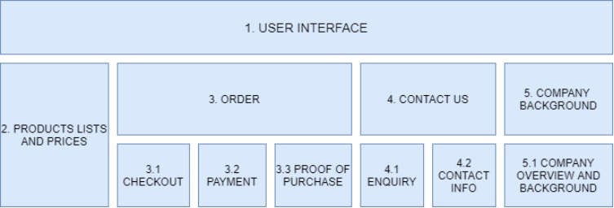

Figure 4 : System Modules for the Abella Scent’z Web Application

The functionality and description of the System Modules for the web application are shown below:

Table 2 : Explanation of System Modules for the Abella Scent’z Web Application

|  |  |  |  |
| --- | --- | --- | --- |
| **Module** | | **Functionality** | **Description** |
| 1. User Interface | | Users can interact and use the web application. | Displays the features and functionality of the system in a user-friendly environment. |
| 2. Product lists and prices | | Displaying information such as perfumes lists and prices of each items | Lists of perfume products listed alongside its price. |
| 3. Order | 3.1 Checkout | To choose specific product to be added into the cart system. | System permits the user to select their own checkout parameters |
|  | 3.2 Payment | To trigger supported online transaction gateway. | Allows customer to pay via online. Redirects customer to FPX payments. |
|  | 3.3 Proof of purchase | Receipt as a proof of purchase. | The receipt will include information on the products that has been bought by the customer. |
| 4. Contact us | 4.1 Enquiry | To enable customers to enquire regarding the business via email. | Customers will be able to send feedbacks, ask questions or any enquiry related to Abella Scent’z. |
|  | 4.2 Contact info | To display the information of the company’s contact. | Customers can view the company’s official social media and web sites in order to receive updates on new products or any new promotions. |
| 5. Company background | 5.1 Company overview and background | To display the company’s background, overview and history. | A section contains the company’s background such as establishment, history and customers’ feedback from any media social applications. |

# Software Methodology

Software Development Approach is a crucial phase in ensuring that the project they include is effective particularly in the broad project involving a lot of IT teams such as engineering teams, team networks, team software and other teams. Many projects have been a failure because of the method they choose is wrong, and they cannot manage their team properly. So, our team have decided to choose Scrum approach for our Software Development Method. The Scrum approach generally has an agile method but its more focus on managing iterative development compare to an actual practice of the agile method. This method is suitable to meet the condition and requirement for our client to build a web application of Abella Perfume.

The Scrum method is more preferred for the framework team compare to the agile method. The agile method only focusses on the coding part and does not have a proper management for the project. An agile method simpler when it comes to develop the software and in the development process. This method wants to avoid the complexity of the system and make sure the system can be properly function. While for the Scrum method it more to team cooperation and adding the agile method. Scrum method Scrum relies on a self-organising, cross-functional team. “The scrum team is self- organising in that there is no overall team leader who decides which person will do which task or how a problem will be solved. Those are issues that are decided by the team as a whole” (Cohn, n.d.). “Scrum has become the most popular agile method among developers, it’s because it promotes the Agile Manifesto values: more collaboration with the client, overcoming the fear of change, putting interaction with people at the centre of any project management, and focusing on delivering operational software.” (Understanding Agile Scrum in 10 minutes • Tuleap,2020)

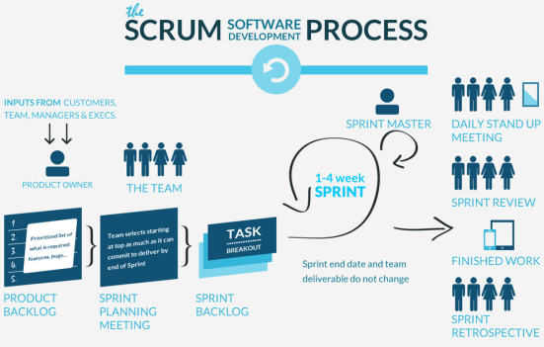

Figure 5 : The Scrum - An Agile Software Methodology Framework

In this Scrum method, it starts with getting the product owner information. The team need to have a product information from the owner product to start the project. The team need to have a middle person to get the information from the client. This step knows as product backlog. We also need prioritise the specific requirement and condition from what client want in this step. Also, at this step, the cooperation and fast responding from product owner really play an important role. Then, sprint is also important in this method because sprint is a duration which we have set to keep our project in the right direction. “A Sprint is time-box of one month or less during which a “Done”, use able, and Scrum Sprint is part of the Empirical Process potentially releasable product Increment is created. Sprints have consistent duration throughout a development effort. A new Sprint starts immediately after the conclusion of the previous Sprint” (What is a Sprint in Scrum, n.d.). There is five type of sprint in this method, which is sprint master, sprint planning meeting, sprint backlog, sprint review and sprint retrospective. A daily stand up need to happen to improve the project and know the mistake in the project.

# Task Allocation & contribution

Each project member is given responsibilities and contribution to make sure the process project smoothly. Bellow is the task, roles and responsibility for each member:

Team Member

1. Mohamed Adzhar bin Zaidi -- Team leader and Process Manager
2. Sh. Nur Aini Wafa binti Wan Ahmadi - Planning Manager and Design Manager
3. Nur Syarwarni binti Berjaya - Project Manager and Implementation Manager
4. Sarah Elena binti Zamizan - Quality Manager and Support Manager
5. Muhammad Iz’aan Fahmi bin Badrusam - Test Manager
6. Syed Mohd Asyraf bin Wan Hashim - Customer Interface Manager

The details about the role and task is in Appendix I.

# Team Goals

There are some goals that each of member have come to an agreement which we want to achieve throughout from this project. The goals consist of the following:

1. Work as a team and help each other when there is a problem occur and solve it together throughout the entire project.
2. Submit each task which has been given within the time given to make sure the project keeps in the track.
3. Active in a group discussion to make improvement and modification in documentation and coding project.
4. To develop a web application which can fulfill the client expectation from the requirement and condition successfully.

# Expected Result / Deliverables

## 9.1. Working System

The system that we have proposed for Abella Scent’z would help in elevating their sales by digitalising their product with this proposed website. The system would have numerous pages that can be viewed by the users and potential customers of the website. It would be divided into two parts whereby consisting of the following the user experience and Abella Scent’z system experience.

Figure 6 : The Expected Results of system and user

## 

## 9.2. System Artefacts/Documentation

Table 3 : Description of System Artefacts/Documentation Involved

|  |  |
| --- | --- |
| Artefacts/Documentation | Description |
| 1. Project Proposal | A documentation which is required to be proposed to the client to showcase them an overview of the project and to the lecturer which is oversighting the project |
| 1. Meeting Minutes | A written report of details and information that was taken into consideration during every group meeting throughout the process of the project |
| 1. System’s User Manual | A document or guided on how the system works and how to utilise the system to its full capability. This document is considered an important piece of information for both the software tester where acts for testing purpose and the client side where in terms of using the system. |
| 1. Software Requirement Specification (SRS) | A more –in depth version of proposal where involves a deeper explanation of the system which relates to the functional and non-functional requirement. |
| 1. System Design Specification (SDS) | A document which explains the complete design structure of the system, in line with the scheduling, staffing and point by point costing. This document is crucial for the development team in order to build the proposed system |
| 1. Test Summary Report | A document whereby would state the overall report of the system in terms of the functionality of the system with regards to the client’s demand. |
| 1. TSPi Forms | A various of forms which are use to standardize the progress and information that are discussed in the project. This is done for the good of user or developers who choose to improve the system and also a schedule which provides a guide to ensure the project is completed accordingly. |

# Project Planning

# 

Figure 7 : Gantt Chart for Sprint #1 - Planning

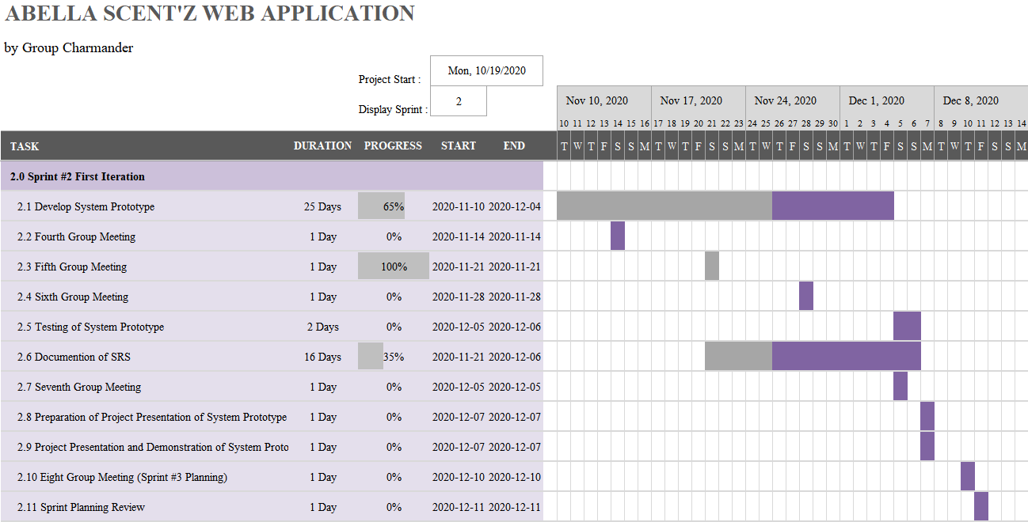

Figure 8 : Gantt Chart for Sprint #2 - First Iteration

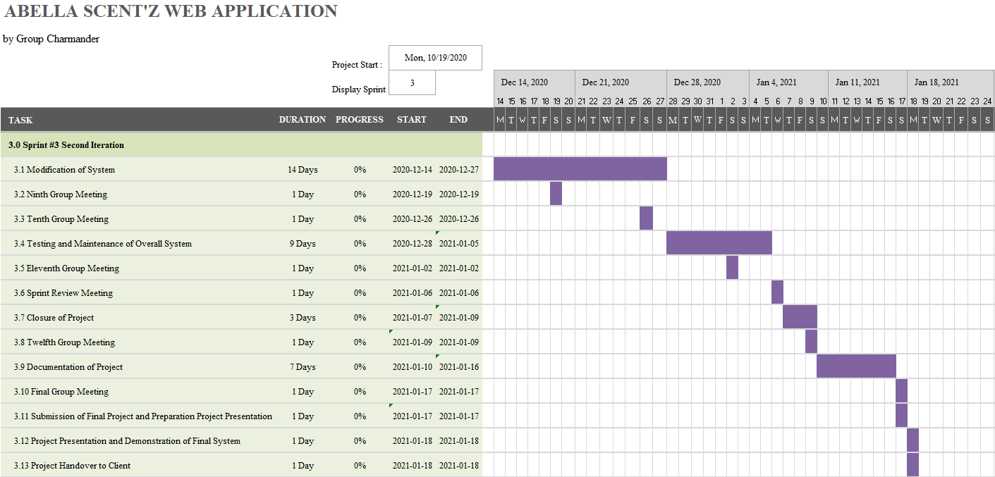

Figure 9 : Gantt Chart for Sprint #3 - Second Iteration

# References

Cohn, M. (n.d.). *Scrum Methodology and Project Management*. Retrieved October 28, 2020, from https://www.mountaingoatsoftware.com/agile/scrum

Understanding Agile Scrum in 10 minutes • Tuleap. (2020, October 13). Retrieved October 28, 2020, from https://www.tuleap.org/agile-scrum-in-10-minutes/

What is a Sprint in Scrum? (n.d.). Retrieved October 28, 2020, from https://www.scrum.org/resources/what-is-a-sprint-in-scrum

# Appendices

## Appendix A: Details of Scrum Method Roles in the Scrum Method.

There are usually three type of common role needed in the Scrum. This is the following description of the role:

1. **Sprint Master**

- The scrum master is one of the development team which will be responsible to make sure the team always practices Scrum method and keep the balance between product owner/stakeholder requirement and team. This role needs to make sure the product backlog keeps in the right shape and the Scrum process can be ready in the next sprint. Lastly, Scrum master also make sure the team is not over-commit to achieve the task they handle during the sprint duration due to pressure from the owner product requirement. In this role the person in charge is the project manager, Nur Syarwarni binti Berjaya and the team leader, Mohamed Adzhar bin Zaidi.

1. **Owner Product**

- Owner products need to cooperate with the team developer by giving the information of the product in Scrum. They are also responsible to provide feedback for the system which need to keep the product backlog stage up to date. This role representing the client/stakeholder of the product we choose for our web which is Abella Perfume Scent, founder by Madam Linda.

1. **Development Team**

- The team can be multidisciplinary and include many categories of individuals: developers, architects of software, functional analysts, graphic designers, ergonomists, engineers of systems, etc. This represent our team member.

**Artifacts of the Scrum process**

Artifacts usually a main step for Scrum process, the following is a little bit explanation of the process:

1. **Product backlog**

**-** The main person in charge with this step is the product owner. Product owner will give some information related to what kind of customers they have because the product owner has a direct relation with their customer. This step will keep the product backlog up to date. Product backlog is one of the main steps if using Scrum method in development of product. Product owner also need to keep the information easily shared with our development team through the project manager.

1. **The Sprint Backlog**

**-** The sprint backlog is a duration of time up to 2 weeks until 1 month is the max for development team to develop their design, realise and test new features.

1. **Finished work**

**-** At this step, mostly about the web we build will delivered to the final user, owner. But it also can refer as a multiple sprint because it can refer as a duration of time which one is part is still under development, going through successive sprints, until the delivery to the user.

**Scrum cycle.**

This section will explain a little bit about the scrum life cycle:

1. **Sprint planning meeting**

**-** This step is for organising what can be conveyed in the sprint duration and how will that work be finished.

1. **Daily stand up meeting**

**-** Daily meeting is when the development team having a discussion about the process which usually take 15 - 30 minutes by using WhatsApp chat, discord, Trello and other app. This meeting to make sure the process up to date in the following 24 hours and make future plan about the next process.

1. **Sprint review**

**-** Sprint meeting is the step when our development team have meeting with the client/stockholder about the informal review of web application. We will give some demo of the web we build and figure which part we need to improve also have not done yet.

1. **Sprint retrospective**

**-** This step is one of the keys for future continuous improvement in the development of project. The development team will have meeting that takes place at the end of sprint duration. By analysing charts (Burnup chart, Burndown chart, Speed of team process). Moreover team development will openly examining and taking a step back from the past sprint to seeks improvement, looks for change also ponders how to optimise the interaction between each teammates which can help in gaining more idea and inspiration between people and choose the most suitable idea to raise the product quality, and generally, to move forward its efficiency.

## Appendix B: Task Allocation, Responsibilities and Contribution

Table 4 : Task Allocation, Responsibilities and Contribution

|  |  |
| --- | --- |
| **Team Member** | **Roles, Task and Responsibility** |
| Mohamed Adzhar bin Zaidi | 1. **Team Leader**   - Make a final decision in the group discussion.  - Monitor the project process from each member.  - Encourage the member project to do their task.  - Ensuring the project can be delivered on time     1. **Process Manager**   - Working with the project manager to discuss about client requirement.  - Identifying the improvement needed in some area during the project process.  - Create and present the report of process which have been improve in the project.  - Conduct ongoing process of analyses  - Lead a team that will be responsible for process assessments, and process design and redesign.  - Assist in programming process. |
| Sh. Nur Aini Wafa binti Wan Ahmadi | 1. **Planning Manager**   - Ensuring the project keep in the right track and monitor all the planning process during the project duration.  - Remind the member to submit task given before sprint duration over.  - Set schedule for meeting, task due for member to submit and other planning propose which involve in the project development.  - Managing reports and necessary documentation   1. **Design Manager**   - Developing project design with the help of the project manager about the requirement client want  - Developing design strategies  - Conducting presentation  - Assist technically internal and external process. |
| Nur Syarwarni binti Berjaya | 1. **Project Manager**   - Become the middle person between team and client  - Contact the client and get the specific requirement need in web application.  - Update and monitor the process of web application to the client  - Maintains organisation's effectiveness and efficiency by defining, delivering, and supporting strategic plans for implementing information needed in the project.  - Select the suitable framework of methodology for development team during the duration of project.   1. **Implementation Manager**   **-** Responsible for the implementation of technical systems, software and solution.  - Oversee and support multiple implementation project  - Review external clients product demand, develops project plans and ensures that the implementations are completed on time and meet the client expectations. |
| Sarah Elena binti Zamizan | 1. **Quality Manager**   - Understanding customer expectations of and needs from a product.  - Designing product specifications  - Engaging with client by working with project manager and gathering product feedback.  - Ensuring products are designed with adherence to legal and safety standards.  - Producing statistical reports on quality standards.     1. **Support Manager**   - Assessing the technical needs of development team.  - Manage and upholding the troubleshooting escalation during the project process  - Assist the team when they need help.  - Measure service satisfaction levels |
| Muhammad Iz’aan Fahmi bin Badrusam | 1. **Test Manager**   - Check / Review the Test Cases documents.  - Escalate the issues about project requirements (Software, Hardware, Resources) to development team.  - Manage software testing projects and resources  - Prepare / present test reports to development team.  - Identify the bug that occur in the web application.  - Report if there is any functionality that not needed in the web system |
| Syed Mohd Asyraf bin Wan Hashim | 1. **Customer Interface Manager**   - responsible for ensuring that the software systems are functioning, and that interface coordinators and other users.  - Help create and execute on action plans to improve customer experience  - Ensure the design meet the client standard and requirement  - Keep monitor in the change of interface.  - Ensure the interface is user friendly, well design and be responsible in handle all about web interface. |