Software Requirements Specification

for

Abella Scent’z Web Application

Version 1.0

Prepared by

Group Name: Charmander (G19)

|  |  |  |
| --- | --- | --- |
| Mohamed Adzhar bin Zaidi | 64868 | 64868@siswa.unimas.my |
| Sh. Nur Aini Wafa binti Wan Ahmadi | 67655 | [67655@siswa.unimas.my](mailto:67655@siswa.unimas.my) |
| Nur Syarwarni binti Berjaya | 67241 | 67241@siswa.unimas.my |
| Sarah Elena binti Zamizam | 71486 | 71486@siswa.unimas.my |
| Muhammad Iz’aan Fahmi bin Badrusam | 64952 | [64952@siswa.unimas.my](mailto:64952@siswa.unimas.my) |
| Syed Mohd Asyraf bin Wan Hashim | 65245 | 65245@siswa.unimas.my |

|  |  |
| --- | --- |
| Instructor: | Madam Nurfauza Jali  Madam Norazian Mohamad Hamdan |
| Course: | TME3413 Software Engineering Lab |
| Lab Section: | Group 19 |
| Teaching Assistant: | Madam Nurfauza Jali  Madam Norazian Mohamad Hamdan |

|  |  |
| --- | --- |
| Date: | 7th December 2020 |

Contents

Contents ii

Revisions v

1 Introduction 1

1.1 Document Purpose 1

1.2 Product Scope 1

1.3 Intended Audience and Document Overview 1

1.4 Definitions, Acronyms and Abbreviations 2

1.5 Document Conventions 3

1.6 References and Acknowledgments 3

2 Overall Description 4

2.1 Product Perspective 4

2.2 Product Functionality 4

2.3 Users and Characteristics 6

2.4 Operating Environment 6

2.5 Design and Implementation Constraints 7

2.6 User Documentation 7

2.7 Assumptions and Dependencies 7

3 Specific Requirements 8

3.1 External Interface Requirements 8

3.2 Functional Requirements 23

3.3 Behaviour Requirements 45

4 Other Non-functional Requirements 47

4.1 Performance Requirements 47

4.2 Safety and Security Requirements 47

4.3 Software Quality Attributes 47

Appendix A – CLASS DIAGRAM 49

Appendix B - Group Log 50

Appendix C – Sequence Diagram 71

List of Figure

[Figure 1: System Architecture of Abella Scent'z Web Application 4](#_Toc58260810)

[Figure 2: Home Page (Part 1) 8](#_Toc58260811)

[Figure 3: Home Page (Part 2) 9](#_Toc58260812)

[Figure 4: Home Page (Part 3) 9](#_Toc58260813)

[Figure 5: Home Page (Part 4) 10](#_Toc58260814)

[Figure 6: Product Page (Part 1) 10](#_Toc58260815)

[Figure 7: Product Page (Part 2) 11](#_Toc58260816)

[Figure 8: Checkout Page (Part 1) 11](#_Toc58260817)

[Figure 9: Checkout Page (part 2) 12](#_Toc58260818)

[Figure 10: Checkout Page (Part 3) 12](#_Toc58260819)

[Figure 11: About Us Page (Part 1) 13](#_Toc58260820)

[Figure 12: About Us Page (Part 2) 13](#_Toc58260821)

[Figure 13: Contact Us Page (Part 1) 14](#_Toc58260822)

[Figure 14: Contact Us Page (Part 2) 14](#_Toc58260823)

[Figure 15 : Selling Team Log In page 15](#_Toc58260824)

[Figure 16: Selling Team Dashboard page 15](#_Toc58260825)

[Figure 17: Selling Team Sales page 16](#_Toc58260826)

[Figure 18: Selling Team Products page 16](#_Toc58260827)

[Figure 19: Selling Team Hierarchy page 17](#_Toc58260828)

[Figure 20: Management Staff Log In page 18](#_Toc58260829)

[Figure 21: Management Staff Dashboard page 18](#_Toc58260830)

[Figure 22: Manage Web - Basic Info page 19](#_Toc58260831)

[Figure 23: Manage Web - Product Info page (part 1) 19](#_Toc58260832)

[Figure 24: Manage Web - Product Info page (part 2) 20](#_Toc58260833)

[Figure 25: Orders & Sales page (part 1) 20](#_Toc58260834)

[Figure 26: Orders & Sales page (part 2) 21](#_Toc58260835)

[Figure 27: Management Team page (part 1) 21](#_Toc58260836)

[Figure 28: Management Team Page (part 2) 22](#_Toc58260837)

[Figure 29: Use Case Diagram for Abella Scent'z Web Application 45](file:///C:\\Users\\ACER\\Desktop\\UNIMAS\\SEM%205\\TME%203413%20Software%20Engineering%20Laboratory\\Project\\2%20SRS%20Samples%20%20Template-20201118\\SRS_Charmander\\Draft_SRS_G19_Charmander.docx" \l "_Toc58260838)

Figure 30 : Class Diagram Abella Scent’z ....................................................................................49

[Figure 31: Sequence Diagram for Customer Abella Scent'z Web Application 73](file:///C:\\Users\\ACER\\Desktop\\UNIMAS\\SEM%205\\TME%203413%20Software%20Engineering%20Laboratory\\Project\\2%20SRS%20Samples%20%20Template-20201118\\SRS_Charmander\\Draft_SRS_G19_Charmander.docx" \l "_Toc58260839)

[Figure 32: Sequence Diagram for Selling Team Abella Scent'z Web Application 74](#_Toc58260840)

[Figure 33: Sequence Diagram for Management Staff Abella Scent'z Web Application 75](#_Toc58260841)

List of Table

[Table 1: Abella Scentz Web Application’s System Environment 6](#_Toc58260909)

[Table 2: Response Sequence for Customer View Product Info 23](#_Toc58260910)

[Table 3: Direct Functional Requirement for Customer View Product Info 24](#_Toc58260911)

[Table 4: Response Sequence for Customer View Company Info 24](#_Toc58260912)

[Table 5: Direct Functional Requirement fo Customer View Company Info 24](#_Toc58260913)

[Table 6: Response Sequence for Customer Purchase Product 25](#_Toc58260914)

[Table 7: Direct Functional Requirement for Customer Purchase Product 25](#_Toc58260915)

[Table 8: Response Sequence for Customer Checkout 26](#_Toc58260916)

[Table 9: Direct Functional Requirement for Customer Checkout 27](#_Toc58260917)

[Table 10: Response Sequence for Selling Team Log In 27](#_Toc58260918)

[Table 11: Direct Functional Requirement for Selling Team Log In 28](#_Toc58260919)

[Table 12: Response Sequence for Selling Team View Company Info 28](#_Toc58260920)

[Table 13: Direct Functional Requirement for Selling Team View Company Info 29](#_Toc58260921)

[Table 14: Response Sequence Selling Team View Product(s) Info 29](#_Toc58260922)

[Table 15: Direct Functional Requirement for Selling Team View Product(s) Info 29](#_Toc58260923)

[Table 16: Response Sequence for Selling Team Purchase Product(s) 30](#_Toc58260924)

[Table 17: Direct Functional Requirement for Selling Team Purchase Product(s) 31](#_Toc58260925)

[Table 18: Response Sequence for Selling Team View Commission Sales 31](#_Toc58260926)

[Table 19: Direct Functional Requirement for Selling Team View Commission Sales 32](#_Toc58260927)

[Table 20: Response Sequence for Selling Team View Performance Sales 32](#_Toc58260928)

[Table 21: Direct Functional Requirement for Selling Team View Performance Sales 33](#_Toc58260929)

[Table 22: Response Sequence for Selling Team View Hierarchy 33](#_Toc58260930)

[Table 23: Direct Functional Requirement for Selling Team View Hierarchy 34](#_Toc58260931)

[Table 24: Response Sequence Change Password for Selling Team 34](#_Toc58260932)

[Table 25: Direct Functional Requirement Change Password for Selling Team 35](#_Toc58260933)

[Table 26: Response Sequence Manage Profile for Selling Team 35](#_Toc58260934)

[Table 27: Direct Functional Requirement Manage Profile for Selling Team 36](#_Toc58260935)

[Table 28: Response Sequence Log in for Management Staff. 36](#_Toc58260936)

[Table 29: Direct Functional Requirement Log In for Management Staff 37](#_Toc58260937)

[Table 30: Response Sequence Manage Product Info for Management Staff. 37](#_Toc58260938)

[Table 31: Direct Functional Requirement Manage Product Info for Management Staff 38](#_Toc58260939)

[Table 32: Response Sequence Manage Company Info for Management Staff 39](#_Toc58260940)

[Table 33: Direct Functional Requirement 40](#_Toc58260941)

[Table 34: Response Sequence Manage Order Receive for Management Staff 40](#_Toc58260942)

[Table 35: Direct Functional Requirement Manage Order Receive for Management Staff 41](#_Toc58260943)

[Table 36: Response Sequence for Management Staff Add New Member 41](#_Toc58260944)

[Table 37: Direct Functional Requirement Management Staff Add New Member 42](#_Toc58260945)

[Table 38: Response Sequence Change Password for Management Staff 42](#_Toc58260946)

[Table 39: Direct Functional Requirement Change Password for Management Staff 43](#_Toc58260947)

[Table 40: Response Sequence Manage Profile for Management Staff 44](#_Toc58260948)

[Table 41: Direct Functional Requirement Manage Profile for Management Staff 44](#_Toc58260949)

Revisions

| Version | Primary Author(s) | Description of Version | Date Completed |
| --- | --- | --- | --- |
|  |  |  |  |

# 

# Introduction

With the hope to expand their business, our client, Abella Trigona agreed with our idea to develop a web application for them which we named as Abella Scent’z Web Application. The web application will enable their customers to purchase their products directly. Besides customers, the web application will also be used by our client’s management staff and the selling team to manage their business operations. This section describes the overview of the whole Software Requirements Specifications and provides brief information regarding the web application.

## Document Purpose

Abella Scent’z Web Application will be our client’s first web application once it is successfully developed. The web application aims to resolve the problems that our client faced with their current business strategy that becomes a bottleneck in the smoothness of their business operation and their ability to expand their business. The problems include the difficulty in keeping track of orders, less customer attention and the customers inability to be alert on client’s latest updates. We managed to identify and analyze the problems they faced and the requirements compulsory for the web app based on our findings from our interview with the client and the questionnaire we provided for them.

Thus, the aim of this SRS is to provide an in-depth description of these requirements. The requirements are presented in a proper and formal way to ensure better understanding of the web application. Apart from that, the document acts as a guide for our group to develop the desired web application that meets our client’s expectations and as a software validation document for our client.

## Product Scope

The product that our group intends to develop for our client is a web application which will act as a new platform for our client to sell their products (i.e perfume) and conduct their daily business operation. It was our client’s desire to grow their business online that drives the development of the web application which we named as Abella Scent’z Web Application.

The web application performs various functionalities based on the category of users. The users of the web app comprise of the customers, the selling team and the management. Customers will be able to view the products sold by our client and purchase them directly. Thus, the web application will ease the customers’ shopping experience. The same functionalities go for the selling team but with extra functionalities where they can view their sales and team hierarchy. On the other hand, the management can view the orders received and manage the whole web application.

## Intended Audience and Document Overview

The readers of this document consist of our instructor, our client and our own group members. Our instructor, Madam Fauza Binti Jali will use this document to evaluate the documentation of our project requirements and help us identify and improvise any area that needs improvement. On the other hand, our client, Abella Trigona will use the document to evaluate our understanding on what they want in the web application and correct us on any part that we have misunderstood. Our group will use the SRS to assist us in developing an excellent web application that performs all the functionalities to satisfy all of the requirements. This section, Section 1 basically describes what is available in the SRS while the rest of the SRS describe the requirements of the web application comprehensively. Section 2 provides an overall description of the product including the functions that the web application performs. Section 3 presents the specific requirements of the project including external interface requirements, functional requirements and behaviour requirements. Section 4 contains descriptions on other non-functional requirements of the web application. The last section, Section 5 talks about other related requirements.

The sequence of reading suggested for the readers are as stated below:

|  |  |
| --- | --- |
| * Instructor | * From first page to last page |
| * Client | * From this section (Section 1.3) onwards |
| * Our group (developers) | * Section 2 onwards |

The client and the developers are encouraged to focus more on topic 2.2 from Section 2, topic 3.2 and topic 3.3 from Section 3 because these topics will dive deeper into the web app’s requirements and functions.

## Definitions, Acronyms and Abbreviations

**Definitions**

|  |  |
| --- | --- |
| * Selling team | * Comprise of agents, dropship agents and stockist |
| * Dropship | * People who act as our client’s marketers, promote and sell their products on their behalf but do not keep any stock. |
| * Stockist | * A retailer who keeps stocks of our client’s products. |

**Acronyms and Abbreviations**

|  |  |
| --- | --- |
| * CSS | * Cascading Style Sheets |
| * HTML | * Hypertext Markup Language |
| * IEEE | * Institute of Electrical and Electronic Engineers |
| * PHP | * Hypertext Preprocessor |
| * SRS | * Software Requirements Specifications |
| * UI | * User Interface |
| * XAMPP | * Cross-platform, Apache, MySQL, PHP and Perl |

## Document Conventions

This document follows the IEEE formatting requirements. Therefore, the font used throughout the document is Arial font size 11. The document text is single spaced and uses 1” margins. Sections are separated with dividers (dark rectangle blocks) with section title written inside the divider. The font size used for section title is size 18. Topics and subtopics are indicated using bold letters. Topics are typed using Arial font size 14 while subtopics are typed using Arial font size 12.

## References and Acknowledgments

Aguas, M., Blackman, A., D’Andrea, G., Vu, P., and Singh, G.(n.d.).Software Requirement

Specification for Chess.

Ding, A.S., Nurfauza Jali., Wong, D., Zosipha Zainal Osman, Syed Ardi Syed Yahya Kamal, and Noraini Mohamed.(n.d.).Software Requirements Specifications (SRS) for the Vending Machine Control System (VMCS) of the VendingMachine (VM).

Money, I.T., Chowdhury, S.M.A.K., Lubna, J.I., and Nazlina Naroden.(n.d.).Software Requirements Specification for Caker Holic Web Application Version 1.0.

# Overall Description

## Product Perspective

Figure 1: System Architecture of Abella Scent'z Web Application

Our client, Abella Scent’z requires a system whereby they are able to manage and receive any order for their product online. As per request from the Abella Scent’z management, our team decided to develop a system where an online web app is to be proposed and design to fulfill their request and desire where is Abella Scent’z Web App. This system will have a goal to help Abella Scent’z of their daily sales and marketing whereby with hope to elevate their sales to another level.Customer’s order will be sorted in a more orderly manner compared to the old method of sales whereby through medium like Whatsapp and Tiktok.With the web application system, the customer would be able to access all the Abella Scent’z products with their details which includes the price and description of the product,making it easier for the customers to decide what they want in a product. This web application would also help Abella Scent’z to move to the more conventional of business now whereby creating an official e-commerce website for the company.

The Abella Scent’z Web Application is accessible to customers via devices such as laptops, computer or even their personal phone as long as there is usable web browser and stable internet connection. The web application contain numerous products by Abella Scentz whereby they are able to choose from the catalogue, place an order, input their personal information for the necessary billing information, select delivery option offered and proceed to the required payment using the supported online payment gateway such as Online Banking FPX.. For the management side, the Abella Scentz committee will be able to see the order through the system whereby the administrator can use the system in a way to manage product, view orders and view payment as well to check whether the customer have proceeded to pay in order to proceed with their order.

## Product Functionality

Abella Scent’z Web Application would provide the following functionalities for all three ends of the user which customer, selling team and management.

Customer / User

* Display the product that can be bought by the customers and user which consists of the product info such as pictures, description, and price.
* Display the company info of Abella Scent’z which includes the company info and a page which explain about the company
* Purchase products directly from the website whereby the customer would purchase the products through payment gateway.

Selling Team

* Able to login into the system using their own id/username and password
* Display the company info of Abella Scent’z which includes the company info and a page which explain about the company
* Purchase product directly from the system whereby the price for agents would be slightly lower compared to customer. The prices for the selling team are to decide by the management team
* Able to display the commission sales. The commission sales are part of the total sales which are considered as a reward for the selling team for their sales which are made through their respective agent’s link. This requires the agent to share their link with every transaction.
* Able to show the performance sales. A table/graph/chart would be used as an information sheet that shows the sales that they have achieved.
* Able to show team hierarchy. Every agent belongs to a team whereby they can view their own respective team hierarchy.
* Able to change password of their account. The agent is given a default password when they first register as an agent where they can change their password any time they want.
* Able to manage their very own profile which includes the Agent’ID, Name, Phone Number, Address and also their agent’s link which is auto generated by the web app whereby able to edit except for the ID and their link

Management staff

* Able to log into the system using their own id/ username and password.
* Able to manage product info which includes the picture, product description and price.
* Able to insert info in relating to the product sold.
* Able to determine price for the selling team in the case selling team does direct purchase from the system
* Able to determine the commission for the selling team every time a customer purchase a product through the agent’s link.
* Able to manage the company info which are the contact info and about us page. Management can view, insert info, edit and delete.
* Able to manage the order received. Management can view the order received and update the settled orders.
* Able to add new members to the selling team which consists of agent, stockiest and dropship agent. The management staff create an account for new users whereby the web app would auto generate the username/ID and password
* Able to change password of their account. The agent is given a default password when they first register as an agent where they can change their password any time they want.
* Able to manage their very own profile which includes the ID, Name, Phone Number and Address.

## Users and Characteristics

Abella Scent’z Web Application has up to 3 users which are the customer, selling team and the management team. Regarding the users or customers of the web application are expected to be from variety age group, the interface of the web application should be user friendly where the user can use the system with ease. Our group would design the web app based on the criteria and requirement that have been set by Abella Scent’z demand for the user interface for the customer to look like. As for the selling team, we desire that the system can deliver all the necessary details that they aspire such as the commission sales, performance sales and team hierarchy. As for the management team, the system hopes to deliver the order smoothly everytime a new sets of orders are received and update the settled orders. Other than that, the system can undergo the process of registering new members smoothly without any errors

## Operating Environment

The Table 1 below shows the system environment for Abella Scent’z Web Application. All the mentioned software, hardware and requirement would be used by the development team, whereby in regards to the demand of the client involving the development phase and both the implementation of all 3 ends of the users of the system which are the customer, Abella Scent’z selling team and Abella Scent’z management team.

Abella Scent’z Web Application is developed using the latest web development programming technologies. For the front end of the project, HTML, CSS, JavaScript and Bootstrap 4.1 is used. On the back-end of the project, PHP scripting language and MySQL will be used. The language are chosen in regard to the suitability of the web development which involved building a small e-commerce system for the likes of Abella Scentz.

Table 1: Abella Scentz Web Application’s System Environment

|  |  |  |  |
| --- | --- | --- | --- |
| Environment | Software | Hardware | System Requirement |
| Development | Operating System – macOS Mojave | Personal Computer-PCs (Desktop/Laptop/Notebook/All-In-One PC)  Mobile Devices (Smartphones/ Tablets) | Stable Internet Connection (4G/3G Access for those without Wi-Fi) |
| Operating System – Windows 10 |
| Source Code Editor- Notepad++ |
| Web Browser – Google Chrome |
| Web Hosting – 000webhost.com |
| Local Hosting – XAMPP APACHE Server |
| Delivered | Web Browser – Google Chrome |

## Design and Implementation Constraints

The system has the following constraints:

* All three sides of user (customer, selling team and management team) will require a stable internet connection in order to use the system.
* The system does not support multiple currencies. All the products and transaction done on the website are made in Ringgit Malaysia.
* The system would not be 100% responsive with all smartphones
* The password of the user must consist of 1 upper case, 1 lower case and 1 number.
* Time is one of a constraint to develop the system as we have limited time to develop system with the short term left in the semester
* Another challenge we encounter is the client or the stakeholders have little exposure on information technology, and it is difficult to interact with them regarding the developed system.

## User Documentation

To ensure that the user and the management of the system fully utilised the system to its maximum capacity, a proposal will be presented in the process of the system completion phase. A user manual and a video tutorial which would demonstrate the features the web app provide would be shown alongside with the final product which would be used to guide the user of the system.

## Assumptions and Dependencies

Assumptions and dependencies of the system are as follows:

* The system is dependent on the presence of a stable internet connection. Without a stable internet connection, all three categories of users cannot use the system (customer, selling team and management)
* Frequent checking of the system is required by the management side of Abella Scent’z to cater all the order that they received
* The purchasing through the agent link is needed for by all the agents to ensure that they get their commission with sale conducted by them.
* The management system is the only one who are able to add members and create an account for them thus making the selling team wait for their account for they are able to start selling
* The agent is required to login into their account to ensure that they get a cut in price when they purchase from the system

# Specific Requirements

## External Interface Requirements

### User Interfaces

The Abella Scent’z Web Application is a perfume product ecommerce-based web application. We use Mudah.my and Shopee for design examples for our web application. We chose to adapt a modern ecommerce-based web design because the customers are familiar with the design. Therefore, each page is designed with a consistent UI while adapting modern design and user-friendly to ease the user of all age groups to use it. Other than that, each page has the same navigational properties.

For the customer side, the navigation bar is displayed at the top right for every page of Abella Scent’z web application. This is to ease the customers to change between pages. There are 5 pages on customer sides which is home, product where customer can see all product details, checkout, about us where company info is displayed and lastly, contact us.

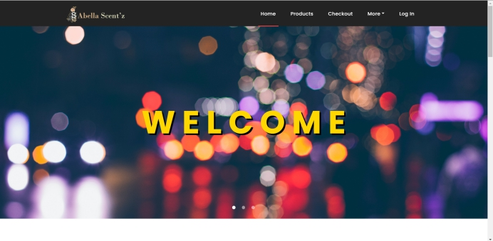

Figure 2: Home Page (Part 1)

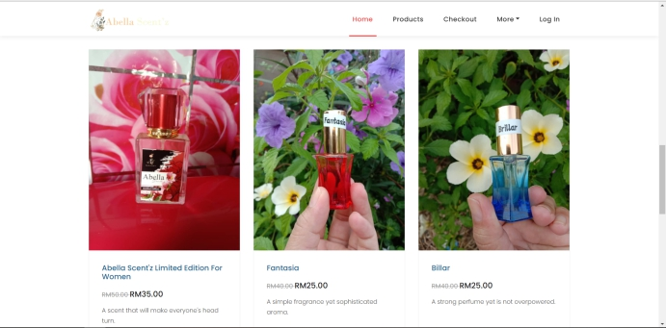

Figure 3: Home Page (Part 2)

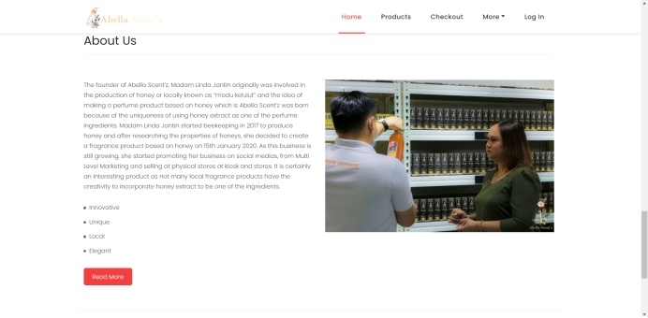

Figure 4: Home Page (Part 3)

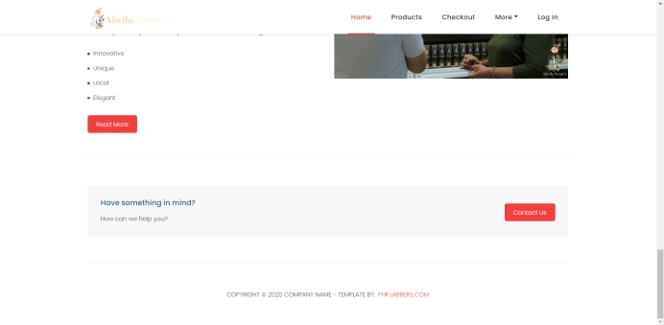

Figure 5: Home Page (Part 4)



Figure 6: Product Page (Part 1)

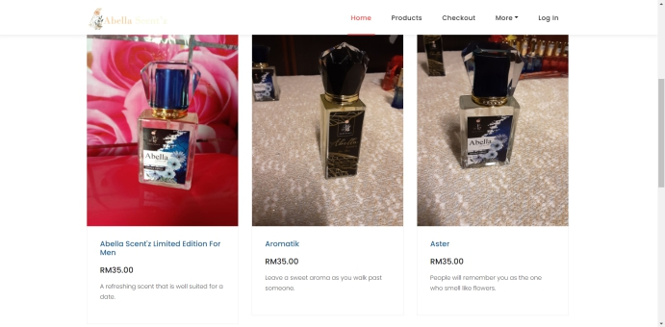

Figure 7: Product Page (Part 2)

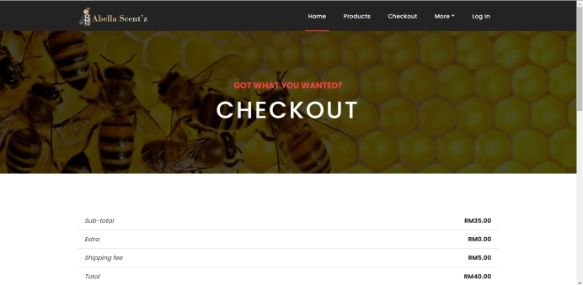

Figure 8: Checkout Page (Part 1)

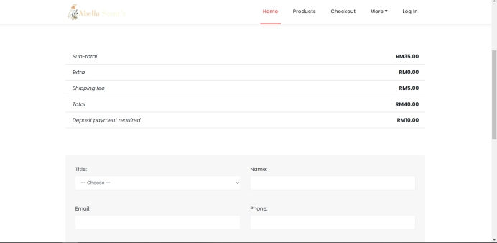

Figure 9: Checkout Page (part 2)

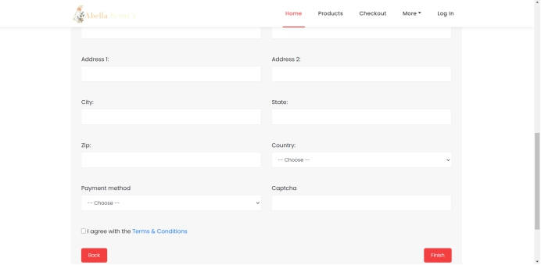

Figure 10: Checkout Page (Part 3)

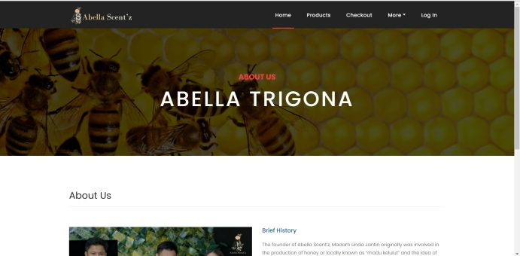

Figure 11: About Us Page (Part 1)

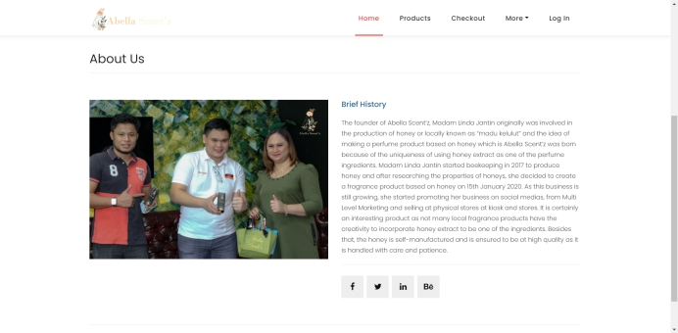

Figure 12: About Us Page (Part 2)

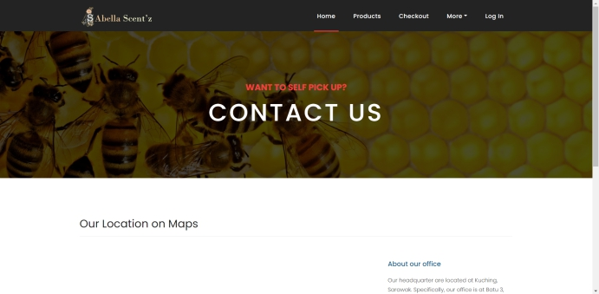

Figure 13: Contact Us Page (Part 1)

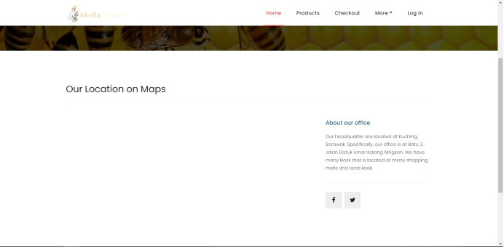

Figure 14: Contact Us Page (Part 2)

For the selling team, there are 5 pages which are logged in where the selling team uses their ID and password, Dashboard where overview of the selling team being shown, Sales including performance and commission, product page and lastly, team hierarchy.

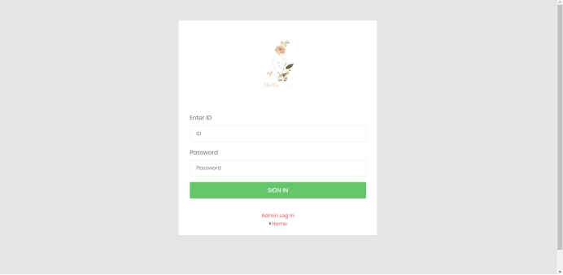

Figure 15 : Selling Team Log In page

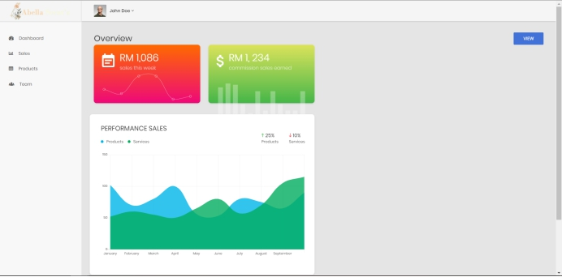

Figure 16: Selling Team Dashboard page

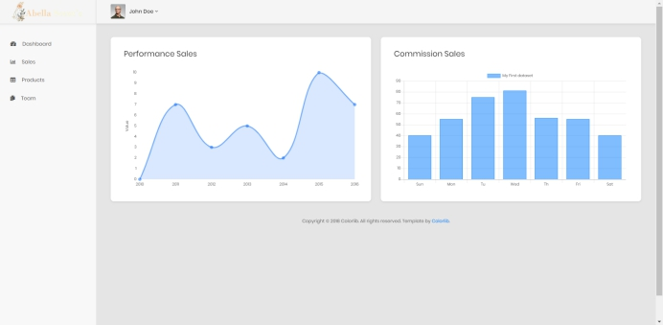

Figure 17: Selling Team Sales page

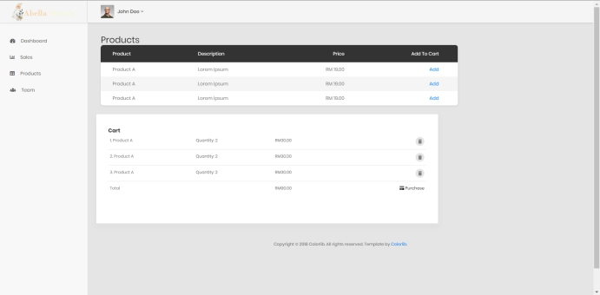

Figure 18: Selling Team Products page

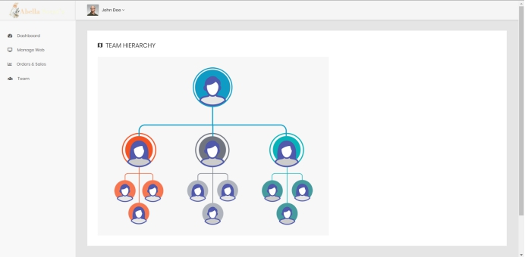

Figure 19: Selling Team Hierarchy page

For management staff, there are 6 pages. First page is Log in page where management staff insert ID and password. When management staff successfully log in, dashboard will be displayed where it displayed total orders in week, total items sold in a month, total earning in a month, total members and new orders. Manage web page where management staff can edit, delete, add or view basic info for company info or announcement for any event and product info. Orders & Sales pages where customer orders and total sales are displayed. Team pages is for management staff to add new member and view all members.

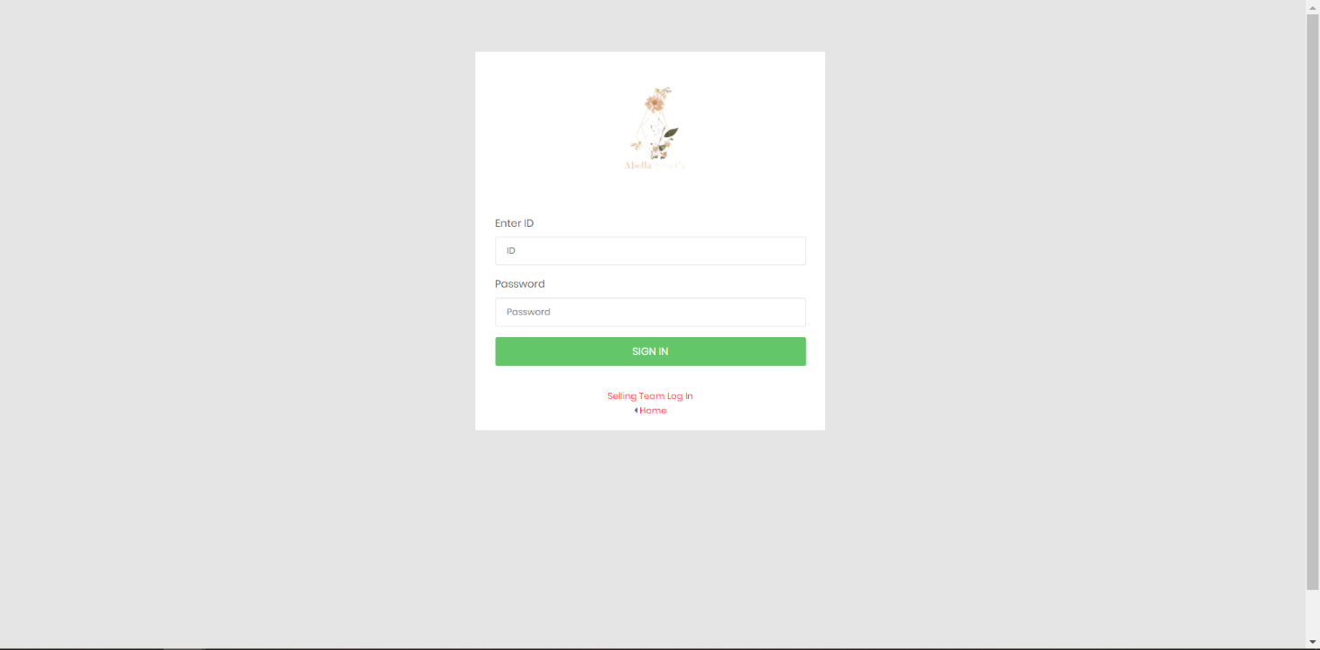

Figure 20: Management Staff Log In page

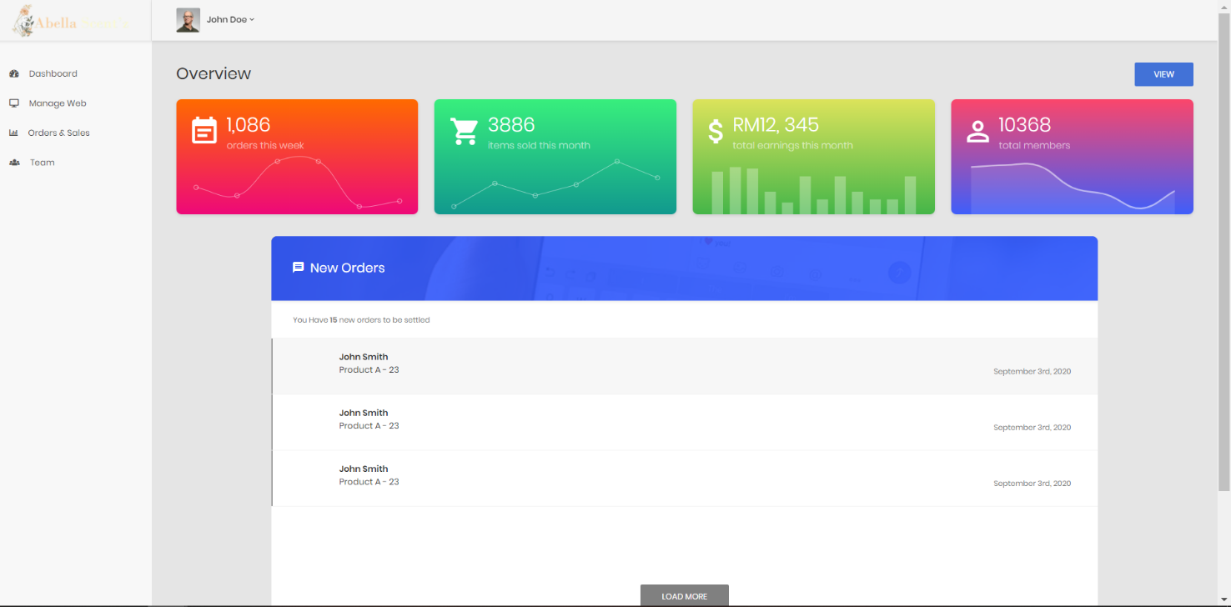

Figure 21: Management Staff Dashboard page

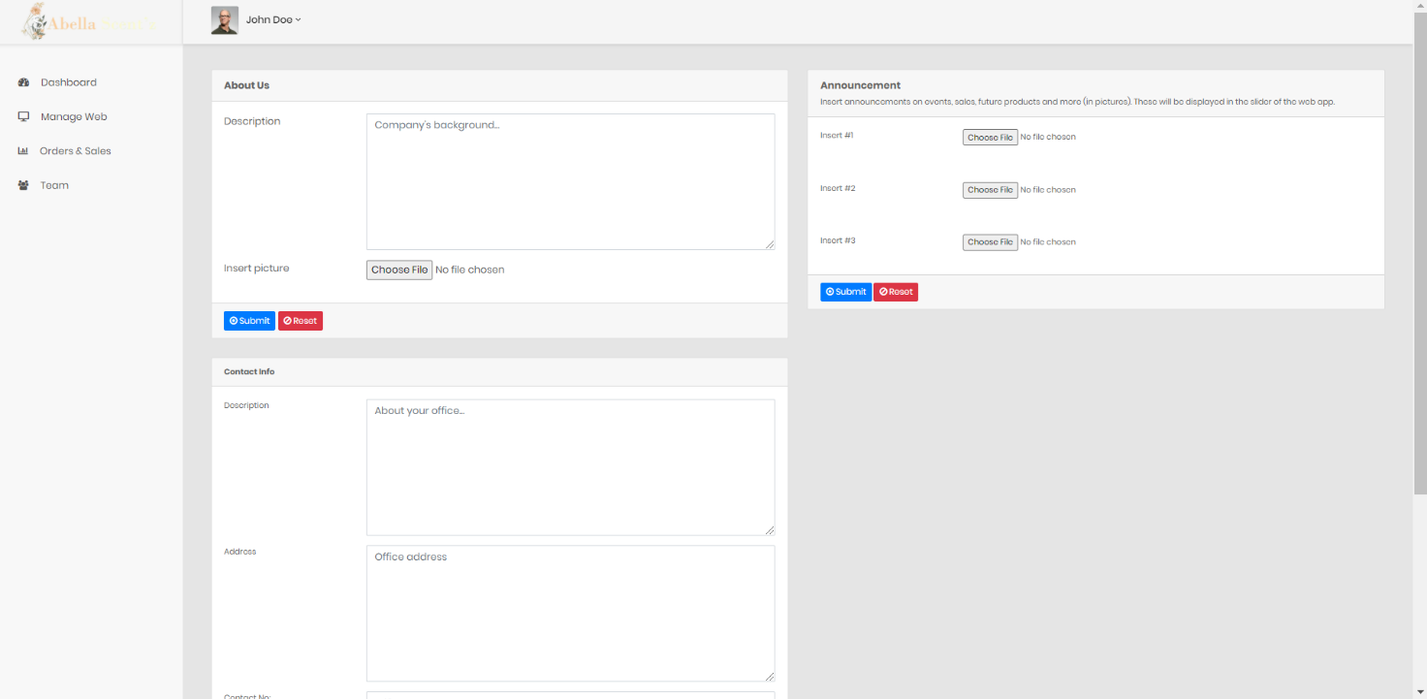

Figure 22: Manage Web - Basic Info page

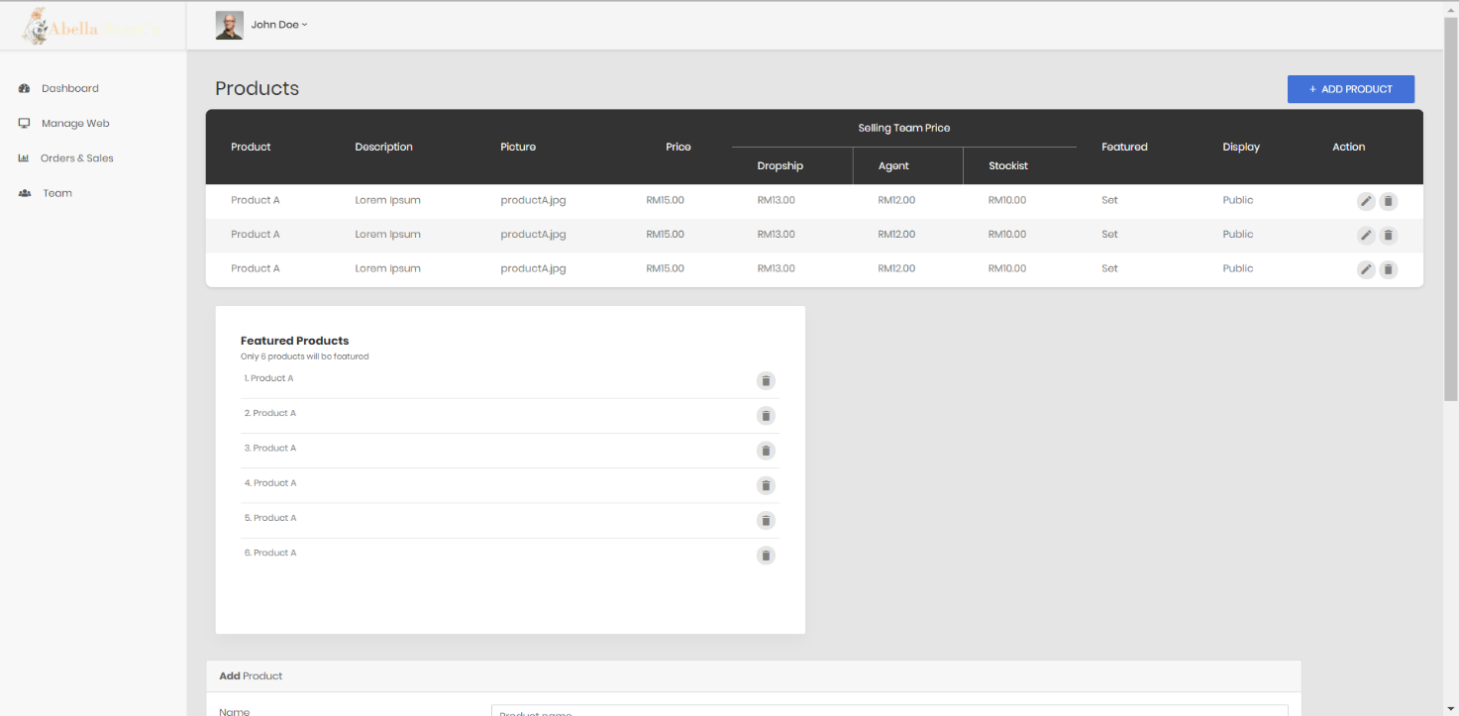

Figure 23: Manage Web - Product Info page (part 1)

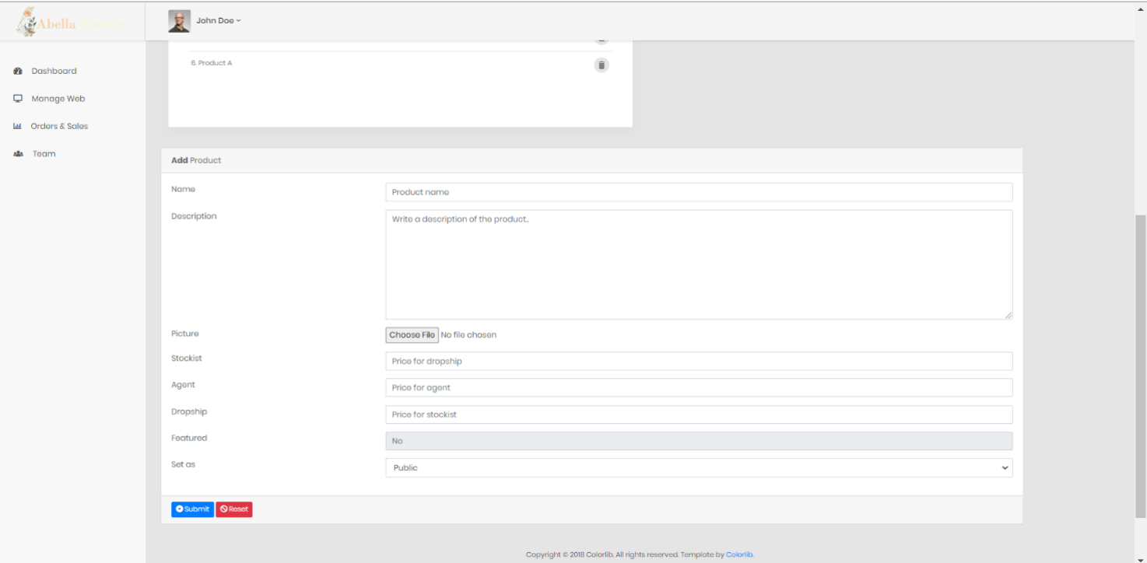

Figure 24: Manage Web - Product Info page (part 2)

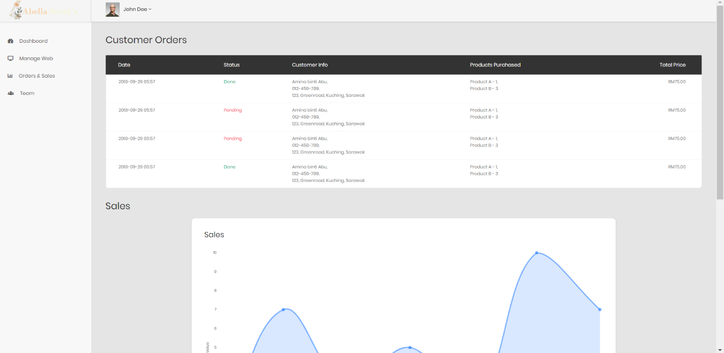

Figure 25: Orders & Sales page (part 1)

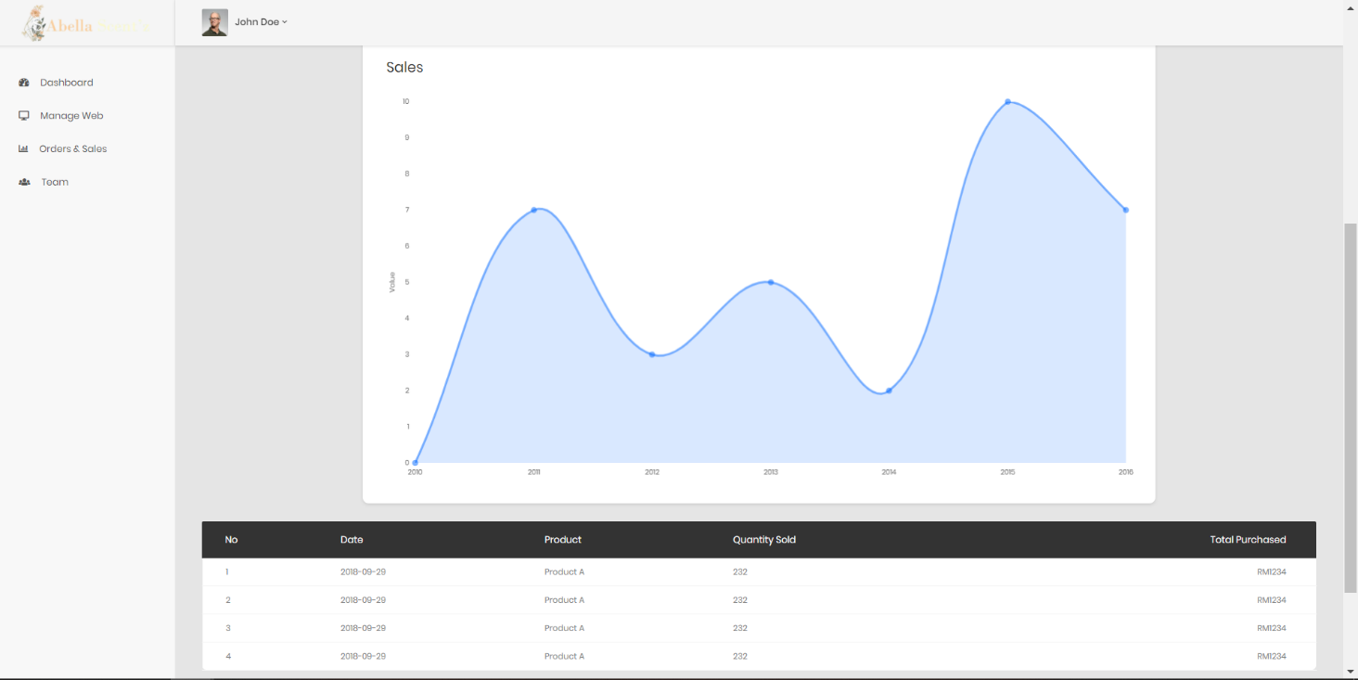

Figure 26: Orders & Sales page (part 2)

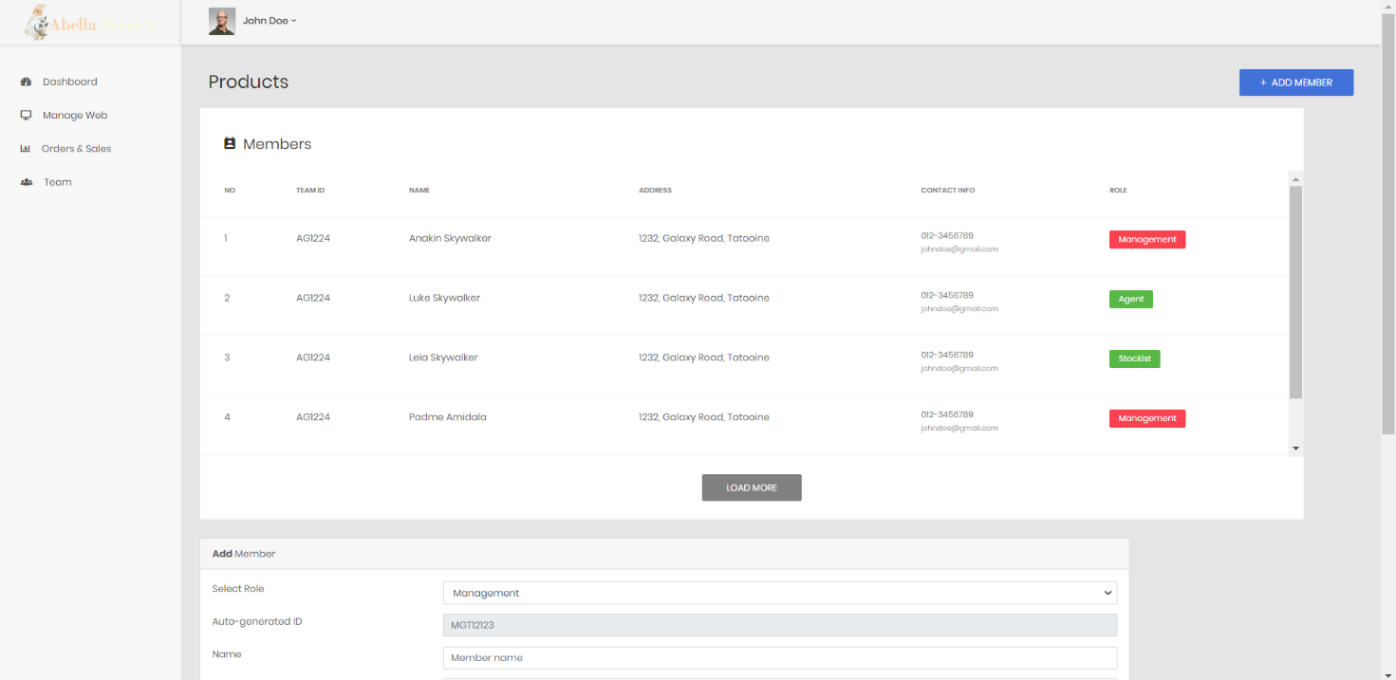

Figure 27: Management Team page (part 1)

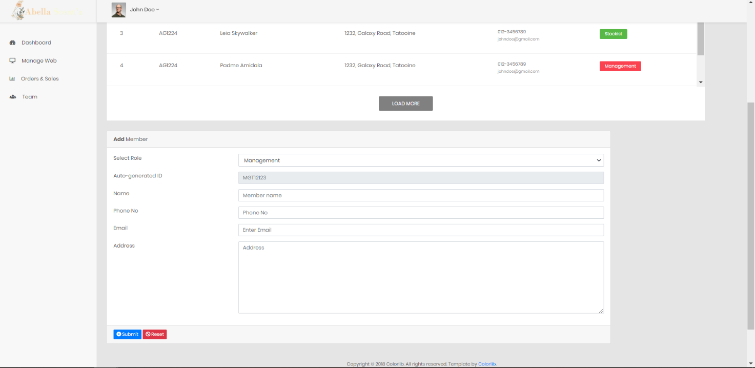

Figure 28: Management Team Page (part 2)

### Hardware Interfaces

All browsers such as Firefox Mozilla, Google Chrome, Microsoft Edge or Safari are compatible for access and run the Abella Scent’z Web Application. The device that can run and access to the app should be Personal Computer, smartphones, tablet, laptop or any device that installed the browsers application. For recommendation, the web application should be accessed using a Personal Computer or laptop which has better revolution compared to other devices.  When running the Abella Scent’z web application, there will be interrelation between software interface and the hardware interface such as monitor, keyboard, mouse, printer or touchscreen for mobile devices to input and output the information needed.

The Abella Scent’z Web Application has great compatibility with all devices and can be run as long as the device has a web browser application installed in the device and also has a stable internet connection.

### Software Interfaces

The Abella Scent’z Web Application will be developed using web application programming languages. There are two sections involved in developing a web application which is front-end section, more to Graphic User Interface, and back-end section, more to database management. The front-end section will be developed using HTML, JavaScript, CSS, template and Bootstrap CSS framework. Meanwhile for the back-end section, the programming language is more to scripting language, PHP, and MySQL for database management systems. Currently this type of programming and framework language is widely used to develop a web application.  By using this programming language, mostly the system will be able to run all available devices that provide the compatible web browser application such as Google Chrome, Safari and other applications. The web application needed to be able to run on the cross platform which is compatible with current operating systems such as Windows, Linux, Apple iOS and Android OS.

### Communications Interfaces

Communication interface for the Abella Scent’z web application is really important to make sure the web can be accessed. All devices that want to run the web application need to have a web browser and a stable internet connection so it can cooperate with the web server to communicate with the TCP/IP (Transmission Control Protocol / Internet Protocol) as a client-server system. The database which will be used by the end user to display, process and store the data will use HTTP (Hypertext Transfer Protocol). The client (a browser) will send an HTTP request to the other end user which is Abella Scent’z Web Application. Then, the Abella Scent’z web application will receive the request for the server running the web application to proceed the necessary process.

In the Email functionality for both end users (customer and employee), SMTP (Simple Mail Transfer Protocol) will be used.  PHPMailer will be incorporated to send the emails safely and easily via PHP code from the web browser using the web application.

In the contact section, there will be a form displaying on the web and customers need to fill in the necessary information. If the customer completes the form, they can proceed to the next step by clicking the submit button and the customer information will directly send to the Abella Scent’z official email address using the PHPMailer which it will incorporate with the PHP codes in response to SMTP.

## Functional Requirements

### Customer view product info

#### Stimulus/Response Sequence

Table 2: Response Sequence for Customer View Product Info

|  |  |
| --- | --- |
| Use Case | View Product |
| Short Description | To allow customers view a detail product info |
| Actor(s) | Customer |
| Pre-condition(s) | A device with compatible browser is needed with a stable internet connection |
| Post-condition(s) | N/A |
| Main Flow | 1. Customer clicks on “Products” on the navigation bar located at the top right 2. The customer then directed to the products page that display all the product list and info including picture and price 3. The customer clicks the product name, then it will be directed to the product description page (A1) 4. The customer can click the similar product that displayed at the bottom to see the other product info |
| Alternative Flow(s) | (A1) The customer can click picture of the product to display product info |
| Exception Flow(s) | N/A |

#### Direct Functional Requirements

Table 3: Direct Functional Requirement for Customer View Product Info

|  |  |
| --- | --- |
| Requirement | Description |
| REQ-1 | The system is able to display the dashboard and the product information pages. |

### Customer Can View Company’s info

#### Stimulus/Response Sequence

Table 4: Response Sequence for Customer View Company Info

|  |  |
| --- | --- |
| Use Case | View Company Info |
| Short Description | To allow user to know about the company information |
| Actor(s) | Customer |
| Pre-condition(s) | A device with compatible browser is needed with a stable internet connection |
| Post-condition(s) | The customer can view the details about company information in the web application. |
| Main Flow | 1. Customer clicks on “More” on the navigation bar located at the top right, then clicks on “About Us” (A1) 2. The customer then directed to the company information pages 3. The customer can read company background and also the company social media such as Facebook |
| Alternative Flow(s) | (A1) Click on the “About us” on the footer web application |
| Exception Flow(s) | N/A |

#### Direct Functional Requirements

Table 5: Direct Functional Requirement fo Customer View Company Info

|  |  |
| --- | --- |
| Requirement | Description |
| REQ-1 | The system is able to display the dashboard and the company information pages. |

### Customer Can Purchase product(s)

#### Stimulus/Response Sequence

Table 6: Response Sequence for Customer Purchase Product

|  |  |
| --- | --- |
| Use Case | Purchase Product(s) |
| Short Description | To allow the customers to purchase Abella Trigona products from the website |
| Actor(s) | Customer |
| Pre-condition(s) | A device with compatible browser is needed with a stable internet connection |
| Post-condition(s) | The customer successfully adds the products to the checkout |
| Main Flow | 1. Customer clicks on “Products” on the navigation bar located at the top right 2. The customer then directed to the products page that display all the product list and info including picture and price 3. The customer clicks the picture or product name then it will be directed to the product description 4. Customer clicks on “Products” on the navigation bar located at the top right 5. The customer then directed to the products page that display all the product list and info including picture and price 6. The customer clicks the picture or product name then it will be directed to the product description 7. The customer selects total quantity then click “add to cart” button 8. The product selected will be available on the cart. |
| Alternative Flow(s) | N/A |
| Exception Flow(s) | N/A |

#### Direct Functional Requirements

Table 7: Direct Functional Requirement for Customer Purchase Product

|  |  |
| --- | --- |
| Requirement | Description |
| REQ-1 | The system is able to allow the customer to add Abella Scent’z products |
| REQ-2 | The system is able to allow the customer to remove products from the cart. |
| REQ-3 | The system is able to display Abella Scent’z products on the purchase products page. |
| REQ-4 | The system is able to save the customer’s billing information and payment transaction to the database. |

### Customer Checkout

#### Stimulus/Response Sequence

Table 8: Response Sequence for Customer Checkout

|  |  |
| --- | --- |
| Use Case | Checkout Product(s) |
| Short Description | To allow user to checkout a placed order earlier |
| Actor(s) | Customer |
| Pre-condition(s) | A device with compatible browser is needed with a stable internet connection and enough money balance in bank |
| Post-condition(s) | The customer successfully checkout the product that they want to buy |
| Main Flow | 1. Customer clicks on “Checkout” on the navigation bar located at the top right 2. The customer will be directed to the checkout page 3. The cart page displays all products purchased that have been added 4. The checkout page displays customer details billing information such as name, ID, phone, address etc which they can change except for the ID information. The customer also can choose the shipping option and payment option they preferred. 5. Then, the customer clicks on the “Confirm Purchase” button and directs to the online payment gateways. [E1] (A1) 6. After the customer finishes the payment, they will be redirected to the main landing page of Abella Scent’z web application. [E2] 7. The customer will receive an email from the Abella Scent’z web application about the purchase receipt. |
| Alternative Flow(s) | (A1) The customer can click on the “Continue Shopping” button, the system will redirect to the agent purchase product page. |
| Exception Flow(s) | [E1] The customer cancels the payment, use case will stop and the customer directed to the checkout page.  [E2] Not enough balance in the customer bank account that led to the payment will be invalid and the customer directed to the checkout page. |

#### Direct Functional Requirements

Table 9: Direct Functional Requirement for Customer Checkout

|  |  |
| --- | --- |
| Requirement | Description |
| REQ-1 | The system is able to allow the agent to add Abella Scent’z products |
| REQ-2 | The system is able to allow the agent to remove products from the cart. |
| REQ-3 | The system is able to display Abella Scent’z products on the purchase products page. |
| REQ-4 | The system is able to save the agent’s billing information and payment transaction to the database. |
| REQ-5 | The system is able to retrieve data from the database. |

### Selling Team Can Log In

#### Stimulus/Response Sequence

Table 10: Response Sequence for Selling Team Log In

|  |  |
| --- | --- |
| Use Case | Log In |
| Short Description | To allow the agent logs into the system |
| Actor(s) | Selling Team |
| Pre-condition(s) | 1. The agent required a device which has installed a web browser and a stable internet. 2. The agent should be able login to the agent page successfully. 3. An agent should already sign up or register as an agent and they are registered agents for Abella Trigona. |
| Post-condition(s) | An agent successfully login and be redirected to the agent website pages. |
| Main Flow | 1. An agent clicks on the login button located at the top right. 2. An agent will be redirected to the login pages that display the ID/username and password. 3. An agent should fill in the ID/username and password information then proceed to press the “Submit” button. [E1] 4. An agent will be logged into the system. 5. An agent redirected to the agent website. |
| Alternative Flow(s) | N/A |
| Exception Flow(s) | (E1) An agent forgot their ID/Username and password to login and thus make them seek support from the developer to retrieve their login credentials information. |

#### Direct Functional Requirements

Table 11: Direct Functional Requirement for Selling Team Log In

|  |  |
| --- | --- |
| Requirement | Description |
| REQ-1 | The system required the login pages to display necessary credentials information to make sure the login process can proceed for the agent. |
| REQ-2 | The system has registered agent database |

### Selling Team View Company’s Info

#### Stimulus/Response Sequence

Table 12: Response Sequence for Selling Team View Company Info

|  |  |
| --- | --- |
| Use Case | View Company Info |
| Short Description | To allow user to know about the company information |
| Actor(s) | Selling Team |
| Pre-condition(s) | 1. Registered agent of Abella Trigona 2. Have a device which has a web browser and stable internet connection. 3. Successfully logged into the system. |
| Post-condition(s) | An agent can view the details about company information in the web application. |
| Main Flow | 1. An agent successfully logs in to the system. 2. An agent clicks on “More” on the navigation bar located at the top right, then clicks on “About Us”. (A1) 3. An agent then directed to the company information pages 4. An agent can read company background and also the company social media such as Facebook |
| Alternative Flow(s) | (A1) Click on the “About us” on the footer web application |
| Exception Flow(s) | N/A |

#### Direct Functional Requirements

Table 13: Direct Functional Requirement for Selling Team View Company Info

|  |  |
| --- | --- |
| Requirement | Description |
| REQ-1 | The system already saves a registered agent of Abella Trigona. |
| REQ-2 | The system is able to display the dashboard and the company information pages. |

### Selling Team View Product(s) info

#### Stimulus/Response Sequence

Table 14: Response Sequence Selling Team View Product(s) Info

|  |  |
| --- | --- |
| Use Case | View Product |
| Short Description | The allow user to view a details products info |
| Actor(s) | Customer |
| Pre-condition(s) | 1. Registered agent of Abella Trigona 2. Have a device which has a web browser and stable internet connection. 3. Successfully logged into the system. |
| Post-condition(s) | An agent can view the details about company information in the web application. |
| Main Flow | 1. An agent successfully logs into the system. [E1] 2. An agent will redirect to the agent dashboard. 3. An agent clicks on “Products” on the navigation bar located at the top right 4. The customer then directed to the products page that display all the product list and info including picture and price 5. An agent clicks the picture or product name then it will be directed to the product description. |
| Alternative Flow(s) | N/A |
| Exception Flow(s) | [E1] An agent forgot their ID/Username and password to login and thus make them seek support from the developer to retrieve their login credentials information. |

#### Direct Functional Requirements

Table 15: Direct Functional Requirement for Selling Team View Product(s) Info

|  |  |
| --- | --- |
| Requirement | Description |
| REQ-1 | The system already has a registered agent of Abella Trigona. |
| REQ-2 | The system is able to display the dashboard and the product information pages. |

### Selling Team Can Purchase Product(s)

#### Stimulus/Response Sequence

Table 16: Response Sequence for Selling Team Purchase Product(s)

|  |  |
| --- | --- |
| Use Case | Purchase Product |
| Short Description | To allow an agent to purchase products with lower price compared to customer’s price |
| Actor(s) | Selling Team |
| Pre-condition(s) | 1. Registered agent of Abella Trigona. 2. Have a device which has a web browser and stable internet connection. 3. Successfully logged into the system. |
| Post-condition(s) | An agent can purchase the products they wanted on the Abella Scent’z web application successfully. |
| Main Flow | 1. An agent successfully logs into the system. [E1] 2. An agent clicks on the “Products” button on the left navigation bar. 3. Then, the agent redirected to the purchase products pages and the page displayed the company current products that were being offered for them with picture, short description, price and other product details. 4. The agent clicks on the “Add to cart” button for products they want to purchase which make an agent redirect to the product’s detailed information page. The page will display the product information and the agent can view the information. (A1) 5. The agent will select the product quantity they required and proceed clicks on the “Add to cart” button displayed. 6. The product selected will be available on the cart. 7. Then, the agent clicks on the cart logo at the top right navigation bar and redirects to the cart page which content the products they purchased. 8. The cart page displays all products purchased that have been added and the agent clicks on the “Checkout” button. The agent will be directed to the checkout page. [E2] 9. The checkout page displays agent details billing information such as name, ID, phone, address etc which they can change except for the ID information. An agent also can choose the shipping option and payment option they preferred. [E3] 10. Then, the agent clicks on the “Confirm Purchase” button and directs to the online payment gateways. [E4] 11. After an agent finishes the payment, they will be redirected to the main landing page of Abella Scent’z web application. 12. An agent will receive an email from the Abella Scent’z web application about the purchase receipt. |
| Alternative Flow(s) | (A1) The agent can click on the “Continue Shopping” button, the system will redirect to the agent purchase product page. |
| Exception Flow(s) | [E1] An agent forgot their ID/Username and password to login and thus make them seek support from the developer to retrieve their login credentials information.  [E2] The agent can delete the unwanted products from the cart by clicking the “Delete item” button.  [E3] An agent clicks on the “Edit” button for changing the agent information and then an agent clicks on the “Save” button to save it.  [E4] Not enough balance in the agent bank account that led to the payment will be invalid and the customer directed to the checkout page. |

#### Direct Functional Requirements

Table 17: Direct Functional Requirement for Selling Team Purchase Product(s)

|  |  |
| --- | --- |
| Requirement | Description |
| REQ-1 | The system is able to allow the agent to add Abella Scent’z products |
| REQ-2 | The system is able to allow the agent to remove products from the cart. |
| REQ-3 | The system is able to display Abella Scent’z products on the purchase products page. |
| REQ-4 | The system is able to save the agent’s billing information and payment transaction to the database. |
| REQ-5 | The system is able to retrieve data from the database. |
| REQ-6 | The system has lowered the product price for the agent |

### Selling Team Can View Commission Sales

#### Stimulus/Response Sequence

Table 18: Response Sequence for Selling Team View Commission Sales

|  |  |
| --- | --- |
| Use Case | View Commission Sales |
| Short Description | To allow an agent to view total sales and reward they get from the purchase customers made through the respective agent’s link |
| Actor(s) | Selling Team |
| Pre-condition(s) | 1. Registered agent of Abella Trigona. 2. Have a device which has a web browser and stable internet connection. 3. Successfully logged into the system. |
| Post-condition(s) | An agent can view the commission sales they get from Abella Trigona. |
| Main Flow | 1. An agent successfully login to their own agent page. [E1] 2. The agent clicks the “Sales” on the navigation bar, and it will redirect to the commission sales details information. (A1) 3. The pages display the total sales agent gets 4. An agent also can view the rewards they get from customer purchases through the respective agent link. |
| Alternative Flow(s) | (A1) Selling team clicks on the “View” on the top right dashboard pages and the system will redirect them to the sales page. |
| Exception Flow(s) | (E1) An agent forgot their ID/Username and password to login and thus make them seek support from the developer to retrieve their login credentials information. |

#### Direct Functional Requirements

Table 19: Direct Functional Requirement for Selling Team View Commission Sales

|  |  |
| --- | --- |
| Requirement | Description |
| REQ-1 | The system already saves a registered agent of Abella Trigona. |
| REQ-2 | The agent must share their link to the customer which auto generates by the system web application. |

### Selling Team Can View Performance Sales

#### Stimulus/Response Sequence

Table 20: Response Sequence for Selling Team View Performance Sales

|  |  |
| --- | --- |
| Use Case | View performance sales |
| Short Description | To allow agents to view information sheets of the sales they archived. |
| Actor(s) | Selling Team |
| Pre-condition(s) | 1. Registered agent of Abella Trigona. 2. Have a device which has a web browser and stable internet connection. 3. Successfully logged into the system. |
| Post-condition(s) | An agent can view the details about their performance sales they archived from the customer using their link. |
| Main Flow | 1. An agent successfully logged into the website system. [E1] 2. The agent will be redirected to the dashboard agent. 3. An agent clicks on the “Sales” button and will be redirected to the sales page. (A1) 4. The pages display the details in table, graph and chart the sales they archived. |
| Alternative Flow(s) | (A1) Selling team clicks on the “View” on the top right dashboard pages and the system will redirect them to the sales page. |
| Exception Flow(s) | [E1] An agent forgot their ID/Username and password to login and thus make them seek support from the developer to retrieve their login credentials information. |

#### Direct Functional Requirements

Table 21: Direct Functional Requirement for Selling Team View Performance Sales

|  |  |
| --- | --- |
| Requirement | Description |
| REQ-1 | The system already registered an agent of Abella Trigona information |
| REQ-2 | The system is able to display the agent dashboard. |
| REQ-3 | The system is able to display the performance sale page. |
| REQ-4 | The system is able to generate the graph, table and chart from the sales |
| REQ-5 | The system is able retrieve database information |

### Selling Team Can View Team Hierarchy

#### Stimulus/Response Sequence

Table 22: Response Sequence for Selling Team View Hierarchy

|  |  |
| --- | --- |
| Use Case | View Team Hierarchy |
| Short Description | To allow every agent to view their own respective team hierarchy. |
| Actor(s) | Selling Team |
| Pre-condition(s) | 1. Registered agent of Abella Trigona 2. Have a device which has a web browser and stable internet connection. 3. Successfully logged into the system. |
| Post-condition(s) | An agent can view the details about the whole information selling team and which team hierarchy they are. |
| Main Flow | 1. An agent successfully logs into the system. [E1] 2. The agent will be redirected to the agent dashboard. 3. An agent clicks on the “Team” button on the right-side navigation bar. (A1) 4. An agent will be redirected to the team hierarchy pages. 5. The system will display the team hierarchy information. |
| Alternative Flow(s) | (A1) An agent clicks the “Team” on the footer of a web application. |
| Exception Flow(s) | [E1] An agent forgot their ID/Username and password to login and thus make them seek support from the developer to retrieve their login credentials information. |

#### Direct Functional Requirements

Table 23: Direct Functional Requirement for Selling Team View Hierarchy

|  |  |
| --- | --- |
| Requirement | Description |
| REQ-1 | The system already has a registered agent of Abella Trigona. |
| REQ-2 | The system is able to display the agent dashboard. |
| REQ-3 | The system is able to display the team hierarchy page. |

### Selling Team Can Change Password

#### Stimulus/Response Sequence

Table 24: Response Sequence Change Password for Selling Team

|  |  |
| --- | --- |
| Use Case | Change Password |
| Short Description | To allow an agent to change password any time. |
| Actor(s) | Selling Team |
| Pre-condition(s) | 1. Registered agent of Abella Trigona 2. Have a device which has a web browser and stable internet connection. 3. Successfully logged into the system. |
| Post-condition(s) | An agent can change the password anytime they want and save the information successfully. |
| Main Flow | 1. An agent successfully logs into the website system. [E1] 2. An agent clicks the “Change Password” button on the below agent link. 3. The system will redirect the agent to the change password section. 4. An agent will fill up the necessary information before changing the password to identify the user. 5. An agent clicks the “Submit” button to save the password. [E2] [E3] 6. An agent will receive email notification about a change of password. |
| Alternative Flow(s) | N/A |
| Exception Flow(s) | [E1] An agent forgot their ID/Username and password to login and thus make them seek support from the developer to retrieve their login credentials information.  [E2] An agent clicks on the “reset” button to reset all the fill up information.  [E3] An agent clicks on the “close” logo to close the section if an agent does not want to change the password. |

#### Direct Functional Requirements

Table 25: Direct Functional Requirement Change Password for Selling Team

|  |  |
| --- | --- |
| Requirement | Description |
| REQ-1 | The system already has a registered agent of Abella Trigona. |
| REQ-2 | The system is able to display the dashboard and manage profile pages. |

### Selling Team Can Manage Profile

#### Stimulus/Response Sequence

Table 26: Response Sequence Manage Profile for Selling Team

|  |  |
| --- | --- |
| Use Case | Manage profile |
| Short Description | To allow agents to manage their profile. |
| Actor(s) | Selling Team |
| Pre-condition(s) | 1. Registered agent of Abella Trigona 2. Have a device which has a web browser and stable internet connection. 3. Successfully logged into the system. |
| Post-condition(s) | An agent can manage profiles anytime they want and save the information successfully. |
| Main Flow | 1. An agent successfully logs into the website system. [E1] 2. An agent will redirect to the agent dashboard. 3. An agent clicks the “Account” button on the left navigation bar that displays an agent’s name and redirects to agent profile pages. 4. Then, the system displays the agent’s ID, Name, Phone Number, Address and the agent’s link. 5. An agent can view and edit the profile. 6. An agent clicks on the “Edit” logo right top profile card section. 7. An agent can edit and input necessary information for the profile except the ID, role and link. 8. An agent clicks on the “Submit” button to save the change in profile. [E2] [E3] |
| Alternative Flow(s) | N/A |
| Exception Flow(s) | [E1] An agent forgot their ID/Username and password to login and thus make them seek support from the developer to retrieve their login credentials information.  [E2] An agent clicks on the “reset” button to reset all the fill up information.  [E3] An agent clicks on the “Close” logo on top right section to close the section if an agent does not want to change the password. |

#### Direct Functional Requirements

Table 27: Direct Functional Requirement Manage Profile for Selling Team

|  |  |
| --- | --- |
| Requirement | Description |
| REQ-1 | The system is able to retrieve registered agents of Abella Trigona. |
| REQ-2 | The system is able to display the dashboard and manage profile pages. |
| REQ-3 | The system is able to save the adding and changing information made by the agent in the database system. |

### Management Staff Can Log In

#### Stimulus/Response Sequence

Table 28: Response Sequence Log in for Management Staff.

|  |  |
| --- | --- |
| Use Case | Log In |
| Short Description | To allow management staff to log in to the website system. |
| Actor(s) | Management Staff |
| Pre-condition(s) | 1. Have a device which has a web browser and stable internet connection. 2. Successfully logged into the system. |
| Post-condition(s) | Management staff successfully logged into the management system. |
| Main Flow | 1. Management staff clicks on the login button located at the top right. 2. Management staff will be redirected to the login pages for agents that display the ID/username and password. 3. Management staff choose and click on the “Admin” button below the “submit” button for agents. 4. Management staff will be redirected to the special login pages for management staff that display the ID/username and password. 5. Management staff should fill in the ID/username and password information then proceed to press the “Submit” button. [E1] 6. Management staff will be logged into the system. 7. Management staff redirected to the agent website. |
| Alternative Flow(s) | N/A |
| Exception Flow(s) | [E1] Management staff forgot their ID/Username and password to login and thus make them seek support from the developer to retrieve their login credentials information. |

#### Direct Functional Requirements

Table 29: Direct Functional Requirement Log In for Management Staff

|  |  |
| --- | --- |
| Requirement | Description |
| REQ-1 | The system has a login page that displays the required information needed for management staff to proceed login on their own page. |
| REQ-2 | The system is already registered the management staff |

### 3.2.15 Management Staff Can Manage Product Info

#### 3.2.15.1 Stimulus/Response Sequence

Table 30: Response Sequence Manage Product Info for Management Staff.

|  |  |
| --- | --- |
| Use Case | Manage product info |
| Short Description | To allow management staff to manage product info in the website system. |
| Actor(s) | Management Staff |
| Pre-condition(s) | 1. Registered as management staff of Abella Trigona. 2. Have a device which has a web browser and stable internet connection. 3. Successfully logged into the system. |
| Post-condition(s) | An agent can manage the product information in the Abella Scent’z’s web application. |
| Main Flow | 1. Management staff log into the website system. [E1] 2. The management staff will be redirected to the staff dashboard and click the “manage product” button on the left side bar. 3. The management staff will be redirected to the product info page which content the picture, description, price and other details. 4. The management can view all the product information on the manage product page. 5. The management staff can manage the product info by inserting new product information, price for the selling team and commission for the selling team by clicking the “Add new” button in the section they want, then clicks the “Save” button.[E2] 6. Then, management staff also can edit the current product information, price for the selling team and commission for the selling team by clicking the “Edit” button in each section they want, then clicks the “Save” button.[E2] 7. The management staff also can delete the current product information, price for the selling team and commission for the selling team by clicking the “Delete” button in each section they want, then clicks the “Save” button. |
| Alternative Flow(s) | N/A |
| Exception Flow(s) | [E1] Management staff forgot their ID/Username and password to login and thus make them seek support from the developer to retrieve their login credentials information.  [E2] Management staff add and edit the existing information which error message will display when clicked on the “Save” button. |

#### Direct Functional Requirements

Table 31: Direct Functional Requirement Manage Product Info for Management Staff

|  |  |
| --- | --- |
| Requirement | Description |
| REQ-1 | The system is able to retrieve data from databases for registered management staff. |
| REQ-1 | The system is able to display the product info page in a web application. |
| REQ-2 | The system is able to save the adding and changing information made by management staff in the database system. |

### Management Staff Can Manage Company Info

#### Stimulus/Response Sequence

Table 32: Response Sequence Manage Company Info for Management Staff

|  |  |
| --- | --- |
| Use Case | Manage Company info |
| Short Description | To allow management staff to manage company info in the website system. |
| Actor(s) | Management Staff |
| Pre-condition(s) | 1. Registered management staff of Abella Trigona. 2. Have a device which has a web browser and stable internet connection. 3. Successfully logged into the system. |
| Post-condition(s) | Every change regarding the company information made by management staff will be saved and carried upon towards the Abella Scent’z web application. |
| Main Flow | 1. The management staff successfully logs into the system by using the admin page link and redirects to the dashboard of management staff page. 2. The management staff clicks on the “Manage Company Info” button at the left side navigation bar and the system will redirect to the company info page. 3. The system displays the company info pages and the management staff can view the content. 4. The management staff can manage company information such as contact info and about us. 5. Then, the management staff can manage to insert new information about the contact info and about us by clicking the “Add” button in the section they want, then clicks the “Save” button. [E2] 6. The management staff can manage to edit current information about the contact info and about us by clicking the “Edit” button in the section they want, then clicks the “Save” button. [E2] 7. The management staff can manage to delete information about the contact info and about us by clicking the “Delete” button in the section they want, then clicks the “Save” button. |
| Alternative Flow(s) | N/A |
| Exception Flow(s) | [E1] Management staff forgot their ID/Username and password to login and thus make them seek support from the developer to retrieve their login credentials information.  [E2] Management staff add and edit the existing information which error message will display when clicked on the “Save” button. |

#### Direct Functional Requirements

Table 33: Direct Functional Requirement

|  |  |
| --- | --- |
| Requirement | Description |
| REQ-1 | The system is able to display the product info page in a web application. |
| REQ-2 | The system is able to save the adding and changing information made by management staff in the database system. |

### Management Staff Can Manage Order Received

#### Stimulus/Response Sequence

Table 34: Response Sequence Manage Order Receive for Management Staff

|  |  |
| --- | --- |
| Use Case | Manage order received |
| Short Description | To allow management staff to manage orders received in the website system. |
| Actor(s) | Management Staff |
| Pre-condition(s) | 1. Registered as management staff of Abella Trigona. 2. Have a device which has a web browser and stable internet connection. 3. Successfully logged into the system. |
| Post-condition(s) | Every change regarding the order recovered made by customer and managed by the management staff will be saved and carried upon towards the Abella Scent’z web application. |
| Main Flow | 1. The management staff successfully logs into the website system using the admin login. [E1] 2. The management staff will be redirected to the dashboard page. 3. The management staff then go to the left section of the navigation bar and click the “Order Received” button. 4. Then, it will redirect the management staff to the order page. 5. The management staff are able to view customer’s orders based on the order they received recently and delete the history list of previous orders which have been successfully delivered. |
| Alternative Flow(s) | N/A |
| Exception Flow(s) | [E1] Management staff forgot their ID/Username and password to login and thus make them seek support from the developer to retrieve their login credentials information. |

**3.2.17.2 Direct Functional Requirements**

Table 35: Direct Functional Requirement Manage Order Receive for Management Staff

|  |  |
| --- | --- |
| Requirement | Description |
| REQ-1 | The system is able to display the product info page in a web application. |
| REQ-2 | The system is able to save the adding and changing information made by management staff in the database system. |
| REQ-3 | The system is able to retrieve data from databases for registered management staff. |

### Management Staff Can Add New Member

#### Stimulus/Response Sequence

Table 36: Response Sequence for Management Staff Add New Member

|  |  |
| --- | --- |
| Use Case | Add new member |
| Short Description | To allow management staff to add new selling team info in the website system. |
| Actor(s) | Management Staff |
| Pre-condition(s) | 1. Registered as management staff of Abella Trigona. 2. Have a device which has a web browser and stable internet connection. 3. Successfully logged into the system. |
| Post-condition(s) | Every new member added by the management staff will be saved and carried upon towards the Abella Scent’z web application |
| Main Flow | 1. Management staff successfully logs into the system. [E1] 2. The system will be redirected to the dashboard page. 3. Management staff clicks on the “Team” button at the right-side navigation bar and redirects to the team hierarchy pages. 4. Management staff clicks the “Add member” button on the right top page and redirect to the add member page. 5. The system displays the add member pages and management staff view the details of the page. 6. The management staff can add management staff and selling teams such as agent, stockist and dropship agent. 7. The management staff fill up the necessary information about that individual. Then, they will create the account for the new members. 8. The management staff clicks on the “Add” button, then directed to pages which will display the auto generated username, Id and password for the new members. 9. The auto generate pages will display the username, Id and password to the management staff. 10. The management staff clicks on the “Okay” button and popup a message “Successfully added a new member” display. [E2] 11. The management clicks on the “Okay” button on the display messages and they will be redirected to the add member pages. |
| Alternative Flow(s) | (A1) Management staff clicks the add member logo at the right top navigation bar. |
| Exception Flow(s) | [E1] Management staff forgot their ID/Username and password to login and thus make them seek support from the developer to retrieve their login credentials information.  [E2]Management staff get a popup error message “Please fill all the requirements” or “Please try again” which made them need to clicks on the “Okay” button to make them refill the empty place. |

#### Direct Functional Requirements

Table 37: Direct Functional Requirement Management Staff Add New Member

|  |  |
| --- | --- |
| Requirement | Description |
| REQ-1 | The system is able to display the management staff dashboard and add a member page in a web application. |
| REQ-2 | The system is able to save the adding and changing information made by management staff in the database system. |
| REQ-3 | The system is able to auto regenerate the username, ID and password for the new member. |
| REQ-4 | The system is able to retrieve data from databases for registered management staff. |

### Management Staff Can Change Password

#### Stimulus/Response Sequence

Table 38: Response Sequence Change Password for Management Staff

|  |  |
| --- | --- |
| Use Case | Change Password |
| Short Description | To allow the management staff to change passwords any time. |
| Actor(s) | Management staff |
| Pre-condition(s) | 1. Registered as management staff of Abella Trigona. 2. Have a device which has a web browser and stable internet connection. 3. Successfully logged into the system. |
| Post-condition(s) | Management staff can change the password anytime they want and save the information successfully. |
| Main Flow | 1. Management staff successfully logs into the website system. [E1] 2. Management clicks the “Change Password” button on the below agent link. 3. The system will redirect the agent to the change password section. 4. Management staff will fill up the necessary information before changing the password to identify the user. 5. Management staff clicks the “Submit” button to save the password. [E2] [E3] 6. Management staff will receive email notification about a change of password. |
| Alternative Flow(s) | N/A |
| Exception Flow(s) | [E1] Management staff forgot their ID/Username and password to login and thus make them seek support from the developer to retrieve their login credentials information.  [E2] Management staff clicks on the “reset” button to reset all the fill up information.  [E3] Management staff clicks on the “Close” logo on top right section to close the section if an agent does not want to change the password. |

#### Direct Functional Requirements

Table 39: Direct Functional Requirement Change Password for Management Staff

|  |  |
| --- | --- |
| Requirement | Description |
| REQ-1 | The system is able to retrieve data from databases for registered management staff. |
| REQ-2 | The system is able to display the dashboard and manage profile pages. |
| REQ-3 | The system already has a registered management staff of Abella Trigona. |

### Management Staff Can Manage Profile

#### Stimulus/Response Sequence

Table 40: Response Sequence Manage Profile for Management Staff

|  |  |
| --- | --- |
| Use Case | Manage profile |
| Short Description | To allow agents to manage their profile. |
| Actor(s) | Management staff |
| Pre-condition(s) | 1. Registered as management staff of Abella Trigona. 2. Have a device which has a web browser and stable internet connection. 3. Successfully logged into the system. |
| Post-condition(s) | Management staff can manage profiles anytime they want and save the information successfully. |
| Main Flow | 1. Management staff successfully logs into the website system. [E1] 2. Management staff will redirect to the agent dashboard. 3. Management staff clicks the “Account” button on the left navigation bar that displays an agent’s name and redirects to agent profile pages. 4. Then, the system displays the staff’s ID, Name, Phone Number, and Address. 5. Management staff can view and edit the profile. 6. Management staff clicks on the “Edit” logo right top profile card section. 7. Management staff can edit and input necessary information for the profile except the ID, role and link. 8. Management staff clicks on the “Submit” button to save the change in profile. [E2] [E3] |
| Alternative Flow(s) | N/A |
| Exception Flow(s) | [E1] Management staff forgot their ID/Username and password to login and thus make them seek support from the developer to retrieve their login credentials information.  E2] An agent clicks on the “reset” button to reset all the fill up information.  [E3] An agent clicks on the “close” logo to close the section if an agent does not want to change the password. |

#### Direct Functional Requirements

Table 41: Direct Functional Requirement Manage Profile for Management Staff

|  |  |
| --- | --- |
| Requirement | Description |
| REQ-1 | The system is able to save the management system of Abella Trigona. |
| REQ-2 | The system is able to auto generate the link by web application. |
| REQ-3 | The system already has a registered management staff of Abella Trigona. |
| REQ-4 | The system is able to display the dashboard and the product manage profile pages. |

## Behaviour Requirements

### Use Case View

Figure 29: Use Case Diagram for Abella Scent'z Web Application

The Abella Scent’z web application consists of 13 use cases and 3 actors which are Abella Scent’z customer, Abella Scent’z selling team and Abella Scent’z management staff. Customer and selling team are the main users of the web application. For the customer, they have functionalities such as view products, view company info and purchase products while for the selling team, they are able to log in to view commission sales, view team hierarchy and view company sales. In addition, they also can view products, view company info and purchase products same as customer functionalities.

For the management staff side, they are able to log in to manage product info and company info like delete, add, edit and view. Other than that, they are also able to add new members, manage orders including view orders received and update settled orders.

Below is the brief description of each use cases on the use case diagram:

1. **View products**: To allow customers and selling teams view a detailed product info.
2. **View company info**: To allow customers and selling teams to know about the company information.
3. **Purchase products:** To allow customers and selling teams to purchase Abella Trigona products from the website.
4. **Checkout:** To allow customers and selling teams to checkout a placed order earlier.
5. **Log in:** To allow selling teams and management staff to log into the system.
6. **View commission sales:** To allow selling teams to view total sales and  reward they get from the purchases customers made through the respective agent’s link View performance sales: To allow selling teams to view information sheets of the sales they archived.
7. **View Performance Sales:** To allow selling teams to view information sheets of the sales they archived.
8. **View team hierarchy:** To allow every selling teams view their own respective team hierarchy.
9. **Change Password:** To allow selling teams and management staff to change password any time.
10. **Manage Profile:** To allow selling teams and management staff to manage their profile.
11. **Manage product info:** To allow management staff to manage product info in the website system.
12. **Manage Ordered Received**: To allow management staff to manage orders received in the website system.
13. **Add a new member:** To allow management staff to add new selling team info in the website system.
14. **Manage company info:** To allow management staff to manage company info in the website system.

# Other Non-functional Requirements

## Performance Requirements

1. The software should be portable. Hence, using it on one operating system to another operating system does not create any problem.
2. Privacy of users’ information such as personal information, account information and transaction information should be audited and secured.
3. A website should be capable enough to handle a handful of users using the website at a time without any performance breakdown.
4. Users should complete the main action of the system with ease once they see the interface of website.
5. The website’s load time should not be unusable or not be more than one second for users.

## Safety and Security Requirements

* When the users are trying to make a transaction, the FPX system will ask them to complete security measurements such as entering captcha or ticking the ‘I am not a bot’ box. This will prevent from any harm from malwares or even unreliable users.
* Information transmission should be securely transmitted to server without any changes in information. Hence, proper webhosts or domain are used as it is more reliable in protecting data as it will transmit through the cloud.
* HTTPS protocol are used for the website as it is vital for ensuring secure communication between a web server and a client. It also improves the basic security standard as it reassures the users that all communication done between websites are secured.

## Software Quality Attributes

### Security

The main security concern is for users account hence proper login mechanism should be used to avoid hacking and sabotages from another user. Hence, security is provided from unwanted use of recognition.

### Usability

As the system is easy to handle in the most expected way with no delays, the users will have no problem during the navigation of the website. In that case, the programs are set accordingly and it also traverses quickly between it states.

### Reliability

The software system can be seen as reliable as the system produces low error rate. The error rate depends on the frequency of inputs and on the probability that an individual input will lead to an error.

### Efficiency

Efficiency is the ability of the software program to fulfil its purpose with the best possible utilization of all necessary resources. For example, the data storage of the users’ information and transaction should be save in the system for future uses.

Appendix A – Class Diagram

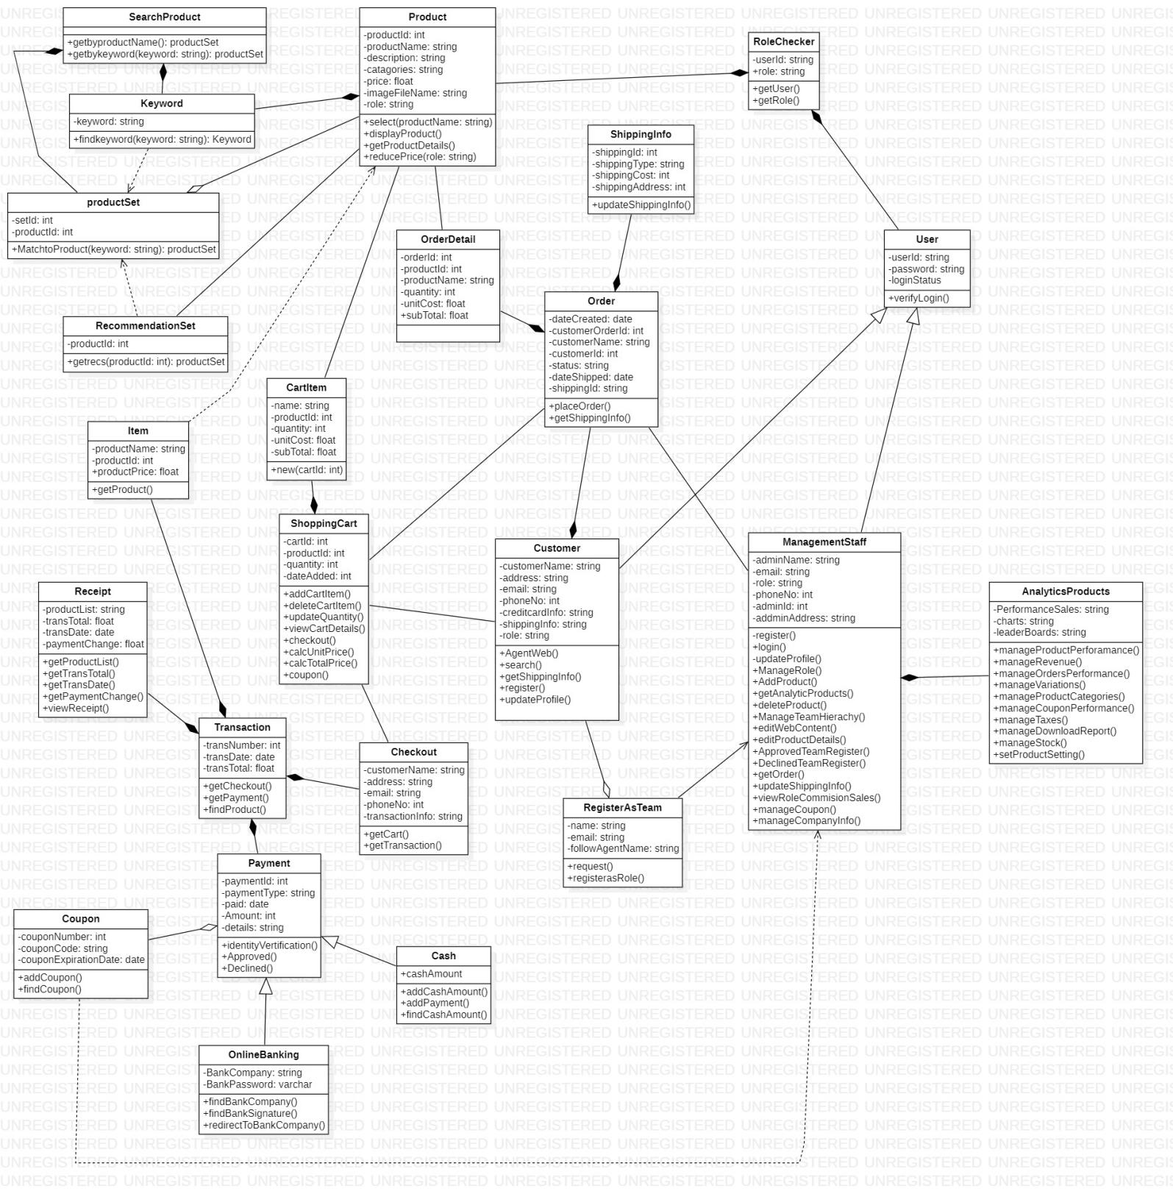

Figure 30 : Class Diagram Abella Scent’z

Appendix B - Group Log

## 

## TSP Student Information Sheet Mohamed Adzhar bin Zaidi

**Name:** Mohamed Adzhar bin Zaidi **Instructor:** Madam Nurfauza binti Jali

**Date:** 8th November 2020 **Number of College Credits:** 71

**Expected Graduation Date:** 03/2022 **Major:** Software Engineering (WC10)

**Briefly describe your relevant experience and interests:**

I worked on various projects from making a simple calculator to a sophisticated shopping website from my web-based project. I have learnt C, C++, Java, JavaScript, HTML and CSS. Even though I am not considered fluent in the languages I found the projects to be doable after a few trials and errors and in the end, it turned out to be a success.

**Briefly describe your work on other team projects:**

I have been a group leader and I always volunteer to be the one to compile documents and videos to make sure it is accurate because I trust in my quality management and my anxiety to make the project as close to the marking rubrics as possible because I think that most of the work will be useless if it does not follow the format that is already stated in the question.

**Briefly describe any leadership or management positions you have held (at work or in clubs/ organization):**

I have been a group leader in several projects that I worked on but I don’t see myself as someone who can lead a team but I prefer to be the one organizing the team and tell the leader on how to improve the team and the quality of the overall project.

**State your team preferences, if any:**

Someone who I am familiar with and know their work ethics.

|  |  |  |  |  |  |  |  |
| --- | --- | --- | --- | --- | --- | --- | --- |
| **List your class schedule and other times when you have scheduled activities such as work, clubs, sports teams, etc.** | | | | | | | |
| Time | Mon | Tues | Wed | Thurs | Fri | Sat | Sun |
| 0800-0900 | TMF3012 | TME3033 | BEU1023 |  |  |  |  |
| 0900-1000 | TMF3012 | TME3413 | BEU1023 |  |  |  |  |
| 1000-1100 | TMF3113 | MPU3122 | BEU1023 | GYM |  | GYM | GYM |
| 1100-1200 | TMF3113 | MPU3122 | GYM | GYM |  | GYM | GYM |
| 1200-1300 | TME3033 |  | GYM |  |  |  |  |
| 1300-1400 | TME3033 |  |  |  | TME3423 |  |  |
| 1400-1500 | TME3413 |  |  | TME3423 | TMF3113 |  |  |
| 1500-1600 | TME3413 |  |  | TME3423 |  |  |  |
| 1600-1700 |  |  |  |  |  |  |  |
| 1700-1800 |  |  |  |  |  |  |  |
| 1800-1900 |  |  |  |  |  |  |  |
| 1900-2000 |  |  |  |  |  |  |  |
| 2000-2100 |  |  |  |  |  |  |  |

|  |  |  |  |  |  |
| --- | --- | --- | --- | --- | --- |
| Rank from 1 (least) to 5 (most) your preferences for serving in the following team roles: | | | | | |
| Team Leader | 1 | 2 | 3 | 4 | 5 |
| Development Manager | 1 | 2 | 3 | 4 | 5 |
| Planning Manager | 1 | 2 | 3 | 4 | 5 |
| Quality/Process Manager | 1 | 2 | 3 | 4 | 5 |
| Support Manager | 1 | 2 | 3 | 4 | 5 |



1. **TSP Student Information Sheet Sh. Nur Aini Wafa binti Wan Ahmadi**

**Name:** Sh. Nur Aini Wafa binti Wan Ahmadi **Instructor:** Madam Nurfauza binti Jal

**Date:** 7th November 2020 **Number of College Credits:** 71

**Expected Graduation Date:** 03/2022 **Major:** Software Engineering (WC10)

**Briefly describe your relevant experience and interests:**

Before this, I have designed a website in course Web Based System Development in my third semester (second year). This website needed to use our coding skill and designing skill. It used html, CSS, PHP, MySQL, and JavaScript. I also design database for course Database Concept and Design in my fourth semester (second year). The database that I have design include using MySQL and Microsoft Access. Other than that, I also help my uncle to design a website which called as Zakat Counter for his master besides I got more knowledge about developing a website from him. As for now, I know some programming language such as C, C++ and HyperText Markup Language.

**Briefly describe your work on other team projects:**

In course Web Based System Development, my role in the team projects is as secretary, which the main job was document the progress, rechecked the document, compiled all the documents and remind others about all important events and dates. I also do coding and the main part was JavaScript.

**Briefly describe any leadership or management positions you have held (at work or in clubs/ organization):**

During IT week 2020, I volunteer as Food Committee members. I work with two people to handle food during the whole IT week. I arranged food for the others committee members as well as the participants. I also volunteer to become one of SIR room committee and I still an active member in Penyayang Club. My work as an SIR committee member was monitor the student’s activity in the SIR room and helping PERTEKMA to do work in SIR room. During matric, I become the leader for group project such as IT subject and English language. I also did volunteer for Matric Drone Competition. During my school days, I was the Discipline Committee of Islamic Society. I also appointed as vice president for photography club and secretary for homeroom, class and handball club.

**State your team preferences, if any:**

I prefer to work with people that I know. This is because I know them well and how they do their work. This is because I love when my group members start do the work early so that the quality of the project is excellent. Other than that, I also fine working with new people because later in real job, we also sometime work with people that we are not familiar with. In addition, for roles I would like to become a planning manager, this is because I got some experience during my last project. However, if I get others role, I will do my utmost.

|  |  |  |  |  |  |  |  |
| --- | --- | --- | --- | --- | --- | --- | --- |
| **List your class schedule and other times when you have scheduled activities such as work, clubs, sports teams, etc.** | | | | | | | |
| Time | Mon | Tues | Wed | Thurs | Fri | Sat | Sun |
| 0800-0900 | TMF3012 | TME3033 | KNU1033 |  |  |  |  |
| 0900-1000 | TMF3012 | TME3413 | KNU1033 |  |  |  |  |
| 1000-1100 |  |  | KNU1033 |  |  |  |  |
| 1100-1200 |  |  |  |  |  |  |  |
| 1200-1300 | TME3033 |  |  |  |  |  |  |
| 1300-1400 | TME3033 |  |  |  |  |  |  |
| 1400-1500 | TME3413 |  |  | TME3113 | MPU3312 |  |  |
| 1500-1600 | TME3413 |  |  | TME3113 | MPU3312 |  |  |
| 1600-1700 |  |  |  | TME3113 | TME3423 |  |  |
| 1700-1800 |  |  |  | TME3423 |  |  |  |
| 1800-1900 |  |  |  | TME3423 |  |  |  |
| 1900-2000 |  |  |  |  |  |  |  |
| 2000-2100 |  |  |  |  |  |  |  |

|  |  |  |  |  |  |
| --- | --- | --- | --- | --- | --- |
| Rank from 1 (least) to 5 (most) your preferences for serving in the following team roles: | | | | | |
| Team Leader | 1 | 2 | 3 | 4 | 5 |
| Development Manager | 1 | 2 | 3 | 4 | 5 |
| Planning Manager | 1 | 2 | 3 | 4 | 5 |
| Quality/Process Manager | 1 | 2 | 3 | 4 | 5 |
| Support Manager | 1 | 2 | 3 | 4 | 5 |



## TSP Student Information Sheet Nur Syarwarni binti Berjaya

**Name:** Nur Syarwarni binti Berjaya **Instructor**: Madam Nurfauza binti Jali

**Date:** 8th November 2020 **Number of College Credits:** 71

**Major:** Software Engineering (WC10) **Expected Graduation Date:** 05/2022

**Briefly describe your relevant experience and interests:**

I have experience in doing web base project which we learn html, java script and php. I also learn how to do database by using sql and database software tools. I do not know my interest of work, I just do want I have been assigned.

**Briefly describe your work on other team projects:**

I think my work is not so organized. I work to remind people about task we have to submit, get some example for coding, do diagram (flowchart, uml chart etc) help other with their coding, do some coding and recheck the document.

**Briefly describe any leadership or management positions you have held (at work or in clubs/** organization):

I think I have been a leader for group project but do not remember which subject. I also have been a volunteer in It week and become volunteer in SIR room. In matric I become the leader in group project and club president at high school.

**State your team preferences, if any:**

I do not mind to much about my team preference. Assign me a role and I will do my best to do it.

|  |  |  |  |  |  |  |  |
| --- | --- | --- | --- | --- | --- | --- | --- |
| **List your class schedule and other times when you have scheduled activities such as work, clubs, sports teams, etc.** | | | | | | | |
| Time | Mon | Tues | Wed | Thurs | Fri | Sat | Sun |
| 0800-0900 | TMF3012 |  |  |  |  |  |  |
| 0900-1000 | TMF3012 | TME3413 |  |  |  |  |  |
| 1000-1100 |  |  |  |  |  |  |  |
| 1100-1200 |  |  | EBU1023 |  |  |  |  |
| 1200-1300 |  |  | EBU1023 |  |  |  |  |
| 1300-1400 |  |  | EBU1023 |  |  |  |  |
| 1400-1500 | TME3413 | TMF1434 |  | TMF3113 | MPU3312 |  |  |
| 1500-1600 | TME3413 | TMF1434 |  | TMF3113 | MPU3312 |  |  |
| 1600-1700 |  |  |  | TME3423 | TME3423 |  |  |
| 1700-1800 |  |  |  | TME3423 |  |  |  |
| 1800-1900 |  |  |  |  |  |  |  |
| 1900-2000 |  | TMF1434 |  |  |  |  |  |
| 2000-2100 |  | TMF1434 |  |  |  |  |  |

|  |  |  |  |  |  |
| --- | --- | --- | --- | --- | --- |
| Rank from 1 (least) to 5 (most) your preferences for serving in the following team roles: | | | | | |
| Team Leader | 1 | 2 | 3 | 4 | 5 |
| Development Manager | 1 | 2 | 3 | 4 | 5 |
| Planning Manager | 1 | 2 | 3 | 4 | 5 |
| Quality/Process Manager | 1 | 2 | 3 | 4 | 5 |
| Support Manager | 1 | 2 | 3 | 4 | 5 |



1. **TSP Student Information Sheet Sarah Elena binti Zamizan**

**Name:** Sarah Elena Binti Zamizan **Instructor:** Madam Nurfauza binti Jali

**Date:** 8th November 2020 **Number of College Credits:** 71

**Major:** Software Engineering (WC10) **Expected Graduation Date:** 2023

**Briefly describe your relevant experience and interests:**

I was responsible in developing the web-based system in our Smart Clothes Line invention during the Young Invention, Innovation and Design Competition (YIID) 2018 where at His will, our group won the Gold Award. On February 2019, at His will, I have been acknowledged as an Android Certified Application Developer which I successfully achieved during my short course in CENTEXS after diploma. At His will, I won the Web Design Category in Worldskills Malaysia Sarawak 2019. I love programming especially web programming and aspire to be a professional web developer one day.

**Briefly describe your work on other team projects:**

I am usually the group leader in most of my team projects though on certain occasions, my group does not decide who should be the team leader, but I would usually get the ball rolling when no one initiates the work. Apart from that, alongside a couple of friends, I would usually do the programming part in my projects.

**Briefly describe any leadership or management positions you have held (at work or in clubs/ organization):**

I was appointed as one of the “Biro Perhubungan & Publisiti” for “Jawatankuasa Perwakilan Surau Al-Ghazali" in 2016 – 2017 in UiTM Kampus Samarahan 2. As one of the members of this association, I became facilitators in most of the events held especially during Kursus Kemahiran Islam (KKI). During my school days, I was the Vice President of Islamic Society.

**State your team preferences, if any:**

I love the kind of team where everyone is quick in deciding the team leader because without one, it is hard to initiate the work. I also like it when everyone participates during any decision-making process and give their response even if they disagree. I do not mind if any of my group members consumes a lot of time as they struggle to do their part but it is best if they notify other group members on their progress and inform any of the members earlier about their problems so other members can lend a helping hand as soon as possible. Besides that, I like it better if my team completes their work, not just early but also excellently. I find it a bit troublesome if one chooses to complete their work early but neglects the quality of their work.

The team preferences I stated here are all from past experiences.

|  |  |  |  |  |  |  |  |  |
| --- | --- | --- | --- | --- | --- | --- | --- | --- |
| **List your class schedule and other times when you have scheduled activities such as work, clubs, sports teams, etc.** | | | | | | | | |
| Time | Mon | Tues | Wed | Thurs | Fri | Sat | Sun |
| 0800-0900 | TMF3012 | TME3033 |  |  |  |  |  |
| 0900-1000 | TMF3012 | TME3413 |  |  |  |  |  |
| 1000-1100 | TMF3113 |  |  |  |  |  |  |
| 1100-1200 | TMF3113 |  |  |  |  |  |  |
| 1200-1300 | TME3033 |  |  |  |  |  |  |
| 1300-1400 | TME3033 |  |  |  |  |  |  |
| 1400-1500 | TME3413 |  |  | PBI1092 |  |  |  |
| 1500-1600 | TME3413 |  |  | PBI1092 |  |  |  |
| 1600-1700 |  |  |  |  | TME3423 |  |  |
| 1700-1800 |  |  |  | TME3423 | TMF3113 |  |  |
| 1800-1900 |  |  |  | TME3423 |  |  |  |
| 1900-2000 | MPU3192 |  |  |  |  |  |  |
| 2000-2100 | MPU3192 |  |  |  |  |  |  |

|  |  |  |  |  |  |
| --- | --- | --- | --- | --- | --- |
| Rank from 1 (least) to 5 (most) your preferences for serving in the following team roles: | | | | | |
| Team Leader | 1 | 2 | 3 | 4 | 5 |
| Development Manager | 1 | 2 | 3 | 4 | 5 |
| Planning Manager | 1 | 2 | 3 | 4 | 5 |
| Quality/Process Manager | 1 | 2 | 3 | 4 | 5 |
| Support Manager | 1 | 2 | 3 | 4 | 5 |

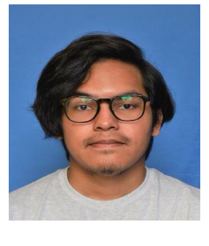

## TSP Student Information Sheet Muhammad Iz’aan Fahmi bin Badrusam

**Name:** Muhammad Iz’aan Fahmi Bin Badrusam **Instructor:** Madam Nurfauza Binti Jali

**Date:** 7th Novermber 2020 **Number of College Credits:** 71

**Major:** Software Engineering (WC10) **Expected Graduation Date:** 2022

**Briefly describe your relevant experience and interests:**

A good listener, will finish tasks early in a time span given because I do not like to make my teammates’ work harder as we are students, we have a lot of assignments and projects.

**Briefly describe your work on other team projects:**

Developing on a certain or experienced work. For example, making the presentation slides for my team.

**Briefly describe any leadership or management positions you have held (at work or in clubs/ organization):**

An active member in sport clubs such as ping-pong and a lead in past semester’s group project.

State your team preferences, if any:

Prefer to work in circle of known friends so that I will know how well they do in group assignments. Thus, it is easier to contact well known people around me.

|  |  |  |  |  |  |  |  |  |
| --- | --- | --- | --- | --- | --- | --- | --- | --- |
| **List your class schedule and other times when you have scheduled activities such as work, clubs, sports teams, etc.** | | | | | | | | |
| Time | Mon | Tues | Wed | Thurs | Fri | Sat | Sun |
| 0800-0900 | TMF3012 | TME3033 | BEU1023 |  |  |  |  |
| 0900-1000 | TMF3012 | TME3413 | BEU1023 |  |  |  |  |
| 1000-1100 | TMF3113 | MPU3122 | BEU1023 |  |  |  |  |
| 1100-1200 | TMF3113 | MPU3122 |  |  |  |  |  |
| 1200-1300 | TME3033 |  |  |  |  |  |  |
| 1300-1400 | TME3033 |  |  |  | TME3423 |  |  |
| 1400-1500 | TME3413 |  |  | TME3423 | TMF3113 |  |  |
| 1500-1600 | TME3413 |  |  | TME3423 |  |  |  |
| 1600-1700 |  |  |  |  |  |  |  |
| 1700-1800 |  |  |  |  |  |  |  |
| 1800-1900 |  |  |  |  |  |  |  |
| 1900-2000 |  |  |  |  |  |  |  |
| 2000-2100 |  |  |  |  |  |  |  |

|  |  |  |  |  |  |
| --- | --- | --- | --- | --- | --- |
| Rank from 1 (least) to 5 (most) your preferences for serving in the following team roles: | | | | | |
| Team Leader | 1 | 2 | 3 | 4 | 5 |
| Development Manager | 1 | 2 | 3 | 4 | 5 |
| Planning Manager | 1 | 2 | 3 | 4 | 5 |
| Quality/Process Manager | 1 | 2 | 3 | 4 | 5 |
| Support Manager | 1 | 2 | 3 | 4 | 5 |



## TSP Student Information Sheet Syed Mohd Asyraf bin Wan Hashim

**Name:** Syed Mohd Asyraf bin Wan Hashim  **Instructor:** Madam Nurfauza binti Jali

**Date:** 8th November 2020 **Number of College Credits:** 71

**Major:** Software Engineering (WC10) **Expected Graduation Date**: 03/2022

**Briefly describe your relevant experience and interests:**

I have worked on numerous project whereby from making a simple system and simple calculator to a classy website from my web – based project. Over the 2 years of my studies, I have learnt C, C++, Java, JavaScript, HTML and CSS. I am not fully fluent with the following programming language but after a few trial and error session during the past project, it can be said it can be done.

**Briefly describe your work on other team projects:**

I been one of the key programmers of my previous project as I have an anxiety of not doing any job and hence putting myself in a position whereby I am surely going to do some work. Other than that, I have also been a group leader in terms of compiling work as I am the kind of person to ensure that the work is done as good as possible and as close to the marking scheme to get the most of the project.

**Briefly describe any leadership or management positions you have held (at work or in clubs/ organization):**

I currently hold a position in PERTEKMA whereby is the Sport and Culture Exco of PERTEKMA 19/20. Other than that, I am also the vice president of Pencak Silat UNIMAS for 19/20. I am the kind of leader who likes to be a team player as I want to be involved as much as I can and like to ensure that all my members can work well with me.

**State your team preferences, if any:**

I would prefer to work with people who know what they are supposed to do and remain focus and achieving what it meant for them to do to obtain the best of result from the project.

|  |  |  |  |  |  |  |  |
| --- | --- | --- | --- | --- | --- | --- | --- |
| **List your class schedule and other times when you have scheduled activities such as work, clubs, sports teams, etc.** | | | | | | | |
| Time | Mon | Tues | Wed | Thurs | Fri | Sat | Sun |
| 0800-0900 | TMF3012 | TME3033 |  |  |  |  |  |
| 0900-1000 | TMF3012 | TME3413 |  |  |  |  |  |
| 1000-1100 | TMF3113 | MPU3312 |  |  |  |  |  |
| 1100-1200 | TMF3113 | MPU3312 |  |  |  |  |  |
| 1200-1300 | TMF3033 |  |  |  |  |  |  |
| 1300-1400 | TMF3033 |  |  |  |  |  |  |
| 1400-1500 | TME3413 |  |  | TME3423 | TME3423 | SPORTS | SPORTS |
| 1500-1600 | TME3413 | SPORTS | SPORTS | TME3423 | TME3113 | SPORTS | SPORTS |
| 1600-1700 |  |  |  |  |  |  |  |
| 1700-1800 |  |  |  |  |  |  |  |
| 1800-1900 |  |  |  |  |  |  |  |
| 1900-2000 |  |  |  |  |  |  |  |
| 2000-2100 |  |  |  |  |  |  |  |

|  |  |  |  |  |  |
| --- | --- | --- | --- | --- | --- |
| Rank from 1 (least) to 5 (most) your preferences for serving in the following team roles: | | | | | |
| Team Leader | 1 | 2 | 3 | 4 | 5 |
| Development Manager | 1 | 2 | 3 | 4 | 5 |
| Planning Manager | 1 | 2 | 3 | 4 | 5 |
| Quality/Process Manager | 1 | 2 | 3 | 4 | 5 |
| Support Manager | 1 | 2 | 3 | 4 | 5 |

Minute Meeting

Company Name: Charmander

Project Title: Abella Scent’z Web Application

Date: 24th October 2020

Time: 11:00 am

Venue: Online platform Webex

Attendance: All group members attend the meeting

|  |  |
| --- | --- |
| **Topic of Discussion** | **Action Taken by** |
| Assign specific roles for everyone | Sarah Elena binti Zamizan |
| Distribute work to everyone | Mohamed Adzhar bin Zaidi |
| Discuss about what needed in project proposal | All members |
| Discuss about project requirements | All members |
| Set fixed time for meeting | Mohamed Adzhar bin Zaidi |
| Set the discussion platform from Webex to discord due to time limit | Mohamed Adzhar bin Zaidi |

Prepared by:

\_\_\_\_\_ \_\_\_\_\_\_\_\_

(SH. NUR AINI WAFA BINTI WAN AHMADI)

Endorsed by:

\_\_\_\_\_\_\_ \_\_\_\_\_\_\_

(MOHAMED ADZHAR BIN ZAIDI)

Minute Meeting

Company Name: Charmander

Project Title: Abella Scent’z Web Application

Date: 24th October 2020

Time: 11:00 am

Venue: Online platform Webex

Attendance: All group members attend the meeting

|  |  |
| --- | --- |
| **Topic of Discussion** | **Action Taken by** |
| Assign specific roles for everyone | Sarah Elena binti Zamizan |
| Distribute work to everyone | Mohamed Adzhar bin Zaidi |
| Discuss about what needed in project proposal | All members |
| Discuss about project requirements | All members |
| Set fixed time for meeting | Mohamed Adzhar bin Zaidi |
| Set the discussion platform from Webex to discord due to time limit | Mohamed Adzhar bin Zaidi |

Prepared by:

\_\_\_\_\_\_\_\_\_\_\_\_\_\_

(SH. NUR AINI WAFA BINTI WAN AHMADI)

Endorsed by:

\_\_\_\_\_\_\_\_\_\_\_\_\_\_\_\_\_

(MOHAMED ADZHAR BIN ZAIDI)

Minute Meeting

Company Name: Charmander

Project Title: Abella Scent’z Web Application

Date: 7th November 2020

Time: 02:00 pm

Venue: Online platform Webex

Attendance: All group members attend the meeting with client (Mdm Adibah)

|  |  |
| --- | --- |
| **Topic of Discussion** | **Action Taken by** |
| Introduce the group members and their respective roles | Nur Syarwarni binti Berjaya |
| Presentation on project idea | Syed Mohd Asyraf bin Wan Hashim |
| Presentation on project planning | Sh. Nur Aini Wafa binti Wan Ahmadi |
| Session for client to give feedback | Client (Mdm Adibah) |
| Ask questions about any uncertainties in the development of the web app | Mohamed Adzhar bin Zaidi, Sarah Elena binti Zamizan and Muhammad Iz’aan bin Badrusam |

Prepared by:

\_\_\_\_\_\_\_\_\_\_\_

(SH. NUR AINI WAFA BINTI WAN AHMADI)

Endorsed by:

\_\_\_\_\_\_\_\_\_\_\_\_\_

(MOHAMED ADZHAR BIN ZAIDI)

Minute Meeting

Company Name: Charmander

Project Title: Abella Scent’z Web Application

Date: 7th November 2020

Time: 03:00 pm

Venue: Online platform Webex

Attendance: All group members attend the meeting

|  |  |
| --- | --- |
| **Topic of Discussion** | **Action Taken by** |
| Ask madam about our project due to payment gateway | Mohamed Adzhar bin Zaidi |
| Assign someone to settle the payment gateway part | Muhammad Iz’aan bin Badrusam |
| Review others website for project idea | All members |
| Discuss about to start do the project in next week | All members |

Prepared by:

\_\_\_\_\_\_\_\_\_

(SH. NUR AINI WAFA BINTI WAN AHMADI)

Endorsed by:

\_\_\_\_\_\_\_\_\_\_

(MOHAMED ADZHAR BIN ZAIDI)

Minute Meeting

Company Name: Charmander

Project Title: Abella Scent’z Web Application

Date: 21st November 2020

Time: 08:15 pm

Venue: Online platform discord

Attendance: All group members attend the meeting

|  |  |
| --- | --- |
| **Topic of Discussion** | **Action taken by** |
| Show process of web app | Mohamed Adzhar bin and Sarah Elena binti Zamizan |
| Select Presenter | Mohamed Adzhar bin Zaidi (lead) |
| Divise main task | All members |
| Divide task for SRS Template | All members |
| Divide content presentation | Mohamed Adzhar bin Zaidi (lead) |
| Set a date for meeting with client | Nur Syarwarni binti Berjaya |

Prepared by:

\_\_\_\_\_\_\_\_\_

(SH. NUR AINI WAFA BINTI WAN AHMADI)

Endorsed by:

\_\_\_\_\_\_\_\_\_\_\_\_\_\_

(MOHAMED ADZHAR BIN ZAIDI)

Minute Meeting

Company Name: Charmander

Project Title: Abella Scent’z Web Application

Date: 6th December 2020

Time: 10.00 am

Venue: Online platform discord

Attendance: All group members attend the meeting

|  |  |
| --- | --- |
| **Topic of Discussion** | **Action Taken by** |
| Review SRS documentation | All members |
| Review prototype | All members |
| Discuss about meeting face to face | Mohamed Adzhar bin Zaidi (lead) |
| Ask about client respond | Nur Syarwarni binti Berjaya |
| Discuss about the presentation | All members |

Prepared by:

\_\_\_\_\_\_\_\_\_

(SH. NUR AINI WAFA BINTI WAN AHMADI)

Endorsed by:

\_\_\_\_\_\_\_\_\_\_\_\_\_\_

(MOHAMED ADZHAR BIN ZAIDI)

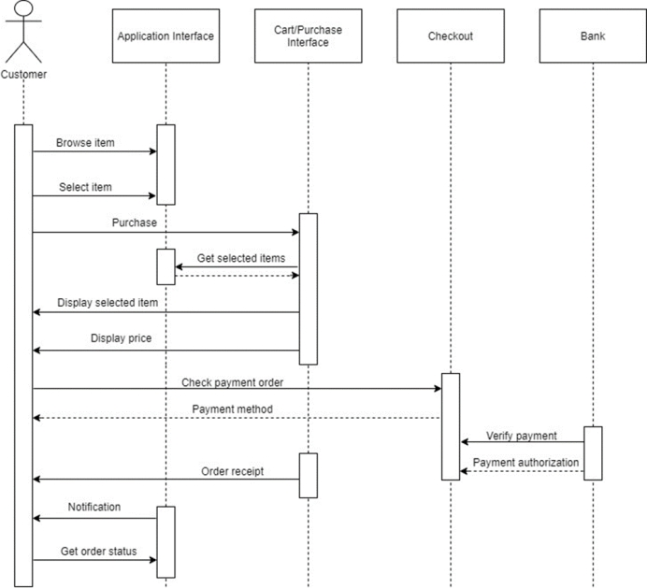Appendix C – Sequence Diagram

Figure 31: Sequence Diagram for Customer Abella Scent'z Web Application

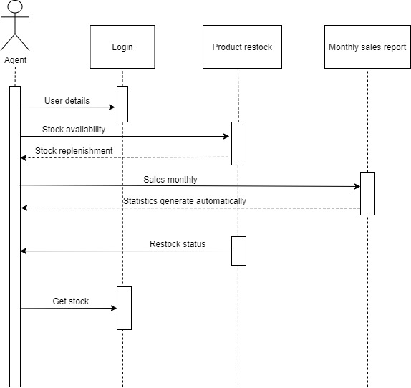

Figure 32: Sequence Diagram for Selling Team Abella Scent'z Web Application

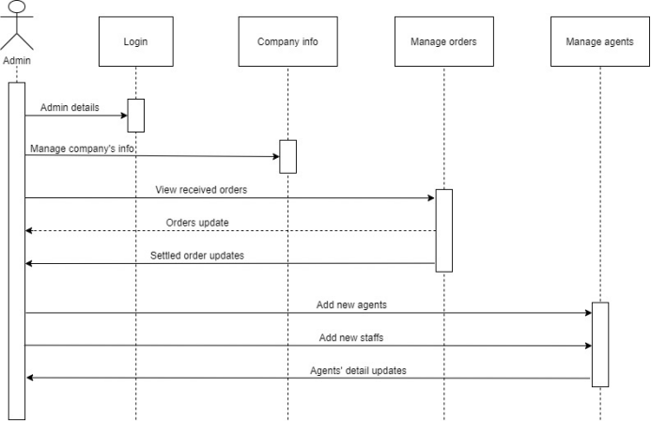

Figure 33: Sequence Diagram for Management Staff Abella Scent'z Web Application