TSP Student Information Sheet Mohamed Adzhar bin Zaidi
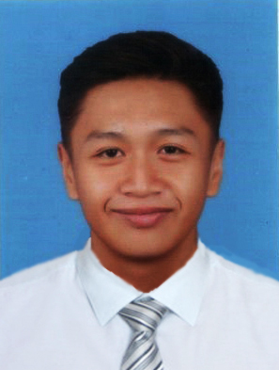
Name: Mohamed Adzhar bin Zaidi
Date: 8th November 2020
Expected Graduation Date: 03/2022

Instructor: Madam Nurfauza binti Jali
Number of College Credits: 3
Major: Software Engineering (WC10)

Briefly describe your relevant experience and interests:
I worked on various projects from making a simple calculator to a sophisticated shopping website from my web-based project. I have learnt C, C++, Java, JavaScript, HTML and CSS. Even though I am not considered fluent in the languages I found the projects to be doable after a few trials and errors and in the end, it turned out to be a success.

Briefly describe your work on other team projects:
I have been a group leader and I always volunteer to be the one to compile documents and videos to make sure it is accurate because I trust in my quality management and my anxiety to make the project as close to the marking rubrics as possible because I think that most of the work will be useless if it does not follow the format that is already stated in the question.

Briefly describe any leadership or management positions you have held (at work or in clubs/ organization):
I have been a group leader in several projects that I worked on but I don’t see myself as someone who can lead a team but I prefer to be the one organizing the team and tell the leader on how to improve the team and the quality of the overall project.

State your team preferences, if any:
Someone who I am familiar with and know their work ethics.

List your class schedule and other times when you have scheduled activities such as work, clubs, sports teams, etc.
Time | Mon | Tues | Wed | Thurs | Fri | Sat | Sun
0800-0900 | TMF3012 | TME3033 | BEU1023
0900-1000 | TMF3012 | TME3413 | BEU1023
1000-1100 | TMF3113 | MPU3122 | BEU1023 | GYM |  | GYM | GYM
1100-1200 | TMF3113 | MPU3122 | GYM | GYM |  | GYM | GYM
1200-1300 | TME3033 |  | GYM
1300-1400 | TME3033 |  |  |  | TME3423
1400-1500 | TME3413 |  |  | TME3423 | TMF3113
1500-1600 | TME3413 |  |  | TME3423
1600-1700
1700-1800
1800-1900
1900-2000
2000-2100

Rank from 1 (least) to 5 (most) your preferences for serving in the following team roles:
Team Leader 1 2 3 4 5
Development Manager 1 2 3 4 5
Planning Manager 1 2 3 4 5
Quality/Process Manager 1 2 3 4 5
Support Manager 1 2 3 4 5
- TSP Student Information Sheet Sh. Nur Aini Wafa binti Wan Ahmadi
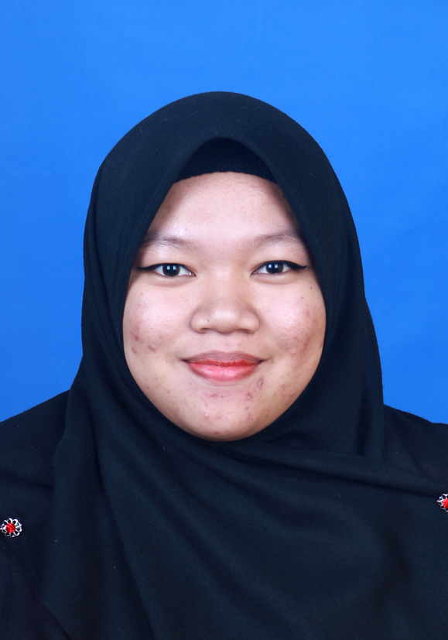
Name: Sh. Nur Aini Wafa binti Wan Ahmadi
Date: 7th November 2020
Expected Graduation Date: 03/2022

Instructor: Madam Nurfauza binti Jali
Number of College Credits: 3
Major: Software Engineering (WC10)

Briefly describe your relevant experience and interests:
Before this, I have designed a website in course Web Based System Development in my third semester (second year). This website needed to use our coding skill and designing skill. It used html, CSS, PHP, MySQL, and JavaScript. I also design database for course Database Concept and Design in my fourth semester (second year). The database that I have design include using MySQL and Microsoft Access. Other than that, I also help my uncle to design a website which called as Zakat Counter for his master besides I got more knowledge about developing a website from him. As for now, I know some programming language such as C, C++ and HyperText Markup Language.

Briefly describe your work on other team projects:
In course Web Based System Development, my role in the team projects is as secretary, which the main job was document the progress, rechecked the document, compiled all the documents and remind others about all important events and dates. I also do coding and the main part was JavaScript.

Briefly describe any leadership or management positions you have held (at work or in clubs/ organization):
During IT week 2020, I volunteer as Food Committee members. I work with two people to handle food during the whole IT week. I arranged food for the others committee members as well as the participants. I also volunteer to become one of SIR room committee and I still an active member in Penyayang Club. My work as an SIR committee member was monitor the student’s activity in the SIR room and helping PERTEKMA to do work in SIR room. During matric, I become the leader for group project such as IT subject and English language. I also did volunteer for Matric Drone Competition. During my school days, I was the Discipline Committee of Islamic Society. I also appointed as vice president for photography club and secretary for homeroom, class and handball club.

State your team preferences, if any:
I prefer to work with people that I know. This is because I know them well and how they do their work. This is because I love when my group members start do the work early so that the quality of the project is excellent. Other than that, I also fine working with new people because later in real job, we also sometime work with people that we are not familiar with. In addition, for roles I would like to become a planning manager, this is because I got some experience during my last project. However, if I get others role, I will do my utmost.

List your class schedule and other times when you have scheduled activities such as work, clubs, sports teams, etc.
Time | Mon | Tues | Wed | Thurs | Fri | Sat | Sun
0800-0900 | TMF3012 | TME3033 | KNU1033
0900-1000 | TMF3012 | TME3413 | KNU1033
1000-1100 |  |  | KNU1033
1100-1200
1200-1300 | TME3033
1300-1400 | TME3033
1400-1500 | TME3413 |  |  | TME3113 | MPU3312
1500-1600 | TME3413 |  |  | TME3113 | MPU3312
1600-1700 |  |  |  | TME3113 | TME3423
1700-1800 |  |  |  | TME3423
1800-1900 |  |  |  | TME3423
1900-2000
2000-2100

Rank from 1 (least) to 5 (most) your preferences for serving in the following team roles:
Team Leader 1 2 3 4 5
Development Manager 1 2 3 4 5
Planning Manager 1 2 3 4 5
Quality/Process Manager 1 2 3 4 5
Support Manager 1 2 3 4 5

TSP Student Information Sheet Nur Syarwarni binti Berjaya
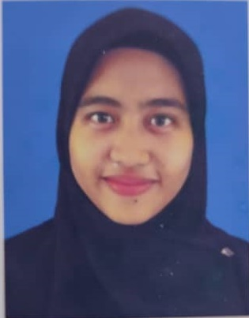
Name: Nur Syarwarni binti Berjaya
Date: 8th November 2020
Major: Software Engineering (WC10)

Instructor: Madam Nurfauza binti Jali
Number of College Credits: 3
Expected Graduation Date: 05/2022

Briefly describe your relevant experience and interests:
I have experience in doing web base project which we learn html, java script and php. I also learn how to do database by using sql and database software tools. I do not know my interest of work, I just do want I have been assigned.

Briefly describe your work on other team projects:
I think my work is not so organized. I work to remind people about task we have to submit, get some example for coding, do diagram (flowchart, uml chart etc) help other with their coding, do some coding and recheck the document.

Briefly describe any leadership or management positions you have held (at work or in clubs/ organization):
I think I have been a leader for group project but do not remember which subject. I also have been a volunteer in It week and become volunteer in SIR room. In matric I become the leader in group project and club president at high school.

State your team preferences, if any:
I do not mind to much about my team preference. Assign me a role and I will do my best to do it.

List your class schedule and other times when you have scheduled activities such as work, clubs, sports teams, etc.
Time | Mon | Tues | Wed | Thurs | Fri | Sat | Sun
0800-0900 | TMF3012
0900-1000 | TMF3012 | TME3413
1000-1100
1100-1200 |  |  | EBU1023
1200-1300 |  |  | EBU1023
1300-1400 |  |  | EBU1023
1400-1500 | TME3413 | TMF1434 |  | TMF3113 | MPU3312
1500-1600 | TME3413 | TMF1434 |  | TMF3113 | MPU3312
1600-1700 |  |  |  | TME3423 | TME3423
1700-1800 |  |  |  | TME3423
1800-1900
1900-2000 |  | TMF1434
2000-2100 |  | TMF1434

Rank from 1 (least) to 5 (most) your preferences for serving in the following team roles:
Team Leader 1 2 3 4 5
Development Manager 1 2 3 4 5
Planning Manager 1 2 3 4 5
Quality/Process Manager 1 2 3 4 5
Support Manager 1 2 3 4 5

- TSP Student Information Sheet Sarah Elena binti Zamizan
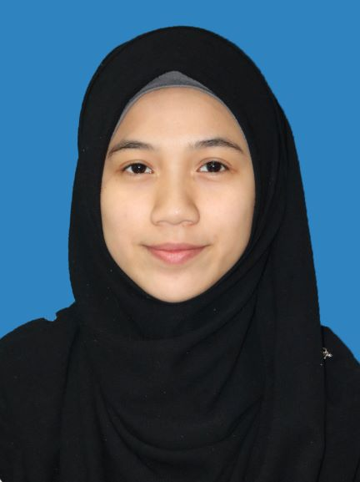
Name: Sarah Elena Binti Zamizan
Date: 8th November 2020
Major: Software Engineering (WC10)

Instructor: Madam Nurfauza binti Jali
Number of College Credits: 3
Expected Graduation Date: 2023

Briefly describe your relevant experience and interests:
I was responsible in developing the web-based system in our Smart Clothes Line invention during the Young Invention, Innovation and Design Competition (YIID) 2018 where at His will, our group won the Gold Award. On February 2019, at His will, I have been acknowledged as an Android Certified Application Developer which I successfully achieved during my short course in CENTEXS after diploma. At His will, I won the Web Design Category in Worldskills Malaysia Sarawak 2019. I love programming especially web programming and aspire to be a professional web developer one day.

Briefly describe your work on other team projects:
I am usually the group leader in most of my team projects though on certain occasions, my group does not decide who should be the team leader, but I would usually get the ball rolling when no one initiates the work. Apart from that, alongside a couple of friends, I would usually do the programming part in my projects.

Briefly describe any leadership or management positions you have held (at work or in clubs/ organization):
I was appointed as one of the “Biro Perhubungan & Publisiti” for “Jawatankuasa Perwakilan Surau Al-Ghazali" in 2016 – 2017 in UiTM Kampus Samarahan 2. As one of the members of this association, I became facilitators in most of the events held especially during Kursus Kemahiran Islam (KKI). During my school days, I was the Vice President of Islamic Society.

State your team preferences, if any:
I love the kind of team where everyone is quick in deciding the team leader because without one, it is hard to initiate the work. I also like it when everyone participates during any decision-making process and give their response even if they disagree. I do not mind if any of my group members consumes a lot of time as they struggle to do their part but it is best if they notify other group members on their progress and inform any of the members earlier about their problems so other members can lend a helping hand as soon as possible. Besides that, I like it better if my team completes their work, not just early but also excellently. I find it a bit troublesome if one chooses to complete their work early but neglects the quality of their work.

The team preferences I stated here are all from past experiences.

List your class schedule and other times when you have scheduled activities such as work, clubs, sports teams, etc.
Time | Mon | Tues | Wed | Thurs | Fri | Sat | Sun
0800-0900 | TMF3012 | TME3033
0900-1000 | TMF3012 | TME3413
1000-1100 | TMF3113
1100-1200 | TMF3113
1200-1300 | TME3033
1300-1400 | TME3033
1400-1500 | TME3413 |  |  | PBI1092
1500-1600 | TME3413 |  |  | PBI1092
1600-1700 |  |  |  |  | TME3423
1700-1800 |  |  |  | TME3423 | TMF3113
1800-1900 |  |  |  | TME3423
1900-2000 | MPU3192
2000-2100 | MPU3192

Rank from 1 (least) to 5 (most) your preferences for serving in the following team roles:
Team Leader 1 2 3 4 5
Development Manager 1 2 3 4 5
Planning Manager 1 2 3 4 5
Quality/Process Manager 1 2 3 4 5
Support Manager 1 2 3 4 5

TSP Student Information Sheet Muhammad Iz’aan Fahmi bin
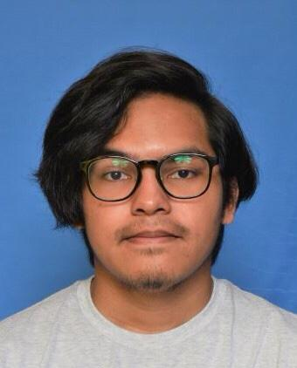

Badrusam
Name: Muhammad Iz’aan Fahmi Bin Badrusam
Date: 7th Novermber 2020
Major: Software Engineering (WC10)

Instructor: Madam Nurfauza Binti Jali
Number of College Credits: 3
Expected Graduation Date: 2022

Briefly describe your relevant experience and interests:
A good listener, will finish tasks early in a time span given because I do not like to make my teammates’ work harder as we are students, we have a lot of assignments and projects.

Briefly describe your work on other team projects:
Developing on a certain or experienced work. For example, making the presentation slides for my team.

Briefly describe any leadership or management positions you have held (at work or in clubs/ organization):
An active member in sport clubs such as ping-pong and a lead in past semester’s group project.

State your team preferences, if any:
Prefer to work in circle of known friends so that I will know how well they do in group assignments. Thus, it is easier to contact well known people around me.

List your class schedule and other times when you have scheduled activities such as work, clubs, sports teams, etc.
Time | Mon | Tues | Wed | Thurs | Fri | Sat | Sun
0800-0900 | TMF3012 | TME3033 | BEU1023
0900-1000 | TMF3012 | TME3413 | BEU1023
1000-1100 | TMF3113 | MPU3122 | BEU1023
1100-1200 | TMF3113 | MPU3122
1200-1300 | TME3033
1300-1400 | TME3033 |  |  |  | TME3423
1400-1500 | TME3413 |  |  | TME3423 | TMF3113
1500-1600 | TME3413 |  |  | TME3423
1600-1700
1700-1800
1800-1900
1900-2000
2000-2100

Rank from 1 (least) to 5 (most) your preferences for serving in the following team roles:
Team Leader 1 2 3 4 5
Development Manager 1 2 3 4 5
Planning Manager 1 2 3 4 5
Quality/Process Manager 1 2 3 4 5
Support Manager 1 2 3 4 5

TSP Student Information Sheet Syed Mohd Asyraf bin Wan Hashim
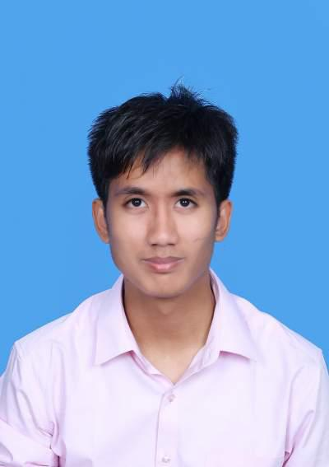
Name: Syed Mohd Asyraf bin Wan Hashim
Date: 8th November 2020
Major: Software Engineering (WC10)

Instructor: Madam Nurfauza binti Jali
Number of College Credits: 3
Expected Graduation Date: 03/2022

Briefly describe your relevant experience and interests:
I have worked on numerous project whereby from making a simple system and simple calculator to a classy website from my web – based project. Over the 2 years of my studies, I have learnt C, C++ , Java , Javascript , HTML and CSS. I am not fully fluent with the following programming language but after a few trial and error session during the past project, it can be said it can be done.

Briefly describe your work on other team projects:
I been one of the key programmers of my previous project as I have an anxiety of not doing any job and hence putting myself in a position whereby I am surely going to do some work. Other than that, I have also been a group leader in terms of compiling work as I am the kind of person to ensure that the work is done as good as possible and as close to the marking scheme to get the most of the project.

Briefly describe any leadership or management positions you have held (at work or in clubs/ organization):
I currently hold a position in PERTEKMA whereby is the Sport And Culture Exco of PERTEKMA 19/20. Other than that, I am also the vice president of Pencak Silat UNIMAS for 19/20. I am the kind of leader who likes to be a team player as I want to be involve as much as I can and like to ensure that all my members can work well with me.

State your team preferences, if any:
I would prefer to work with people who know what they are supposed to do and remain focus and achieving what it meant for them to do to obtain the best of result from the project.
Listyour class schedule and other times when you have scheduled activities such as work, clubs, sports teams, etc.
Time | Mon | Tues | Wed | Thurs | Fri | Sat | Sun
0800-0900 | TMF3012 | TME3033
0900-1000 | TMF3012 | TME3413
1000-1100 | TMF3113 | MPU3312
1100-1200 | TMF3113 | MPU3312
1200-1300 | TMF3033
1300-1400 | TMF3033
1400-1500 | TME3413 |  |  | TME3423 | TME3423 | SPORTS | SPORTS
1500-1600 | TME3413 | SPORTS | SPORTS | TME3423 | TME3113 | SPORTS | SPORTS
1600-1700
1700-1800
1800-1900
1900-2000

Rank from 1 (least) to 5 (most) your preferences for serving in the following team roles:
Team Leader 1 2 3 4 5
Development Manager 1 2 3 4 5
Planning Manager 1 2 3 4 5
Quality/Process Manager 1 2 3 4 5
Support Manager 1 2 3 4 5

