**Project (50%)**

The Project is consist of THREE (3) parts:

1. Project Design (10%) 🡪 Submit by 22 April 2020, 11.55pm through eLeap
2. Project Output (20%) 🡪 Submit by 26 April 2020, 11.55pm through eLeap
3. Contribution & QA (20%) 🡪 Project Presentation in Week 13

Project Description

Your group is hired by a research team from the Centre of Pre-University Studies, UNIMAS to build a **Graphical User Interface System** (using Java) for cataloguing palm specimens. For each specimen observed by the team, the following vital statistics are recorded:

1. Common Name
2. Genus
3. Species
4. Photo
5. Characteristics
   1. Stem
   2. Leaf

Plus, time, date and location (for example, Kubah National Park, Bako National or Mount Santubong) of the *sampling* *event*1. Samples of the species observed are provided in Figure 1-5 and Table 1-5.

The system should have the following basic functionalities:

1. enter a new record
2. view an existing record
3. edit an existing record
4. delete an existing record

and the following two more advanced functionalities:

1. search for an existing record
2. generate a summary report that can be filtered by location and date range.

The exact implementation of the features is based on your own ideas and creativity. Please refer to the rubric on how to score marks for this group exercise.

For **Project design**, you are to design your project using the Unified Modeling Language (UML). Do refer to the rubrics for details of the design. Submit your project design document (.pdf only) by 22 April 2020, 11.55pm.

All the best!

1The event where the specimen is observed by the research team.

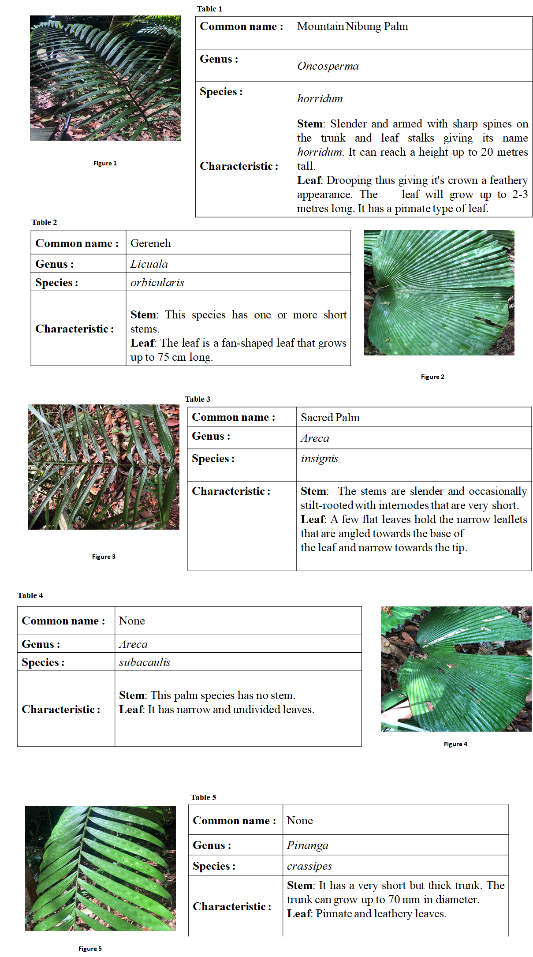

Reference:

Goh, M.B.L, Rasid, A.Z. Masa, A.A, Abang Abbeha, E.N, Ismail, F.A, Moris@Michael, M.I, Thomas Inau, M.B, Mohd Asri, N.A, Arizal, M.A, Rosli, N.A, Dainis, S.N, Justin, V.C, Wan Ismail, W.M, Folten, V.M. (2019). DOCUMENTATIONS OF PALMS IN KUBAH NATIONAL PARK, SARAWAK. Centre for Pre-University Studies, Universiti Malaysia Sarawak, 94300 Kota Samarahan, Sarawak

**Rubrics**

Part A: Project Design (10%)

|  |  |  |  |
| --- | --- | --- | --- |
|  | **0m** | **2m** | **5m** |
| **Classes, Attributes and Methods [CLO2)** | Less than 2 classes  **OR for each class**  Less than 2 attributes and methods | 2 classes  **AND for each class,**  2 attributes  AND  2 methods | 2 classes or more  **AND for each class,**  2 attributes or more  AND  2 methods or more |
| **Association (including inheritance, polymorphism)**  **[CLO1]** | Incorrect association between classes, AND missing inheritance and polymorphism | Classes are associated corrected with incorrect inheritance relationship and no polymorphism | All classes are associated correctly, with correct inheritance and polymorphism. |

Part B: Project Output (20%)

|  |  |  |  |
| --- | --- | --- | --- |
|  | **0m** | **2m** | **4m** |
| **Number of implemented classes and interfaces [CLO2]** | Less than 2 classes  **OR**  Less than 2 interfaces | 2 classes  **AND**  2 interfaces | 2 classes or more  **AND**  5 interfaces or more |
| **Basic functionalities [CLO2]** | Less than 2 from (a.) to (d.) are working correctly | At least 2 from (a.) to (d.) are working correctly | All basic functionalities, i.e., (a.) to (d.), are working correctly |
| **Search function [CLO2]** | Does not exist / Is not working | Search query can only involve one field at a time,  e.g.,  Search for records that fulfil the following criteria: “*between 100-150cm*” | Search query can involve two fields (or more) at a time,  e.g.,  Search for records that fulfil the following criteria: “Genus *Pinanga* ” and “*found in Mount Santubong*” |
| **Summary Report**  **[CLO2]** | Does not exist / Is not working | Can only generate a single, unfiltered report. | Can generate report that can be filtered either by location, or by date range, or by both. |
| **GUI menu & Flow [CLO2]** | Confusing / only text-based menu | Simple GUI menu with acceptable flow of program | Well-designed GUI and logical flow of program. |

Part C: Contribution and Question and Answer

|  |  |  |  |  |  |
| --- | --- | --- | --- | --- | --- |
|  | **0m** | **3m** | **5m** | **7m** | **10m** |
| **Contribution (CLO2)** | Only code 1 interface  AND test 1 class (implemented by other group members) | Only code 1 class  AND test 1 class (implemented by other group members) | Code 1 class,  code 1 interface  AND test 1 class (implemented by other group members) | Code more than 1 class  OR code more than 1 interface AND test 1 or more class (implemented by other group members) | Code more than 1 class  AND code more than 1 interface AND test more than 1 class (implemented by other group members) |
| **Peer Grading (CLO3)** | **(Peer review form 10m. Available in Week 13)** | | | | |
|  | **0m** | **1m** | **3m** | **5m** |  |
| **Question & Answer**  **(CLO 1)** | Missing in action during Q & A session | Unable to answer the questions | Able to present but partially correct answer for the questions. | Able to present, answer the questions well and pinpoint in the coding the correct answer |  |