Redirect to login page if no matching credentials with flash message saying Your credentials donot match.

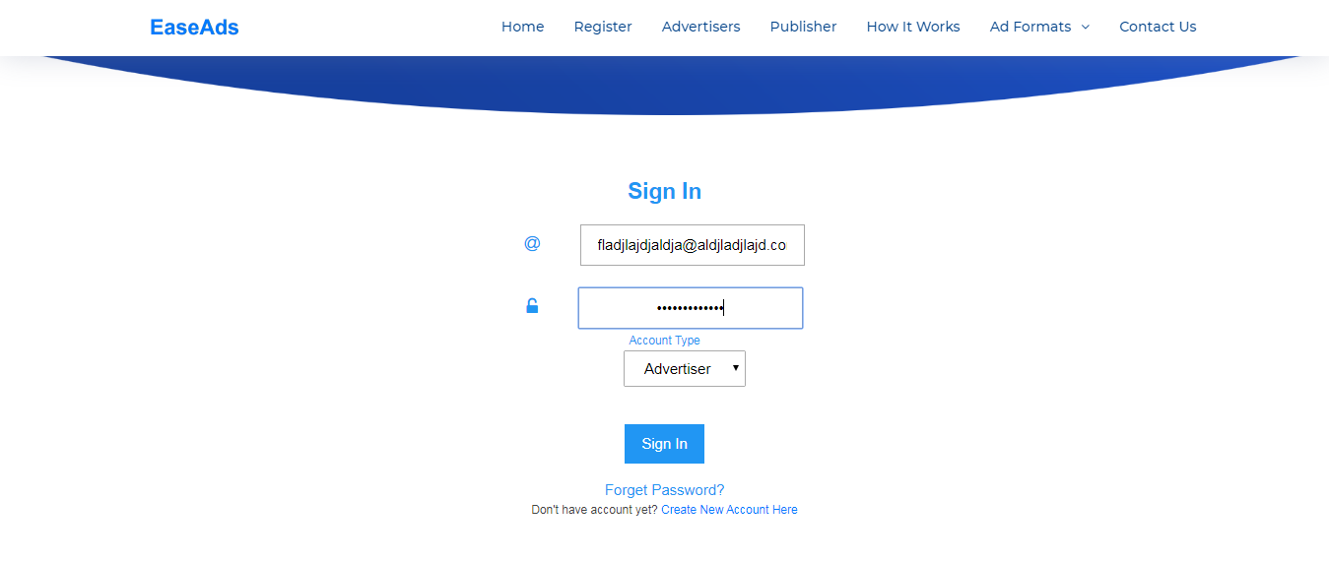

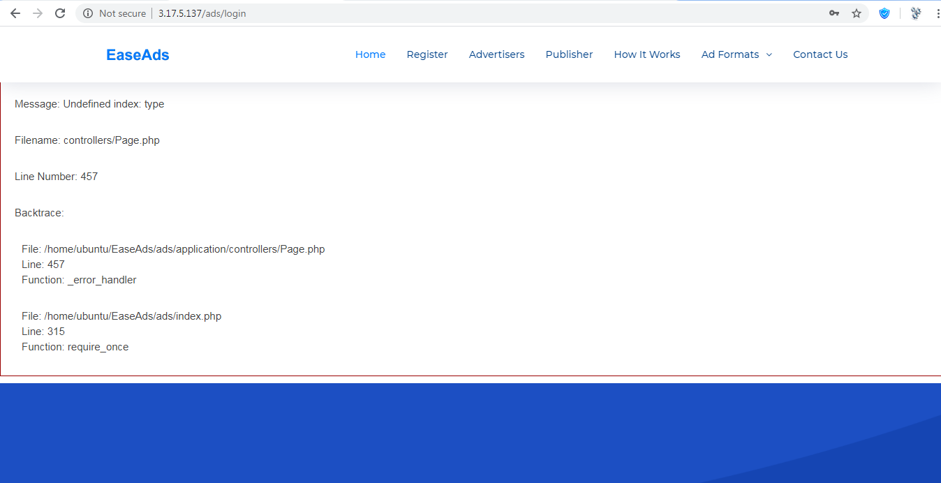

* Validate register page for compulsory field.

i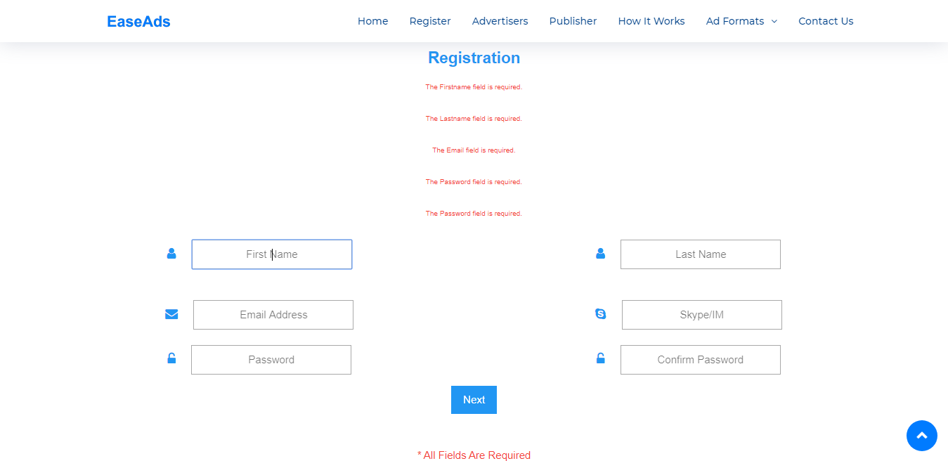

The mandatory fields must be starred

* No admin approval required for publishers .The user should be verified by email verification link

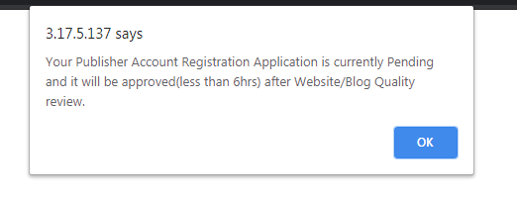

* All Data Same For Every User.Fix it

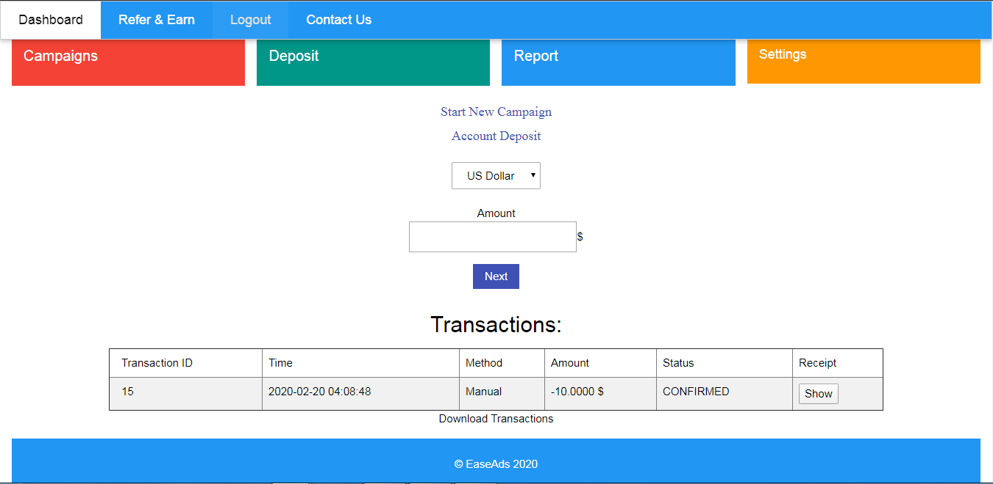

This screenshot s for a new advertiser registered but he has this data already

Same goes for publishers dashboard as well.

* Add Start Campaign and Add Fund Button like campaign deposits and others in Advertiser Dashboard and Add Site Buttton in Publisher dashboard . Campaign cannot be started without fund on user dashbords.
* Sort Every List From Latest to Oldest (on Avertiser and publisher lists on admin panel) Our system time zone should be in GMT +5:45
* Add Notification bell on top of Admin Panel for every pending campaigns, payments approval sites approvals, end of campaign
* 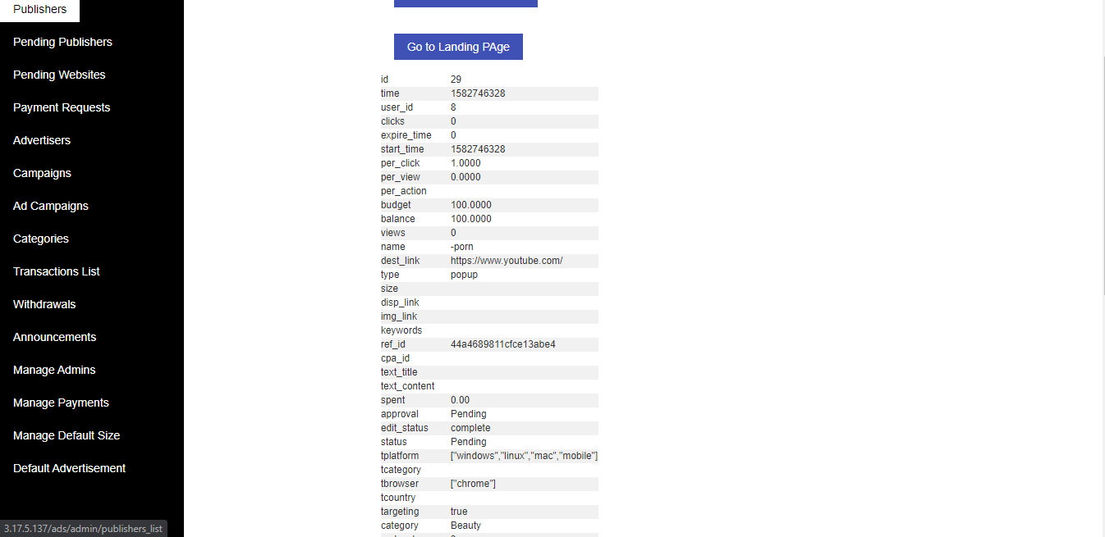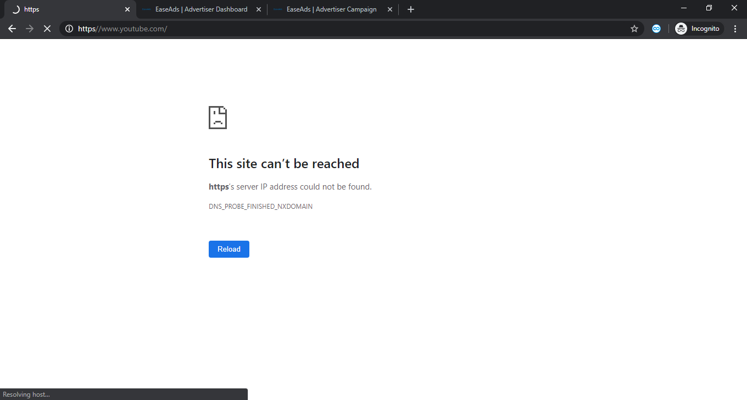

This error is due to missing : in the URL for the landing page button. The link goes https//www.youtube.com  
Fix this issue.

Notification Bell for every user in the dashboard for Approvals of campaign, hold of campaign or campaigns out of money ( advertiser) withdrawal approval, and site approval for publisher panel. The user should be notified after the admin approves.

Today’s Clicks, Today’s Views, Today’s Spent, Current balance button with datas available for advertiser in their dashboard.  
Also, A simple geo distribution map or country traffic map statistics available directly in the dashboard of both publisher and advertiser.

In Advertiser panel, when the user opens campaign then he will see campaign list and has a start campaign button. In the campaign list, list them in order of date created. The list will have following details, Date created, Status, Campaign Name, if the budget for that campaign is $50 and the expended amount is $15 in the campaign it should be seen in the listing as $15/$50 as campaign balance.

Also, the campaign list and start new campaign should be two different buttons under option Campaigns.

In the Deposit button, replace its name with Funds button and add scroll down buttons Add funds and Transactions list

And Add total spent data in place of total earnings in advertisers dashboard.