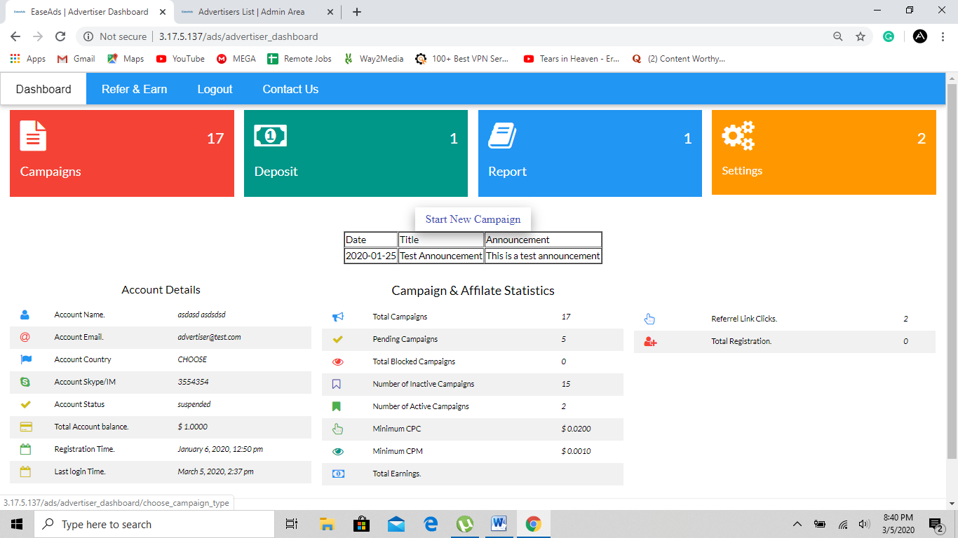

Remove total earnings button from advertisers: keep total views, total clicks, today spent details in advertiser details. Also, main balance should be visible in the dashboard.  
Also, add Add funds button in the dashboard like campaigns button, it should be a bit smaller and will be on the side.  
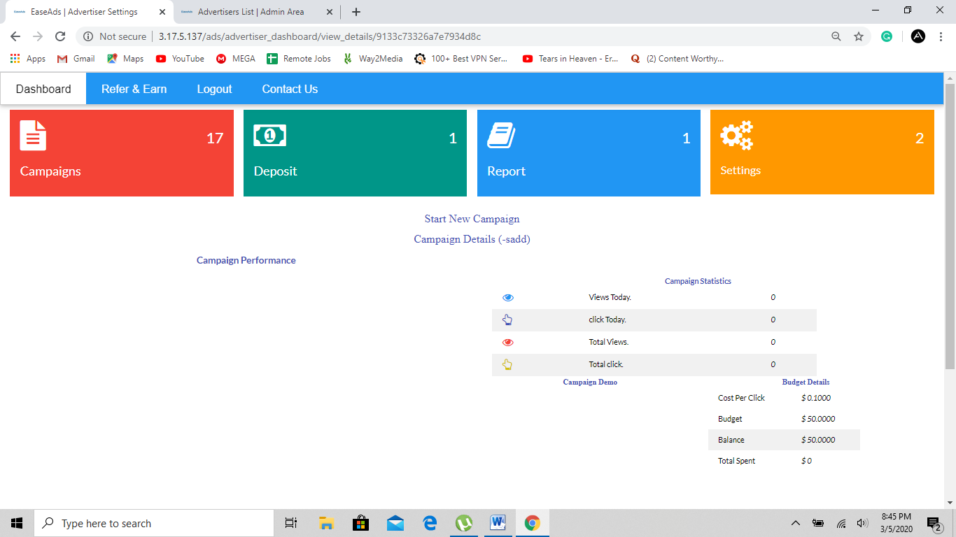

When I click on campaign name and it opens the detail. I should also have the option to review what I had set for the campaign earlier and I can submit for approval again after making change to the same campaign. User should be able to edit the campaign settings, they should be given that option. Also, they should have a option to hold, stop, resume or delete the campaign.

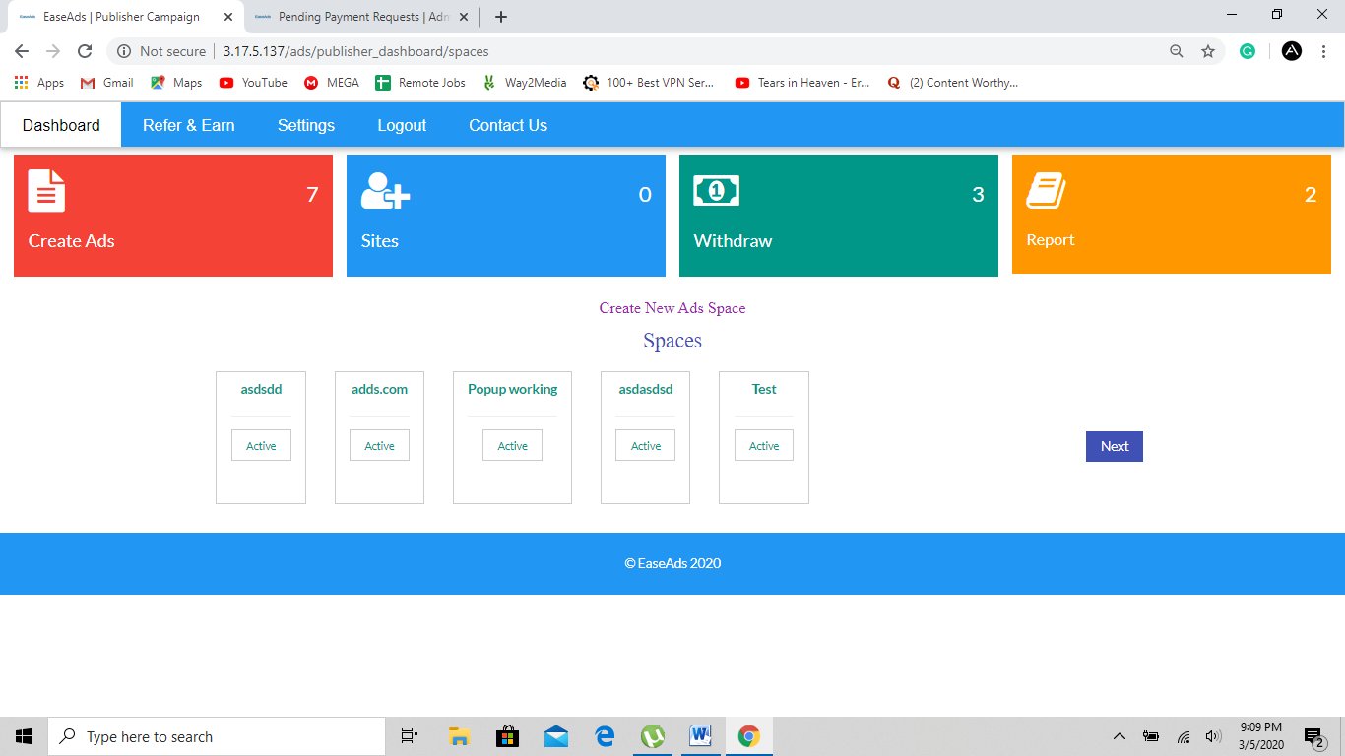

In publisher panel, the create ads button should have drop down menu with   
Create new ads space  
List of ads spaces

List of ads spaces should be shown like this  
Ads Space Name Category Space status Total impressions Total clicks Total earnings

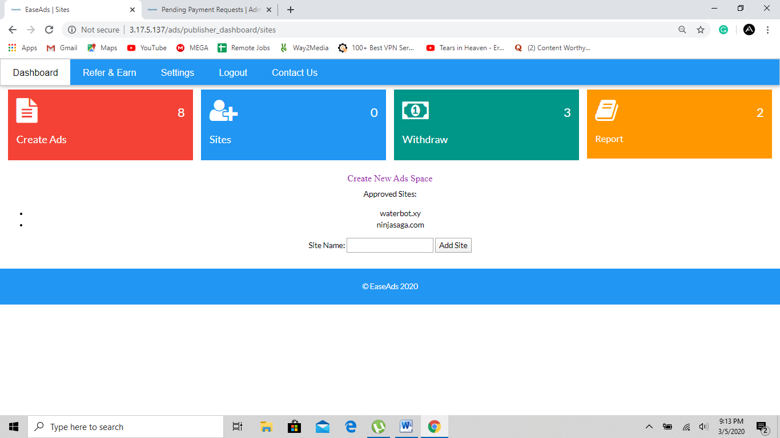

Sites button should have two buttons  
Add new site  
Sites list

Add new site option will have website URL, and there will be a code generated as well which is added by the site owner to their site and the metatag will automatically verify the website as soon as they add the metatag.

Also, site list should include following details  
Site name Site URL Site status Total impressions Total clicks Total earnings

Place other options in withdrawal and add funds. In other they can request for manual adding or withdrawal through paxum, btc, payoneer, skrill, webmoney, etc.

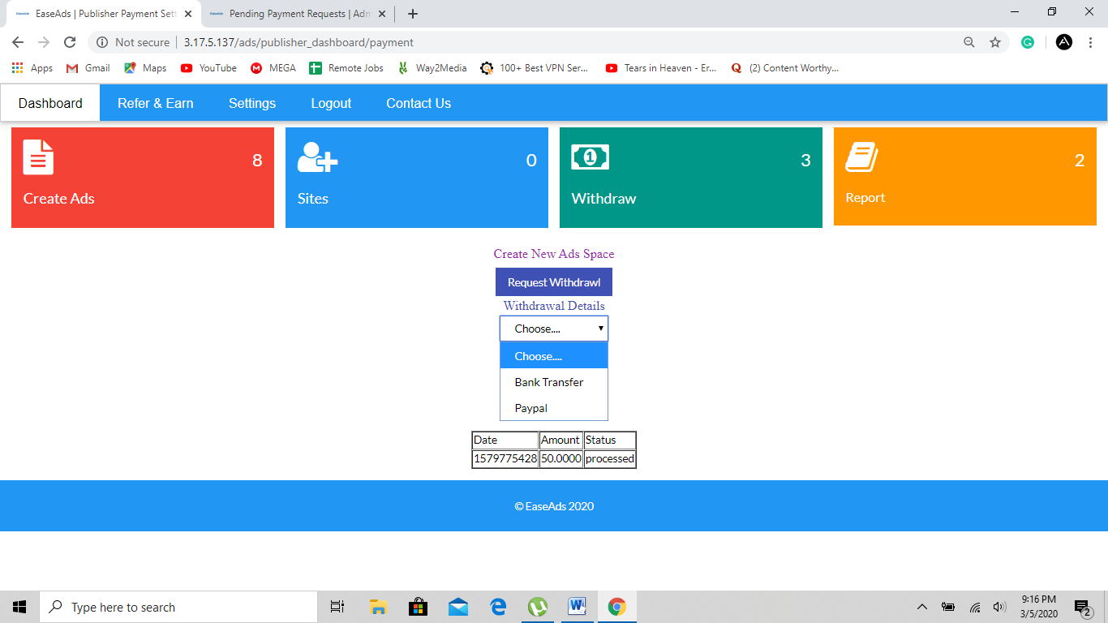

Also, the withdrawal request should be there in the withdrawal list with status pending until the transaction is completed through the admin. The withdrawal request should be listed. Also, while adding fund through bank the request for bank transfer should be available as well in advertisers.

Add logout button in admin panel. Also, admin panels design is not satisfactory. The dashboard should be more attractive and easier. All the notifications for approvals, payment requests should be shown as a red mark if new actions are required. Also, the notifications should be seen on dashboard of the admin. It should show the message like this: 2 campaigns are looking for approval  
2 payment withdrawals are pending  
5 sites are waiting for approval  
The message should show like this. When I click on the message it should open the pending option where admin can approve review and disapprove.

Also DO NOT USE ADS or ADVERTISEMENT IN THE KEYWORDS WHILE CREATING THE LINKS AND SYSTEM.

IF AD blocker finds such keywords it will block our site and traffic.

Create an API that can receive traffic to our system directly from Propeller ads i.e propellerads.com

You can refer to API in the propellerads dashboard for advertisers. The API will be linked with certain publisher account in our platform and it will seem as if the traffic is from our direct pubisher and the traffic must be counted.

Also, add native recommendation ad format which was earlier in the site. Native ads also work well. You must create a system for native as well.

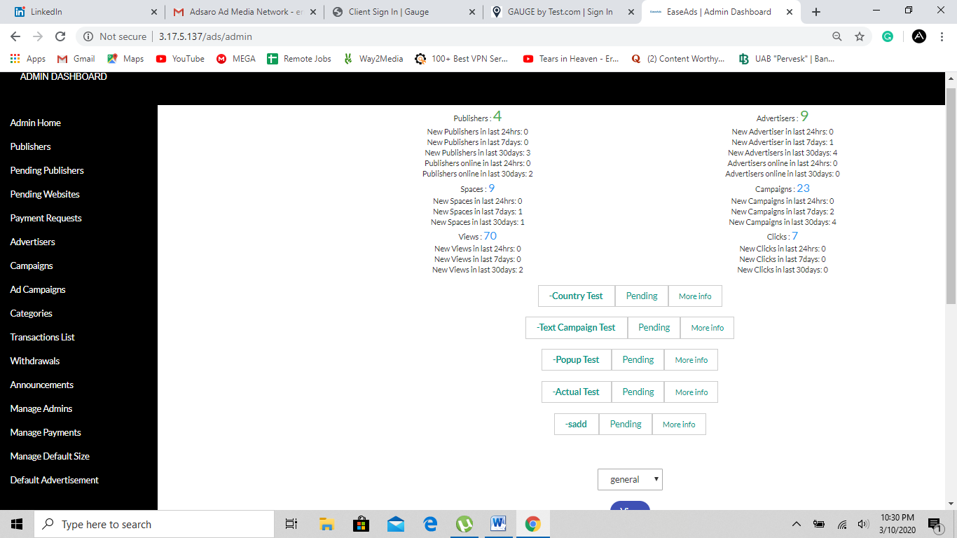

This admin panel buttons seem odd. You should place some buttons with similar functions in a drag down menu. Here are the new version of options that should seem.

Admin Home

Approvals:

* User Approvals: it will include all the pending users approvals.i.e. pending publishers and users
* Payment Approval: All the pending approvals for payments as payment request by advertiser

and Withdrawal reuest by publishers

* Site Approvals: Approval for websites for publisher
* Campaign Approvals: all pending campaign approvals

Payments:

-Transaction Lists

Advertiser

-Advertiser list

-Advertiser deposits

Publisher

-Publisher list

-Publisher ad spaces- this should include detailed info about ad space traffic reports and total earnings for publisher

Publisher withdrawals

Administrative Tools:

* Manage admins
* Manage Bids/ Default Size
* Categories
* Announcements
* Manage Houseads/ Default advertisement- this button should have ability for admin to start campaign internally with remnant traffic that are unused for any other campaigns. The admin will be able to manage houseads

Houseads Report: This will give detailed clicks and views info to admin

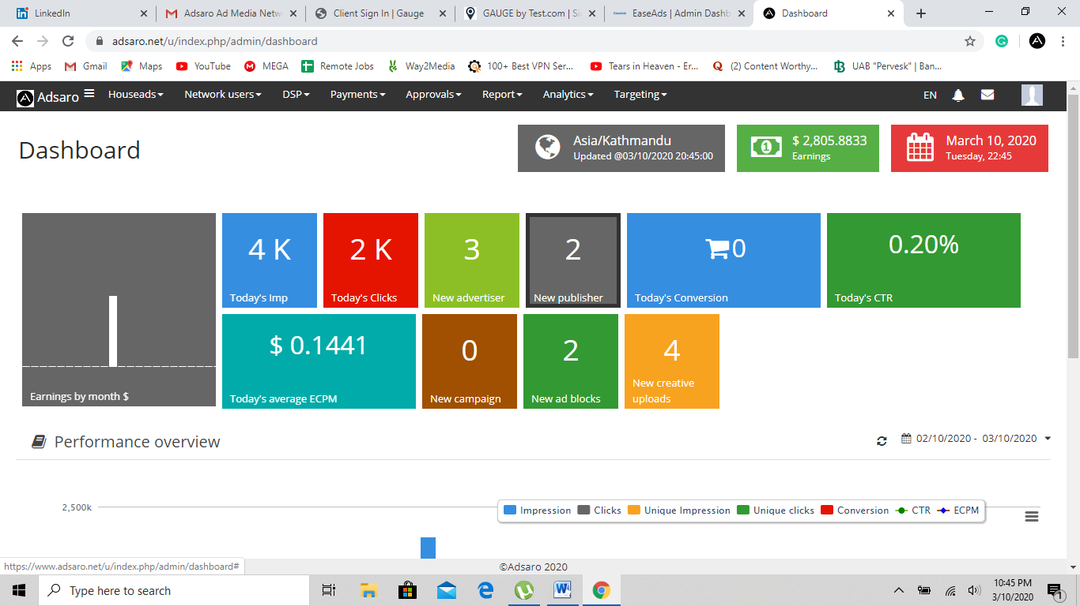

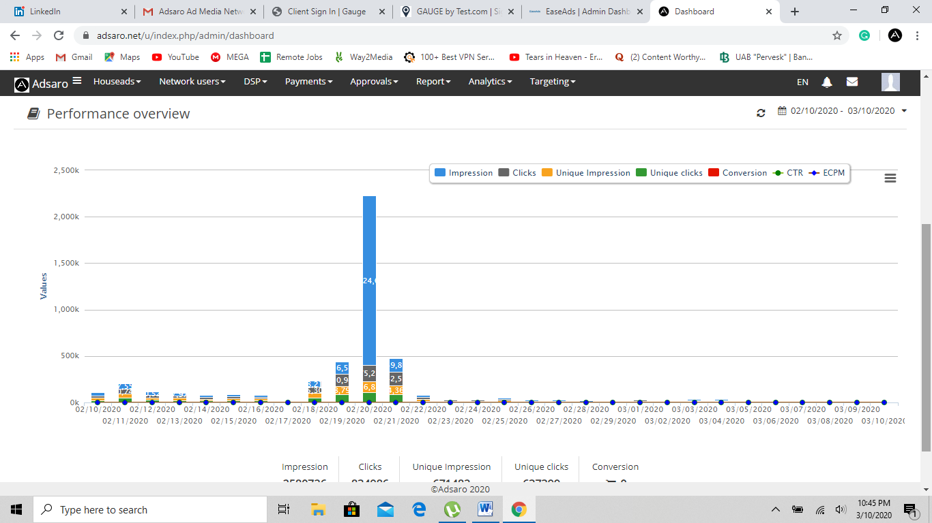

The admin panel should look like this.

Also, you can change all user panel to show such stats and report on dashboard.