Esmaa site add garne belaa, site direct approve garna milne tag create garne jun tag copy garera site maa rakhne bittikai site approve hunxa.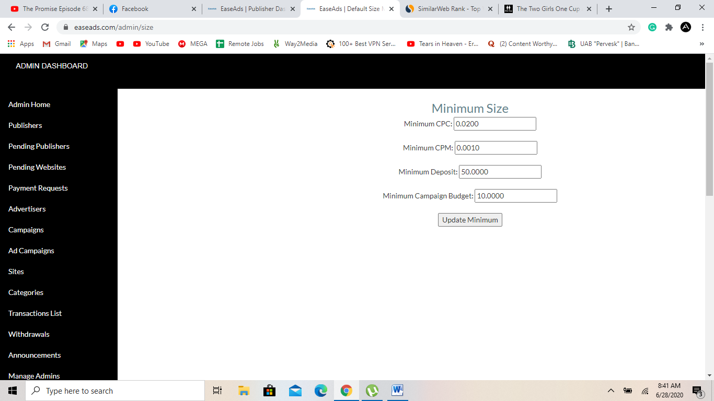 **Add minimum Withdrawal limit option:  
This will allow us to update limit for withdrawal for publishers.**

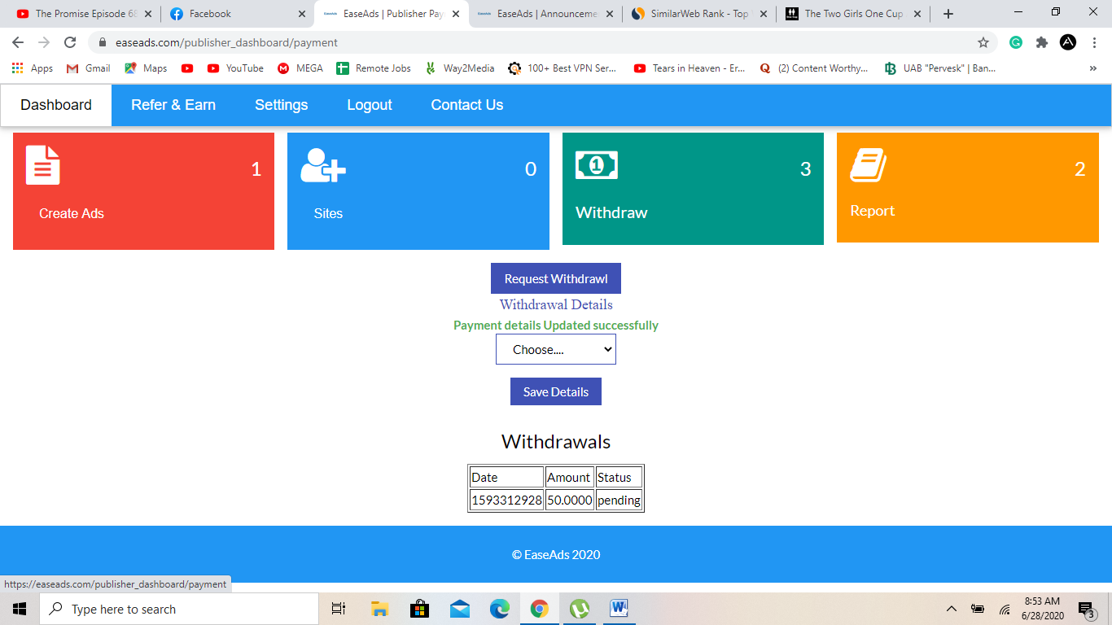

**Yo withdraw button maa Withdrawal detail set garepaxi tesko lis ni aauna paro..**

**Usle set gareko withdraw ko detail  
Ani yo request withdrawal maa click gardaa direct withdraw request hunu vaYena**

**There should be a message saying, we will credit the account after you reach the minimum threshold. Please keep in touch with your publisher manager for your report of earnings.**

**Ani maile withdraw garne vaye vane Total withdrawal amount: vanne option hunu parxa**

**Jasko minimum set garna admin bata milxa.**