Progress Report:

PHP codeigniter is being used to develop EaseAds. Functionality is the first priority so please ignore the HTML design. Currently, different admin, publisher and advertiser interface has been created.

Option is provided via registering

Immediately after registration, a URL is asked for publisher.



In the admin dashboard, there is a list of pending publishers

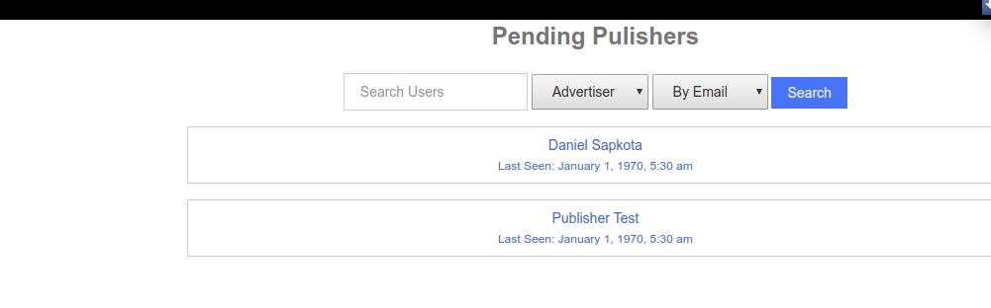
Admin can approve or disapprove them

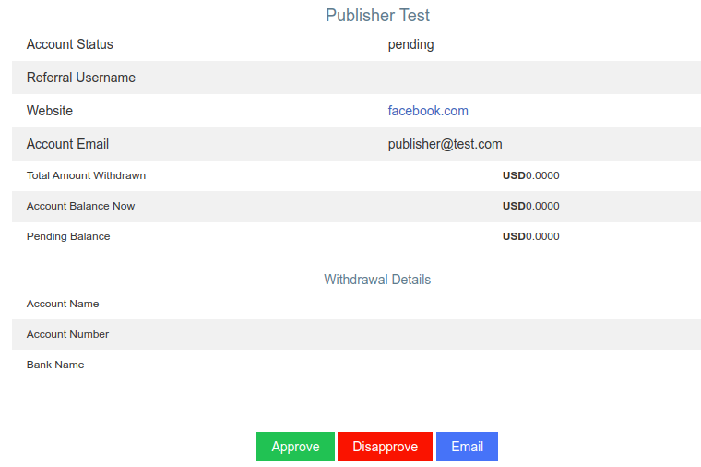

A small summary has been created

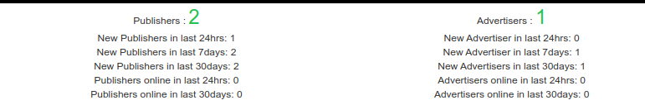

Option to add banner is in the publisher dashboard

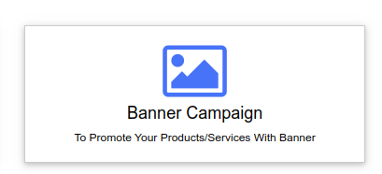

The first priority is to make all of this work. Then sorting by country, keys, adding tags will be done.

