Also total is wrong

Advertiser panel

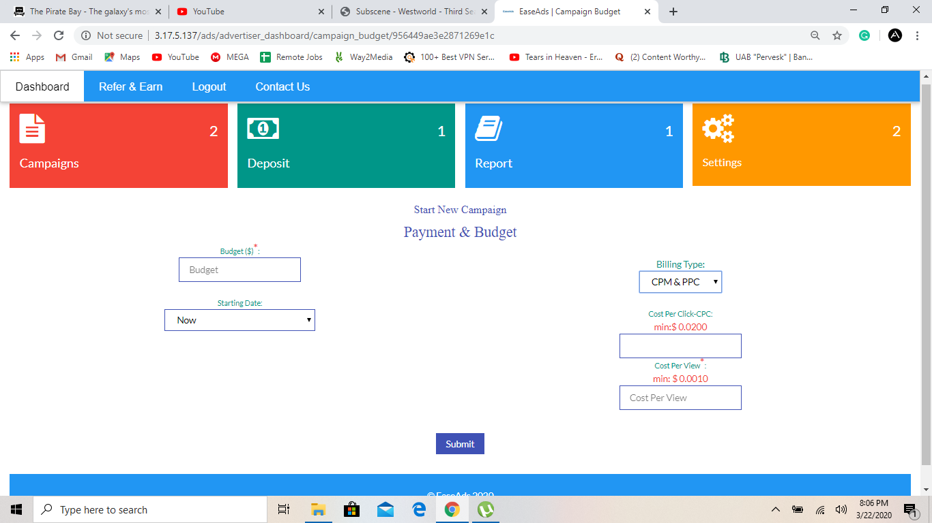

In banner campaign setting option, during payment and budget the billing type should be CPM and CPC separately. Advertiser can choose one option to pay with. If he selects CPM the Cost per view button should appear and if he selects CPC the cost per click button will appear below.

As per the reports the billing and calculation should be made according to advertisers selection if he selects CPC he will only be charged according to the CPC he enters. And if he selects CPM he will be charged according to the no. of impressions or views he receives. The CPM option will only be available for pop under traffic. And CPC and CPM button for banner campaign. The above functionality is for banners. And for pop the charge will be only on CPM.  
This is the sample for how it should look like.

Also, they should have pending approvals button where they can view what they have submitted for approval.

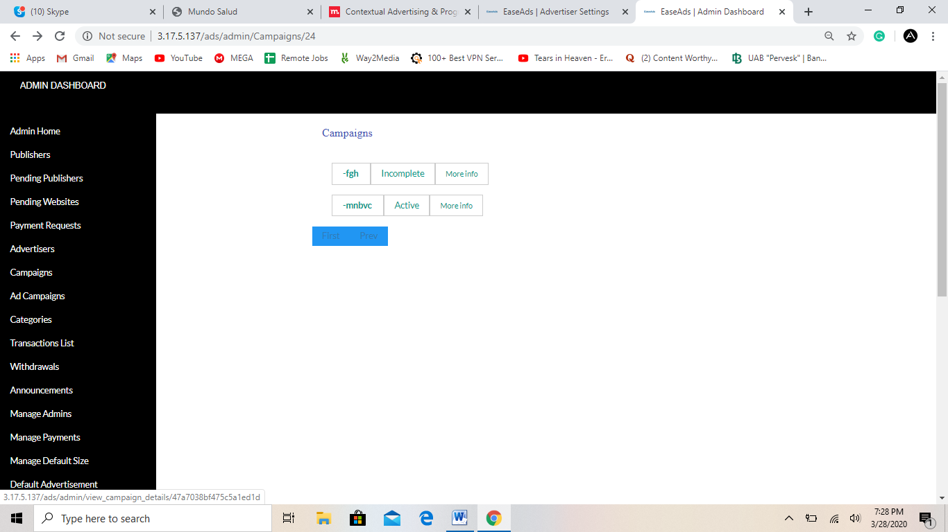

When I click on campaign to see its performance and traffics directly from admin.

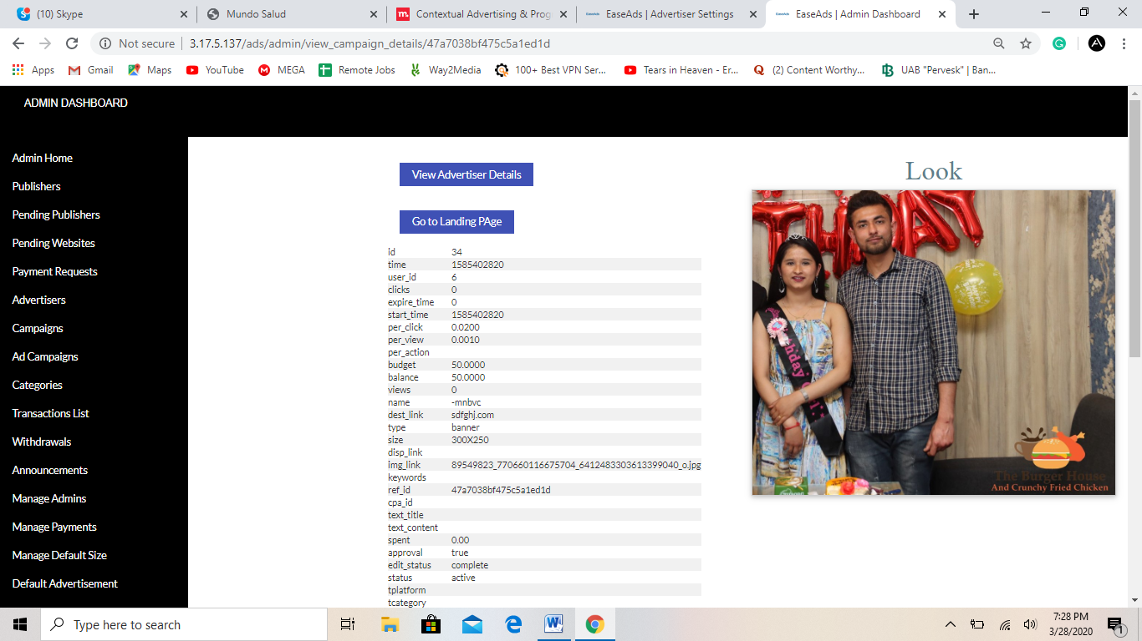

There should be detailed stats for campaign views and clicks and total expenses on traffic. Also, the report for admin should be available for each campaign running and the traffic it is getting.  
Also, the geos or countries from which it is receiving should have different stats for each countries.

This method should be used in ad campaigns or spaces button as well. I should be able to view stat for traffic sent by each website and traffic received by each campaigns and the detailed view for no. of views or clicks and total earning by site or total expense of campaign.

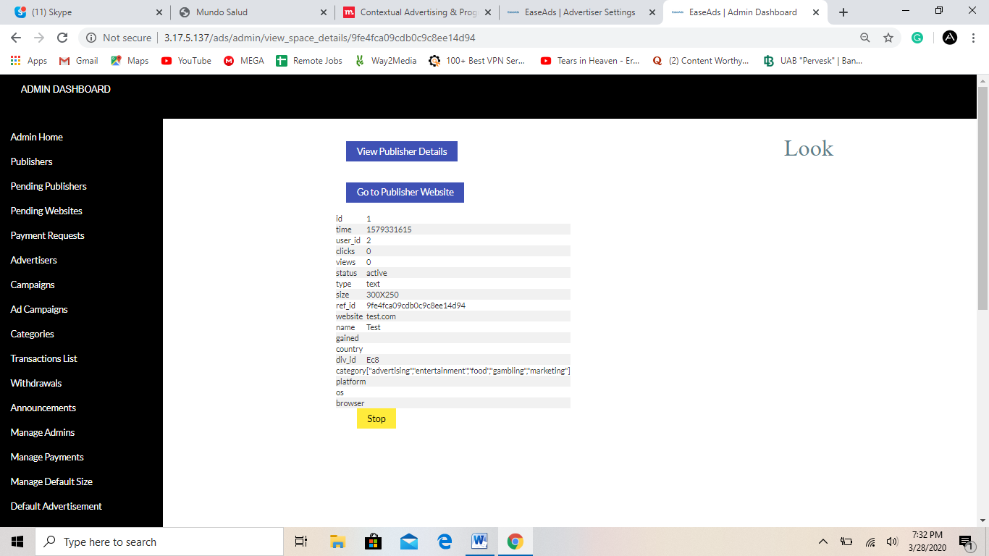

This is current version for stat and detail for the space created by publisher but we need to view total traffic sent and earned by the publisher with traffic number distribution according to the geo.

Also, there should be another button during campaign setting that says Raw traffic:  
Raw traffic  
there will be 3 options  
1- this means that the link or campaign should only get traffic from one user through a website only one time. That is same user wont see the same ad two time in 24 hrs. Even if same person sees the ads the impression wont be counted if the user selects 1. i.e. The impressions will be unique each time.  
Raw traffic 2 means that the ads can be seen by single person 2 times in 24 hours.   
Raw traffic 3 means a single user can view and click the ads 3 times in 24 hours.  
For this system the IP address should be traced for each user and their device is noted through our platform.  
These two buttons should be in below area both in Banners and pop under campaign. This functionality is must.

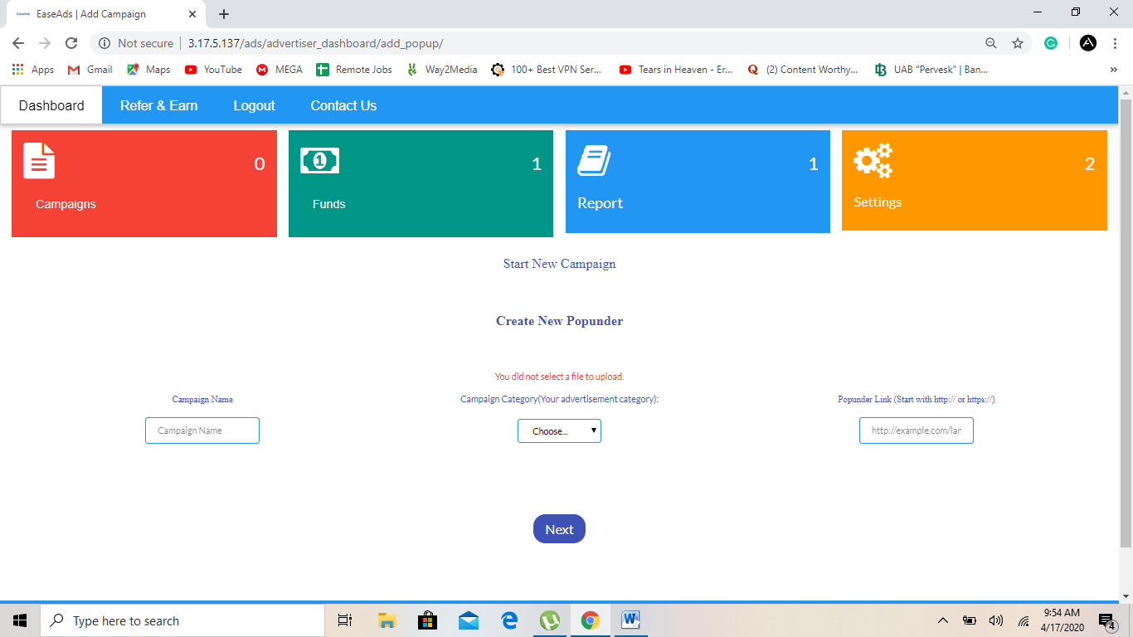

When I start a campaign and go to campaign details to see. I see that it is calculating on CPC whereas I selected CPM in pop under campaign setting. For banners it should show CPM/CPC whichever the advertiser selects. Whereas the calculation for pops should be on CPM which I entered 0.012 and now, it shows following. Please see.  
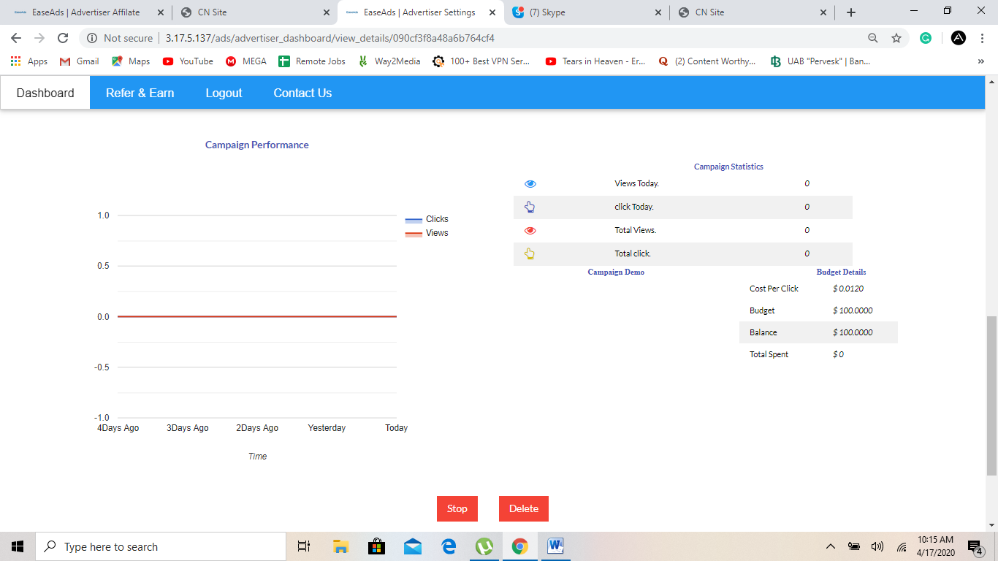

Also, when I enter to this area. There should be a button that says edit campaign details, That way the advertiser can edit all the details he has entered during the start campaign button and it should be same as he has selected before it should not start again but it could be viewed and edited and could be submitted again for approval. They should be able to edit and modify the campaign. As soon as they complete editing, they need to submit the campaign and it will be active only when the admin approves it. It should be pending after the edit.