# Twitter Bot Setup Instruction:

Step 1:  
Install Python 3 and add to path variable

Download python from here:

<https://www.python.org/downloads/>

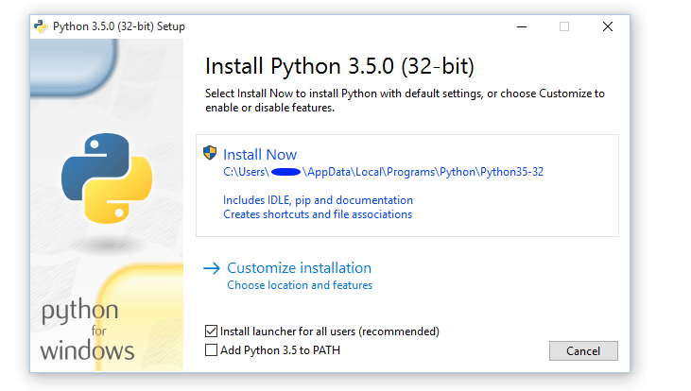

While installing, click the add python 3.x to PATH option

Also add pip to path to do this go to install location

Copy the location of the Scripts path. In default it is:

C:\Python36\Scripts

Then

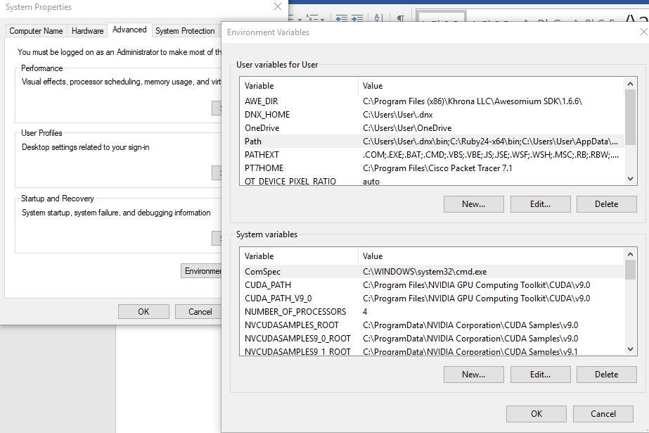

Environment Variables, Path > Edit

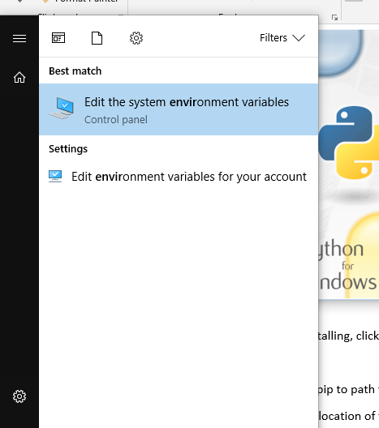

Add the path

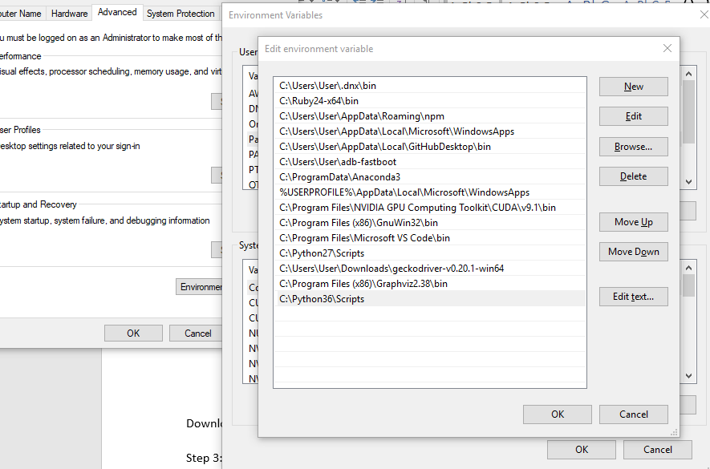

Step 2:

Download these files:

https://mega.nz/#!4nxjHLBJ!qSTRelnCcxZGMKObNwVZK5vtVh7fHc9i6SHB1JkrORc

Step 3:  
Extract those and open cmd with that folder

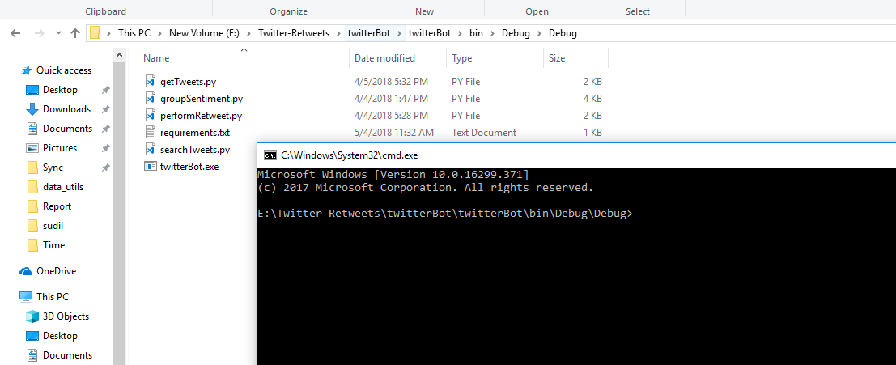

Download the dependencies for the first run. To do this run the following command

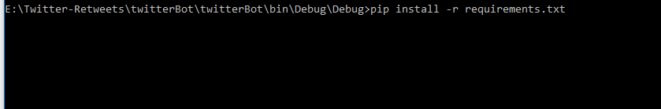

Step 4:  
Download Tweet Embedding and update location

https://mega.nz/#!xjZFRYqA!7DDO2i-JVc0BP4_sovRmXeiKne11wwnAqWLWdXaqY_A

Get the location of the txt file extracted

For me it is:

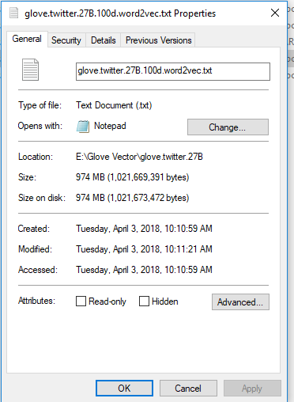

Open groupSentiment.py from a text editor. Change the location in line 14



Add full path in similar pattern

Step 5:

Run.