**Inspiration**

**Anas**

1. [**https://theinspirationgrid.com/never-ending-content-digital-art-by-ben-fearnley/**](https://theinspirationgrid.com/never-ending-content-digital-art-by-ben-fearnley/)
2. [**https://www.youtube.com/watch?v=OhCzX0iLnOc&ab_channel=TED**](https://www.youtube.com/watch?v=OhCzX0iLnOc&ab_channel=TED)
3. [**https://www.youtube.com/watch?v=qCWKalCzOpk&ab_channel=reelyActive**](https://www.youtube.com/watch?v=qCWKalCzOpk&ab_channel=reelyActive)
4. [**https://www.behance.net/gallery/72383155/SK-II-Future-X-Pop-Up-Store?tracking_source=search_projects_recommended%7Cinteractive%20art%20installation**](https://www.behance.net/gallery/72383155/SK-II-Future-X-Pop-Up-Store?tracking_source=search_projects_recommended%7Cinteractive%20art%20installation)
5. [**https://nl.pinterest.com/pin/10907224085648097/**](https://nl.pinterest.com/pin/10907224085648097/)
6. [**https://vimeo.com/119073497**](https://vimeo.com/119073497)
7. [**https://www.wsj.com/articles/the-quiet-growth-of-race-detection-software-sparks-concerns-over-bias-11597378154**](https://www.wsj.com/articles/the-quiet-growth-of-race-detection-software-sparks-concerns-over-bias-11597378154)
8. [**https://www.youtube.com/watch?v=wFkFf6Zu8i4&ab_channel=hochelaga**](https://www.youtube.com/watch?v=wFkFf6Zu8i4&ab_channel=hochelaga)

**Rachelle**

1. <https://pin.it/72YefdU>
2. <https://installationart.tv/new-media-art/>
3. <https://interestingengineering.com/everything-you-need-to-know-about-the-artistic-world-of-creative-coding>
4. <https://timrodenbroeker.de/how-to-rasterize-an-image-with-processing/>
5. <https://krom.studio>

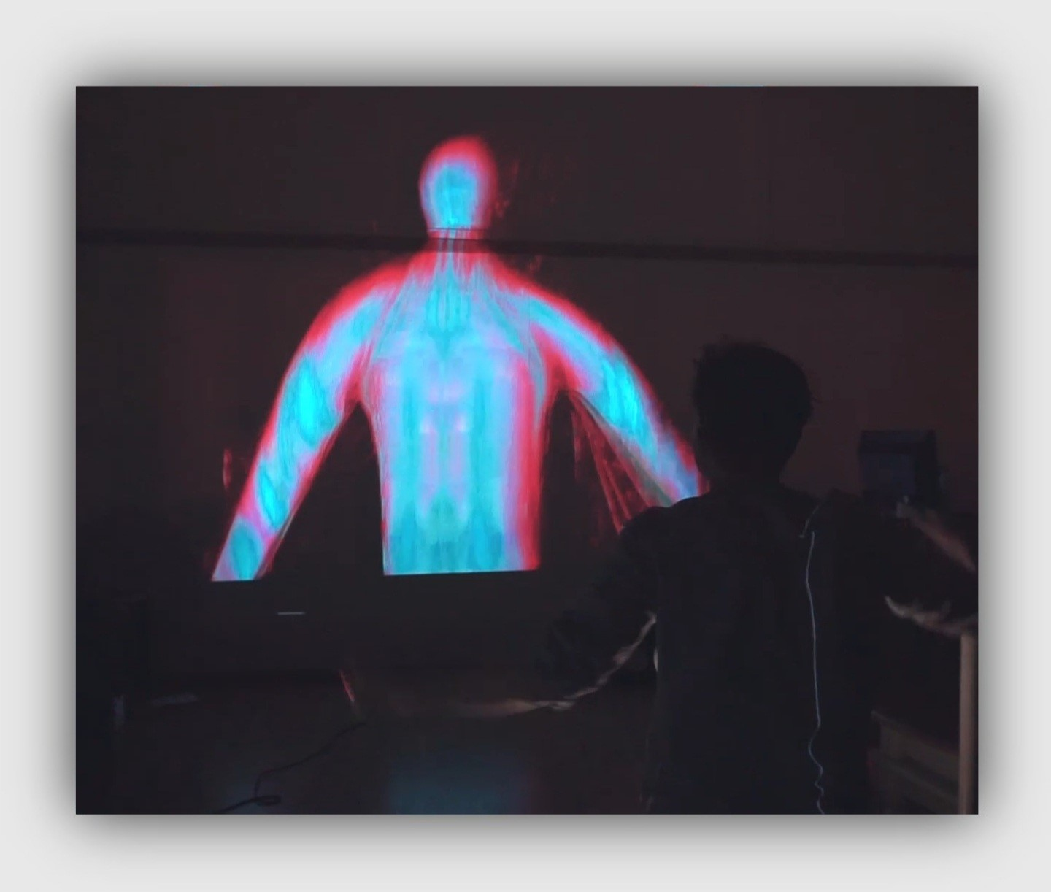

1. 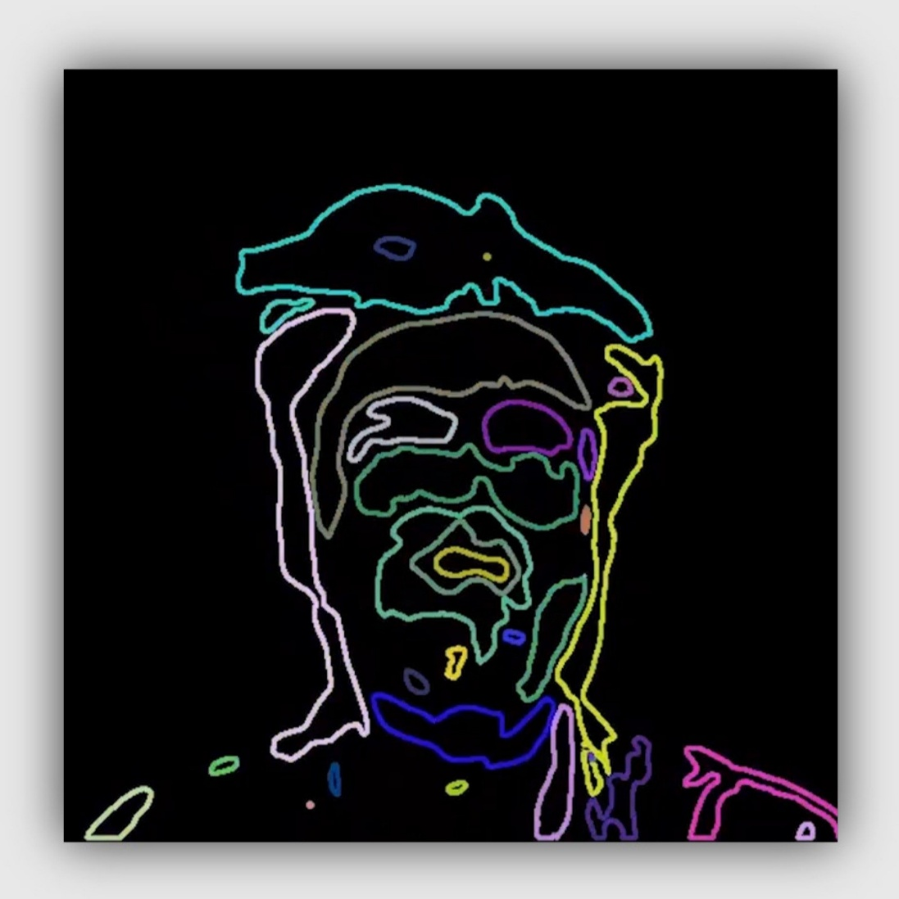
2. <https://medium.com/behind-the-screens-challenge/behind-the-screens-kesson-a7f8e0a870e4> (<https://www.instagram.com/creativecodingutrecht/> )
3. <https://oneiricmirror.art> (<https://kesson.io/work/Oneiric%20Mirror> )
4. <https://www.instagram.com/p/B4fTJItoInE/?utm_source=ig_web_copy_link>
5. <https://www.instagram.com/p/BymYknlH13o/?utm_source=ig_web_copy_link> (<https://www.studiorf.io/shakespeare-interactive-museum/> )
6. <https://www.studiorf.io/pygmachia/>
7. <https://www.am-cb.net/projets/xyzt>
8. <https://www.am-cb.net/en/projets/pixel>
9. <https://www.youtube.com/watch?v=1MJCohk3-04> (TedTalk: <https://www.youtube.com/watch?v=UxQDG6WQT5s>)
10. <https://www.behance.net/gallery/91186295/Arkhe?tracking_source=search_projects_recommended%7Ccreative%20coding>
11. <https://www.behance.net/gallery/67009145/Multiverse-Perpetual-light-installation?tracking_source=search_projects_recommended%7Ccreative%20coding>
12. <https://www.behance.net/gallery/114183287/Real-time-generative-art?tracking_source=search_projects_recommended%7Ccreative%20coding>
13. <https://www.behance.net/gallery/72383155/SK-II-Future-X-Pop-Up-Store?tracking_source=search_projects_recommended%7Cinteractive%20art%20installation>
14. <https://www.behance.net/gallery/93863537/Quantum-Space?tracking_source=search_projects_recommended%7Cinteractive%20art%20installation>
15. <https://www.behance.net/gallery/100612245/Remnant?tracking_source=search_projects_recommended%7Cinteractive%20art%20installation>
16. <https://www.behance.net/gallery/113886057/Still-Moving-Installation?tracking_source=search_projects_recommended%7Cinteractive%20art%20installation>