Supplementary information

For: Variable and sub-optimal responses to a choice problem are a persistent default mode

Amelia R. Hunt¹, Warren R.G. James¹, Josephine Reuther², Melissa Spilioti¹ & Alasdair D.F. Clarke³

Contains Additional plots and analysis

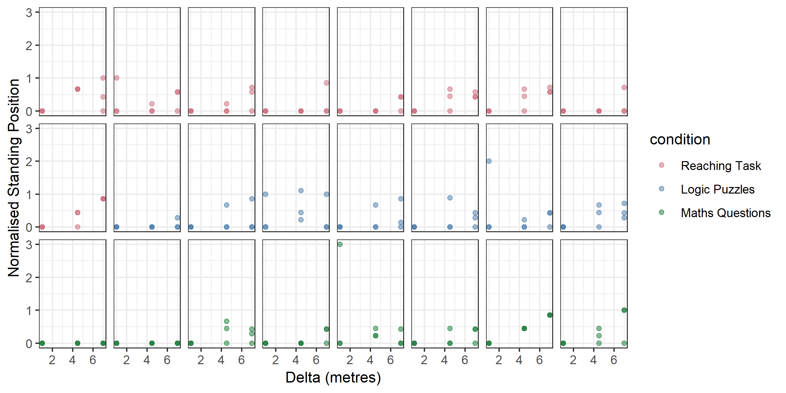
Figure S.1.1. Normalized standing position for each of three distances between hoops in E1B. Each dot represents one trial and each panel is a participant. The throwing task was preceded by the reaching/table task, a relevant logic puzzle, or math questions. Which task the participant performed is denoted by the dot color.

Accuracy across the three groups is shown in Figure S.1.2. The table group is more variable, but the means are overall very similar across the three groups, suggesting the experience of doing the table task or the logic puzzles did not lead to better decisions in the throwing task.

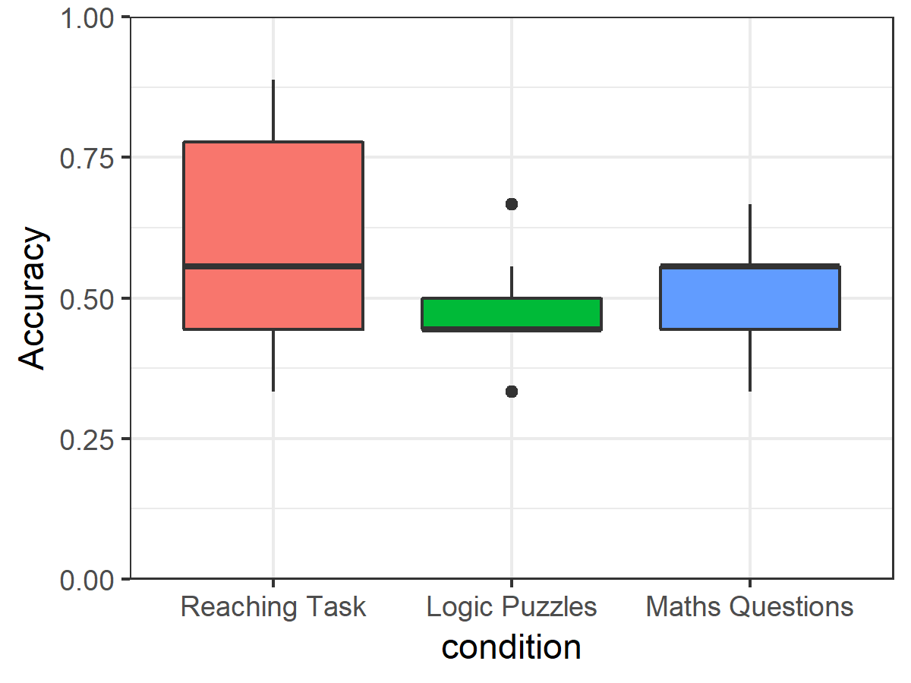
Figure S.1.2. Boxplots showing throwing accuracy for each of the three groups of participants.

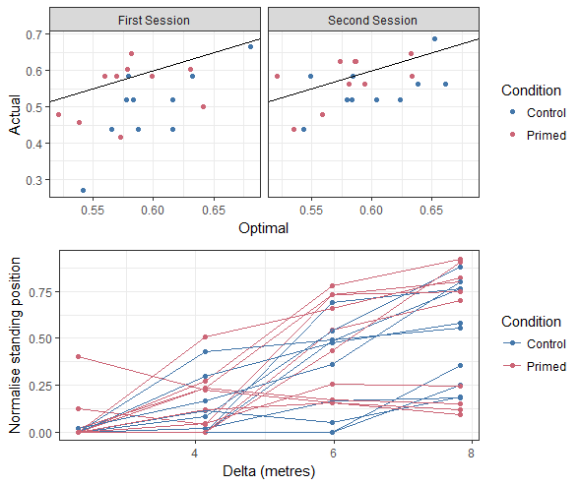
Figure S.2.1. Top row scatterplots show the actual accuracy relative to an estimate of optimal accuracy in the first and second session of Experiment 1C. The primed group did the table task between sessions. The bottom row line plot shows the average standing position across hoop separations during the second session. There is no difference between groups on either measure.

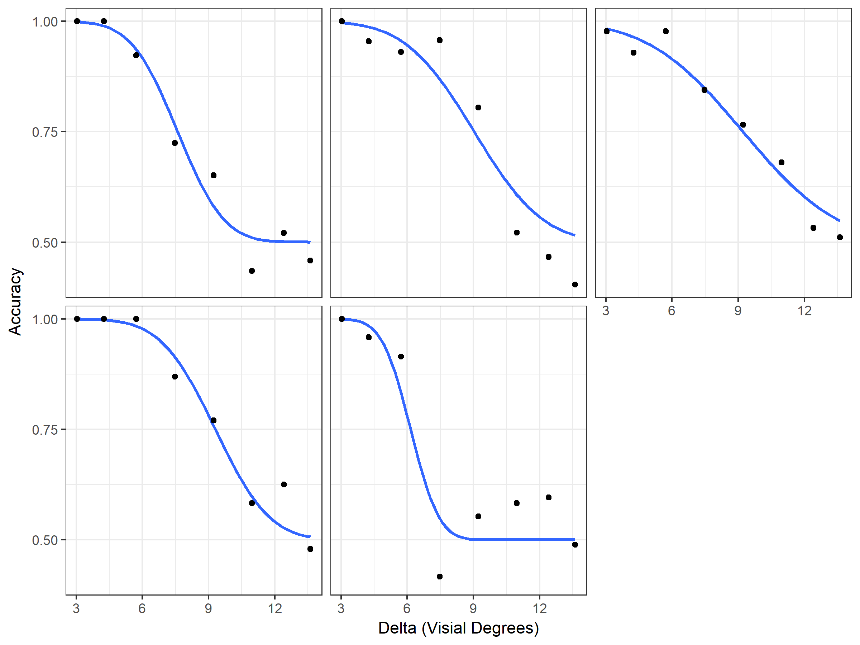
Figure S.4.1. Performance curves from the sensitivity mapping phase for the 5 non-naive participants in Experiment 3. Chance is 0.50. The value of Delta where accuracy is 0.75 is the switch point calculated for each individual for the choice task. For separations below this value, they should fixate the center box, and for separations above this value, they should fixate one of the two side boxes.
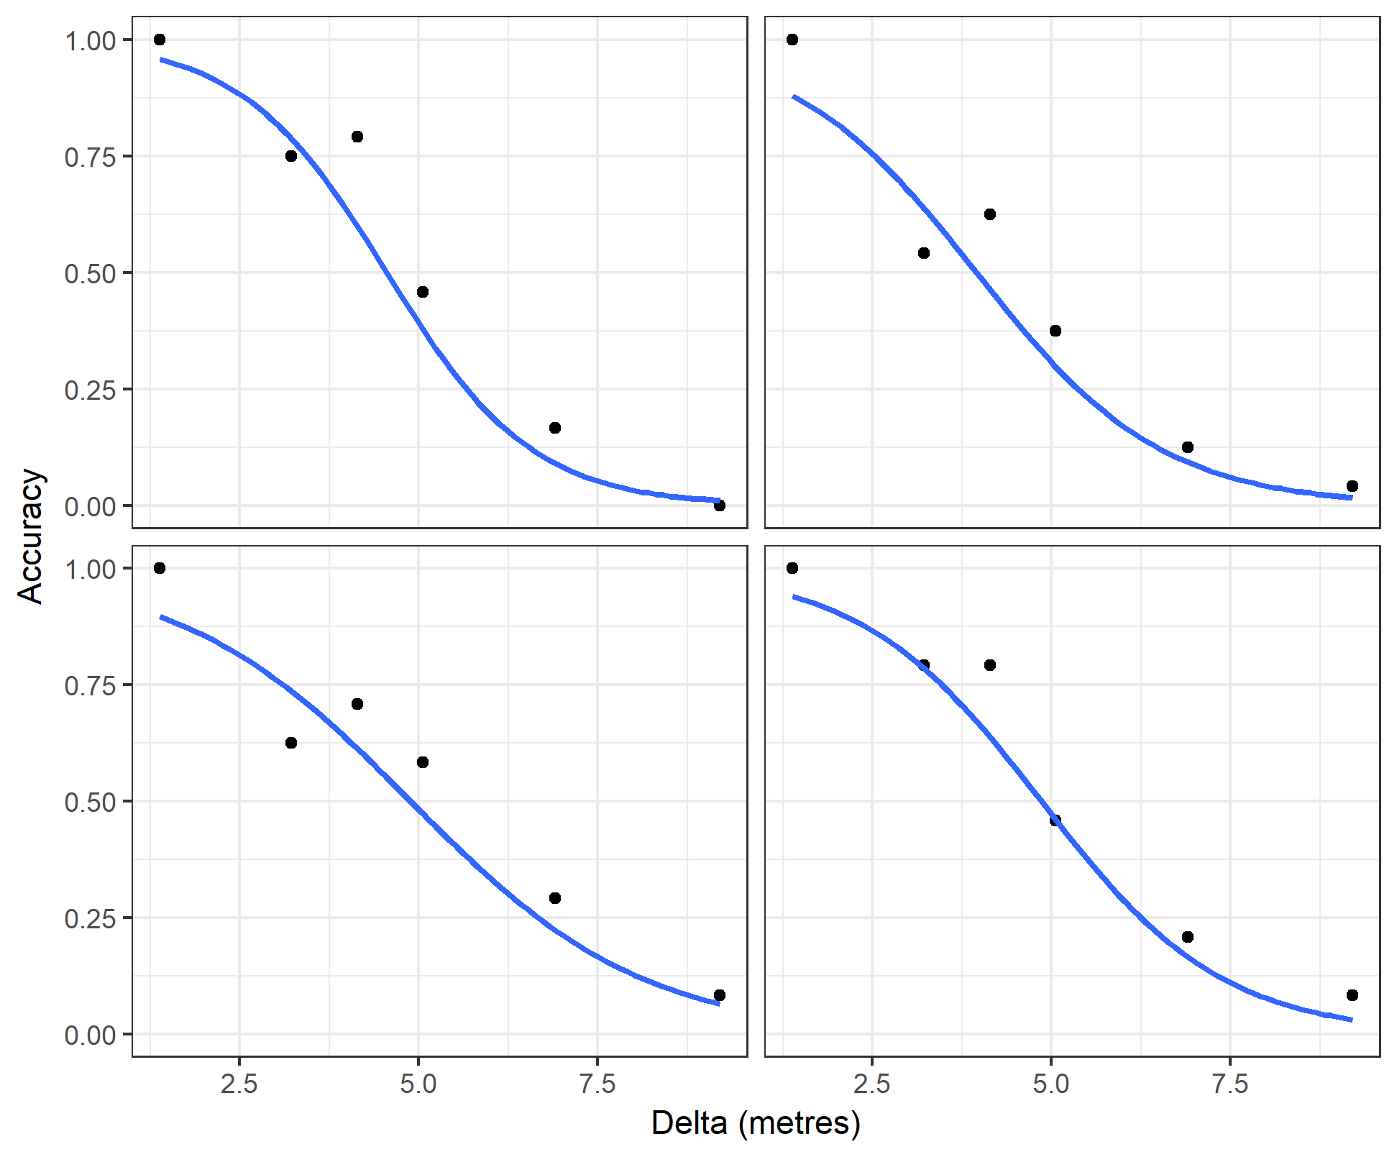
Figure S.4.2. Performance curves from the throwing accuracy session for the 4 non-naive participants in Experiment 3. The value of Delta where accuracy is 0.5 is the switch point calculated for each individual for the choice task. For separations below this value, they should stand midway between the two hoops, and for separations above this value, they should stand near one of the hoops.
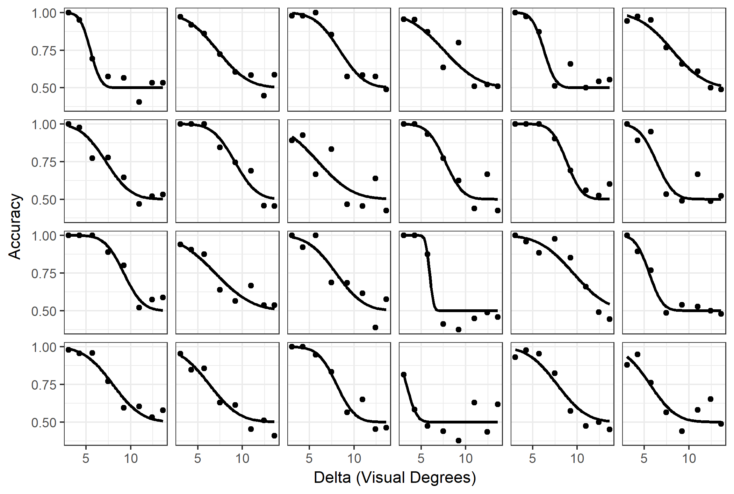
Figure S.4.3. Performance curves from the acuity mapping phase for participants in Experiment 2 in the main text. Chance is 0.50. The value of Delta where accuracy is 0.75 is the switch point calculated for each individual for the choice task. For separations below this value, they should fixate the center box, and for separations above this value, they should fixate one of the two side boxes. These switch points are plotted in Figure S.4.2 below.

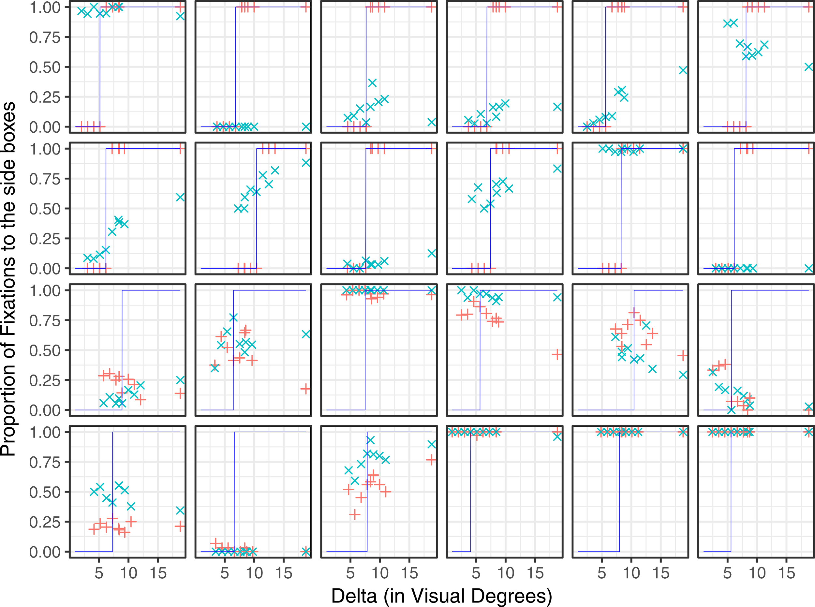
Figure S.4.4. Proportion of fixations to the side boxes for each participant in Experiment 2. The red crosses show Session 1 performance and the blue show Session 2. The top two rows are participants in the Primed group, and the bottom two rows are control. The blue lines depict optimal performance based on each participant’s sensitivity shown in Figure S.4.1 above.

Bayesian model of the results of Experiment 2.
We used a Bayesian generalised linear mixed effect model to compare the effects of practise and instruction on accuracy between groups and over values of delta. The advantage of using such an approach is that it allows us to estimate the effect size, and the associated uncertainty. Modelling was done using rStan v2.17.3 (Carpenter et al., 2017) and the rethinking package v1.59 (McElreath, 2016) for R 3.4.0. A logit link was used and we accounted for differences between individuals by allowing intercepts to vary. We included three fixed effects: group (control/instructed); block (in the first block, one group was instructed where to fixate, while in the second block, neither group were given instruction); and delta (the separation between the centre and side boxes). The model that allowed for all two-way interactions and a three-way interaction between these predictors outperformed the other models we considered (using WAIC) so we report results from that model.
To visualise the model, we computed the predicted accuracy for the average participant, and recoded our variables to give: baseline (the control group in the first block), instructed (the instructed group in the first block), practice (the control group in the second block) and transfer (the instructed group in the second block). The posterior distributions are shown in Figure S.4.3. We can see there is some evidence for an effect of learning for the small separations (the transfer condition outperforms the effect of practise), but this does not hold over for the large separations. A plausible interpretation of this result is that instructions biased people to fixate the center more often than the sides; this bias promotes near-optimal performance for the close separations, to the detriment of performance at the far separations. Alternatively, there may have simply been more participants with a central bias in our primed group to begin with. Regardless, the results are consistent with Experiment 1 in suggesting people do not readily recognize and apply an optimal solution to this decision problem. There is very little evidence to suggest experience with implementing the optimal solution led participants to continue to implement it when making subsequent choices in the same decision context.
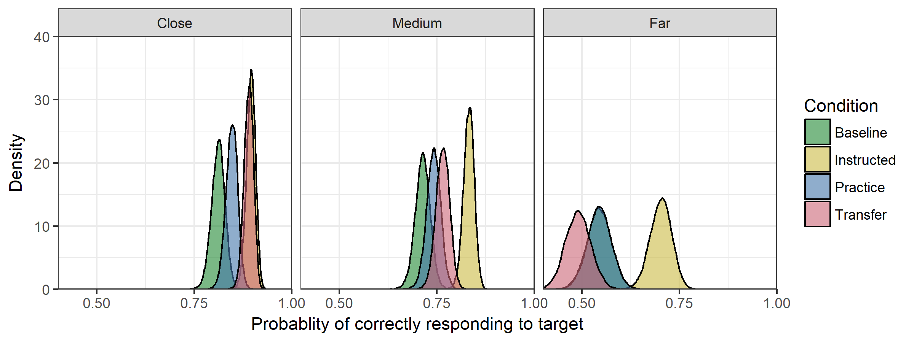
Figure S.4.5. Posterior distributions showing the predicted accuracy for a hypothetical average participant. Instruction improves accuracy across all separations. The “transfer” distribution estimates performance after this instruction is taken away. It is slightly better than practice at the smaller separations, but this difference is not observed at the farthest separations.

References

Carpenter, B., Gelman, A., Hoffman, M. D., Lee, D., Goodrich, B., Betancourt, M., Brubaker, M., Guo, J,. Li, P., & Riddell, A. (2017). Stan: A probabilistic programming language. Journal of statistical software, 76(1).
Clarke, A.D.F. & Hunt, A.R. (2016). Failure of intuition when choosing whether to invest in a single goal or split resources between two goals. Psychological Science, 27, 64–74.
James, W., Clarke, A.D.F. & Hunt, AR. (2017). Failure to use probability of success when deciding whether to pursue one goal or two. in Proceedings of the 39th annual meeting of the Cognitive Science Society. Cogsci, pp. 2279-2283.
James, W.R.G., Hunt, A.R. & Clarke, A.D.F. (in press). Six of one, half dozen of the other: Suboptimal prioritizing for equal and unequal alternatives. Memory and Cognition.

Morvan, C. and Maloney, L. T. (2012). Human visual search does not maximize the post-saccadic probability of identifying targets. PLoS Computational Biology, 8(2):e1002342.
Nowakowska, A., Clarke, A.D.F. & Hunt, A.R. (2017). Human visual search is far from ideal. Proceedings of the Royal Society B: Biological Science, 284, 2016.2676.

