Pd2-Taiko

UML

|  |
| --- |
| mainwindow |
|  |
| <<constructor>>+Form  +MainWindow(QWidget *parent = 0);  -on_pushButton_clicked() : void  -on_pushButton_2_clicked() :void |

|  |
| --- |
| form |
| -Time : int  -Score :int  -Dialog :Dialog  -Callparent : QWidget |
| +Form(QWidget *_callparent = 0, QWidget *parent = 0);  +movelabel() : void  +changeTime() : void  +restart() :void  -*keyPressEvent*(QKeyEvent *) : void |

|  |
| --- |
| dialog |
|  |
| -on_pushButton_clicked() : void  -on_pushButton_2_clicked() : void |

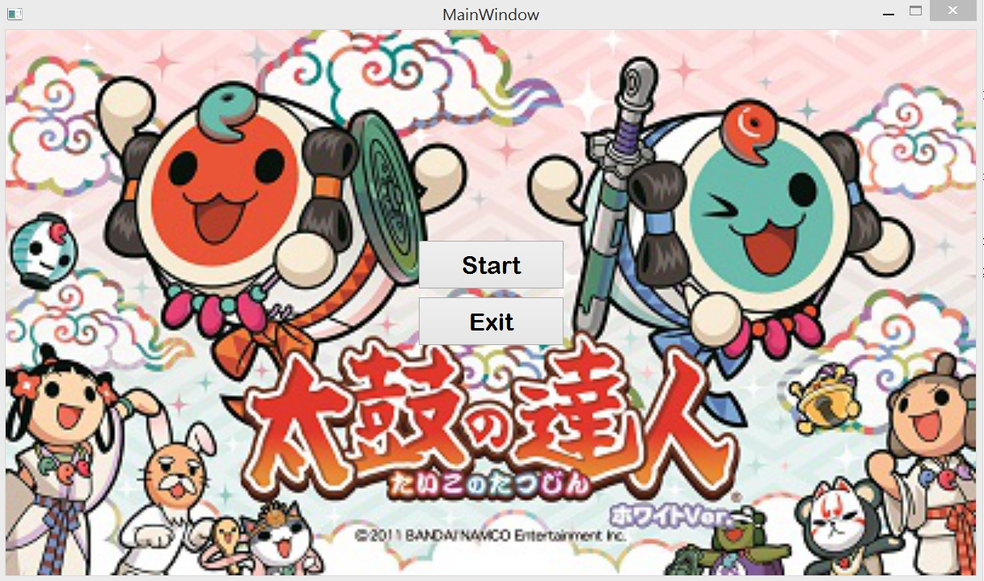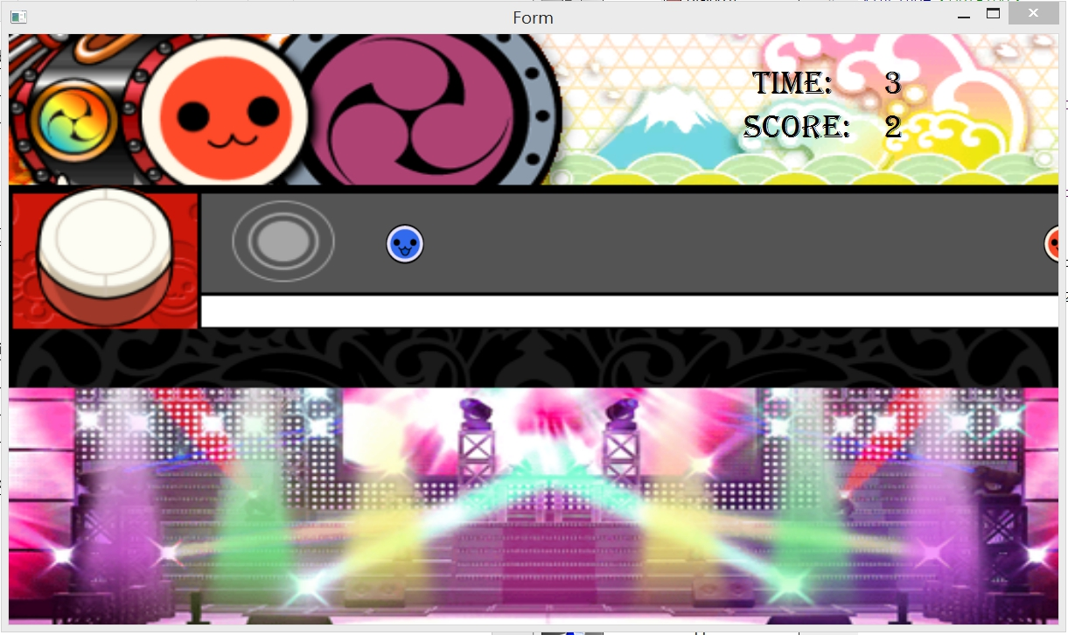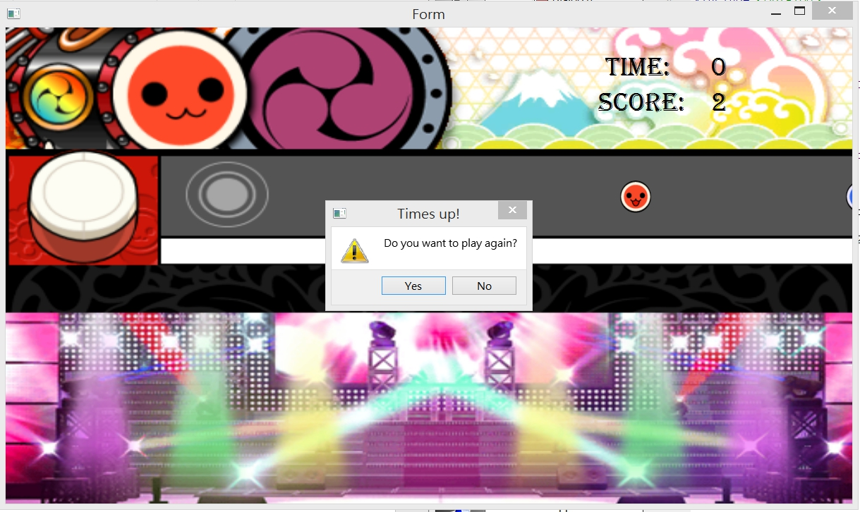

How to play

紅色的鼓用J消去

藍色的鼓用K消去

時間到按Yes就可以restart