FR. CONCEICAO RODRIGUES COLLEGE OF ENGINEERING

Department of Computer Engineering

Course, Subject & Experiment Details

|  |  |
| --- | --- |
| Practical No: | 2 |
| Title: | To study and implement Hosted Virtualization using  VirtualBox& KVM. Objective: To know the concept of Virtualization along with their types, structures and mechanisms. This experiment should have demonstration of creating and running Virtual machines inside hosted hypervisors like VirtualBox and KVM with their comparison based on various virtualization parameters. |
| Name of the Student: | Warren Fernandes |
| Roll No: | 8940 |
| Date of Performance: | 28/03/2022 |
| Date of Submission: | 28/03/2022 |

Evaluation:

|  |  |  |
| --- | --- | --- |
| Sr. No. | Rubric | Grade |
| 1 | On time submission/completion (2) |  |
| 2 | Preparedness (2) |  |
| 3 | Skill (4) |  |
| 4 | Output (2) |  |

Signature of the Teacher

Hosted Virtualization on Oracle Virtual Box Hypervisor

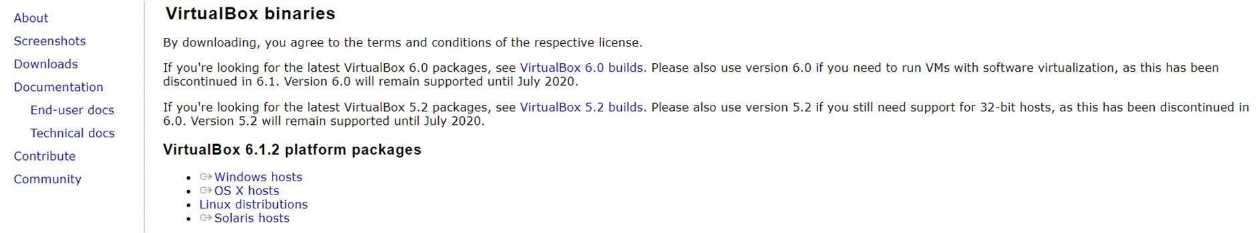

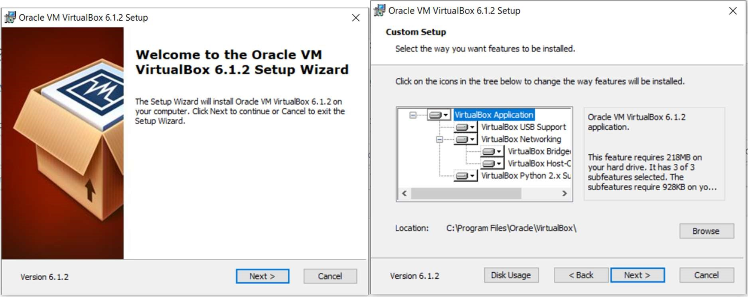

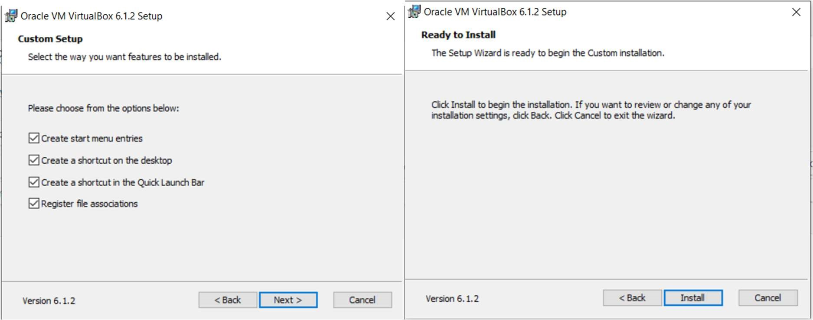

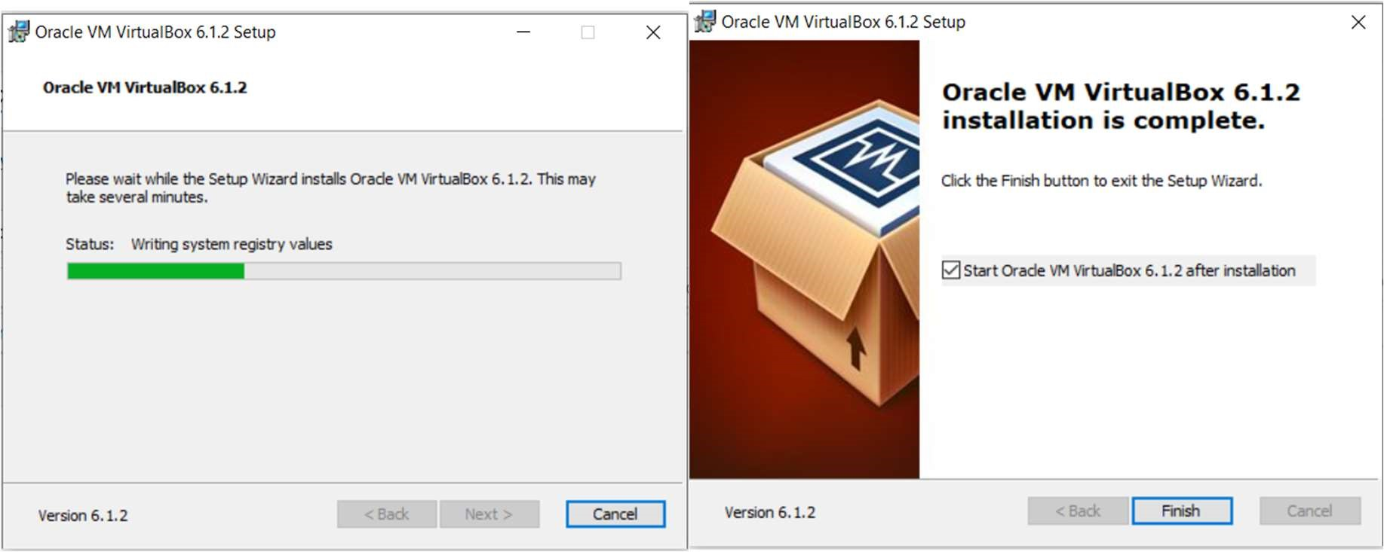

Hosted Virtualization on KVM Hypervisor

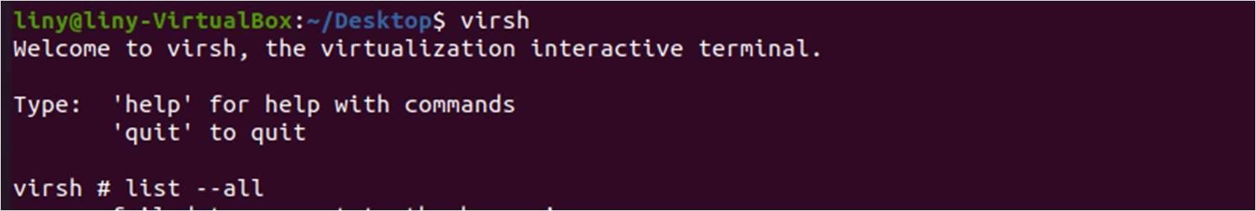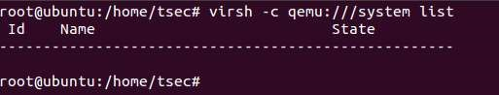

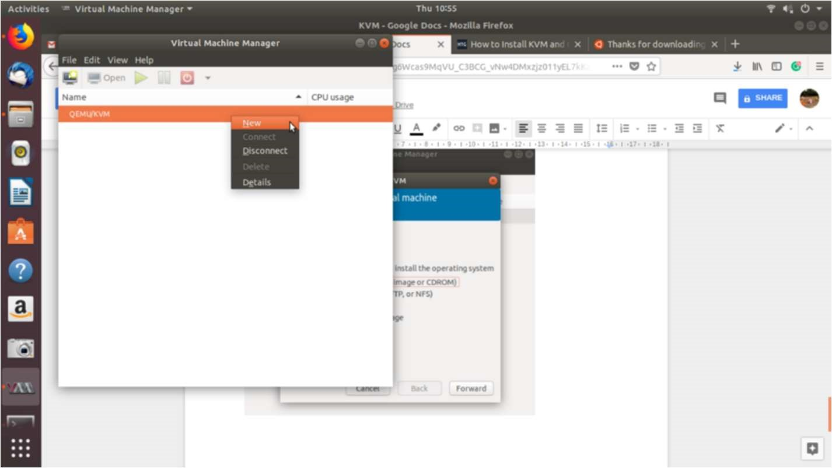

Experiment 2: Virtualization Post Lab Questions

1. What are the basic pros and cons of virtualization? Pros of Virtualization in Cloud Computing:

1. Utilization of Hardware Efficiently –

With the help of Virtualization Hardware is Efficiently used by user as well as Cloud Service Provider. In this the need of Physical Hardware System for the User is decreases and this results in less costly. In Service Provider point of View, they will vitalize the Hardware using Hardware Virtualization which decrease the Hardware requirement from Vendor side which are provided to User is decreased.

1. Availability increases with Virtualization –

One of the main benefits of Virtualization is that it provides advance features which allow virtual instances to be available all the times. It also has capability to move virtual instance from one virtual Server another Server which is very tedious and risky task in Server Based System. During migration of Data from one server to another it ensures its safety. Also, we can access information from any location and any time from any device.

1. Disaster Recovery is efficient and easy –

With the help of virtualization Data Recovery, Backup, Duplication becomes very easy. In traditional method, if somehow due to some disaster if Server system Damaged then the surety of Data Recovery is very less. But with the tools of Virtualization real time data backup recovery and mirroring become easy task and provide surety of zero percent data loss.

1. Virtualization saves Energy –

Virtualization will help to save Energy because while moving from physical Servers to Virtual Server’s, the number of Server’s decreases due to this monthly power and cooling cost decreases which will Save Money as well. As cooling cost reduces it means carbon production by devices also decreases which results in Fresh and pollution free environment.

1. Quick and Easy Set up –

In traditional methods Setting up physical system and servers are very timeconsuming. Firstly, Purchase them in bulk after that wait for shipment. When Shipment is done then wait for Setting up and after that again spend time in installing required software etc. Which will consume very time. But with the help of virtualization the entire process is done in very less time which results in productive setup.

1. Cloud Migration becomes easy –

Most of the companies those who already have spent a lot in the server have a doubt of Shifting to Cloud. But it is more cost-effective to shift to cloud services because all the data that is present in their server’s can be easily migrated into the cloud server and save something from maintenance charge, power consumption, cooling cost, cost to Server Maintenance Engineer etc.

Cons of Virtualization:

1. Data can be at Risk –

Working on virtual instances on shared resources means that our data is hosted on third party resource which put’s our data in vulnerable condition. Any hacker can attack on our data or try to perform unauthorized access. Without Security solution our data is in threaten situation.

1. Learning New Infrastructure –

As Organization shifted from Servers to Cloud. They required skilled staff who can work with cloud easily. Either they hire new IT staff with relevant skill or provide training on that skill which increase the cost of company.

1. High Initial Investment –

It is true that Virtualization will reduce the cost of companies but also it is truth that Cloud have high initial investment. It provides numerous services which are not required and when unskilled organization will try to set up in cloud they purchase unnecessary services which are not even required to them.

1. What are Intel VT/ AMD-V / hvm?

Intel VT and AMD's AMD-V are instruction set extensions that provide hardware assistance to virtual machine monitors. They enable running fully isolated virtual machines at native hardware speeds, for some workloads.

HVM (for Hardware Virtual Machine) is a vendor-neutral term often used to designate the x86 instruction set extensions.

1. How to find out If CPU Support Intel VT and AMD-V Virtualization Support?

Check if you have Intel VT-X –

* + Use Win + S to open Start Menu search box and type System Information • Under System Summary > Processor note down the Processor name.
  + Open Intel’s product specification site.
  + Enter the number of the processor in the search box located on the right side.
  + In the processor product page, and under Advanced Technologies, check to see if Intel® Virtualization Technology (VT-x) is supported.

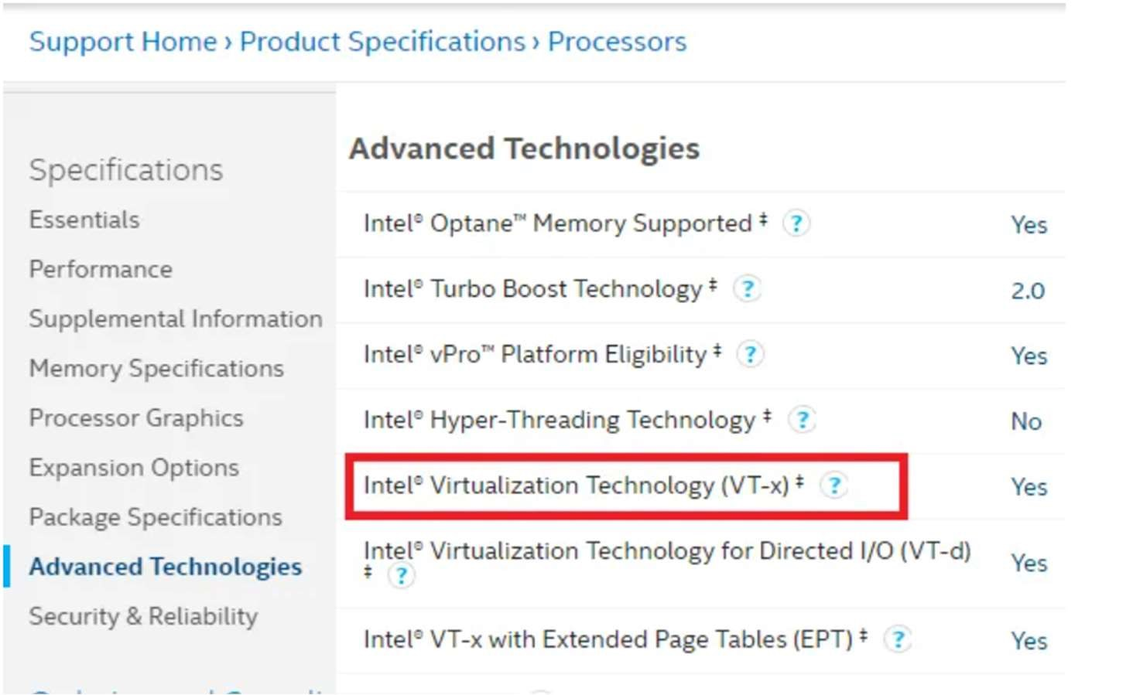

Check if you have AMD-V

It’s hard to figure this out clearly as there is no clear section on AMD website as Intel. The only utility available can check if you have Hyper V. Download and run the AMD-V with RVI Hyper V Compatibility Utility to check.

1. What is the difference between KVM and XEN?

|  |  |  |
| --- | --- | --- |
| Comparison item Xen | | KVM 2007 |
| Released | 2003 |
| Supporting enterprise | Citrix, Novell, Oracle, Ret Hat (RHEL5) and Virtual Iron | Redhat, Ubuntu, etc.  Full virtualization  CPU that supports    virtualization  UNIX, Linux and  Microsoft Windows |
| Supporting virtualization technology | Full virtualization, paravirtualization |
| Supporting structure | x86, IA64 and ARM from AMD, Fujitsu, IBM, Sun and other companies, as well as x86/64 CPU vendors and Intel CPU embedded support |
| Supporting operating system | UNIX, Linux and Microsoft Windows |
| Live migration | stand by | Support (not previously supported) |
| Kernel support | Need to patch the kernel | Built-in the kernel |

1. What is the difference between KVM and VMware?

|  |  |  |
| --- | --- | --- |
| Feature | KVM | VMware vSphere |
| Hypervisor Type | Type 1 | Type 1 |
| Deployment Complexity | Difficult | Easy |
| Storage | All types of storage supported in Linux | SAS disks for local storage. VMFS, iSCSI, NFS datastores |
| Native virtual disk format | RAW(IMG), QCOW2 | VMDK |
| Raw Device Mapping | Yes. LVM is supported | Yes |
| Thin provisioning | Yes | Yes |
| Native file systems | Linux file systems, NFS | VMFS, NFS |
| VM snapshots | Yes | Yes |
| VM live migration | Yes | Yes |
| VM storage migration | Yes | Yes |
| VM Live storage migration | No | Yes |
| Clustering features | Yes (limited) | Yes (wide support) |
| High availability | Yes, with DRBD | Yes |
| Load balancing | Limited | Yes (DRS) |
| Fault Tolerance | No | Yes |
| Management  interface | Command line (virsh), KVM virt-manager | vSphere Client, Host Client, ESXCLI, PowerCLI |
| AD integration | Yes | Yes |
| Price | Free/Low (pay only for tech support) | High |
| Performance | High | High |
| Tech support | Oracle KVM, Red Hat KVM | Yes |
| Supported guest OSs | Wide | Wide |
| Networking | Virtual switch, Distributed switching, NIC bonding, link  aggregation | vSwitch, Distributed vSwitch, NIC Teaming and link aggregation, NSX |
| Firewall | Wide Linux functionality with iptables | Basic ESXi firewall or additional functionality of NSX |
| Container Integration | Yes | Yes |
| Nested  Virtualization | Yes | Yes |
| VM Linked Clones | Yes | Yes |

1. What is the difference between KVM and QEMU?

KVM - resides in the Linux kernel as a loadable module. Once loaded, KVM converts the Linux kernel into a type-1 hypervisor aka bare-metal hypervisor. KVM virtualization uses the Linux kernel as its hypervisor (VM is essentially a process). However, it depends on the Intel-VT and AMD-V virtualization extensions on Intel and AMD respectively for hardware assists to enable robust virtualization. Working in concert with these extensions, KVM helps deliver a better virtualization experience with higher throughput of almost near-zero latency. Thus, all the VMs (read process) can run without any performance or compatibility hit, as if it was running natively on a dedicated CPU. Also, because of the aforementioned extensions the VMs have a greater awareness of the capabilities of the underlying hardware platform. Therefore, is fair to say that KVM offers hardware virtualization in its sincerest and best form.

QEMU - On the other hand resides in the user space and provides system emulation including the processor and various peripherals. Typically, QEMU is deployed along with KVM as an in-kernel accelerator where KVM executes most of the guest code natively, while QEMU emulates the rest of the machine (peripherals) needed by the guest. In places where the VM has to talk to external devices, QEMU uses passthrough.