FR. CONCEICAO RODRIGUES COLLEGE OF ENGINEERING

Department of Computer Engineering

Course, Subject & Experiment Details

|  |  |
| --- | --- |
| Practical No: |  |
| Title: | To study and Implement Platform as a Service using AWS Elastic Beanstalk/ Microsoft Azure App Service. |
| Name of the Student: | Warren Fernandes |
| Roll No: | 8940 |
| Date of Performance: | 28/03/2022 |
| Date of Submission: | 28/03/2022 |

Evaluation:

|  |  |  |
| --- | --- | --- |
| Sr. No. | Rubric | Grade |
| 1 | On time submission/completion (2) |  |
| 2 | Preparedness (2) |  |
| 3 | Skill (4) |  |
| 4 | Output (2) |  |

Signature of the Teacher

With Elastic Beanstalk, you can quickly deploy and manage applications in the AWS Cloud without having to learn about the infrastructure that runs those applications. Elastic Beanstalk reduces management complexity without restricting choice or control. You simply upload your application, and Elastic Beanstalk automatically handles the details of capacity provisioning, load balancing, scaling, and application health monitoring.

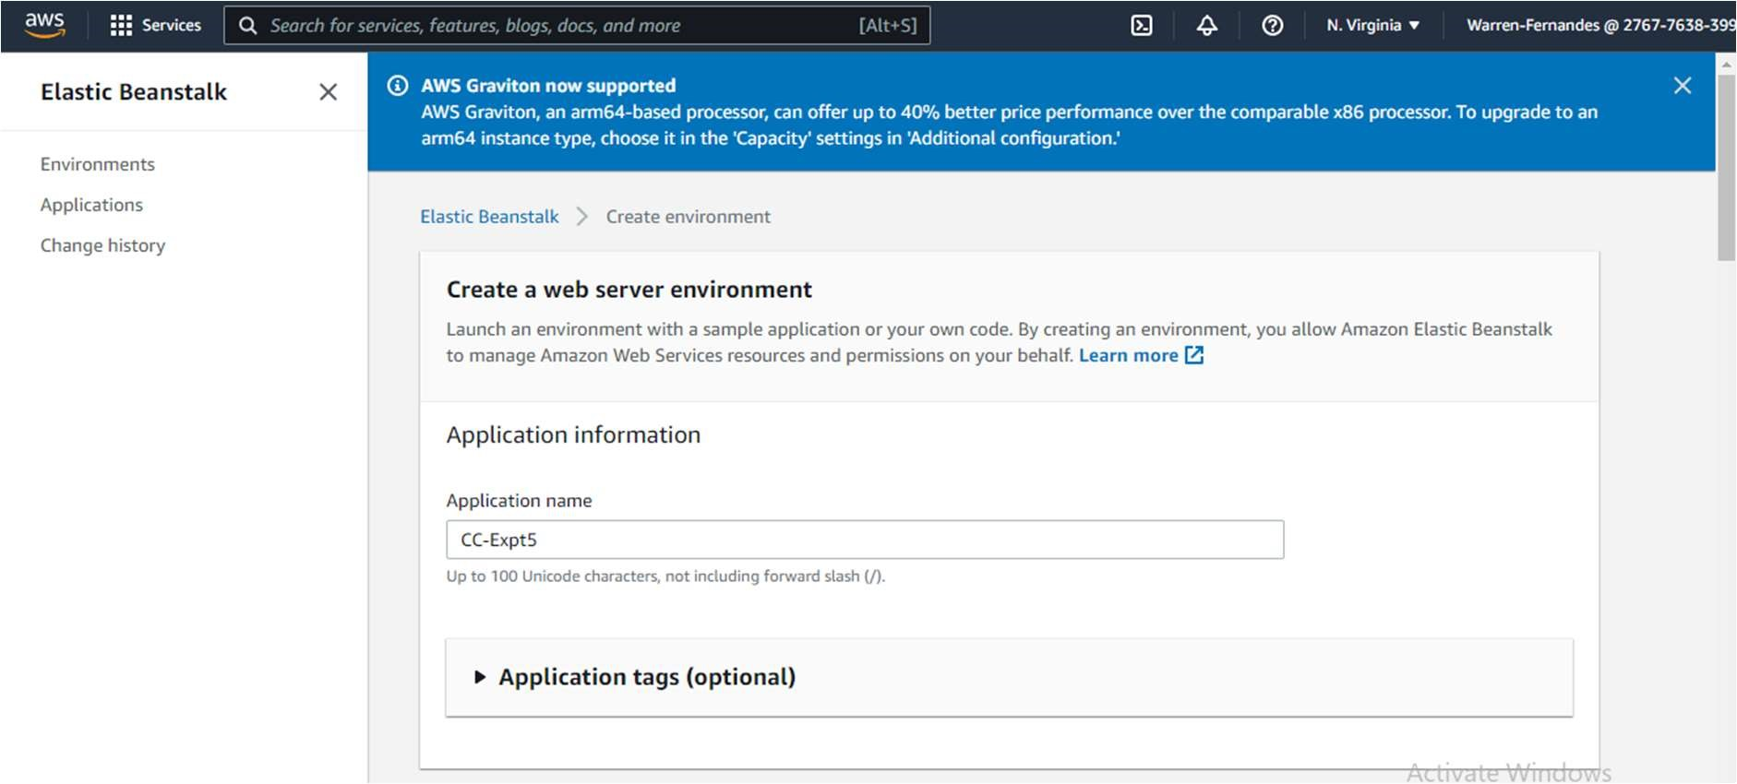

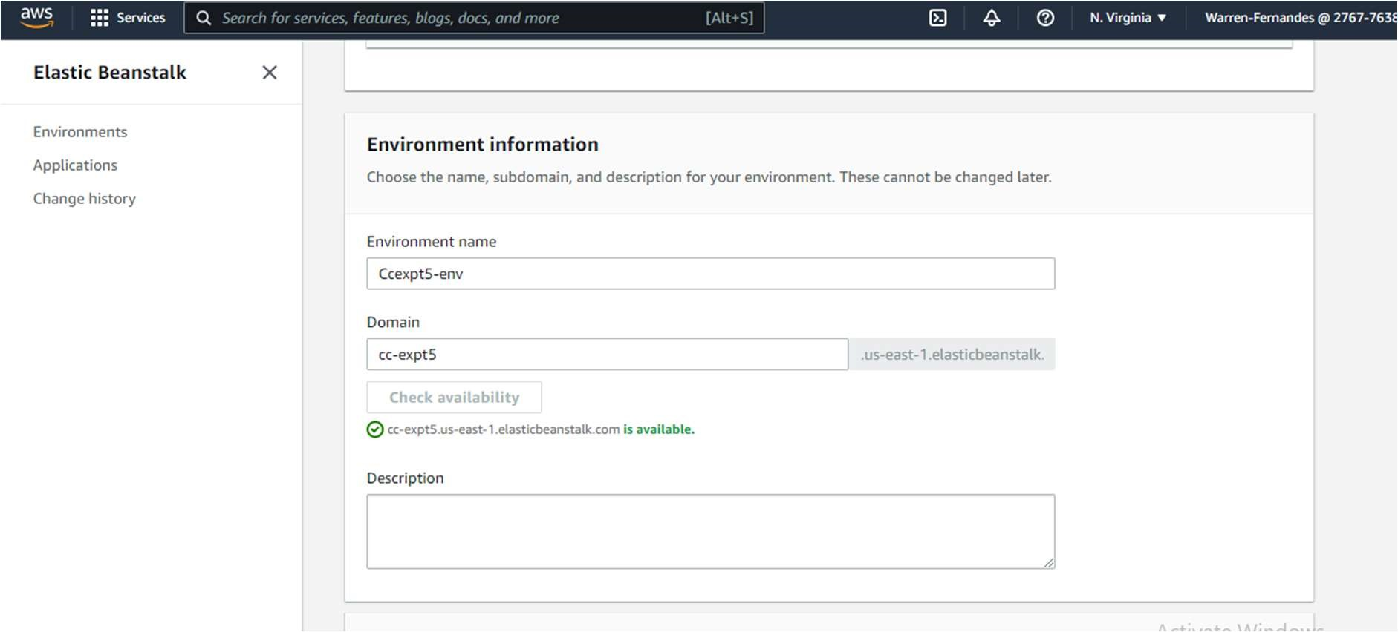

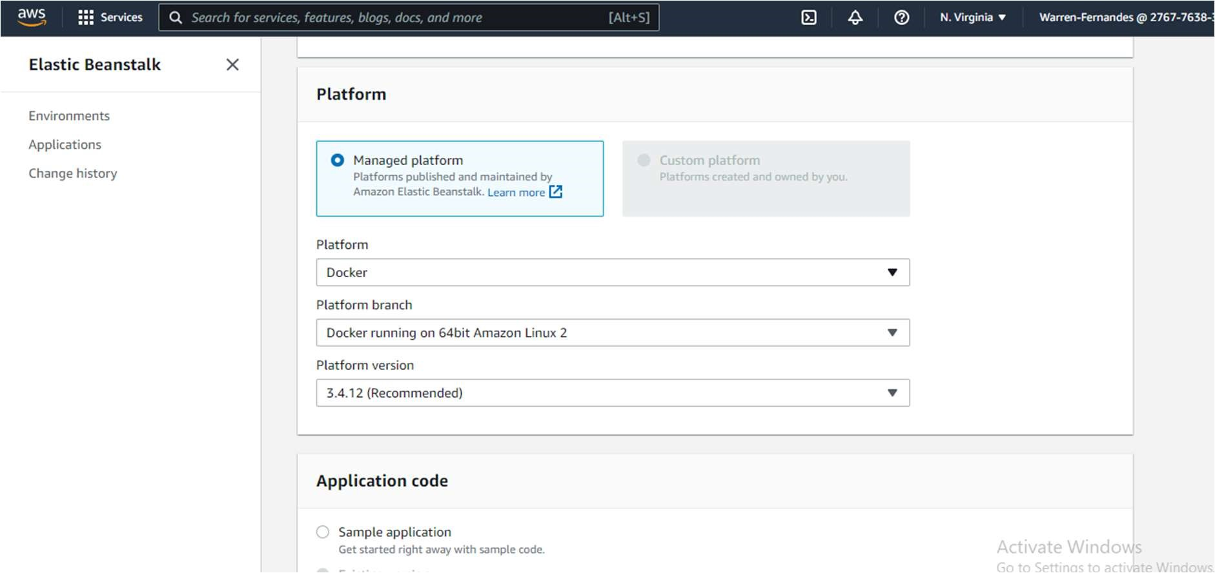

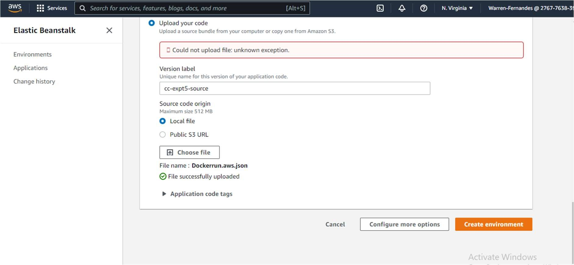

AWS Elastic Beanstalk Postlab Questions

1. How does works Elastic Beanstalk?

By using Elastic Beanstalk, you create an application, upload an application version in the form of an application code bundle (for example, a Python .war file) to Elastic Beanstalk, and then provide some information about the application. Elastic Beanstalk automatically launches an environment, creates and configures the AWS resources needed to run your code. After your environment launch, you can then manage your environment and deploy new application versions. The following diagram illustrates the workflow of Elastic Beanstalk. Elastic Beanstalk supports the DevOps practice name “rolling deployments.” When enabled, your configuration deployments work hand in hand with Auto Scaling to ensure there are always a defined number of instances available as configuration changes made. It gives you control as Amazon EC2 instances are updated.

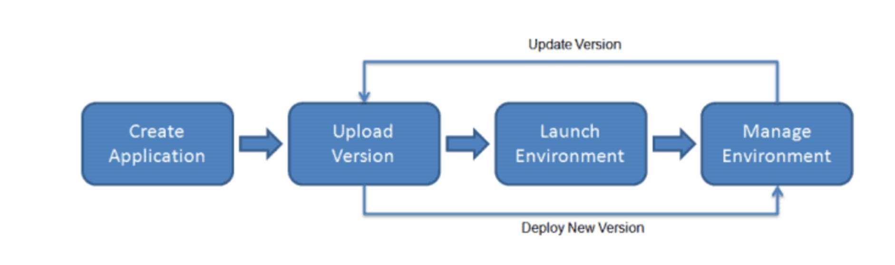

1. What are Benefits and features of Elastic Beanstalk?
   * Fast and simple to deploy: Amazon Elastic Beanstalk is the simplest and fastest way to deploy your application on AWS. You just use the AWS Management Console, a Git repository, or an integrated development environment (IDE) such as Eclipse or Visual Studio to upload your application, and Elastic Beanstalk automatically handles the deployment details of capacity provisioning, auto-scaling, load balancing, and application health monitoring. Within minutes, your application will be ready to use without any infrastructure or resource configuration work on your part.
   * Scalable: Amazon Elastic Beanstalk automatically scales your application up and down based on your application’s need using easily adjustable Auto Scaling settings. For e.g, you can use CPU utilization metrics to trigger Auto Scaling actions. With Elastic Beanstalk, your application can handle peaks in workload or traffic while minimizing your costs.
   * Developer productivity: Amazon Elastic Beanstalk provisions and operates the infrastructure and manages the application stack (platform) for you, so you don’t have to spend the time or develop the expertise. It also keeps the underlying platform running your application up-to-date with the latest patches and updates. So, you can focus on writing code rather than spending time managing and configuring servers, load balancers, databases, firewalls, and networks.
   * Complete infrastructure control: You are free to select the AWS resources, such as Amazon EC2 instance type, that are optimal for your application. Additionally, Elastic Beanstalk lets you “open the hood” and allow you to full control over the AWS resources powering your application. If you decide you want to take over some (or all) of the elements of your infrastructure, you can do so seamlessly by using Amazon Elastic Beanstalk’s management capabilities.
2. Differentiate between AWS CloudFormation and AWS Elastic Beanstalk?

Elastic Beanstalk is intended to make developers' lives easier. CloudFormation is intended to make systems engineers' lives easier.

Elastic Beanstalk is a PaaS-like layer on top of AWS's IaaS services which abstracts away the underlying EC2 instances, Elastic Load Balancers, auto-scaling groups, etc. This makes it a lot easier for developers, who don't want to be dealing with all the systems stuff, to get their application quickly deployed on AWS. It's very similar to other PaaS products such as Heroku, EngineYard, Google App Engine, etc. With Elastic Beanstalk, you don't need to understand how any of the underlying magic works.

CloudFormation, on the other hand, doesn't automatically do anything. It's simply a way to define all the resources needed for deployment in a huge JSON/YAML file. So a CloudFormation template might actually create two Elastic Beanstalk environments (production and staging), a couple of ElasticCache clusters, a DynamoDB table, and then the proper DNS in Route53. I then upload this template to AWS, walk away, and 45 minutes later everything is ready and waiting. Since it's just a plain-text JSON/YAML file, I can stick it in my source control which provides a great way to version my application deployments. It also ensures that I have a repeatable, "known good" configuration that I can quickly deploy in a different region.

1. Who should use AWS Elastic Beanstalk?

Those who want to deploy and manage their applications within minutes in the AWS

Cloud. You don’t need experience with cloud computing to get started. AWS Elastic Beanstalk supports Java, .NET, PHP, Node.js, Python, Ruby, Go, and Docker web applications.

1. What Language Supported by Elastic Beanstalk?

AWS Elastic Beanstalk supports the following languages and development stacks:

Apache Tomcat for Java applications

Apache HTTP Server for PHP applications

Apache HTTP Server for Python applications

Nginx or Apache HTTP Server for Node.js applications

Passenger or Puma for Ruby applications

Microsoft IIS 7.5, 8.0, and 8.5 for .NET applications

Java SE

Docker

Go

1. Can we use Elastic beanstalk to deploy the web application which is made in Node OR PHP?

AWS Elastic Beanstalk is an easy-to-use service for deploying and scaling web applications and services developed with Java, . NET, PHP, Node. js, Python, Ruby, Go, and Docker on familiar servers such as Apache, Nginx, Passenger, and IIS.

1. What kinds of applications are supported by AWS Elastic Beanstalk?

AWS Elastic Beanstalk supports Java, . NET, PHP, Node. js, Python, Ruby, Go, and Docker web applications.

MCQ’s-> provide justification for your answer

Q1] How does Elastic Beanstalk apply updates?

1. By having a duplicate ready with updates before swapping.
2. By updating on the instance while it is running
3. By taking the instance down in the maintenance window - With managed platform updates, you can configure your environment to automatically upgrade to the latest version of a platform during a scheduled maintenance window.
4. Updates should be installed manually

Q2] Elastic Beanstalk is used for?

1. Database
2. Deployment - Elastic Beanstalk is a platform within AWS that is used for deploying and scaling web applications. In simple terms this platform as a service (PaaS) takes your application code and deploys it while provisioning the supporting architecture and compute resources required for your code to run
3. Storage
4. Volume Based Storage

Q3] Which OS does Elastic Beanstalk use?

1. Linux AMI
2. Windows AMI
3. Both A and B - AWS Elastic Beanstalk runs on the Amazon Linux AMI and the Windows Server AMI. Both AMIs are supported and maintained by Amazon Web Services and are designed to provide a stable, secure, and high-performance execution environment for Amazon EC2 Cloud computing. D none of these