FR. CONCEICAO RODRIGUES COLLEGE OF ENGINEERING

Department of Computer Engineering

Course, Subject & Experiment Details

|  |  |
| --- | --- |
| Practical No: |  |
| Title: | To study and Implement Storage as a Service using Own Cloud/ AWS S3, Glaciers/ Azure Storage. |
| Name of the Student: | Warren Fernandes |
| Roll No: | 8940 |
| Date of Performance: | 28/03/2022 |
| Date of Submission: | 28/03/2022 |

Evaluation:

|  |  |  |
| --- | --- | --- |
| Sr. No. | Rubric | Grade |
| 1 | On time submission/completion (2) |  |
| 2 | Preparedness (2) |  |
| 3 | Skill (4) |  |
| 4 | Output (2) |  |

Signature of the Teacher

# AWS S3

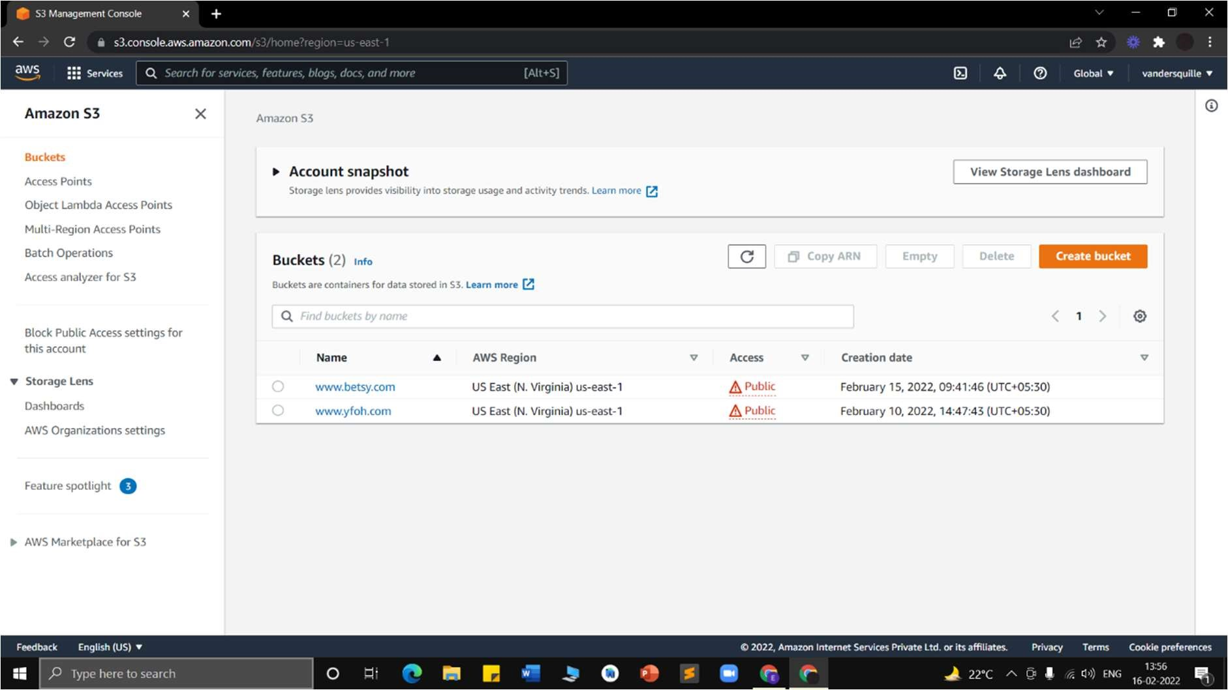

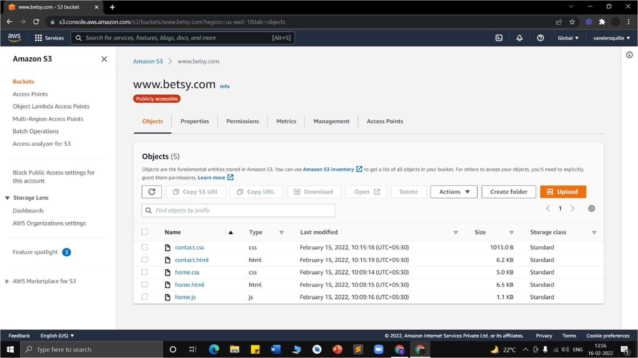

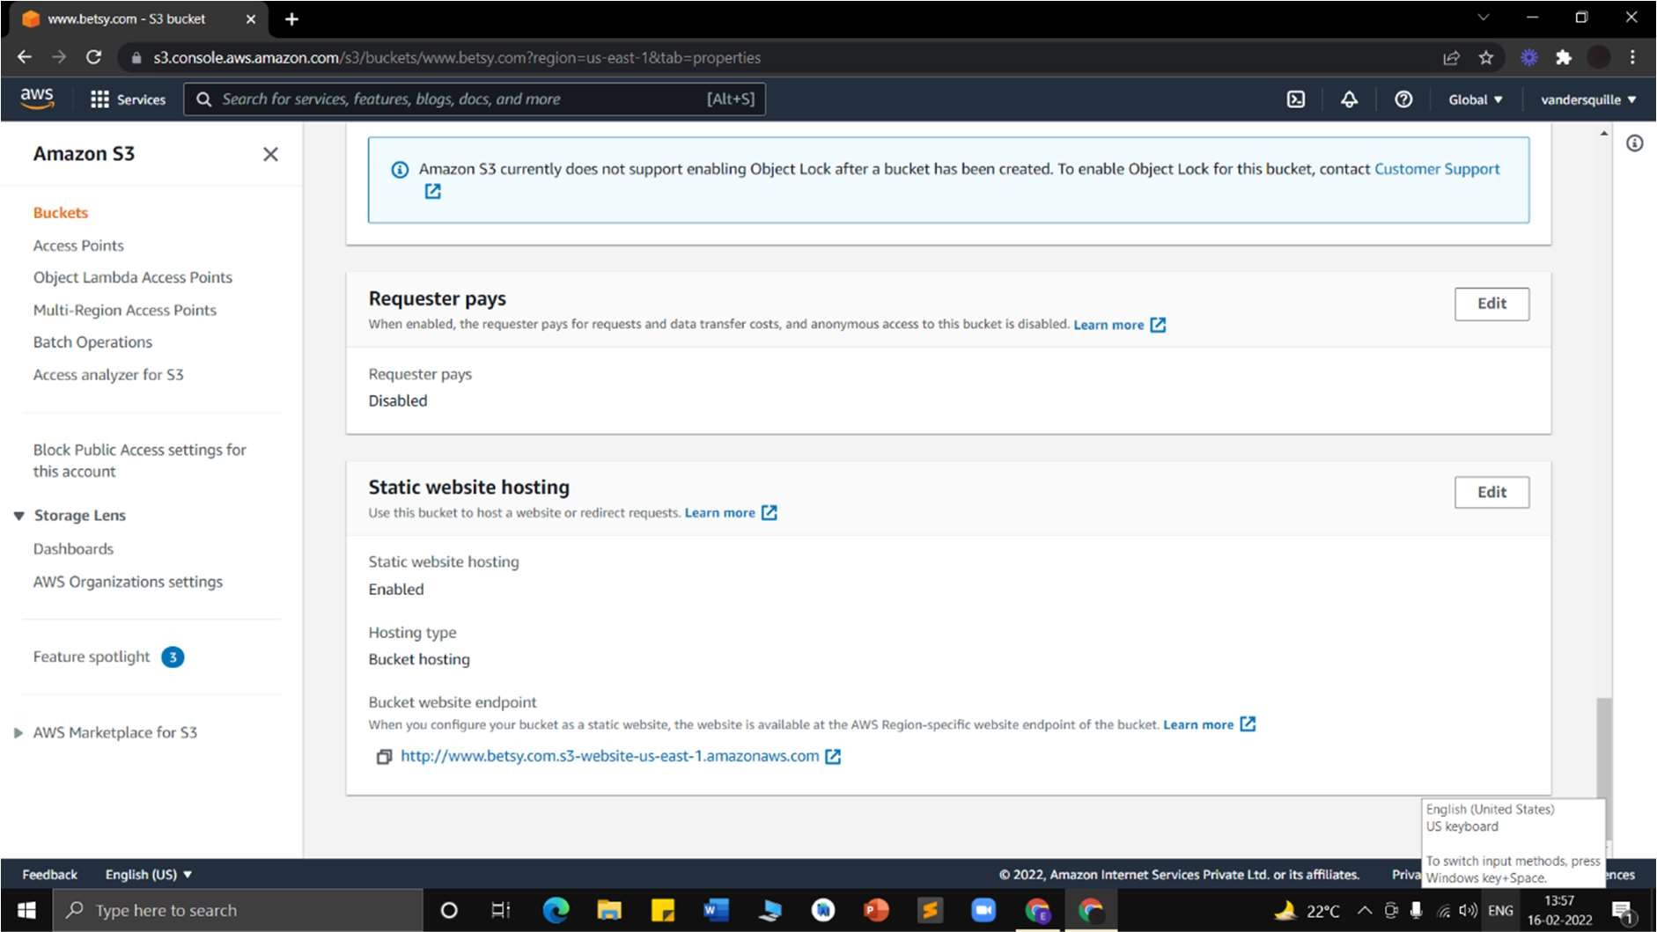

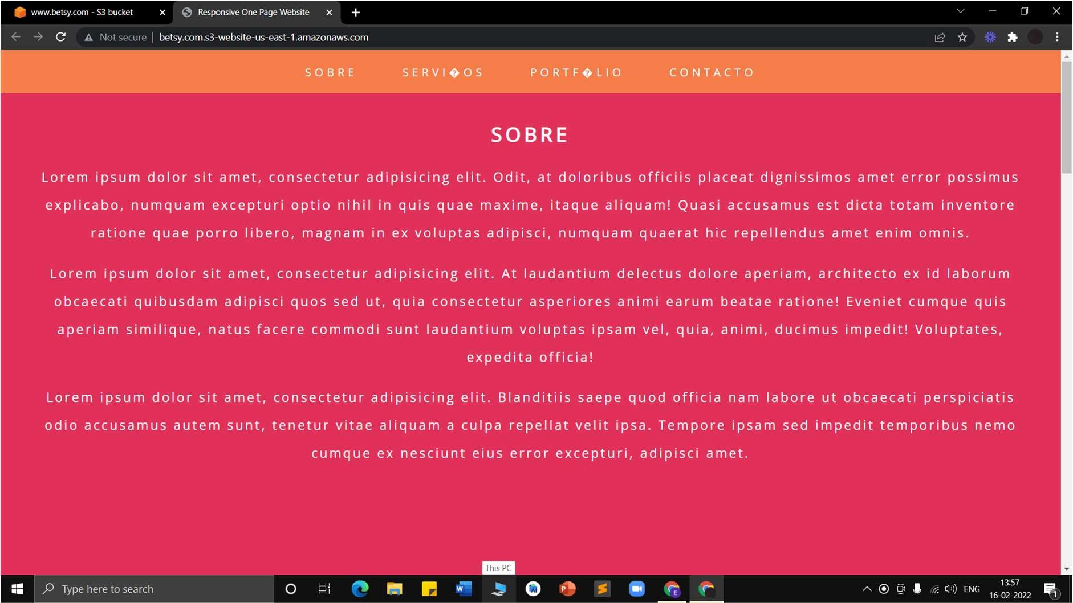

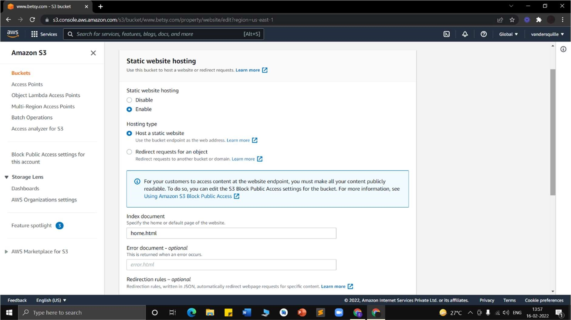

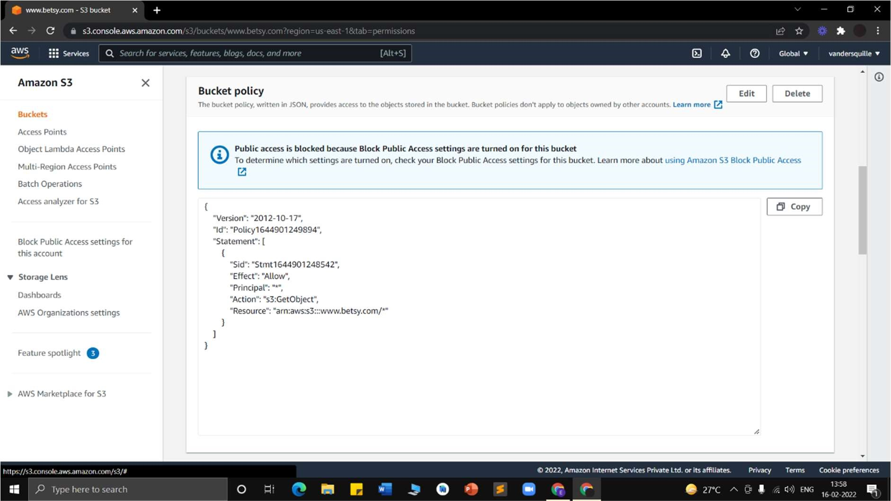

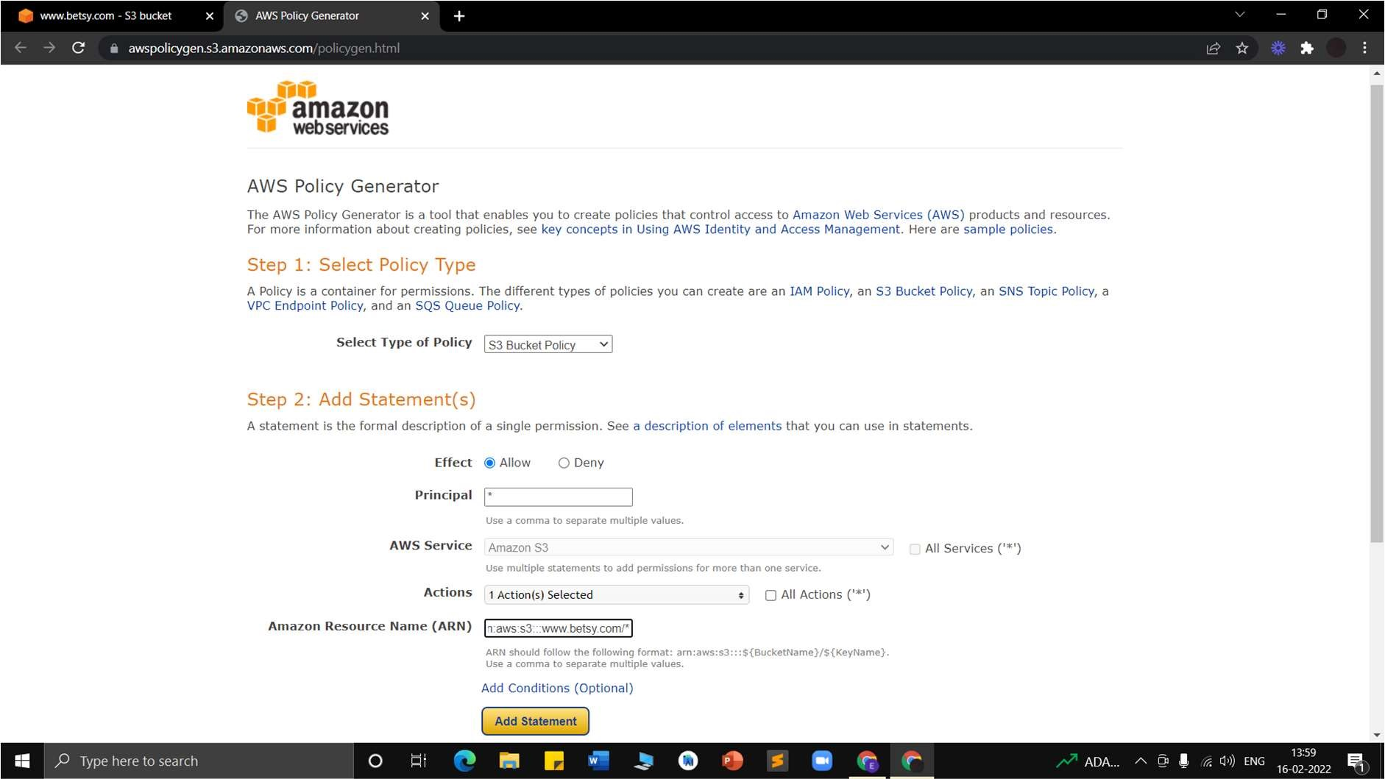

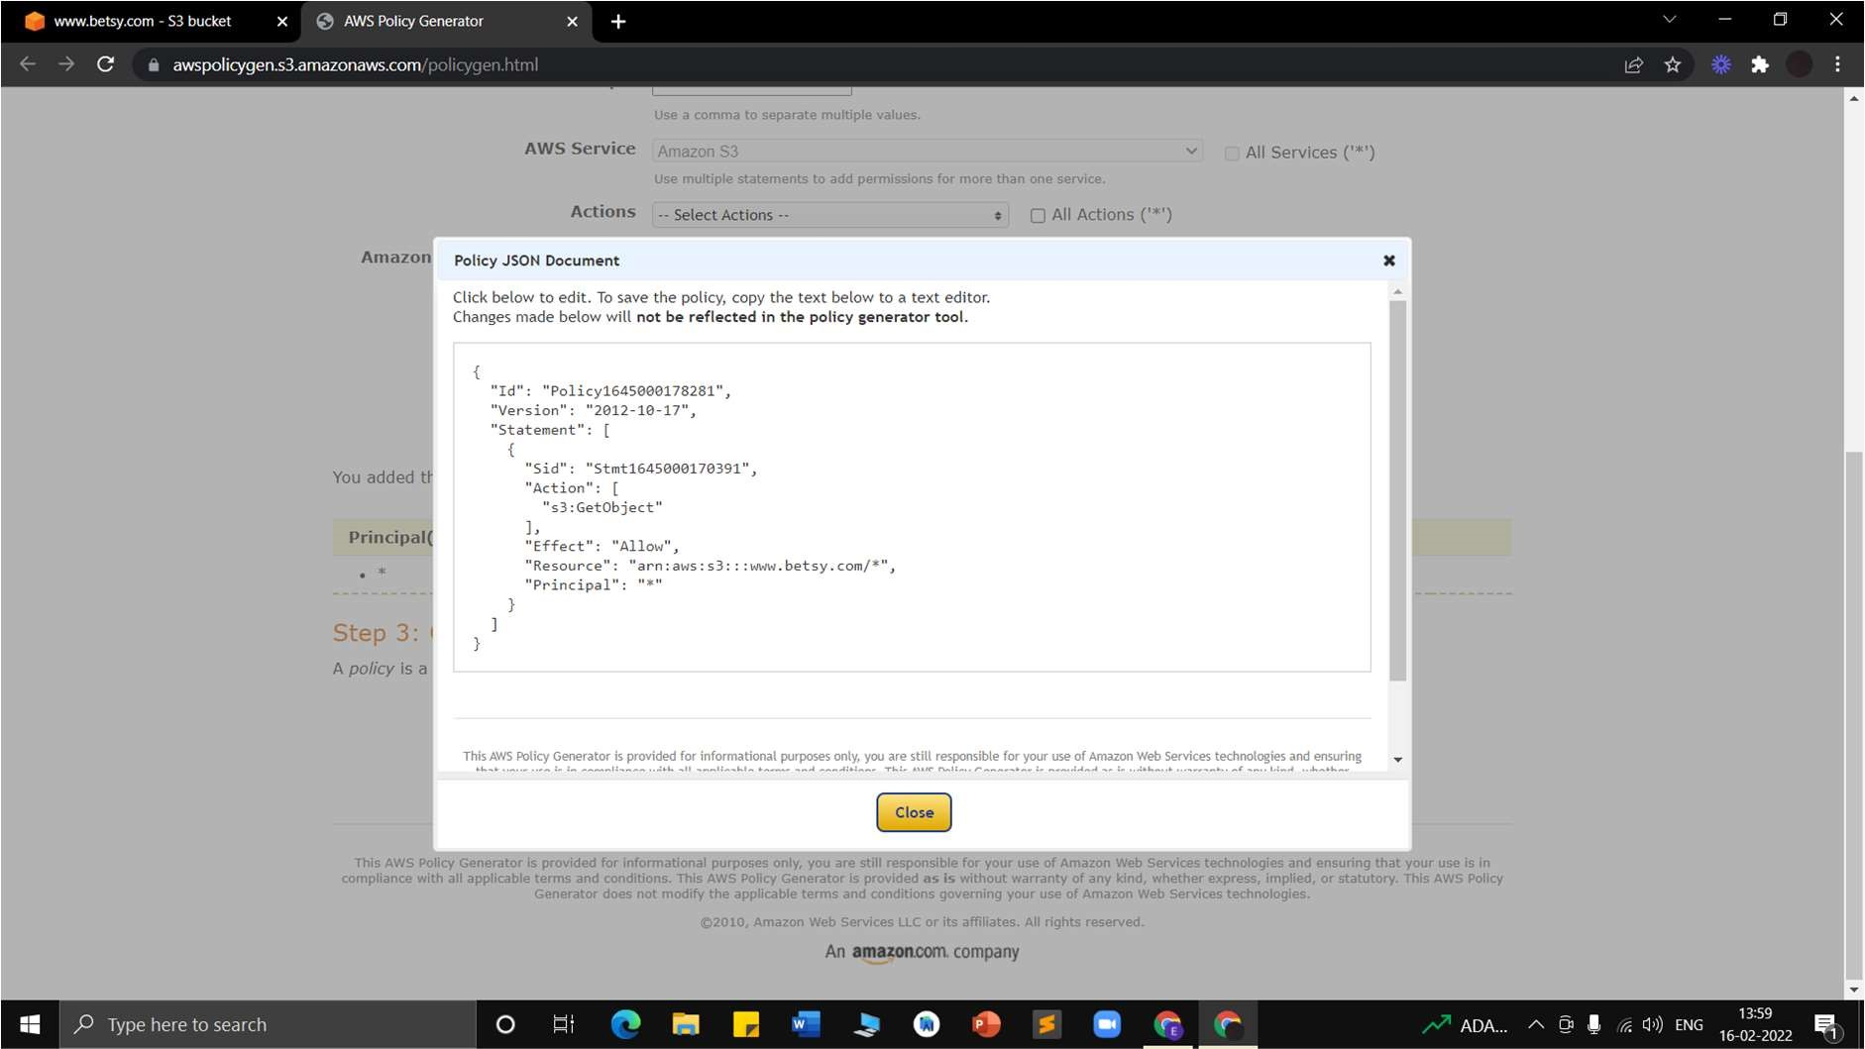

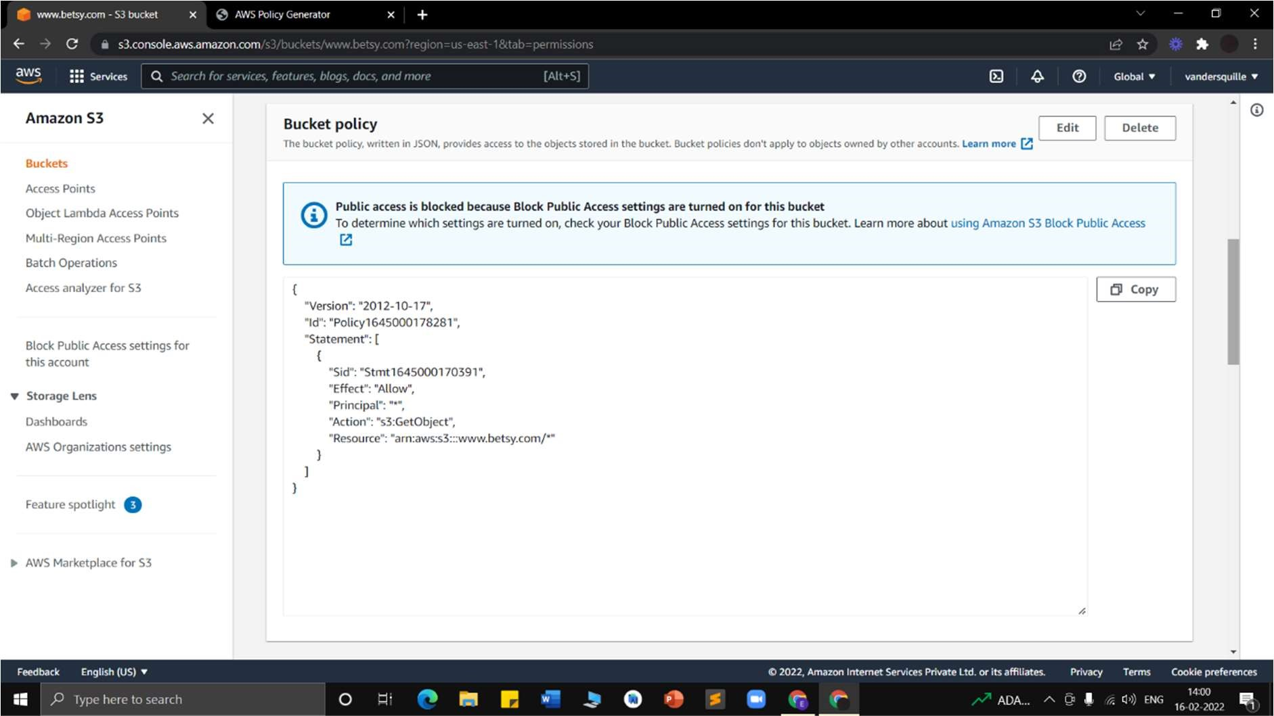

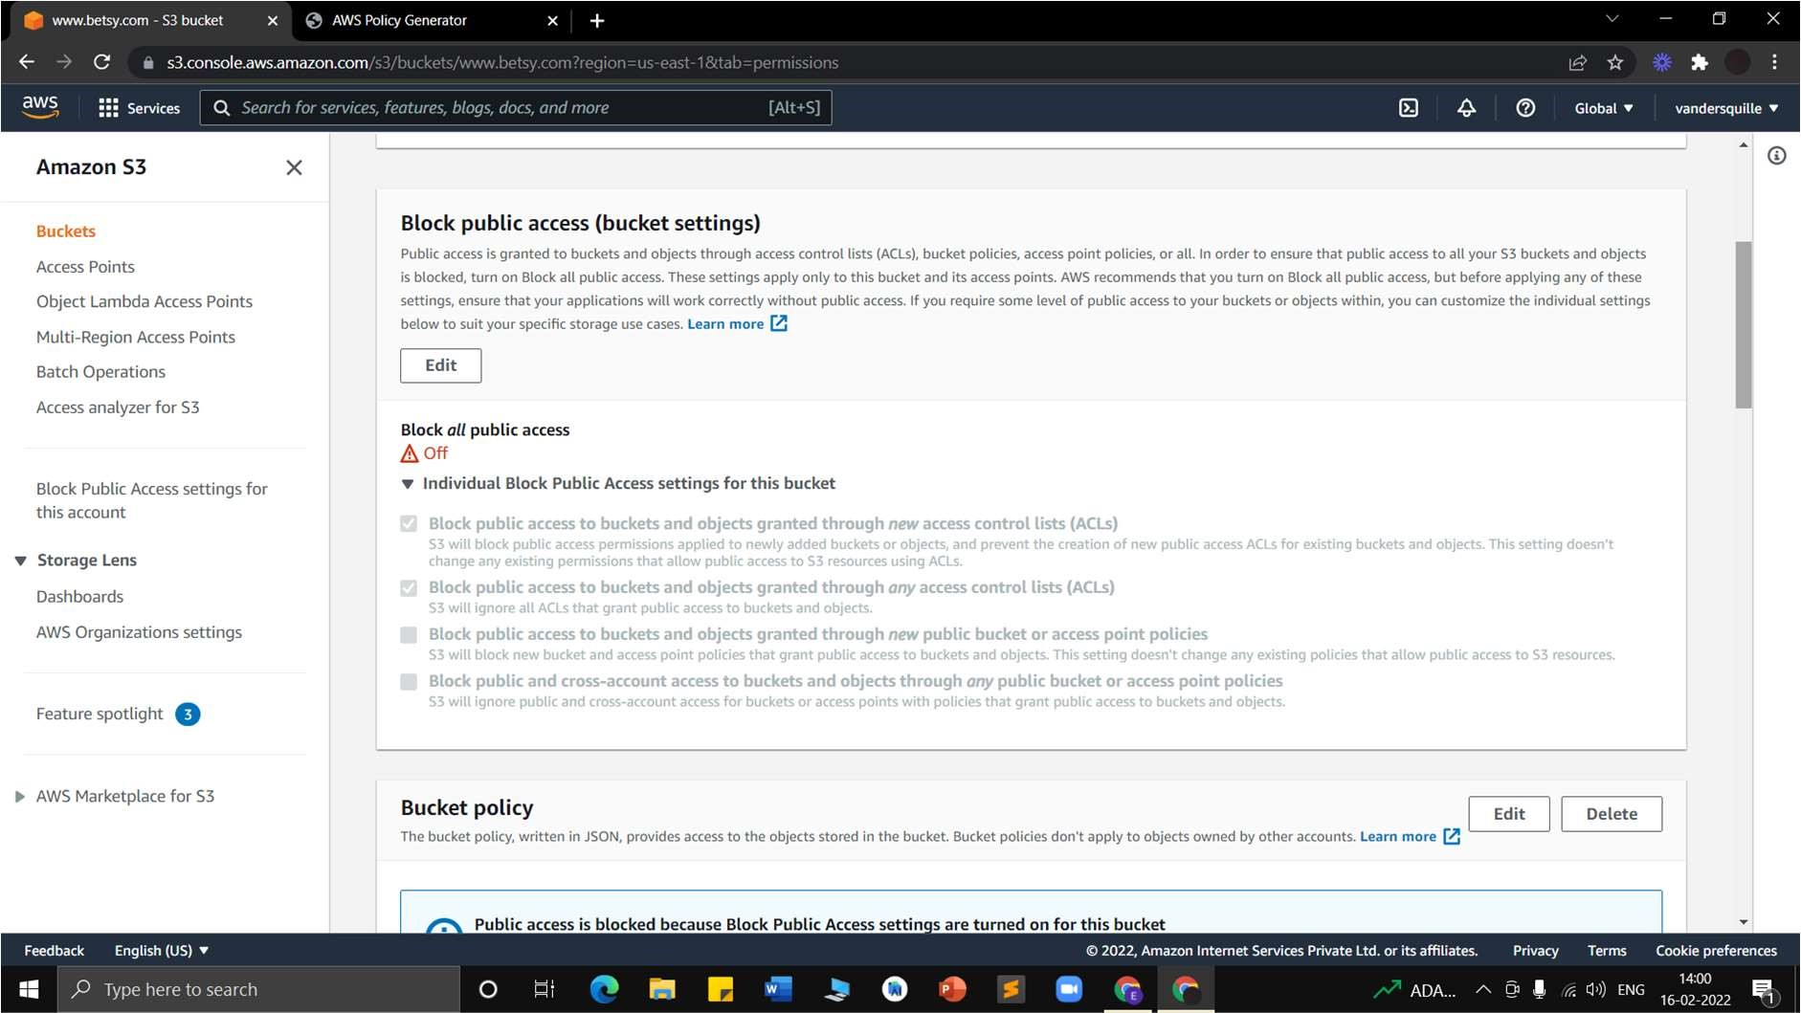

# Experiment 5: Amazon Web Services Post Lab Questions

Q1. What’s the Difference between Domain Name and Web Hosting?

A domain name is your website’s address on the web. It identifies the website and lets people find it via their Chromes or Firefox.

Web hosting (or web host, or web server, or just hosting) is the place where your website files (and all your website data) are kept, and from where the website can be accessed by your website visitors. Most commonly, a web server is a specialized type of computer. Basically, when a visitor puts your website’s domain name into their web browser window, that domain name is then taken and decoded to figure out what specific web host (web server) it points to. Once this is done, the website gets displayed to the visitor. This will surely come as no surprise, but the web is quite a complicated creation, and domains and hosting are just a small part of a bigger puzzle. Luckily for everyone, you really don’t need to be an expert on those things to be able to launch a website for your business and show it to the world.

Q2. What is Amazon s3 and the benefits of using it?

Amazon Simple Storage Service (Amazon S3), is the most fundamental and global Infrastructure as a Service (IaaS) solution provided by Amazon Web Services (AWS). Using Amazon S3 facilitates highly-scalable, secured and low-latency data storage from the cloud. With its simple web service interface, it is easy to store and retrieve data on Amazon S3 from anywhere on the web. All you need to do is choose a region (which is a separate geographic area, choose the closest one to you), create a S3 bucket and start storing data.

Amazon S3 is a pioneer in cloud data storage and has uncountable benefits • Reliable Security:

* All-time Availability:
* Very Low cost:
* Ease of Migration:
* The Simplicity of Management:

* Reliable Security:

When created, Amazon S3 buckets are usable only by the identity that created them (IAM policy grants are the exception). You can set access permissions for each file, each bucket, or via IAM(Identity access management), which provides a complete control over how, where and by whom the data can be frequently accessed. With these set of rules and permissions, you can make sure that there is no unauthorized access to your data.

* All-time Availability:

Amazon S3 gives every user, its service access to the same highly scalable, reliable, fast, inexpensive data storage infrastructure that Amazon uses to run its own global network of websites. S3 Standard is designed for 99.99% availability and Standard – IA is designed for 99.9% availability. Both are backed by the Amazon S3 Service Level Agreement, which is strictly followed by Amazon.

* Very Low cost:

With Amazon S3, you only pay for the data you use, which in itself is a very low price equivalent to $0.022 / GB and ~$0.0125 / GB for infrequent access. You can also define policies to migrate the data automatically to the infrequent access which further reduces the cost as Amazon Glacier is even cheaper( ~$0.004 / GB).

* Ease of Migration:

With Amazon S3 you get multiple options (rsync, S3 command line interface and Glacier command line interface) for Cloud Data Migration which are cost effective and it is very simple to transfer a large amount of data to Amazon S3 or out of Amazon S3. Amazon S3 Storage also provides you with the option to import or export data to any physical device or on any network.

* The Simplicity of Management:

Amazon S3 has a very user-friendly web interface which takes out the usual hard work of maintaining security, optimizing storage classes and managing the data transfer in the most suitable way. You can define its own lifecycle policy, define replication rules and configure the Amazon S3 inventory. It also allows you to configure request metrics and storage classes analysis with many filters to have a better look at your storage.

Q3. What are bucket policies in the Amazon s3?

A bucket policy is type of Resource based Policy; similar to an IAM Identity based Policy except it is applied to an AWS managed resource. In addition to Bucket Policies, there are other types of resource-based IAM Policies such as KMS Key Policy; SQS Policy, and VPC Endpoints.

Q4. Explain the core concepts of Amazon s3.

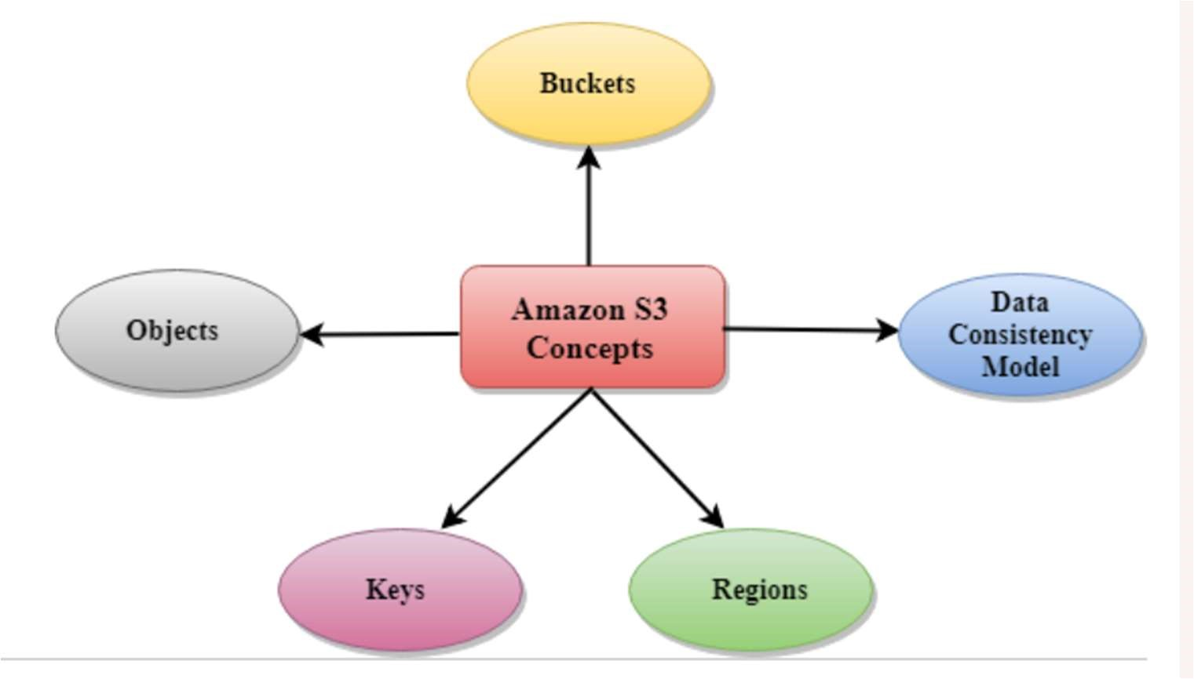

# • Buckets

A bucket is a container used for storing the objects.

Every object is incorporated in a bucket.

For example, if the object named photos/tree.jpg is stored in the treeimage bucket, then it can be addressed by using the URL http://treeimage.s3.amazonaws.com/photos/tree.jpg.

A bucket has no limit to the amount of objects that it can store. No bucket can exist inside of other buckets.

S3 performance remains the same regardless of how many buckets have been created.

The AWS user that creates a bucket owns it, and no other AWS user cannot own it.

Therefore, we can say that the ownership of a bucket is not transferrable.

The AWS account that creates a bucket can delete a bucket, but no other AWS user can delete the bucket.

# • Objects

Objects are the entities which are stored in an S3 bucket.

An object consists of object data and metadata where metadata is a set of name-value pair that describes the data.

An object consists of some default metadata such as date last modified, and standard HTTP metadata, such as Content type. Custom metadata can also be specified at the time of storing an object.

It is uniquely identified within a bucket by key and version ID.

# • Key

A key is a unique identifier for an object.

Every object in a bucket is associated with one key.

An object can be uniquely identified by using a combination of bucket name, the key, and optionally version ID.

For example, in the URL http://jtp.s3.amazonaws.com/2019-01-31/Amazons3.wsdl where "jtp" is the bucket name, and key is "2019-01-31/Amazons3.wsdl"

Regions

You can choose a geographical region in which you want to store the buckets that you have created.

A region is chosen in such a way that it optimizes the latency, minimize costs or address regulatory requirements.

Objects will not leave the region unless you explicitly transfer the objects to another region.

# • Data Consistency Model

Amazon S3 replicates the data to multiple servers to achieve high availability.

Two types of model:

• Read-after-write consistency for PUTS of new objects.

For a PUT request, S3 stores the data across multiple servers to achieve high availability.

A process stores an object to S3 and will be immediately available to read the object.

A process stores a new object to S3, it will immediately list the keys within the bucket.

It does not take time for propagation, the changes are reflected immediately.

• Eventual consistency for overwrite PUTS and DELETES

For PUTS and DELETES to objects, the changes are reflected eventually, and they are not available immediately.

If the process replaces an existing object with the new object, you try to read it immediately. Until the change is fully propagated, the S3 might return prior data. If the process deletes an existing object, immediately try to read it. Until the change is fully propagated, the S3 might return the deleted data.

If the process deletes an existing object, immediately list all the keys within the bucket. Until the change is fully propagated, the S3 might return the list of the deleted key.