**FR. CONCEICAO RODRIGUES COLLEGE OF ENGINEERING**

**Department of Computer Engineering**

**1. Course, Subject & Experiment Details**

|  |  |
| --- | --- |
| **Practical No:** |  |
| **Title:** | **Buffer Overflow** |
| **Name of the Student:** | **Warren Fernandes** |
| **Roll No:** | **8940** |
| **Date of Performance:** | **21-03-2022** |
| **Date of Submission:** | **09-04-2022** |

**Evaluation:**

|  |  |  |
| --- | --- | --- |
| **Sr. No.** | **Rubric** | **Grade** |
| **1** | **On time submission/completion (2)** |  |
| **2** | **Preparedness (2)** |  |
| **3** | **Skill (4)** |  |
| **4** | **Output (2)** |  |

**Signature of the Teacher**

**OUTPUT:**

**Connecting to vulnerable machine**

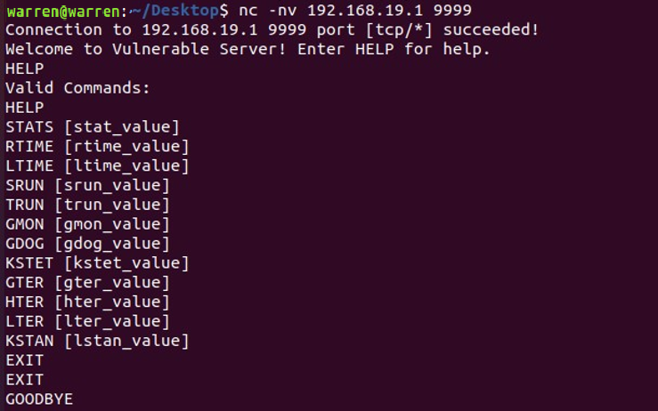

**SPIKING:**

Spike script

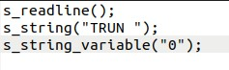

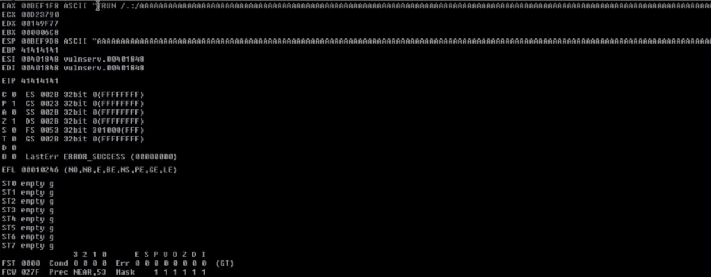

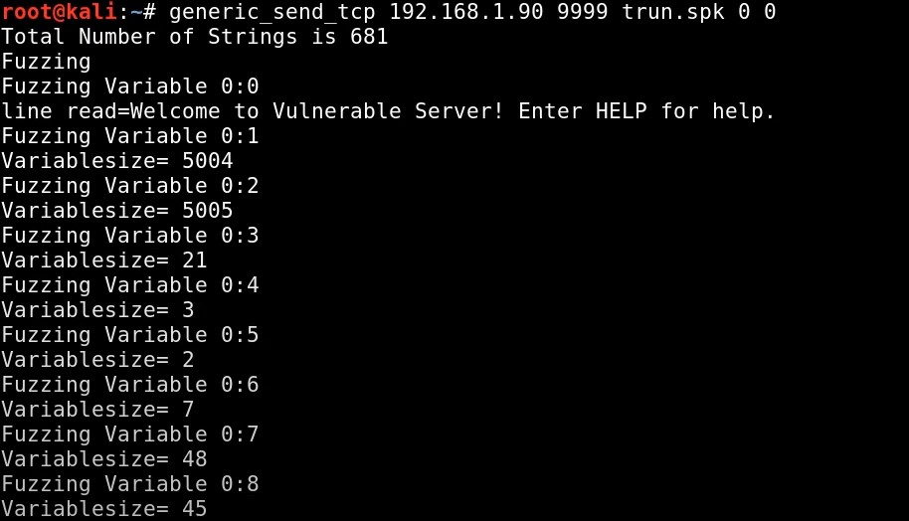

**FUZZING:** 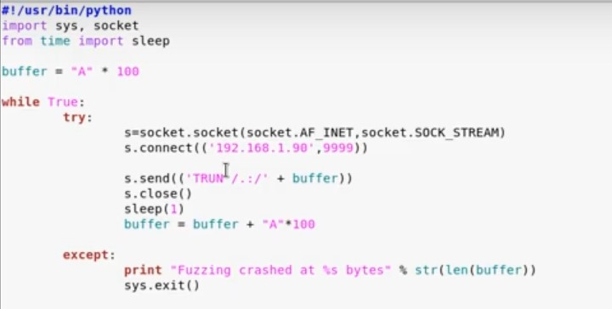

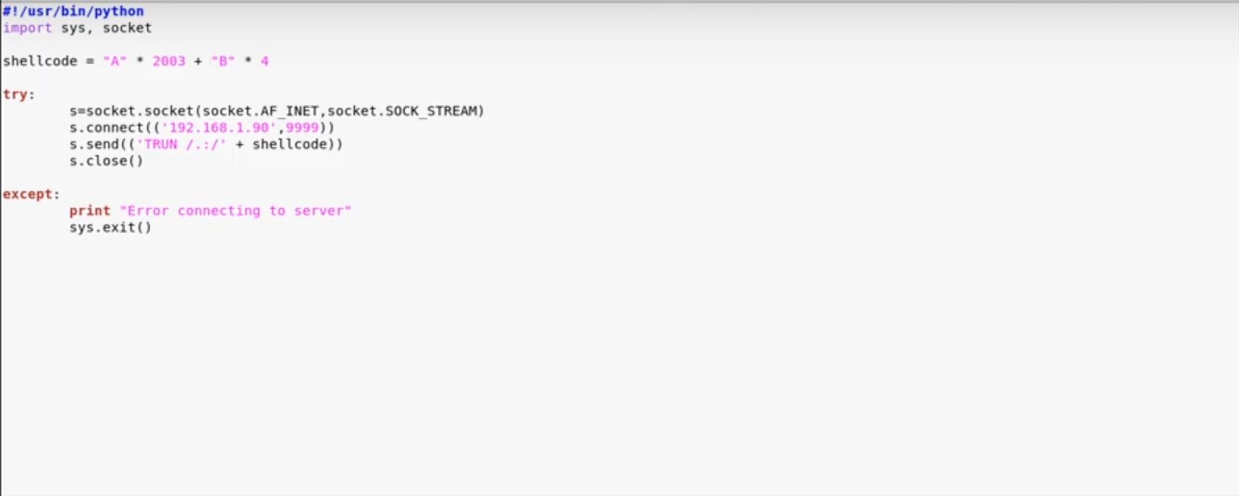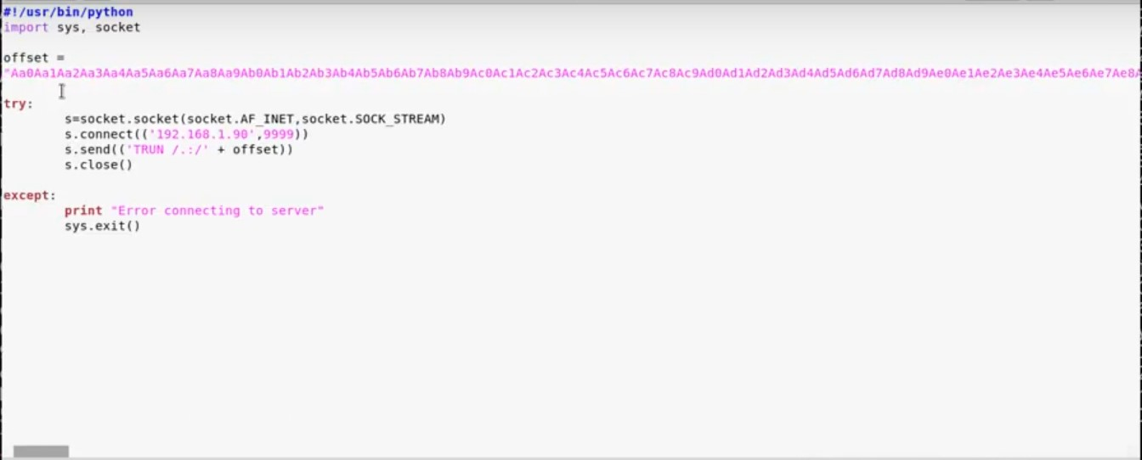

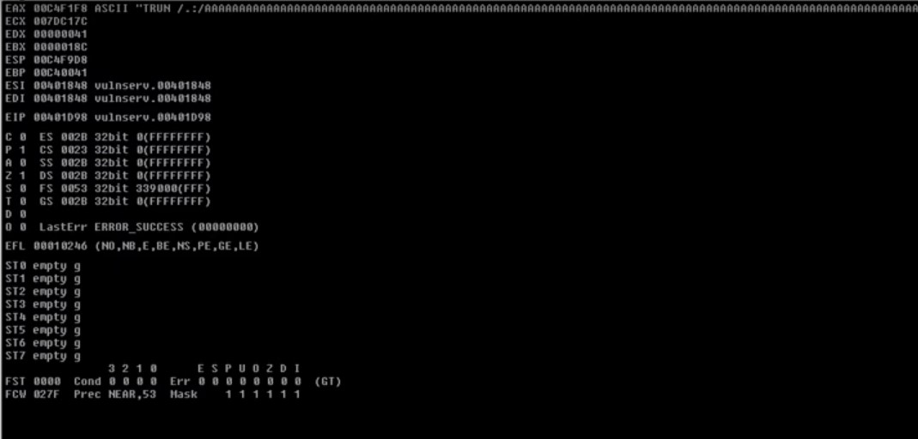

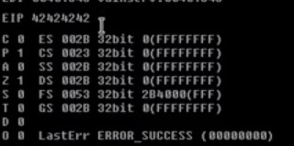

**POSTLAB:**

1. **Elaborate how compile-time and run-time defenses works with respect to Buffer overflow attacks.**

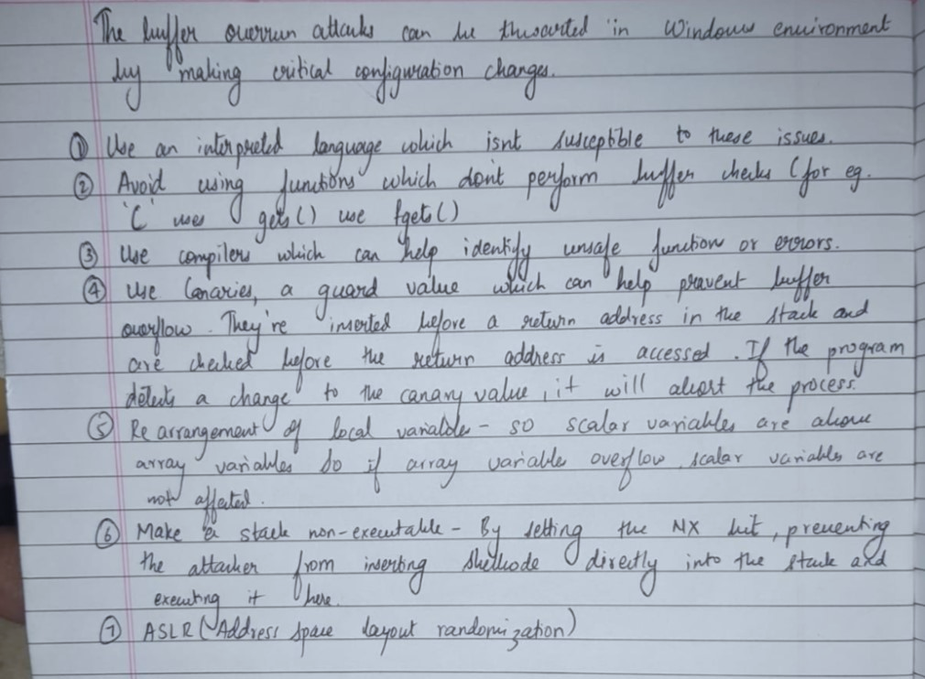

1. **Discuss different types of buffer overflow attacks.**

