**Department of Computer Engineering**

**Academic Term : Jan-Apr 2022**

**Class :** T.E Computer Sem -VI

**Subject :** Mobile Computing

|  |  |
| --- | --- |
| **Practical No:** | 8 |
| **Title:** | Implementation of Mobile Network (MANET) using Network Simulator (NS2): |
| **Date of Performance:** | **28/03/2022** |
| **Date of Submission:** | **28/03/2022** |
| **Roll No:** | **8940** |
| **Name of the Student:** | **Warren Fernandes** |

**Evaluation:**

|  |  |  |
| --- | --- | --- |
| **Sr. No** | **Rubric** | **Grade** |
| **1** | **On time Completion & Submission(2)** |  |
| **2** | **Output(3)** |  |
| **3** | **Code Optimization(3)** |  |
| **4** | **Knowledge of the topic(2)** |  |
| **5** | **Total (10)** |  |

**Signature of the Teacher :**

**PRACTICAL** - **8**

**Title**: Implementation of Mobile Network using Network Simulator (NS2): Create a Mobile Ad hoc network

**Objective**: To study Routing in MANET

**Pre-Requisite**: Basic knowledge of wireless networking

**Description:**

NS (version 2) is an object-oriented, discrete event driven network simulator developed at UC Berkely written in C++ and OTcl. NS is primarily useful for simulating local and wide area networks. It implements network protocols such as TCP and UPD, traffic source behavior such as FTP, Telnet, Web, CBR and VBR, router queue management mechanism such as Drop Tail, RED and CBQ, routing algorithms such as Dijkstra, and more. NS also implements multicasting and some of the MAC layer protocols for LAN simulations.

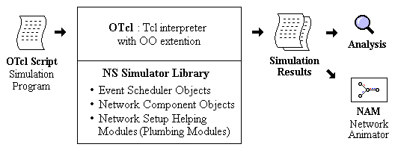

**Program description:**

Each agent keep track of what messages it has seen and only forwards those which it has seen and only forwards those which it hasn’t seen before. Each message is of the form “ID:DATA” where ID is some arbitrary message identifier and DATA is the payload. In order to reduce memory usage , the agent store only the message ID. **Steps:**

1. Set the following configuration for each node’s interface
   * Type of channel - WirelessChannel
   * Type of propagation – TwoRayGround
   * Physical Layer – Wireless
   * Mac Layer – MAC 802.11
   * Type of Queue – DropTail/PriQueue
   * LinkLayer – LL
   * Type of Antenna –OmniAntenna
   * Maximum Packet in Queue - 50
2. Open Trace file in write mode 3. Open NAM file in write mode.
3. Create a topology containing 6 groups each having 4 nodes. Use FlatGrid topology
4. Configure each node using the configuration set in step 1.
5. Create a simple MessagePassing/Flooding agent
6. Create Receive procedure that receives each packet and maintain list of unseen messages
7. Create send procedure that broadcasts message.
8. Create MessagePassing/Flooding agent and attach it with every node.
9. Set up some events.
10. Write finish procedure.

Output:

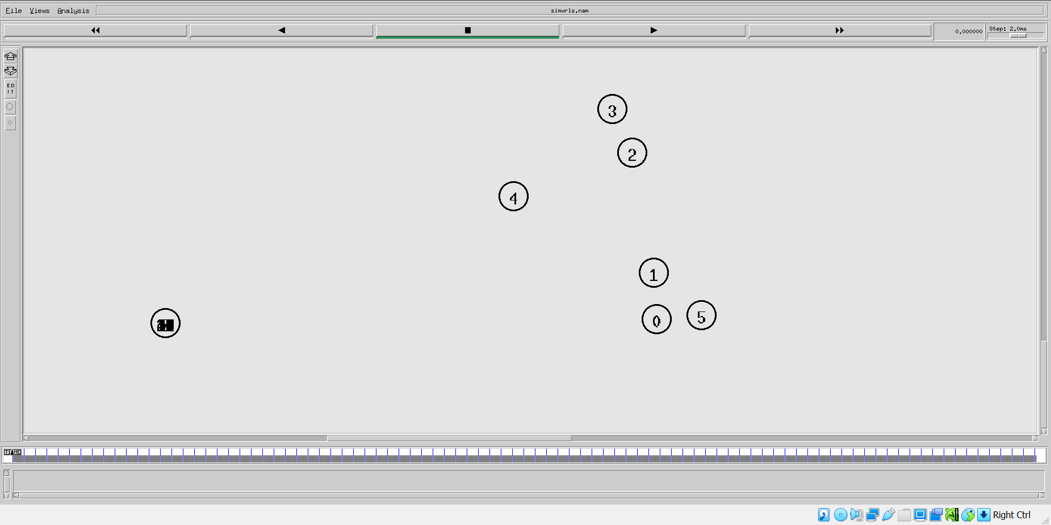

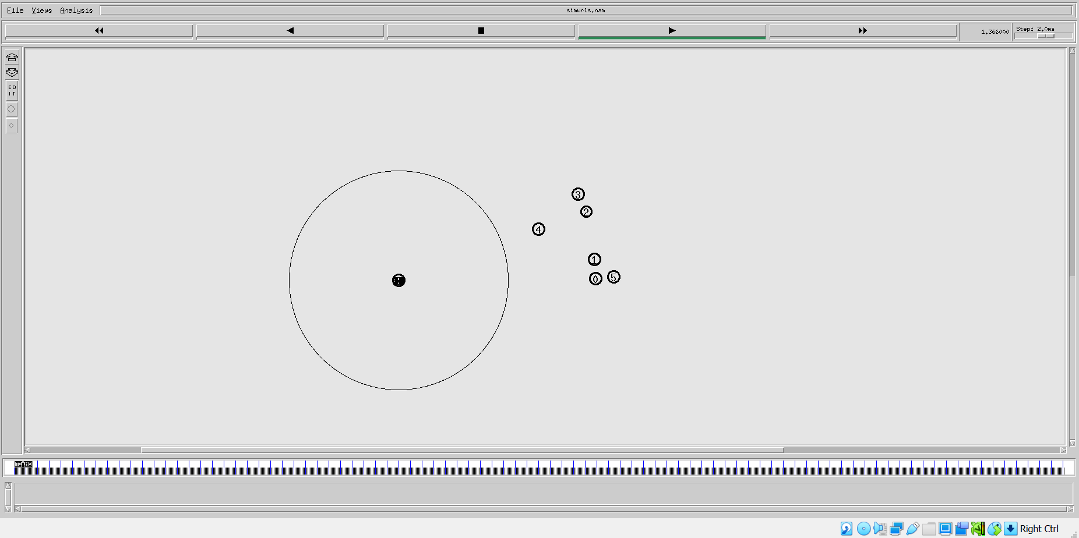

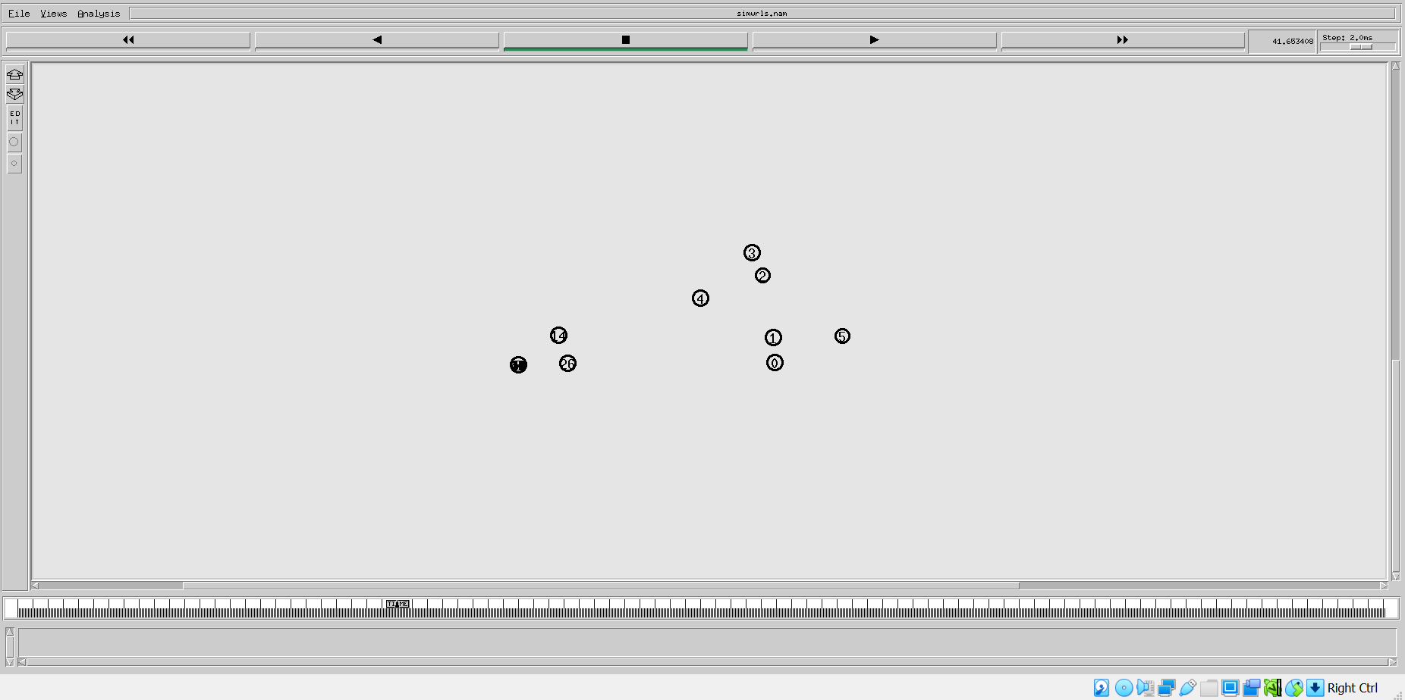

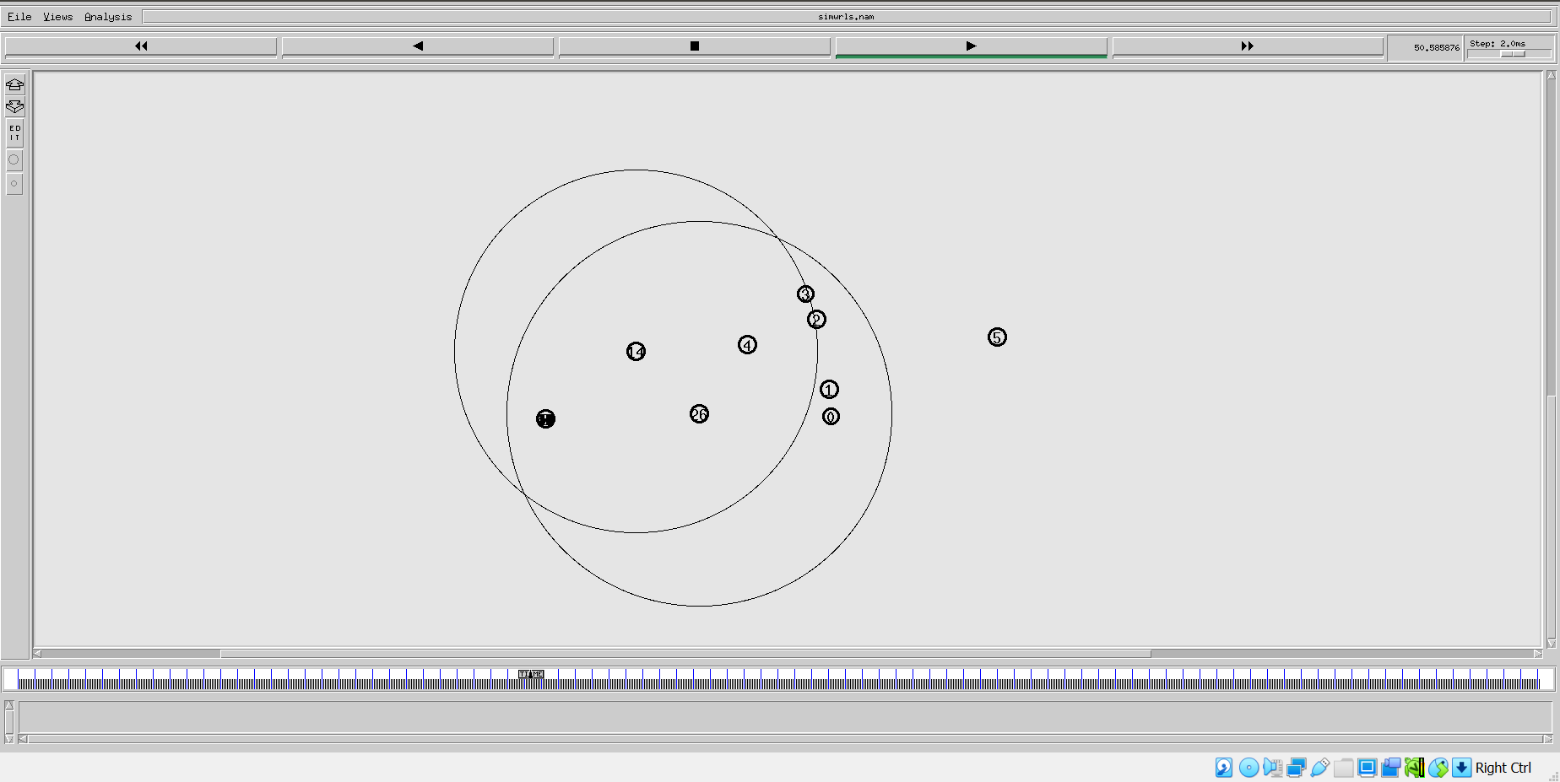

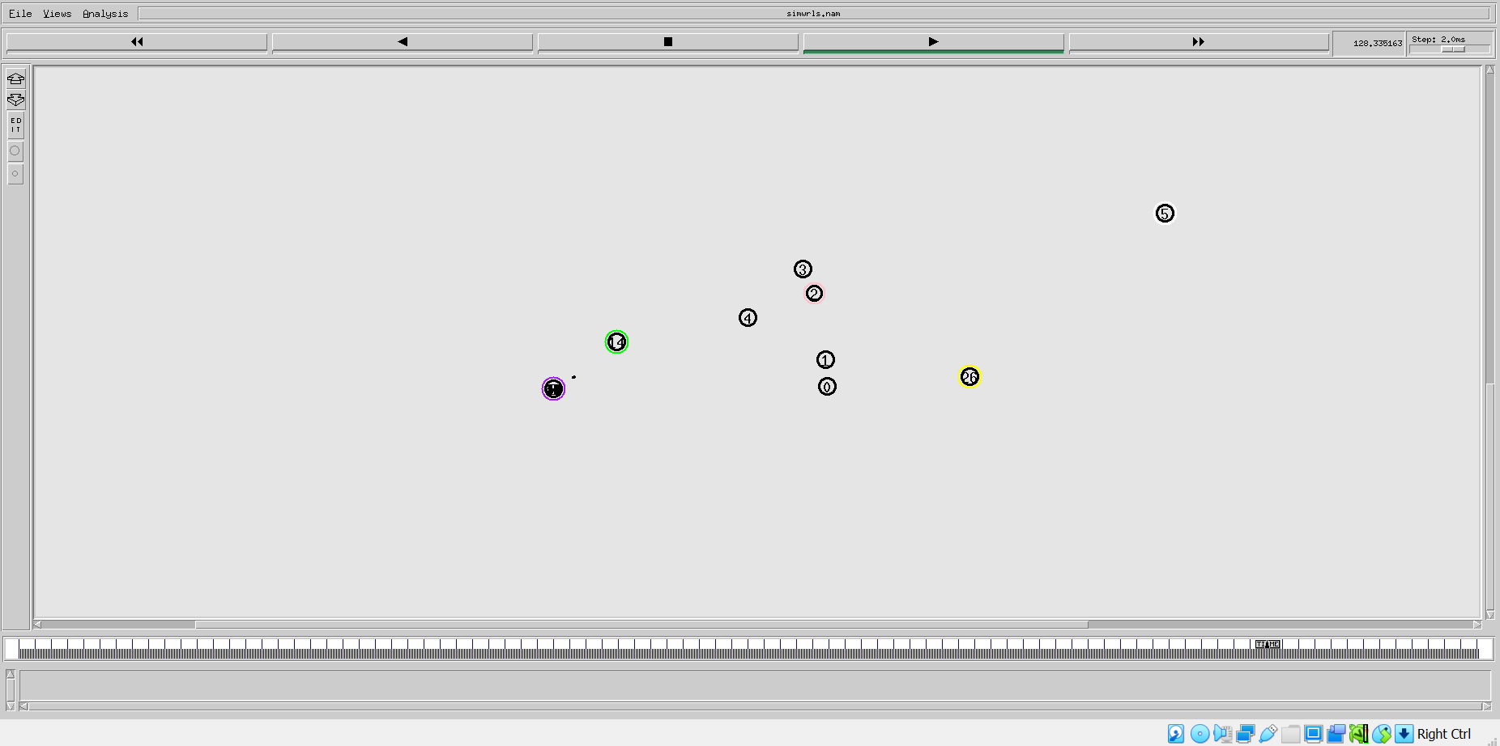

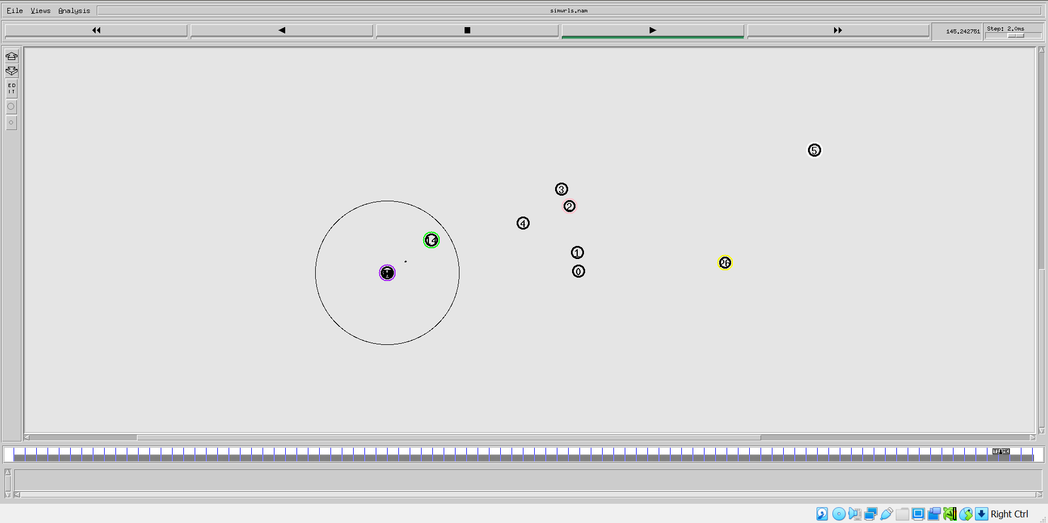

**Conclusion:** Mobile networks using NS2 has been studied and implemented successfully.

**Post Lab Questions:**

1. Describe your observations about output.
2. Explain the working of DSDV protocol.

