**FR. CONCEICAO RODRIGUES COLLEGE OF ENGINEERING**

**Department of Computer Engineering**

**Academic Term : Jan-July 2022**

**Class :** T.E Computer Sem -VI

**Subject :** Mobile Computing

|  |  |
| --- | --- |
| **Practical No:** | **9** |
| **Title:** | Mini Android Application |
| **Date of Performance:** | **28/03/2022** |
| **Date of Submission:** | **11/04/2022** |
| **Roll No:** | **8940** |
| **Name of the Student:** | **Warren Fernandes** |

**Evaluation:**

|  |  |  |  |
| --- | --- | --- | --- |
| **Sr. No** | **Rubric** |  | **Grade** |
| **1** |  | **On time submission Or completion (2)** |  |
| **2** |  | **Preparedness(2)** |  |
| **3** |  | **Skill (4)** |  |
| **4** |  | **Output (2)** |  |

**Signature of the Teacher :**

**PRACTICAL - 9**

**Title :** To develop a Mini Android Application

**Description:** Implement an Android application that takes name as input. It gives radio buttons with list of subjects. User need to choose 1 subject. Then there are list of books user has to choose. Then

display name, choice of subject and selected subjects.

**Objective :** To study basic components and features of Android.

**Procedure:**

Creating a New project:

* Open Android Studio and then click on **File -> New -> New project.**

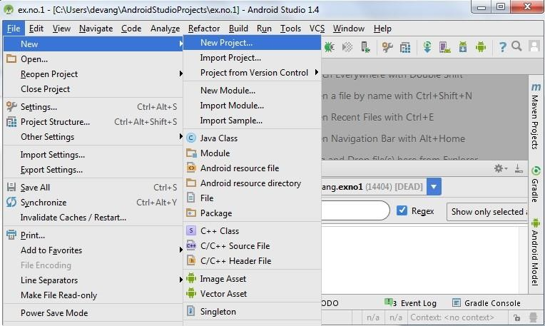

* Then type the Application name as “**ex.no.9″** and click **Next.**

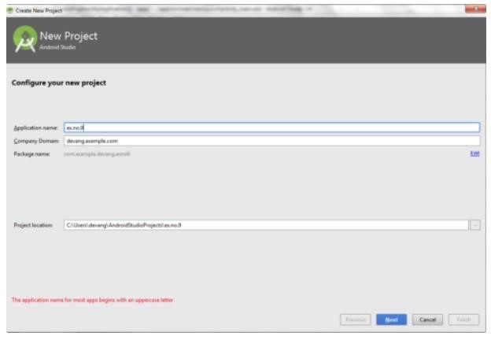

* Then select the **Minimum SDK** as shown below and click **Next**.

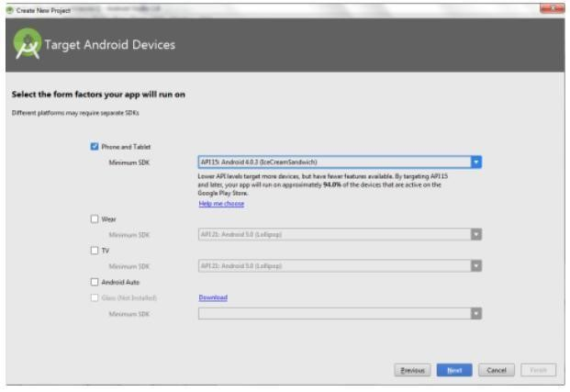

Then select the **Empty Activity** and click **Next.**

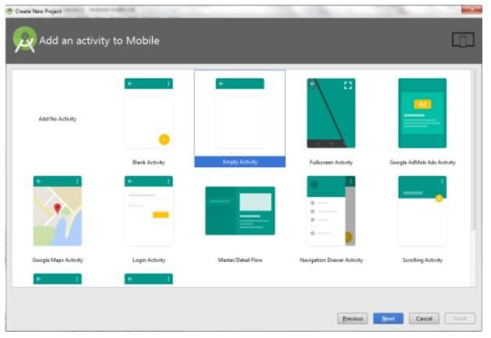

* Finally click F**inish**.

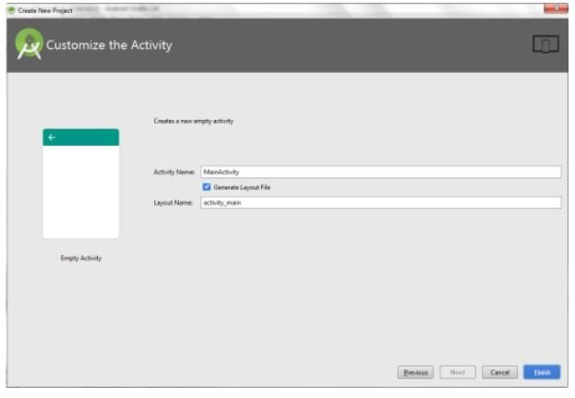

* It will take some time to build and load the project.
* After completion it will look as given below.

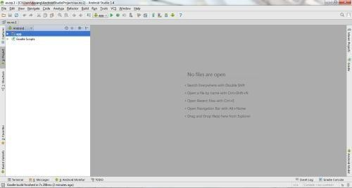

Designing layout for the Android Application:

* Click on app -> res -> layout -> activity_main.xml.
* Now click on Text as shown below.
* Then delete the code which is there and type the code as given below.

Code for Activity_main.xml:

*<?***xml version="1.0" encoding="utf-8"***?>*<**LinearLayout xmlns:android="http://schemas.android.com/apk/res/android"  
 xmlns:app="http://schemas.android.com/apk/res-auto"  
 xmlns:tools="http://schemas.android.com/tools"  
 android:layout_width="match_parent"  
 android:layout_height="match_parent"  
 android:background="#ffffff"  
 android:orientation="vertical"  
 tools:context="com.crce.expt9.MainActivity"**>  
  
 <**TextView  
 android:id="@+id/textView3"  
 android:layout_width="match_parent"  
 android:layout_height="wrap_content"  
 android:text="Mobile Computing"  
 android:textSize="24sp"**/>  
  
 <**EditText  
 android:id="@+id/editTextTextPersonName"  
 android:layout_width="367dp"  
 android:layout_height="43dp"  
 android:layout_marginTop="16dp"  
 android:ems="10"  
 android:inputType="textPersonName"  
 android:text="Name"**/>  
  
 <**TextView  
 android:id="@+id/textView"  
 android:layout_width="373dp"  
 android:layout_height="40dp"  
 android:layout_marginTop="32dp"  
 android:text="Choose your Subject:"  
 android:textSize="24sp"** />  
  
 <**RadioGroup  
 android:id="@+id/groupradio"  
 android:layout_width="377dp"  
 android:layout_height="195dp"**>  
  
 *<!-- In RadioGroup create the 1 Radio Button-->  
 <!-- like this we will add some more Radio Button-->* <**RadioButton  
 android:id="@+id/radia_id1"  
 android:layout_width="fill_parent"  
 android:layout_height="wrap_content"  
 android:text="DBMS"  
 android:textSize="20dp"** />  
  
 <**RadioButton  
 android:id="@+id/radia_id2"  
 android:layout_width="fill_parent"  
 android:layout_height="wrap_content"  
 android:text="C/C++ Programming"  
 android:textSize="20dp"** />  
  
 <**RadioButton  
 android:id="@+id/radia_id3"  
 android:layout_width="fill_parent"  
 android:layout_height="wrap_content"  
 android:text="Data Structure"  
 android:textSize="20dp"** />  
  
 <**RadioButton  
 android:id="@+id/radia_id4"  
 android:layout_width="fill_parent"  
 android:layout_height="wrap_content"  
 android:text="Algorithms"  
 android:textSize="20dp"** />  
  
 </**RadioGroup**>  
  
  
 <**TextView  
 android:id="@+id/textView1"  
 android:layout_width="368dp"  
 android:layout_height="33dp"  
 android:layout_marginTop="28dp"  
 android:text="Choose your Books:"  
 android:textSize="24sp"**/>  
  
 <**CheckBox  
 android:id="@+id/checkBox"  
 android:layout_width="358dp"  
 android:layout_height="48dp"  
 android:text="TechMax"  
 android:textSize="18sp"**/>  
  
 <**CheckBox  
 android:id="@+id/checkBox2"  
 android:layout_width="361dp"  
 android:layout_height="47dp"  
 android:text="TechNeo"  
 android:textSize="18sp"**/>  
  
 <**CheckBox  
 android:id="@+id/checkBox3"  
 android:layout_width="362dp"  
 android:layout_height="47dp"  
 android:text="TechKnowledge"  
 android:textSize="18sp"**/>  
  
 <**Button  
 android:id="@+id/submit"  
 android:layout_width="409dp"  
 android:layout_height="58dp"  
 android:text="submit"**/>  
  
  
</**LinearLayout**>

* Now click on Design and your application will look as given below.
* So now the designing part is completed.
* Click on **app -> java -> com.example.exno9 -> MainActivity.**
* Then delete the code which is there and type the code as given below.
* **Code for MainActivity.java:**

**import** androidx.appcompat.app.AppCompatActivity;  
  
**import** android.os.Bundle;  
**import** android.view.View;  
**import** android.widget.Button;  
**import** android.widget.CheckBox;  
**import** android.widget.EditText;  
**import** android.widget.RadioButton;  
**import** android.widget.RadioGroup;  
**import** android.widget.Toast;  
  
**public class** MainActivity **extends** AppCompatActivity {  
  
 RadioGroup **radioGroup**;  
 Button **submit**;  
 CheckBox **ch**, **ch1**, **ch2**;  
 EditText **et**;  
  
 @Override  
 **protected void** onCreate(Bundle savedInstanceState) {  
 **super**.onCreate(savedInstanceState);  
 setContentView(R.layout.***activity_main***);  
 **radioGroup** = (RadioGroup)findViewById(R.id.***groupradio***);  
 **submit** = (Button)findViewById(R.id.***submit***);  
 **ch**=(CheckBox)findViewById(R.id.***checkBox***);  
 **ch1**=(CheckBox)findViewById(R.id.***checkBox2***);  
 **ch2**=(CheckBox)findViewById(R.id.***checkBox3***);  
 **et**=(EditText)findViewById(R.id.***editTextTextPersonName***);  
 *// Uncheck or reset the radio buttons initially  
  
 // Add the Listener to the RadioGroup* **radioGroup**.setOnCheckedChangeListener(  
 **new** RadioGroup.OnCheckedChangeListener() {  
 @Override  
 *// The flow will come here when  
 // any of the radio buttons in the radioGroup  
 // has been clicked  
 // Check which radio button has been clicked* **public void** onCheckedChanged(RadioGroup group, **int** checkedId)  
 {  
 *// Get the selected Radio Button* RadioButton radioButton = (RadioButton)group.findViewById(checkedId);  
 }  
 });  
  
 *// Add the Listener to the Submit Button* **submit**.setOnClickListener(**new** View.OnClickListener() {  
  
 @Override  
 **public void** onClick(View v)  
 {  
  
 *// When submit button is clicked,  
 // Ge the Radio Button which is set  
 // If no Radio Button is set, -1 will be returned* String msg=**""**;  
  
 *// Concatenation of the checked options in if  
  
 // isChecked() is used to check whether  
 // the CheckBox is in true state or not.* **if**(**ch**.isChecked())  
 msg = msg + **" TechMax "**;  
 **if**(**ch1**.isChecked())  
 msg = msg + **" TechNeo "**;  
 **if**(**ch2**.isChecked())  
 msg = msg + **" TechKnowledge "**;  
  
 **if** (msg.equals(**""**)){  
 Toast.*makeText*(MainActivity.**this**,  
 **"No book has been selected"**,  
 Toast.***LENGTH_SHORT***)  
 .show();  
 }  
  
 **int** selectedId = **radioGroup**.getCheckedRadioButtonId();  
 **if** (selectedId == -1) {  
 Toast.*makeText*(MainActivity.**this**,  
 **"No subject has been selected"**,  
 Toast.***LENGTH_SHORT***)  
 .show();  
 }  
 **else** {  
  
 RadioButton radioButton  
 = (RadioButton)**radioGroup** .findViewById(selectedId);  
  
 *// Now display the value of selected item  
 // by the Toast message* Toast.*makeText*(MainActivity.**this**,  
 **et**.getText().toString()+ **"\n Subject: "** +radioButton.getText()+ **"\n Books:\n"** + msg,  
 Toast.***LENGTH_SHORT***)  
 .show();  
 }  
 }  
 });  
 }  
}

* So now the Coding part is also completed.
* Now run the application to see the output.

OUTPUT:

