FR. CONCEICAO RODRIGUES COLLEGE OF ENGINEERING

Department of Computer Engineering

Course, Subject & Experiment Details

|  |  |
| --- | --- |
| Practical No: | 1 |
| Title: | Study various –   1. Social Media platforms (Facebook, twitter, YouTube etc) 2. Social Media analytics tools (Facebook insights, google analytics, Netlytic etc) 3. Social Media Analytics techniques and engagement metrics (page level, post level, member level) 4. Applications of Social media analytics for business. e.g., Google Analytics https://marketingplatform.google.com/about/analytics/ https://netlytic.org/ |
| Name of the Student: | Warren Fernandes |
| Roll No: | 8940 |
| Date of Performance: | 24/01/2023 |
| Date of Submission: | 31/01/2023 |

Evaluation:

|  |  |  |
| --- | --- | --- |
| Sr. No. | Rubric | Grade |
| 1 | On time submission/completion (2) |  |
| 2 | Preparedness (2) |  |
| 3 | Skill (4) |  |
| 4 | Output (2) |  |

Signature of the Teacher

CASE STUDY – TEDxCRCE

**i) Social Media platforms (Facebook, twitter, YouTube etc)**

1. List each company and their social media accounts.

Twitter:  
<https://twitter.com/tedxcrce>

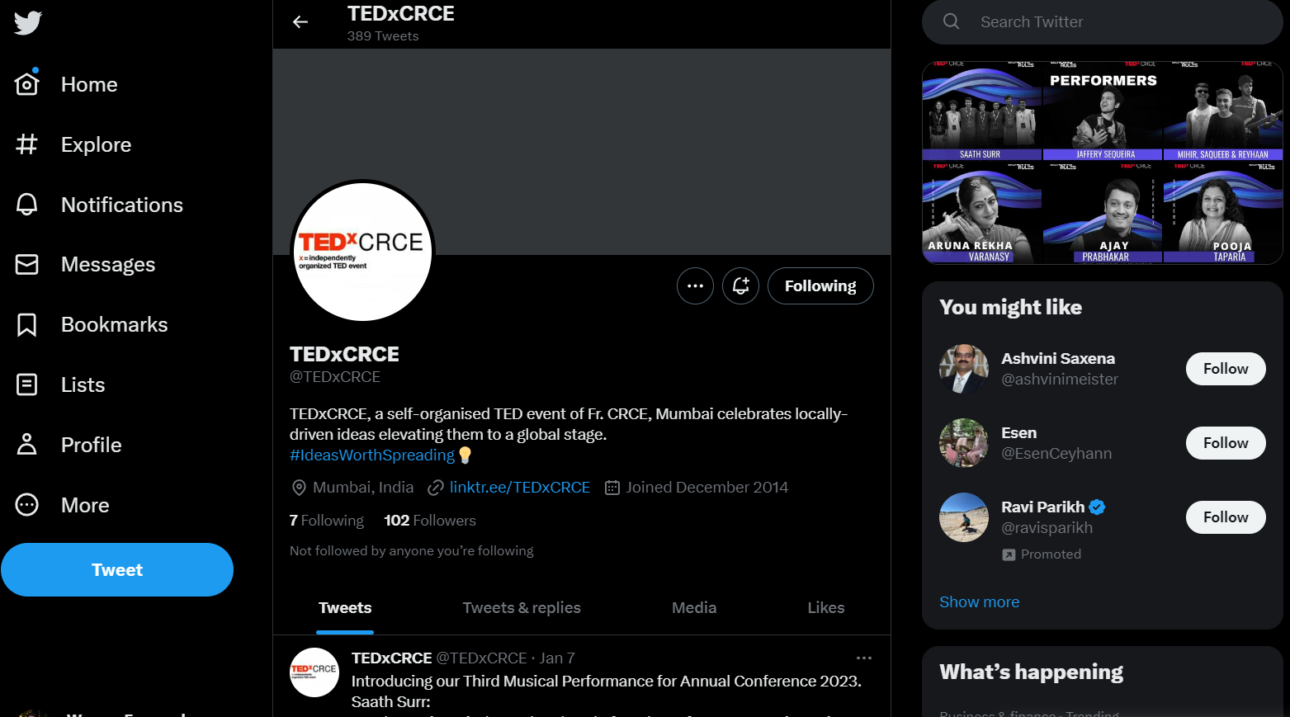

YouTube:  
<https://www.youtube.com/@tedxcrce9174>

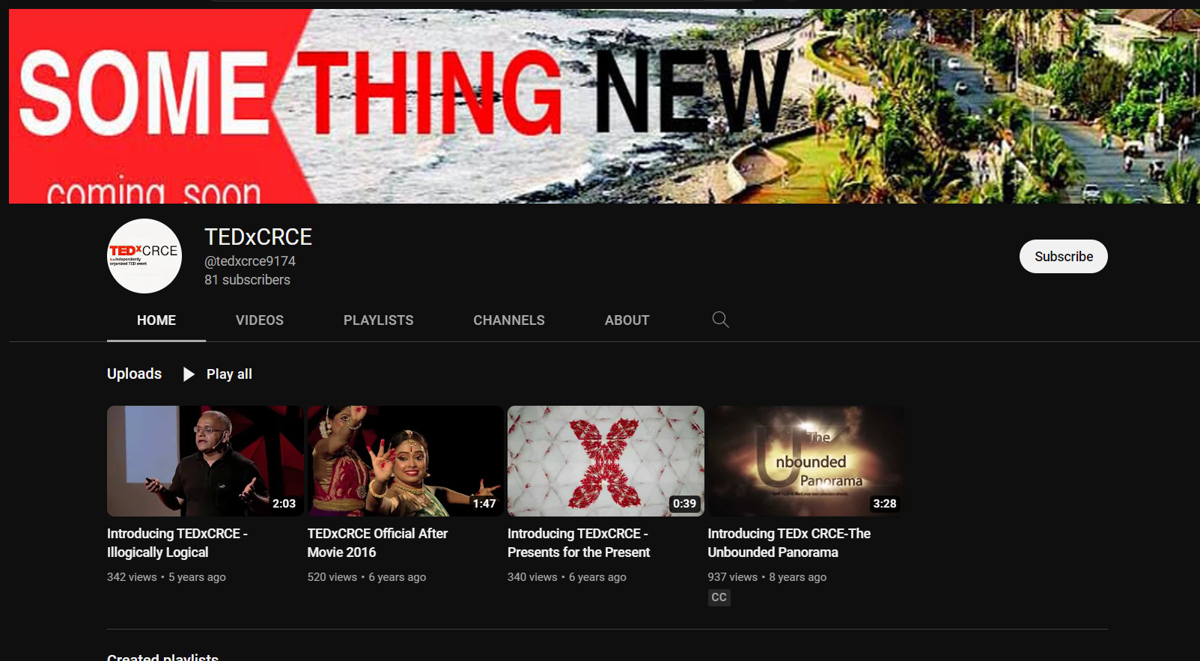

Instagram:

<https://instagram.com/tedxcrce>

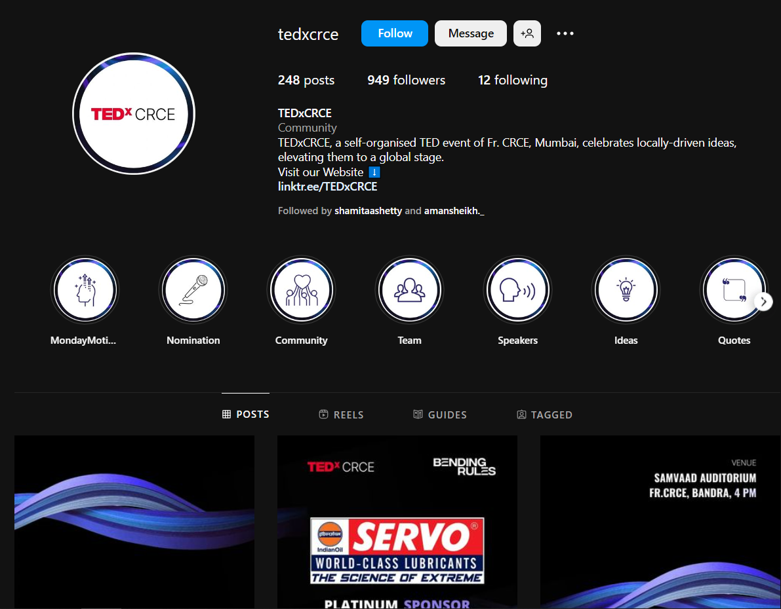

Facebook  
<https://www.facebook.com/tedxcrce>

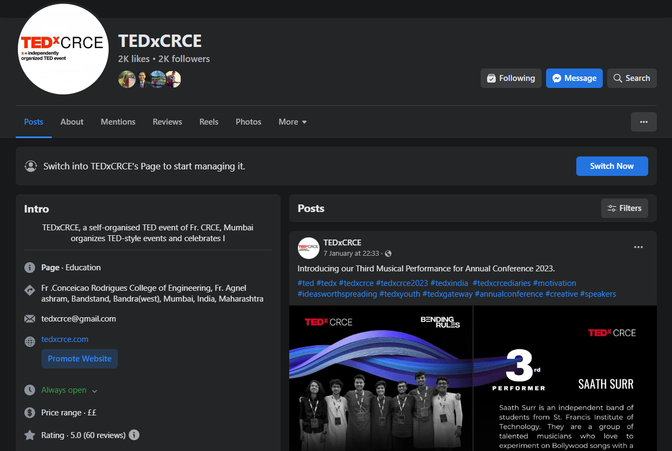

2. Find as many counts for each social media account as described in the section on measuring success.

Twitter:  
102 Followers

Instagram:

949 Followers

YouTube:  
81 Subscribers

Facebook:

2K Followers

3. How often does the company interact on their social network site? Is it many times a day, a few times a week, or never?

Twitter:

Few times a week

Instagram:

Few times a week

YouTube:

Once in a year

Facebook:

Few times a week

4. What kind of interaction is the company doing? Broadcast, request for input, direct interaction, or a combination? Provide an example of each.

1. Advertising and marketing through Instagram reels and memes.
2. Sharing their achievements on the page
3. Request for input: asking followers to answer various questions through tweets to achieve user engagement

Example:



1. Broadcasting of various informative and motivational videos on YouTube.
2. Assess the company’s social media strategy. What are they doing well and why? What could they do better, why would that be better, and how should they do it?

* What they're doing well:

1. Consistent posting: They are regularly posting content which helps to keep their followers engaged.
2. Engaging content: The content they post is relevant and appealing to their target audience.
3. Hashtag utilization: They are using relevant hashtags which helps to increase the visibility of their posts.

* What they could do better:

1. Cross-platform integration: They could better integrate their content across different platforms to create a more cohesive brand image.
2. More visually appealing content: They could use more visual content such as images and videos to make their posts more eye-catching.
3. Collaboration with other brands/influencers: They could collaborate with other brands or influencers in their niche to reach a wider audience.

* To implement these changes, they could:

1. Develop a content calendar that outlines their social media strategy across platforms.
2. Invest in visual content creation tools such as graphic design software or a professional photographer.
3. Research and reach out to relevant brands and influencers to establish partnerships.

**ii) Social Media analytics tools (Facebook insights, google analytics, netlytic, etc.)**

Facebook Insights

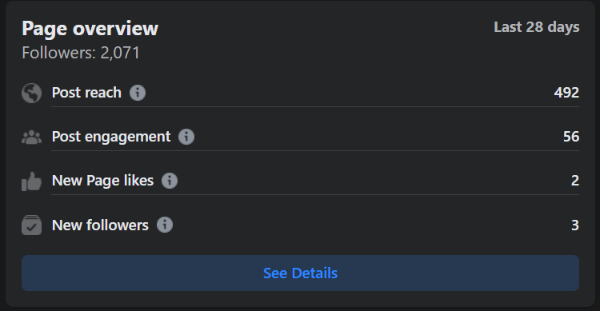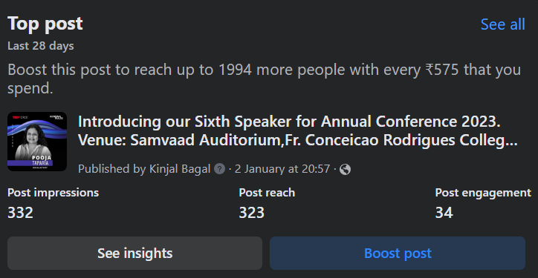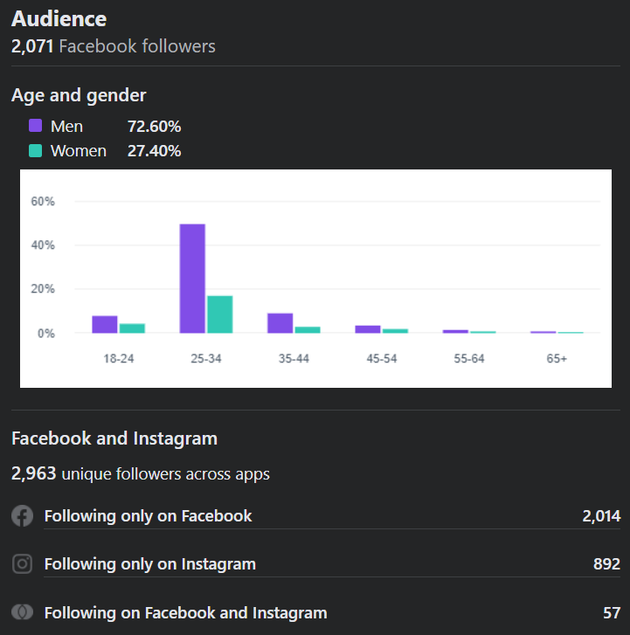

Google Analytics

<https://tedxcrce.com>

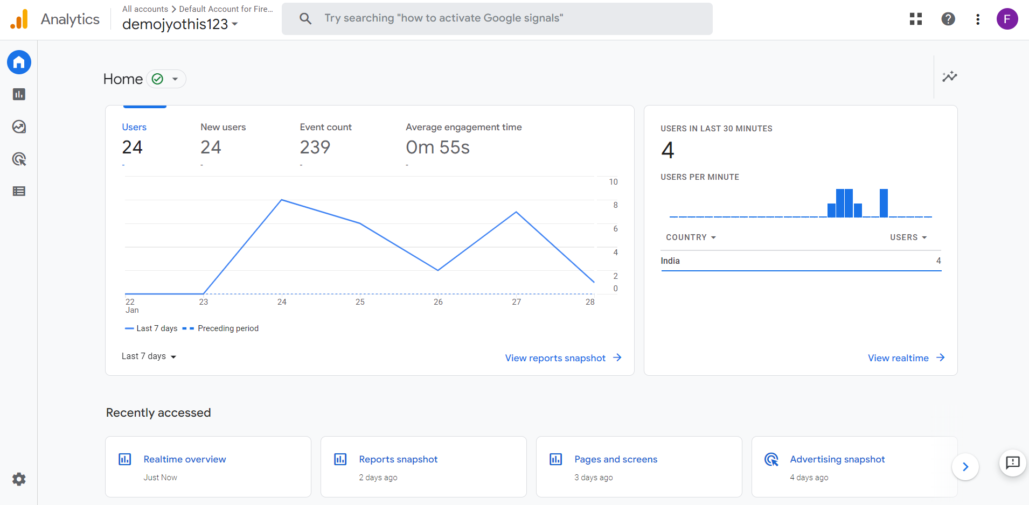

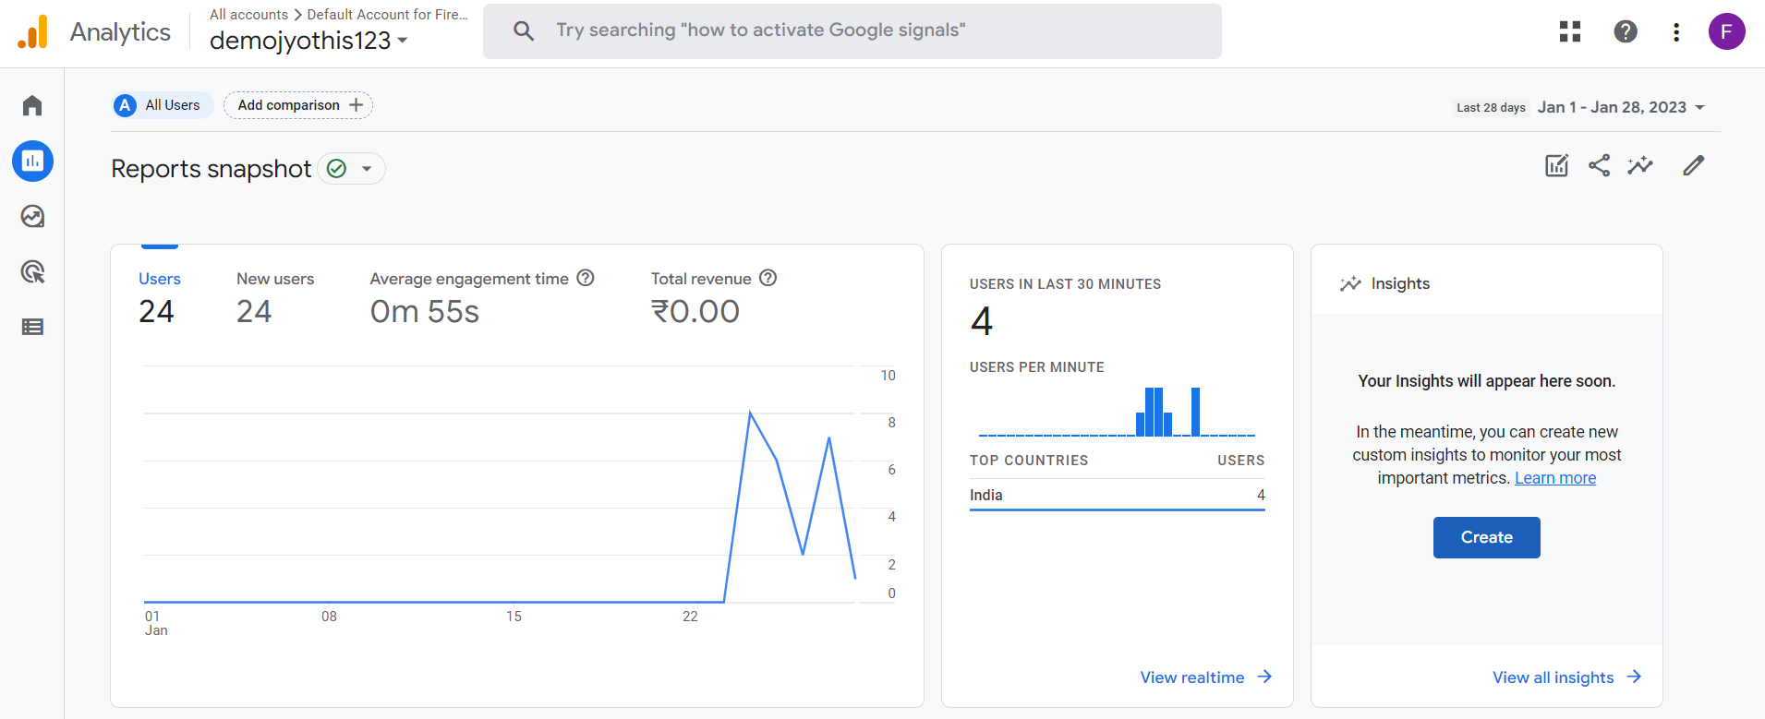 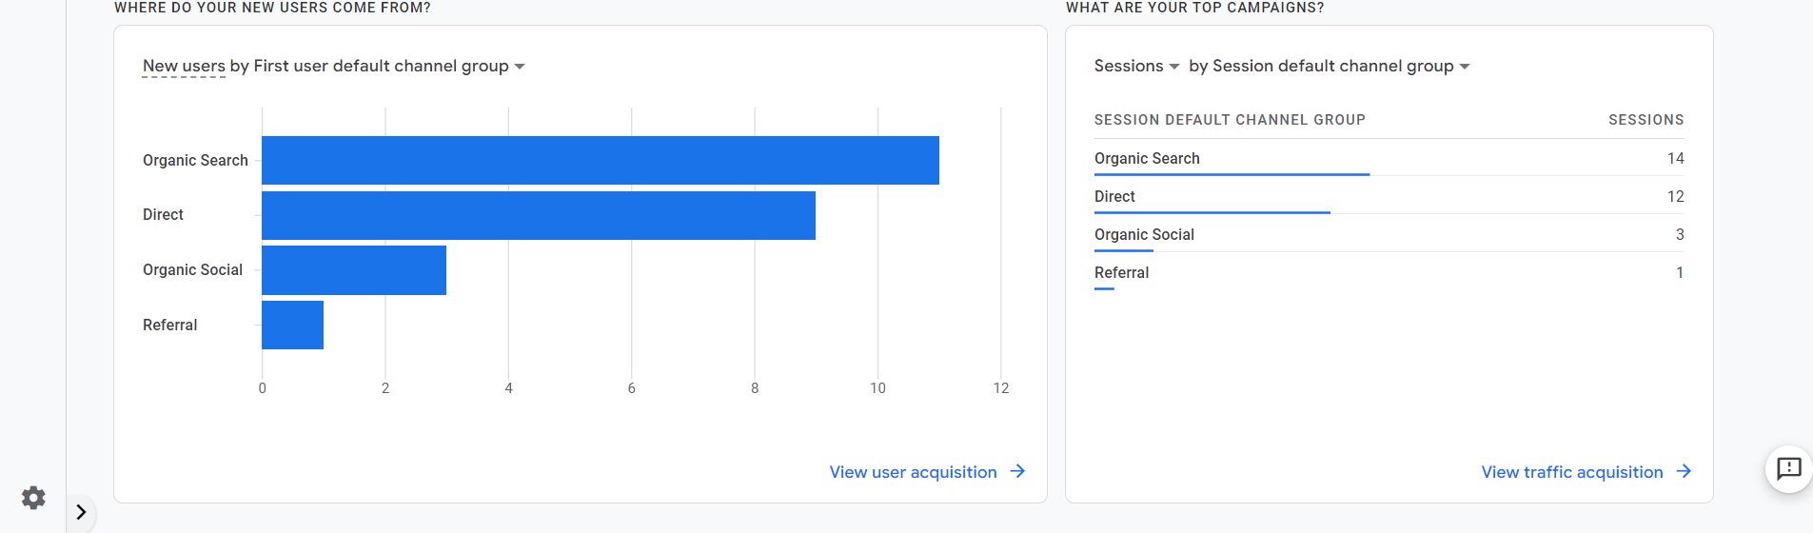

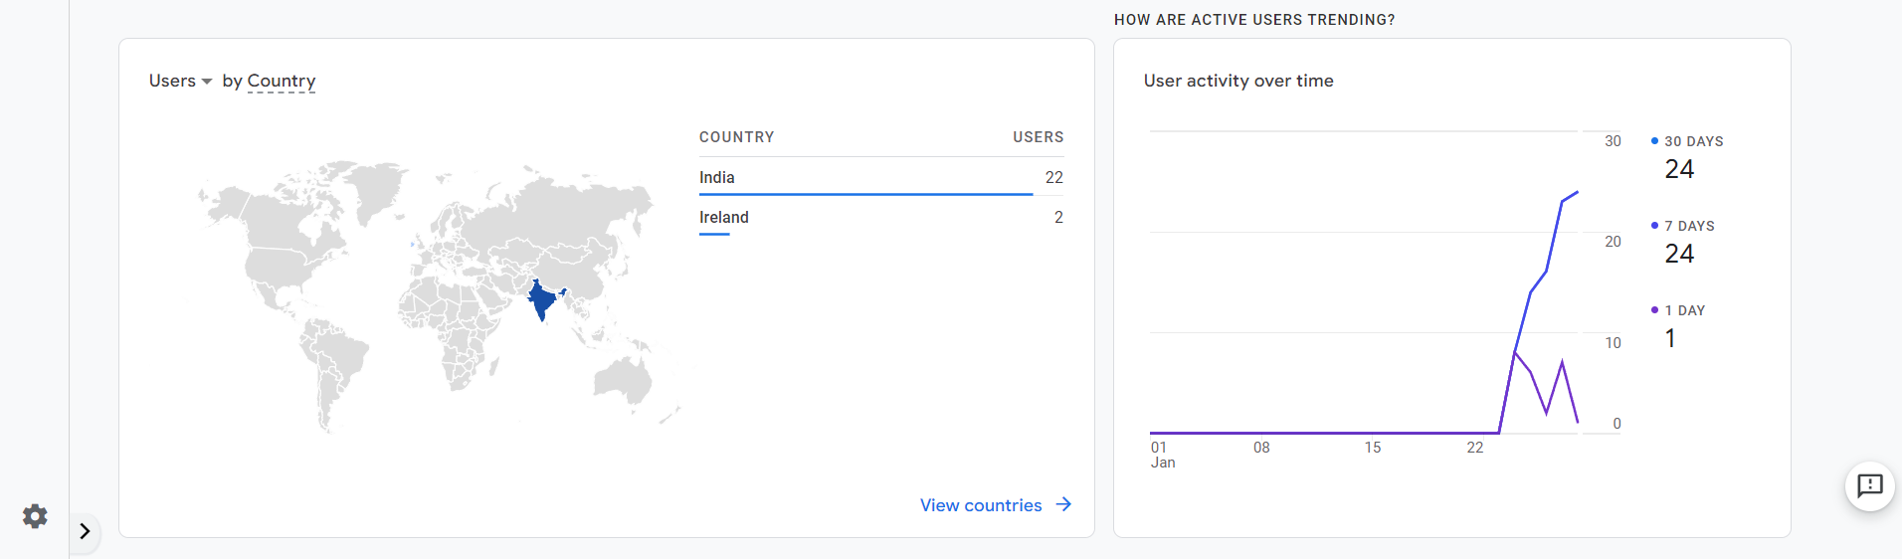 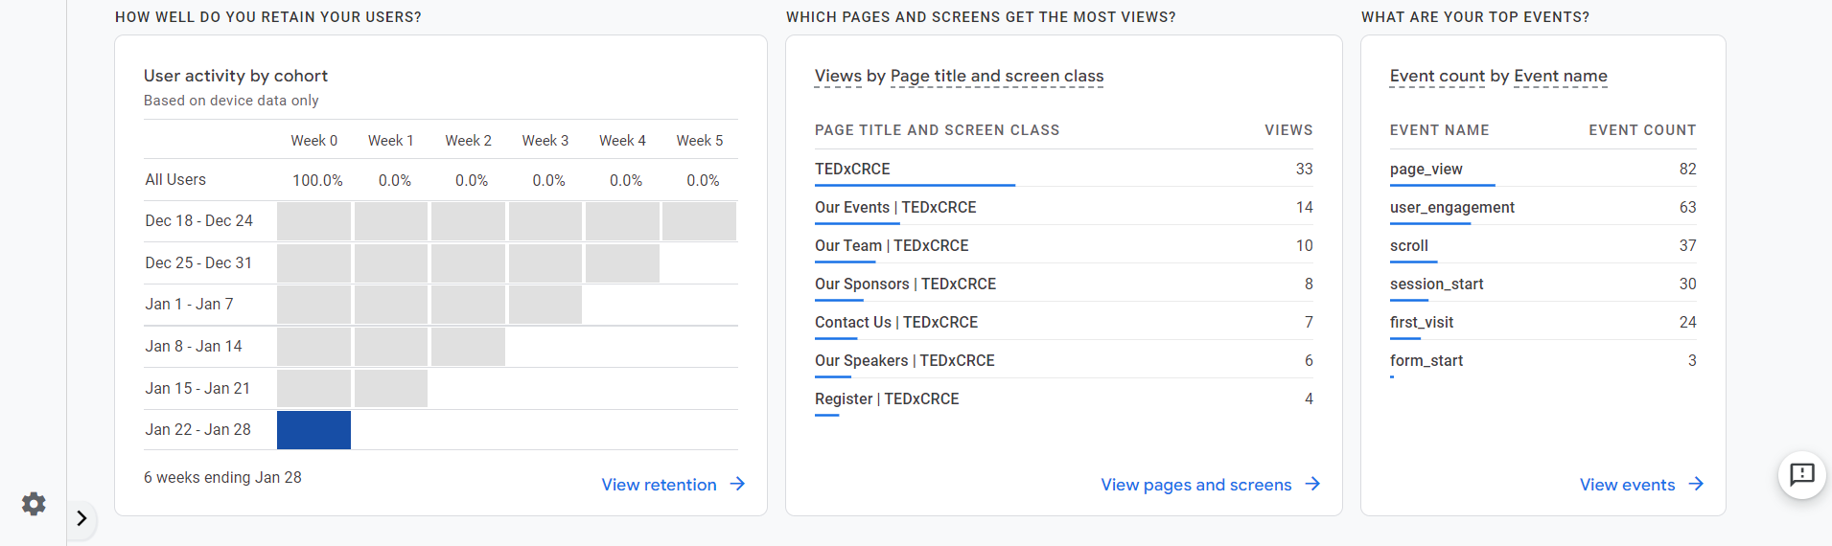

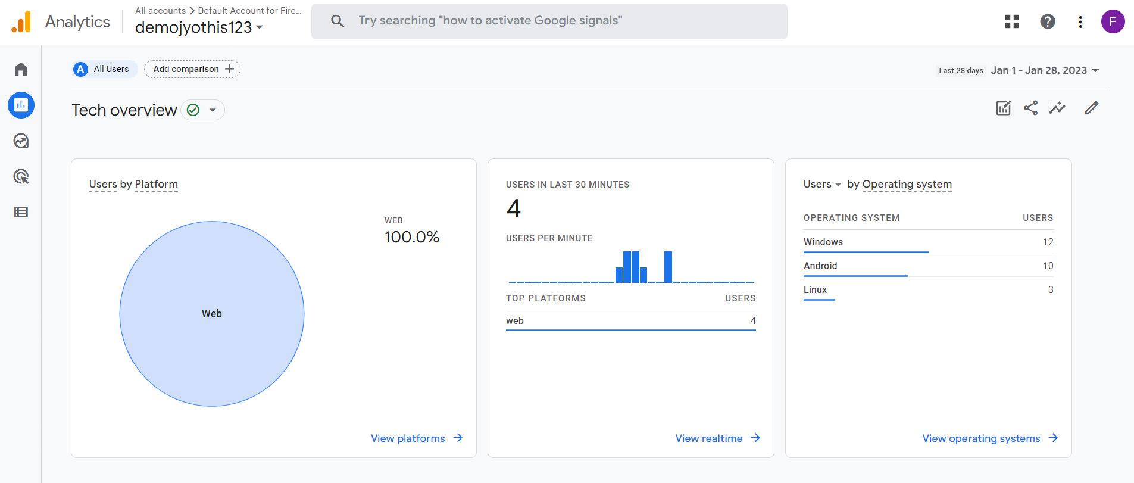

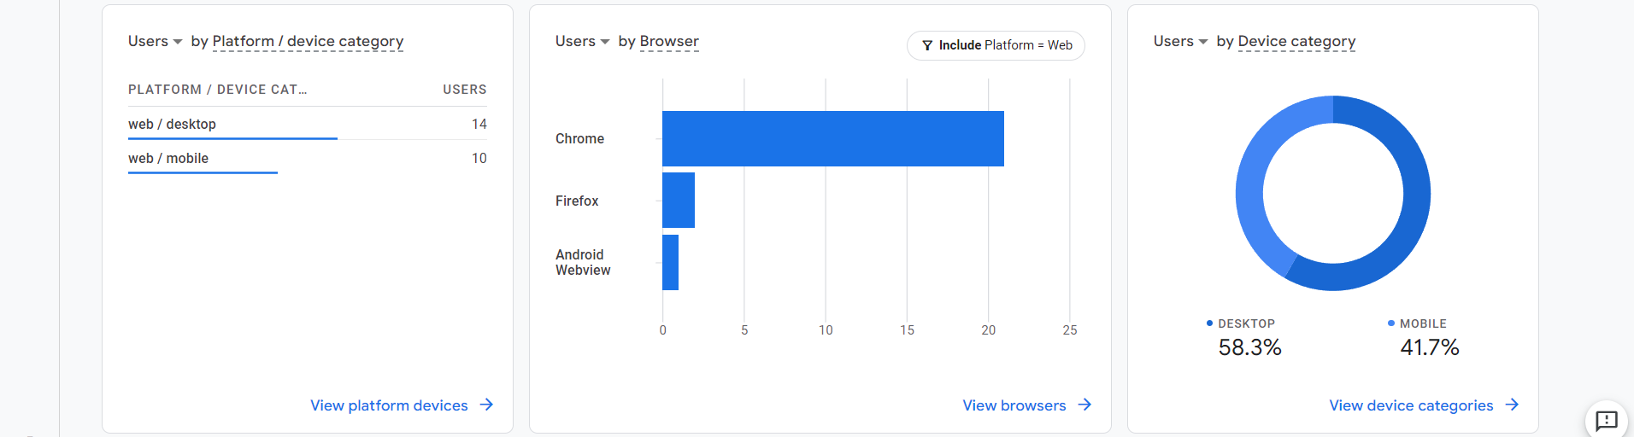

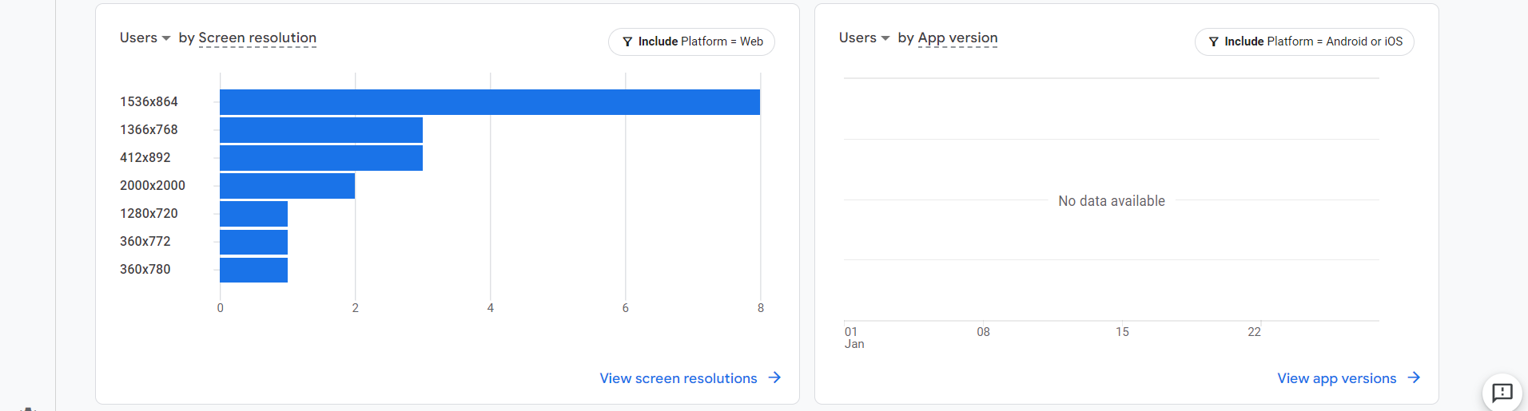

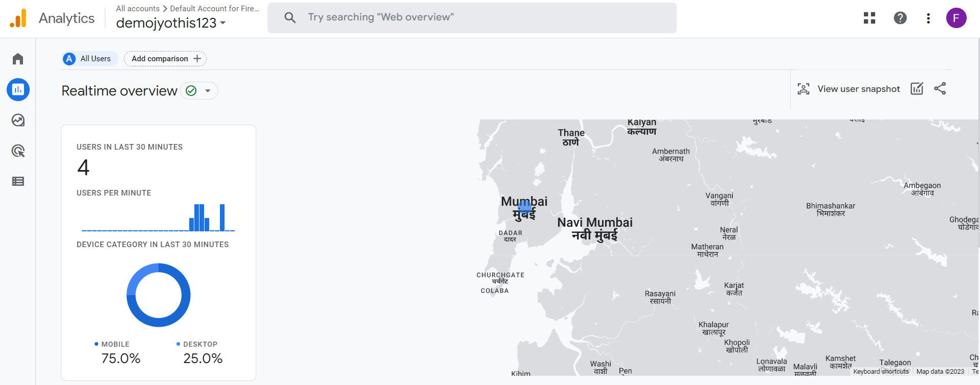 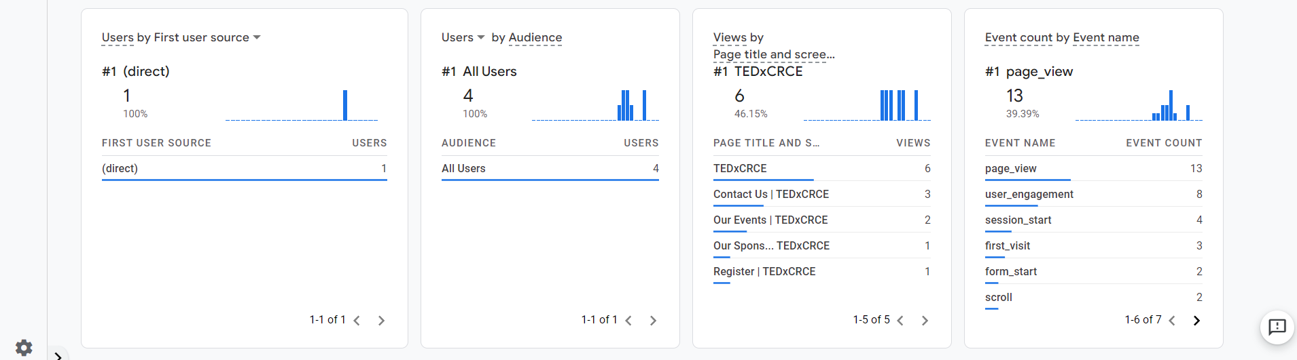

Netlytic

<https://netlytic.org>

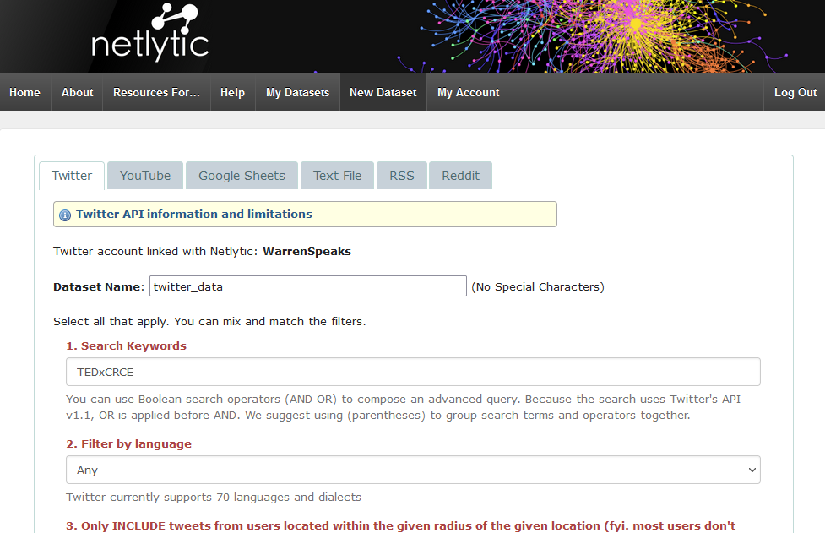 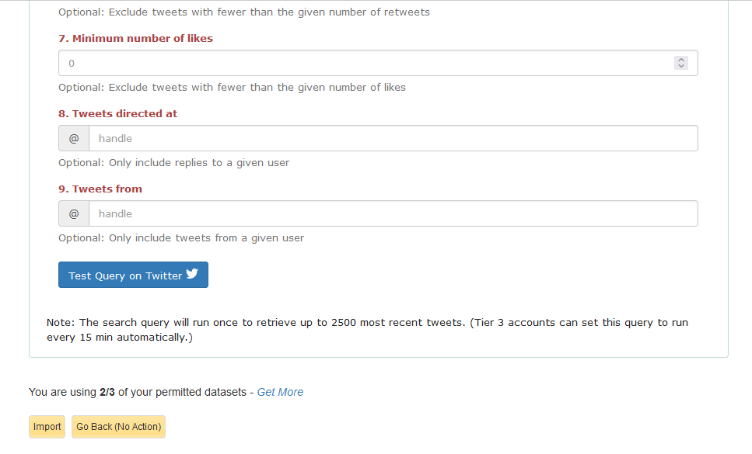

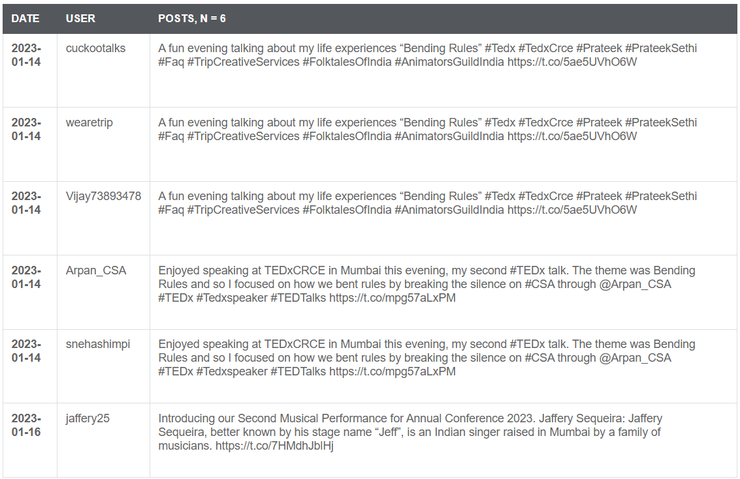

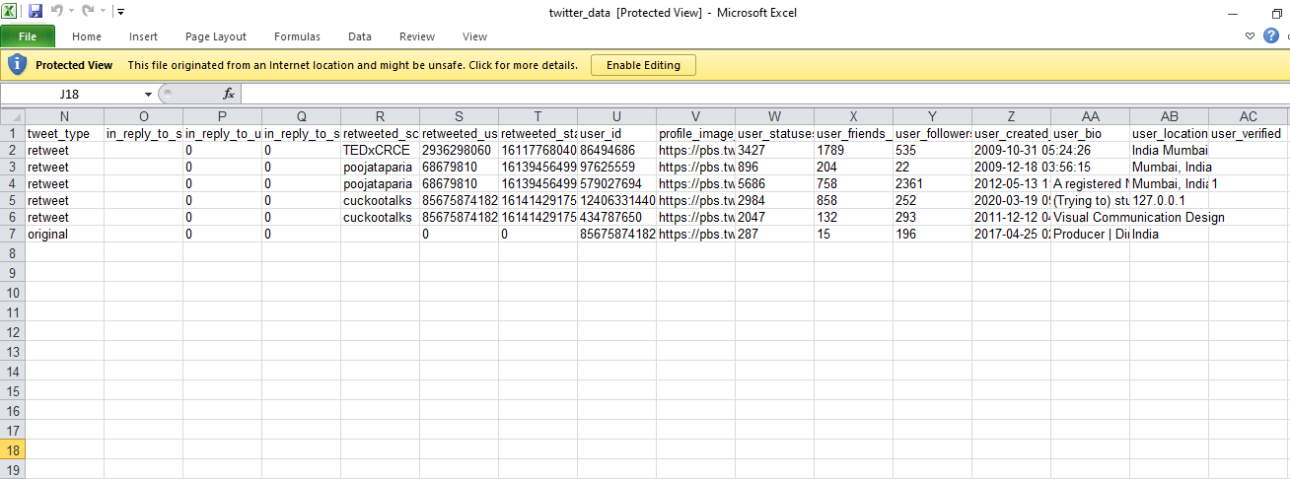

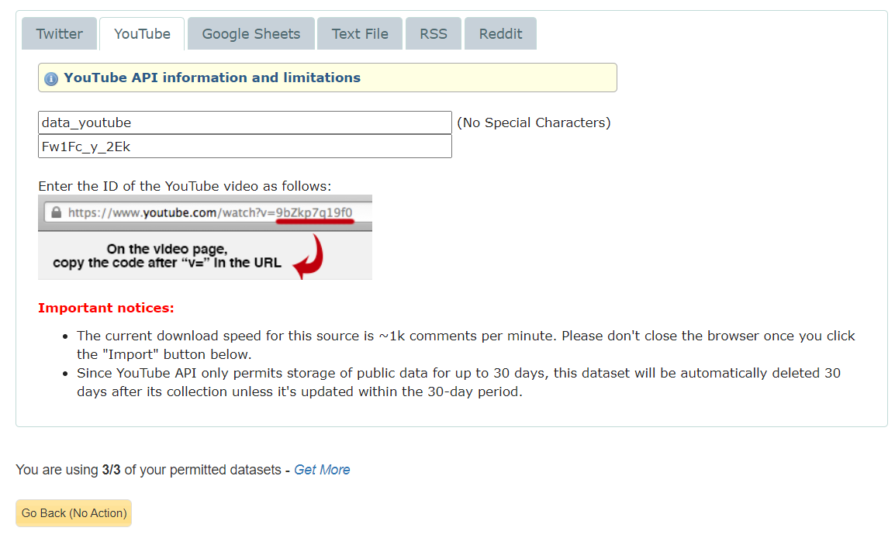

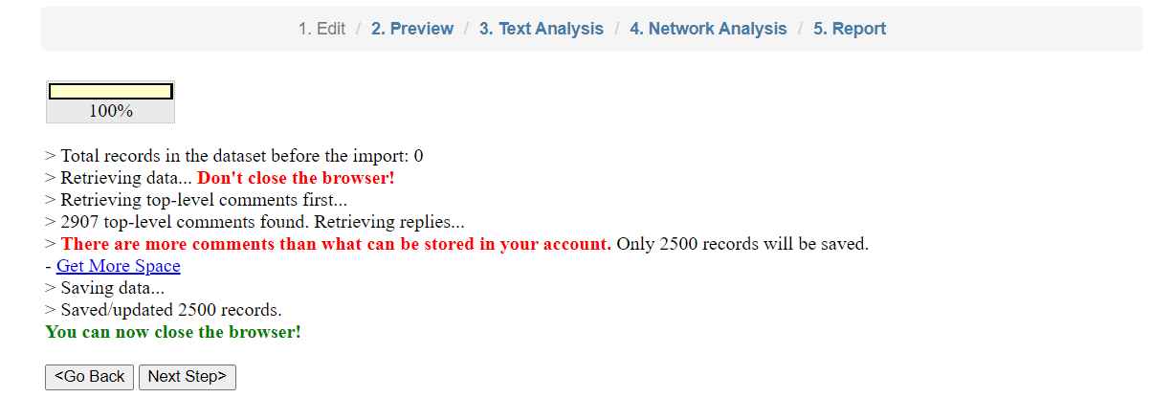

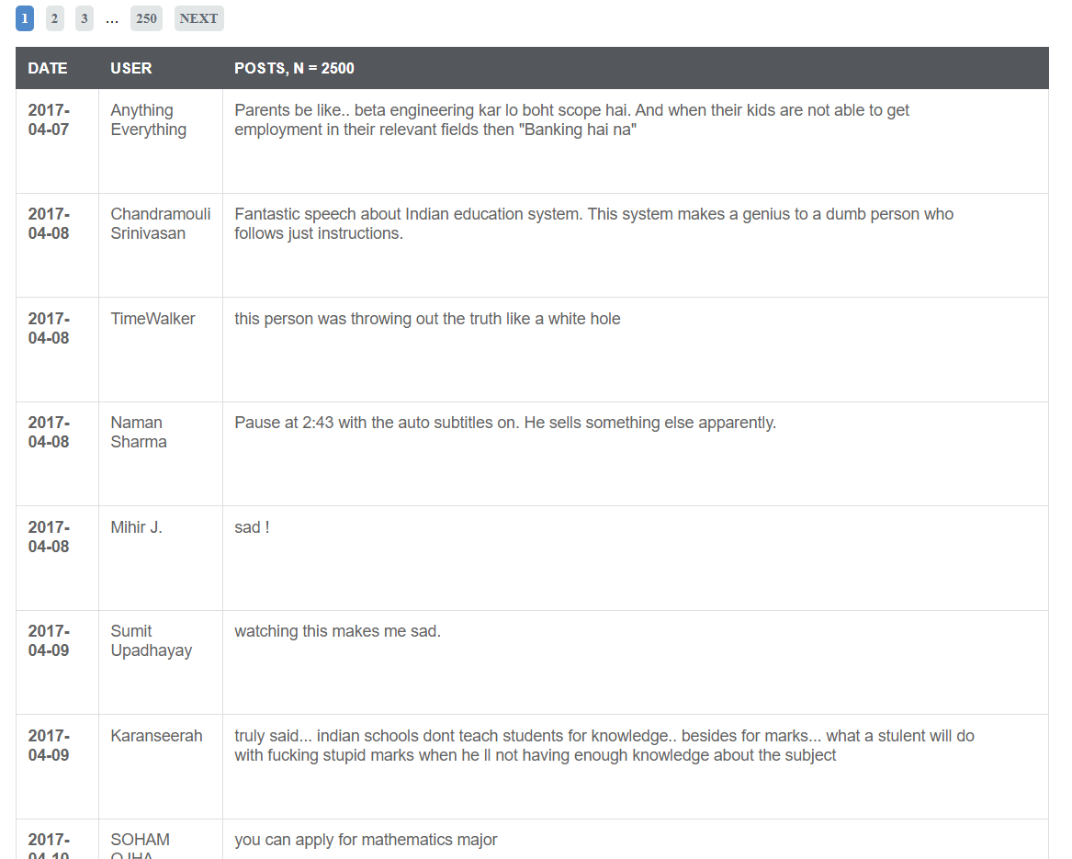

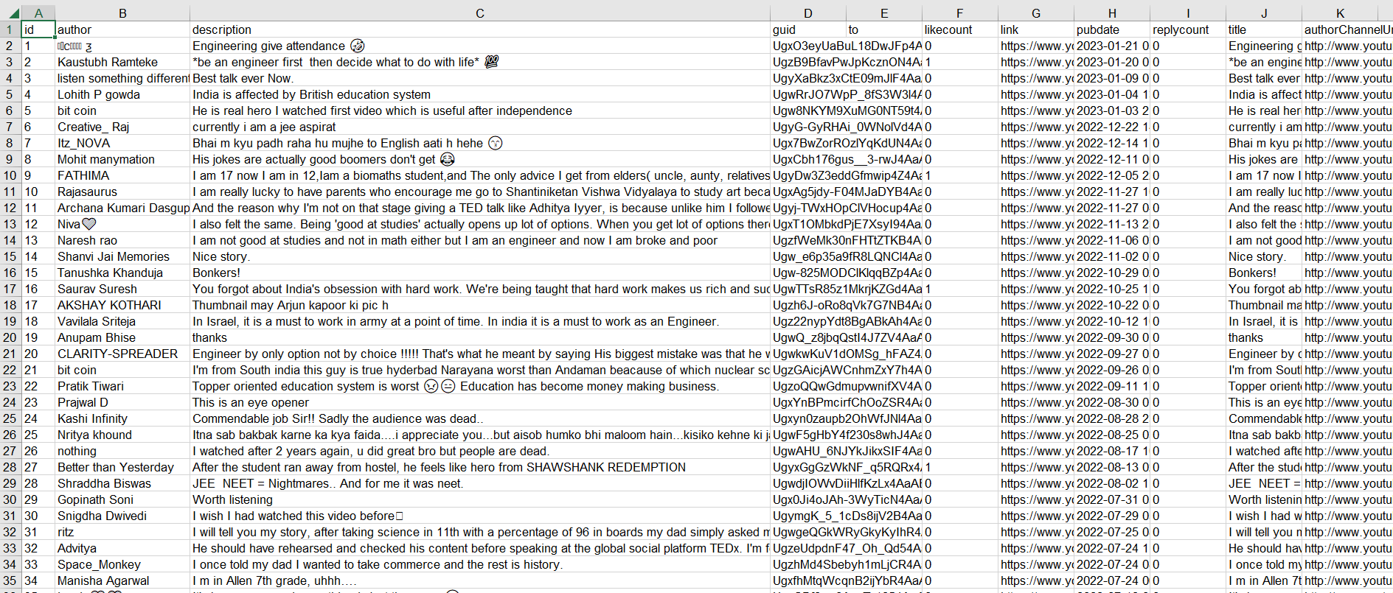

**iii) Social Media Analytics techniques and engagement metrics (page level, post level, member level)**

Page level, post level, and member level are three different ways of categorizing or organizing content or information on a website or platform.

* Page level: Refers to the overall structure and content of a web page. It determines the layout, design, and overall user experience of a page.
* Post level: Refers to individual pieces of content such as blog posts, articles, or social media updates. It determines the format and style of individual pieces of content.
* Member level: Refers to the user account or profile level, including information such as username, password, email address, and access rights. It determines what content a user can see and interact with based on their account privileges.

**iv) Applications of Social media analytics for business.**

Social media analytics can be used in a number of ways by businesses to improve their marketing and customer engagement efforts:

* Market research: Understanding customer preferences, opinions, and feedback on social media can help businesses identify new market opportunities and inform product development.
* Competitor analysis: Tracking competitor activity on social media can provide insights into their marketing strategies, audience engagement, and industry trends.
* Brand reputation management: Monitoring brand mentions and sentiment on social media can help businesses address negative comments and maintain a positive brand image.
* Customer engagement: Analyzing social media interactions can provide insights into what content resonates with customers and how to better engage with them.
* Campaign analysis: Evaluating the success of social media campaigns in terms of reach, engagement, and conversions can help businesses optimize future campaigns.
* Audience targeting: Analyzing social media demographics and interests can help businesses better target their marketing efforts and reach their desired audience.

**CONCLUSION**

In conclusion, learning various social media analytics tools and evaluation matrices is crucial for businesses that want to maximize the value of their social media presence. There are a variety of tools available, each with its own set of features and capabilities, and choosing the right tool requires careful consideration of key evaluation matrices such as ease of use, data accuracy, customization options, integration capabilities, cost, and customer support. By carefully evaluating their options, businesses can choose the right tool to meet their needs and use social media analytics to improve their marketing and customer engagement efforts.