FR. CONCEICAO RODRIGUES COLLEGE OF ENGINEERING

Department of Computer Engineering

Course, Subject & Experiment Details

|  |  |
| --- | --- |
| Practical No: | 4 |
| Title: | Exploratory Data Analysis and visualization of Social Media Data for business. |
| Name of the Student: | Warren Fernandes |
| Roll No: | 8940 |
| Date of Performance: | 21/02/2023 |
| Date of Submission: | 28/02/2023 |

Evaluation:

|  |  |  |
| --- | --- | --- |
| Sr. No. | Rubric | Grade |
| 1 | On time submission/completion (2) |  |
| 2 | Preparedness (2) |  |
| 3 | Skill (4) |  |
| 4 | Output (2) |  |

Signature of the Teacher

## **Getting started with Power BI**

To get started with Desktop Power BI for excel, CSV files will be imported. First, we will click get data, and from that menu, we will select the CSV file and then load the data. In these Fig. we have uploaded data from Sales of LoveBonito.

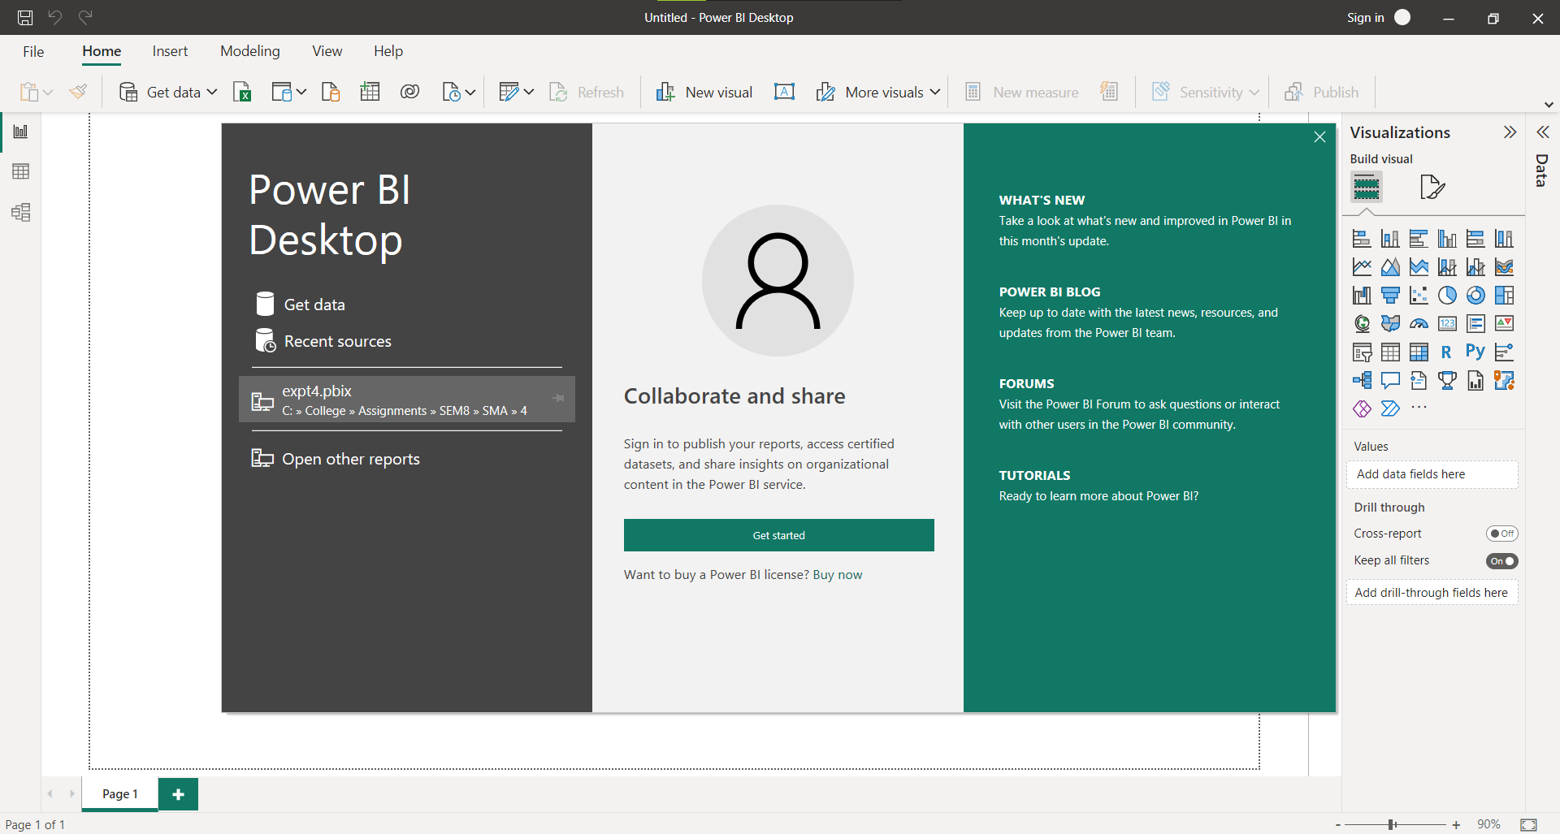

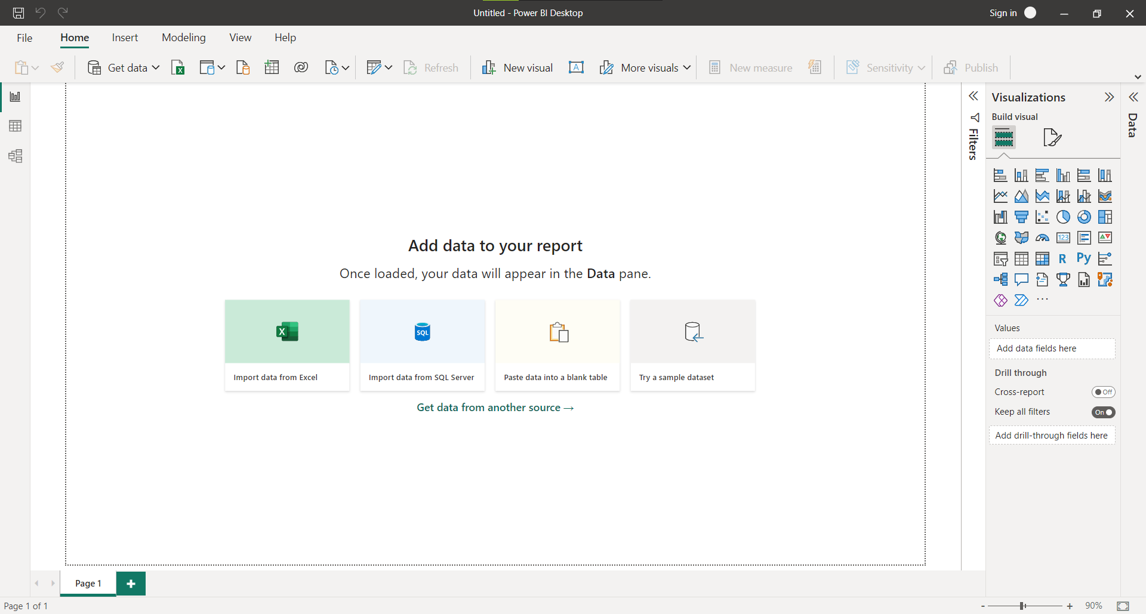

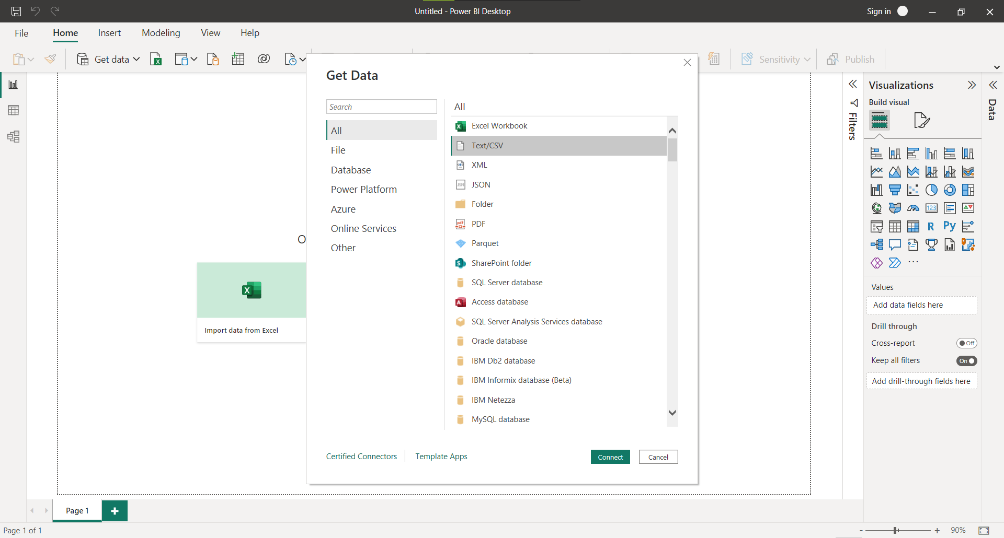

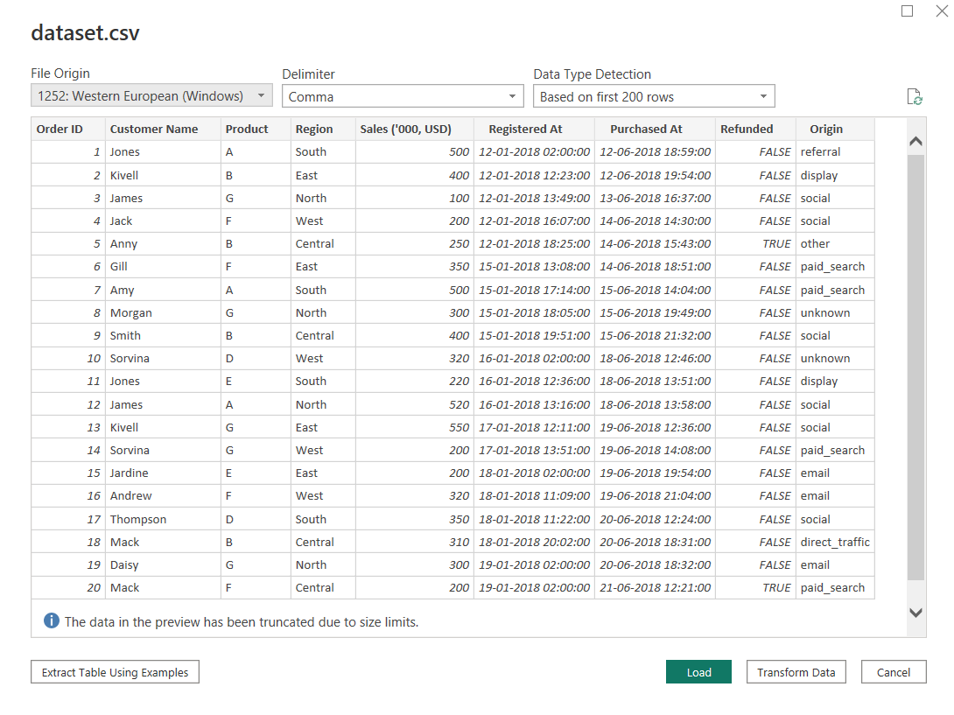

#### **Transforming Data**

Data needs to be formatted according to the need of columns. There are many processing errors which leads to blank rows.

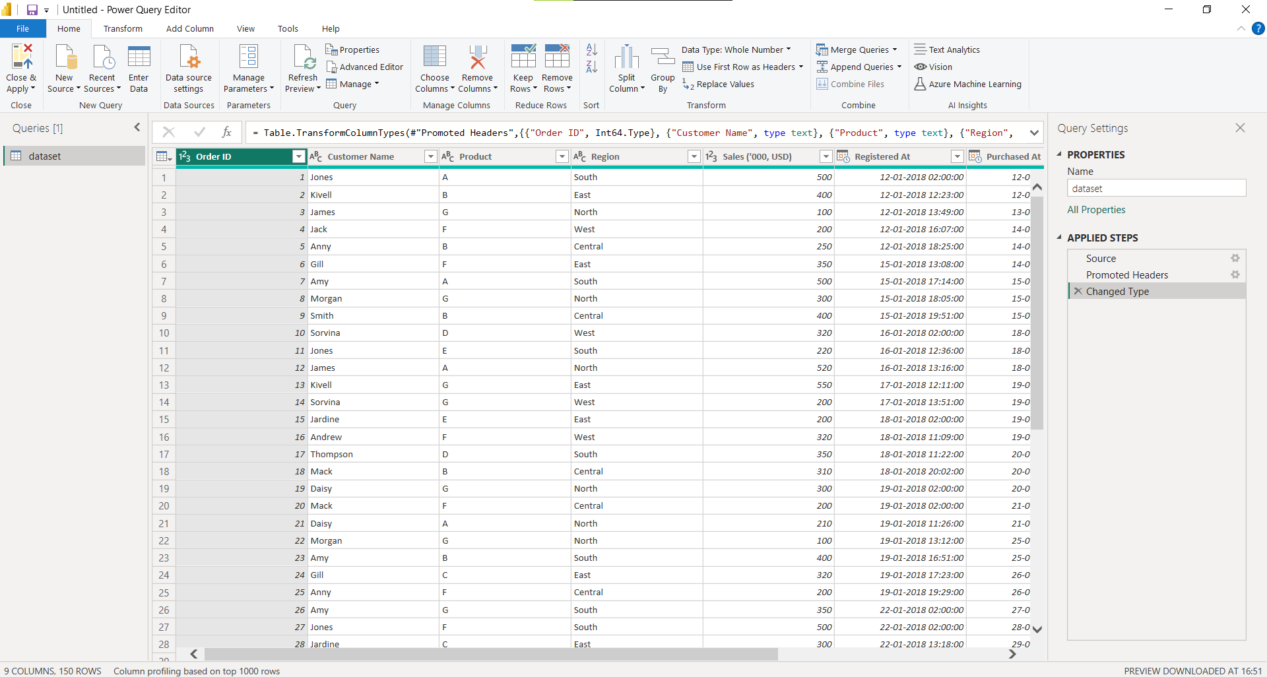

#### **Data View**

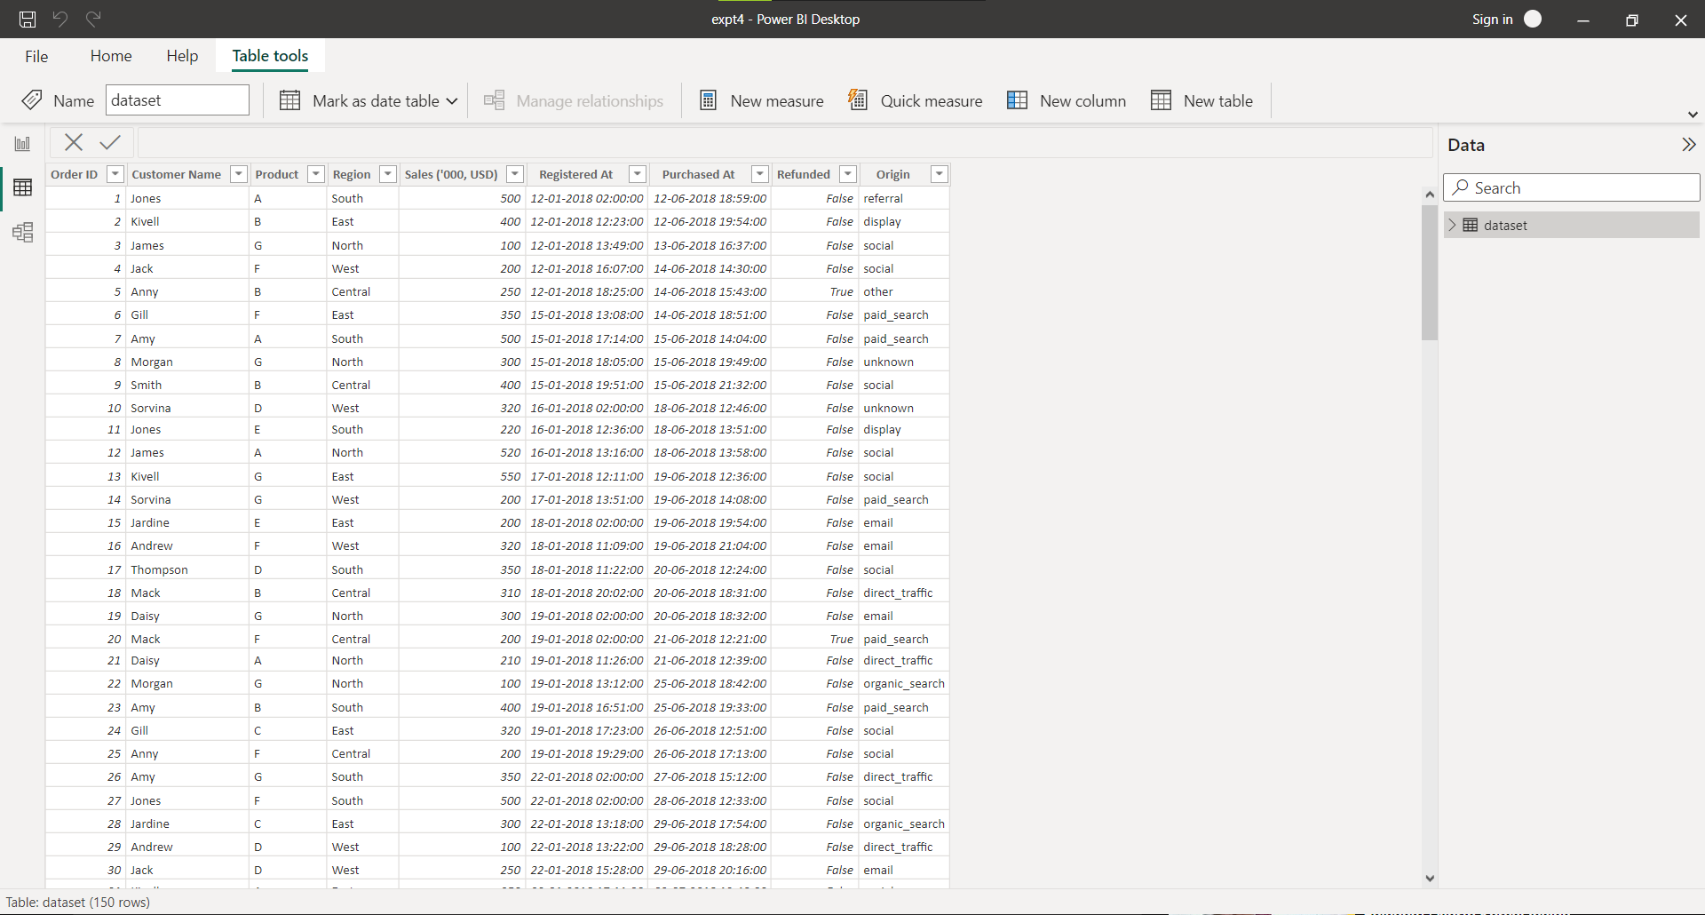

#### **Model View**

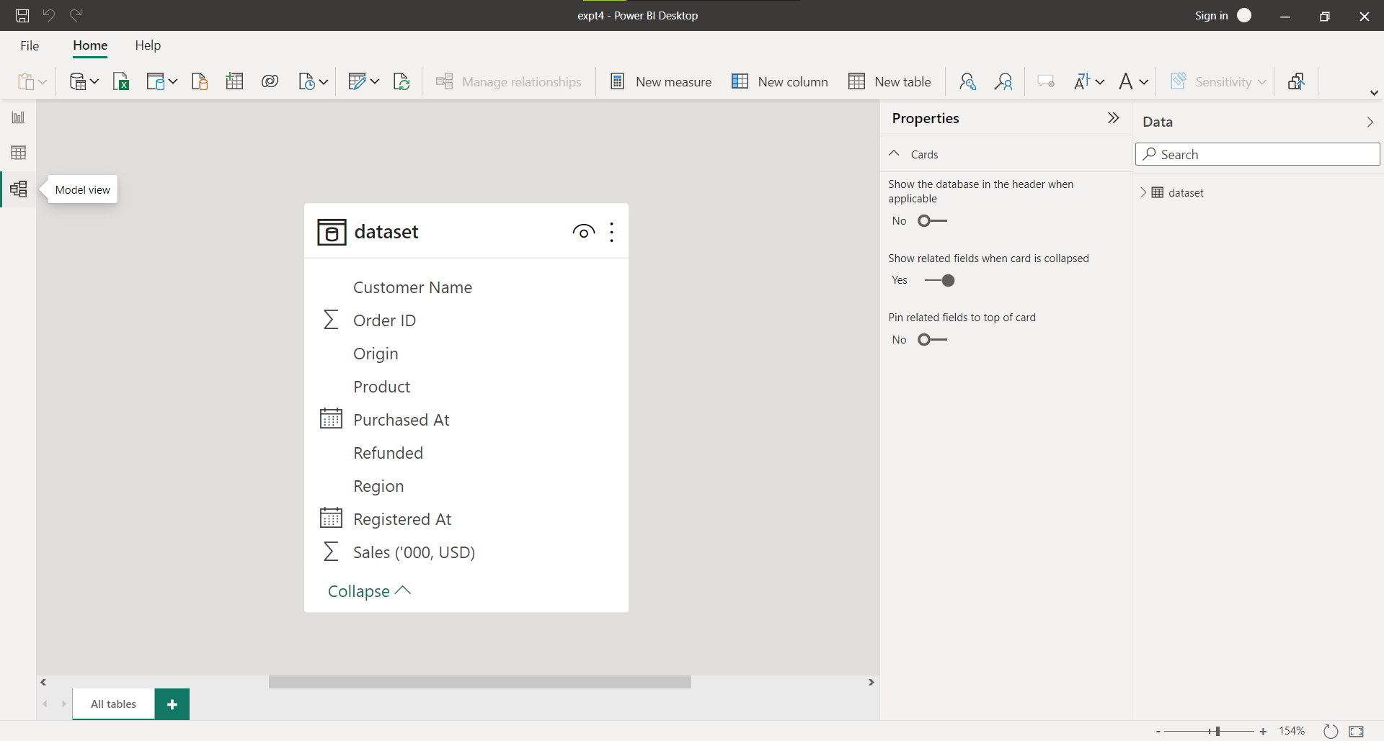

#### **Build Reports**

Build Reports

The top of the screen displays common report and visualization functions.

The middle part is where visualizations are produced and placed.

The bottom of the page tab section allows you to pick or add report pages.

You can filter data visualizations in the Filters window.

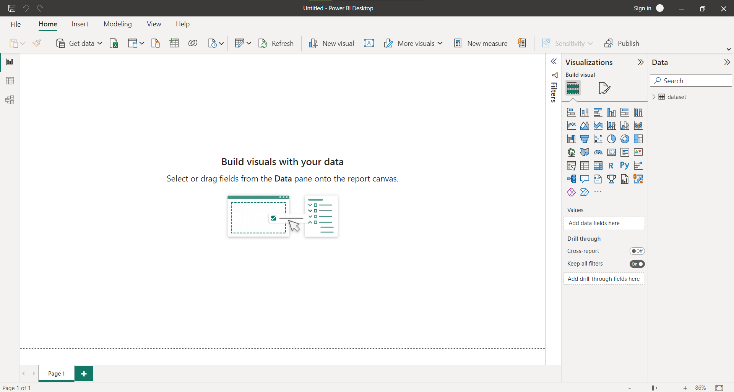

#### **Pie Chart**

A pie chart is a circular statistical graphic, which is divided into slices to illustrate numerical proportion. In a pie chart, the arc length of each slice is proportional to the quantity it represents.

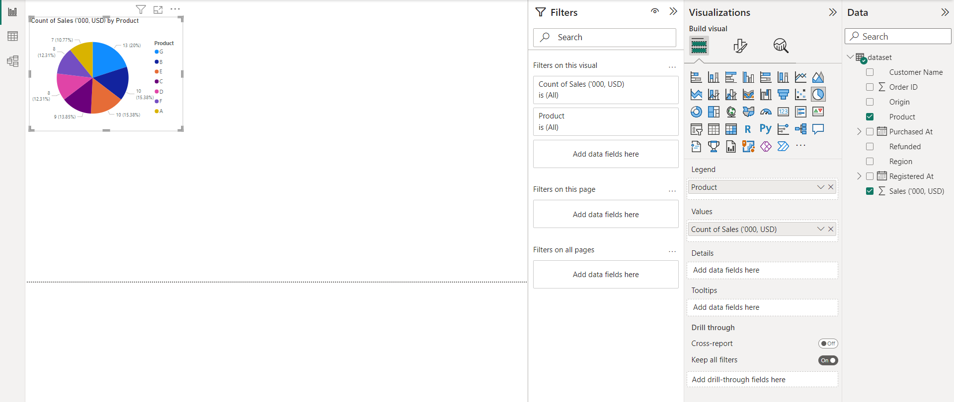

#### **Stacked Area Chart**

A stacked area chart is a type of graph that displays the evolution of a variable over time. It is similar to a regular area chart, but with multiple variables stacked on top of each other. Each variable is represented by a colored area, and the areas are stacked on top of each other to show the total contribution of all the variables at any given point in time.

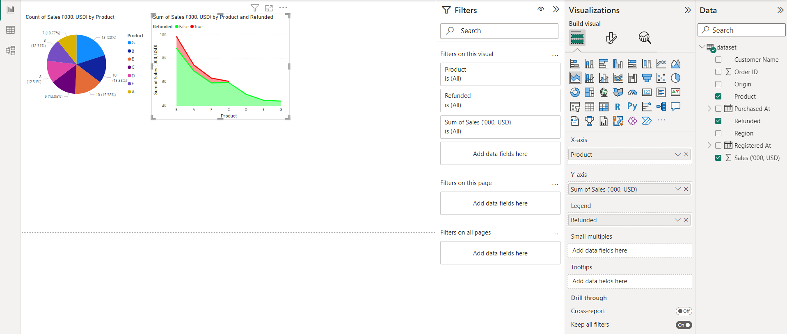

#### **Ribbon Chart**

Ribbon chart is used to visualize the data and quickly identify which data category has the highest rank (largest value). Ribbon charts are effective at showing rank change, with the highest range (value) always displayed on top for each time period.

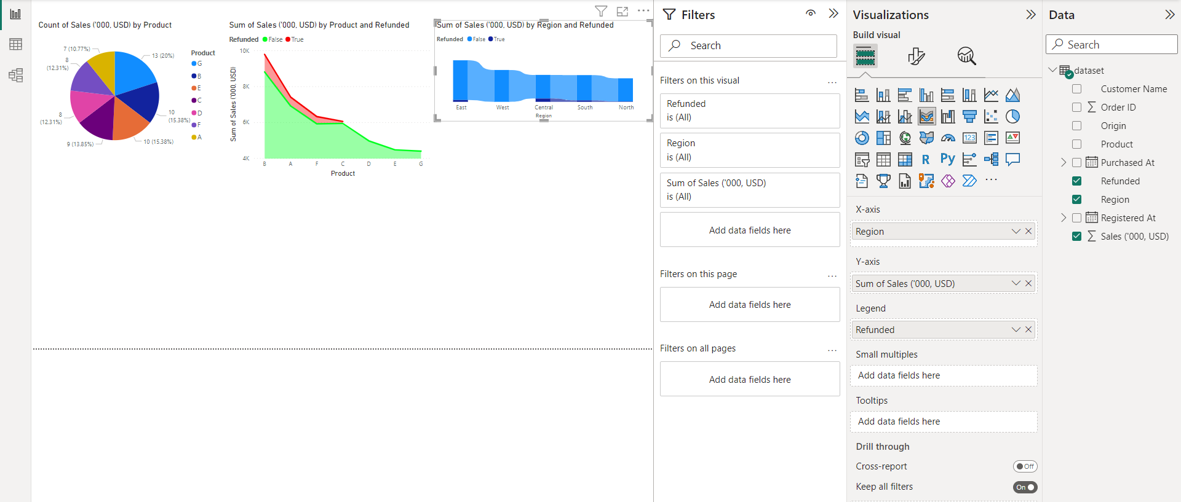

#### **Tree Map**

A tree map is used to show the composition of a whole when there are many components. The arrangement is typically (but not always) a rectangular area divided up into smaller rectangles to represent sub-categories. The size of these sub-category rectangles represents a quantitative value.

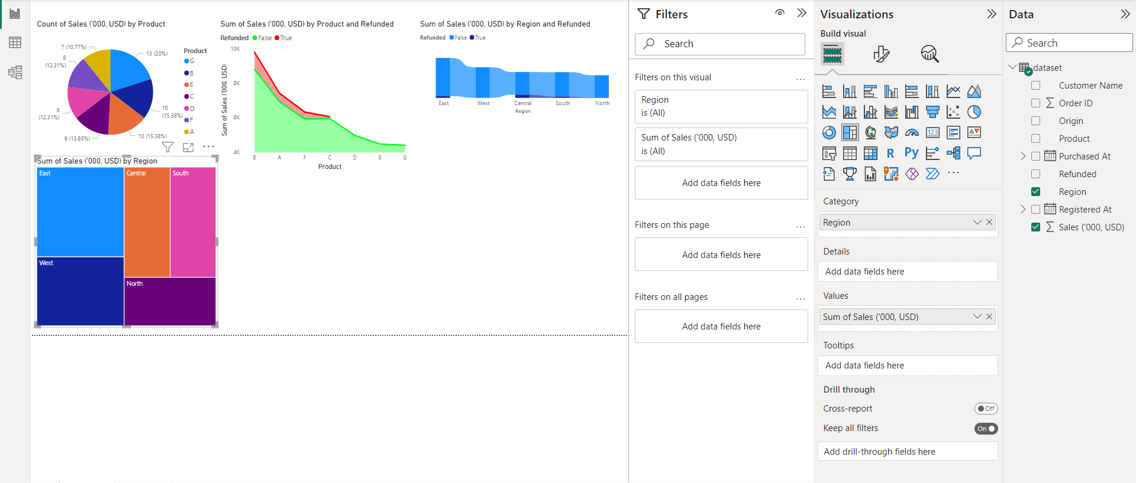

#### **Funnel**

Funnel charts show values across multiple stages in a process. For example, you could use a funnel chart to show the number of sales prospects at each stage in a sales pipeline. Typically, the values decrease gradually, allowing the bars to resemble a funnel.

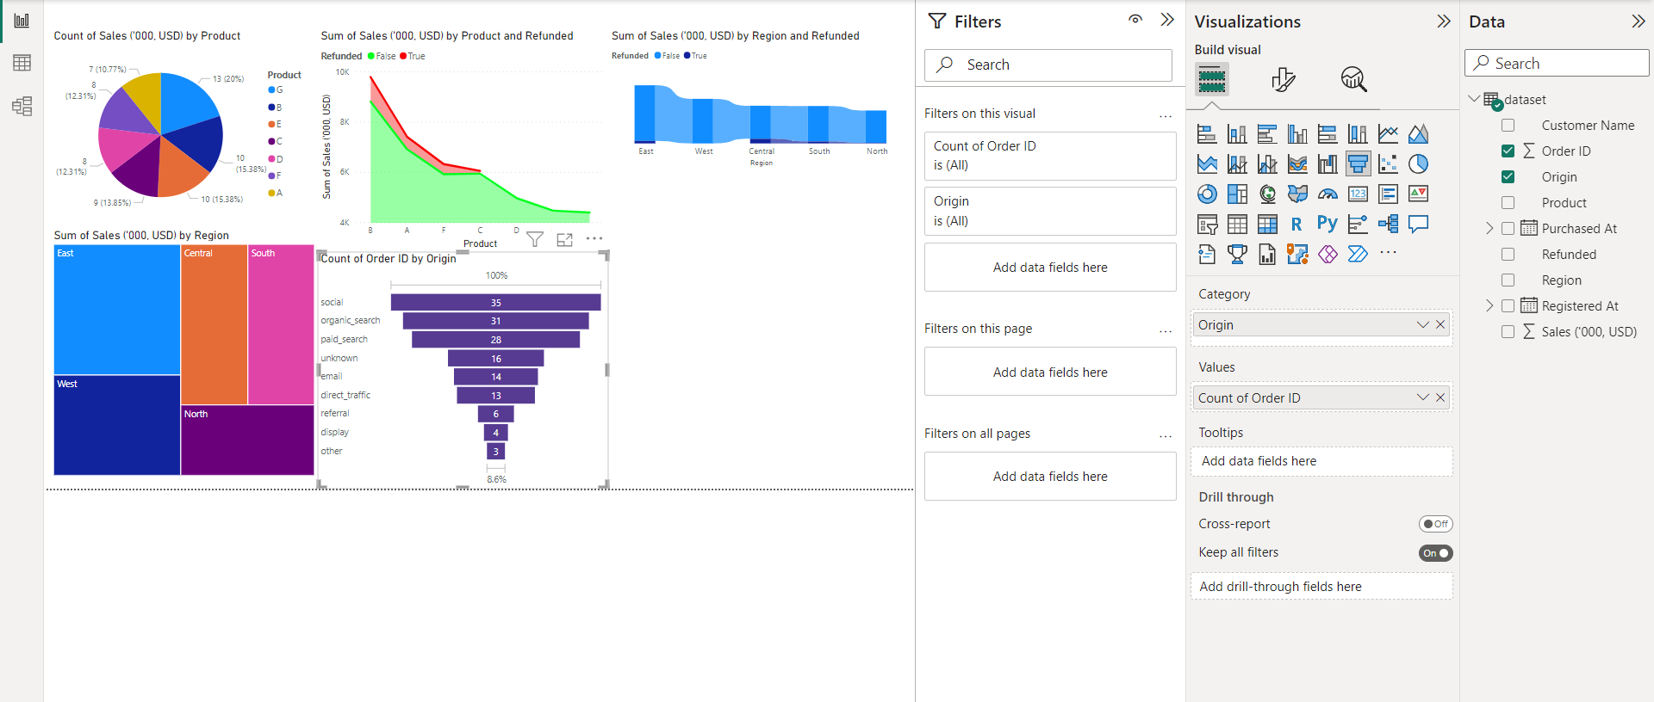

#### **Line Chart**

The line chart is a simple, two-dimensional chart with an X and Y axis, each point representing a single value. The data points are joined by a line to depict a trend, usually over time.

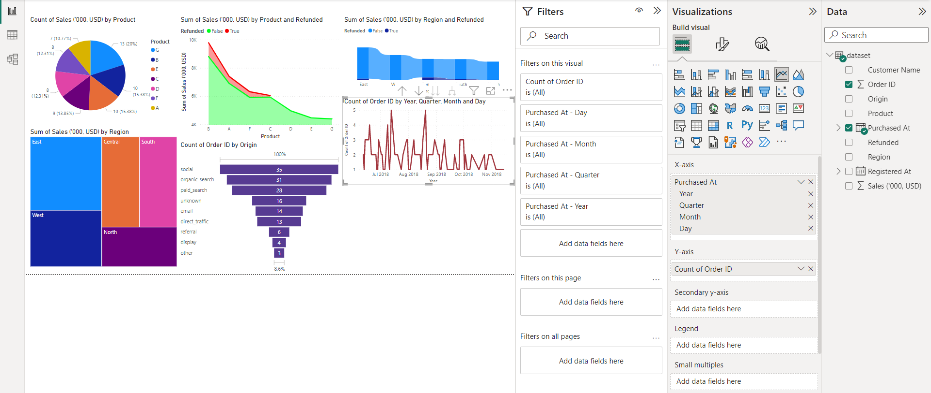

#### **Donut Chart**

A donut chart, in its simplest form, is a pie chart with its center cut out to look like a donut. At first glance, this may not seem to serve a much greater purpose than to create aesthetic variety. However, a donut chart helps avoid confusion around the area parameter that often trips people up in a pie chart.

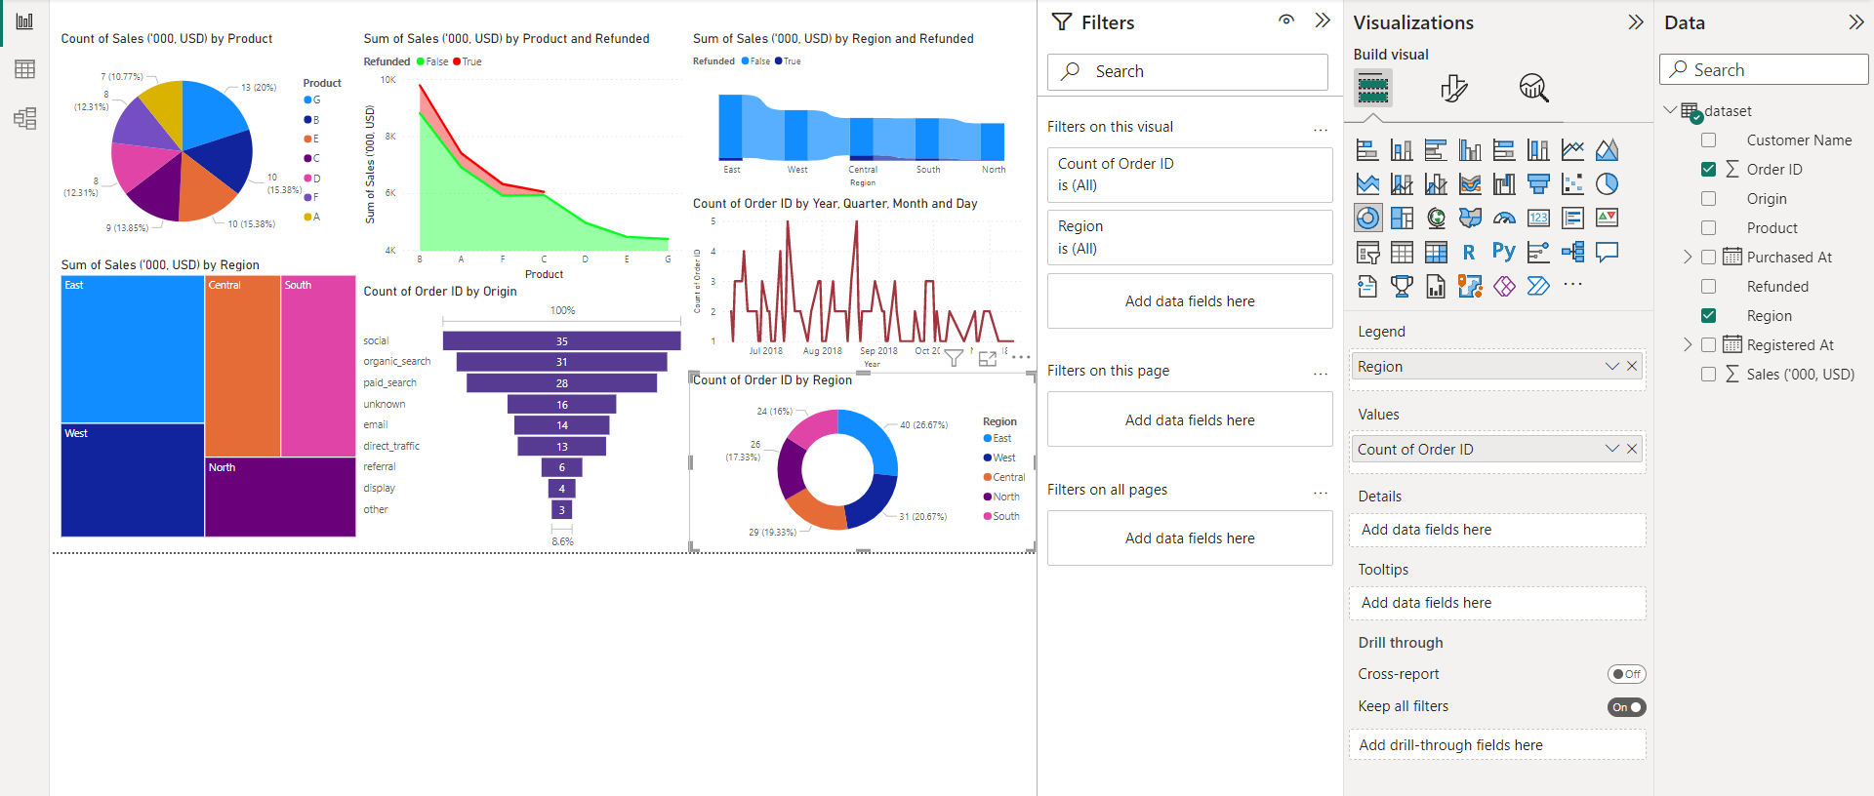

#### **Dashboard**

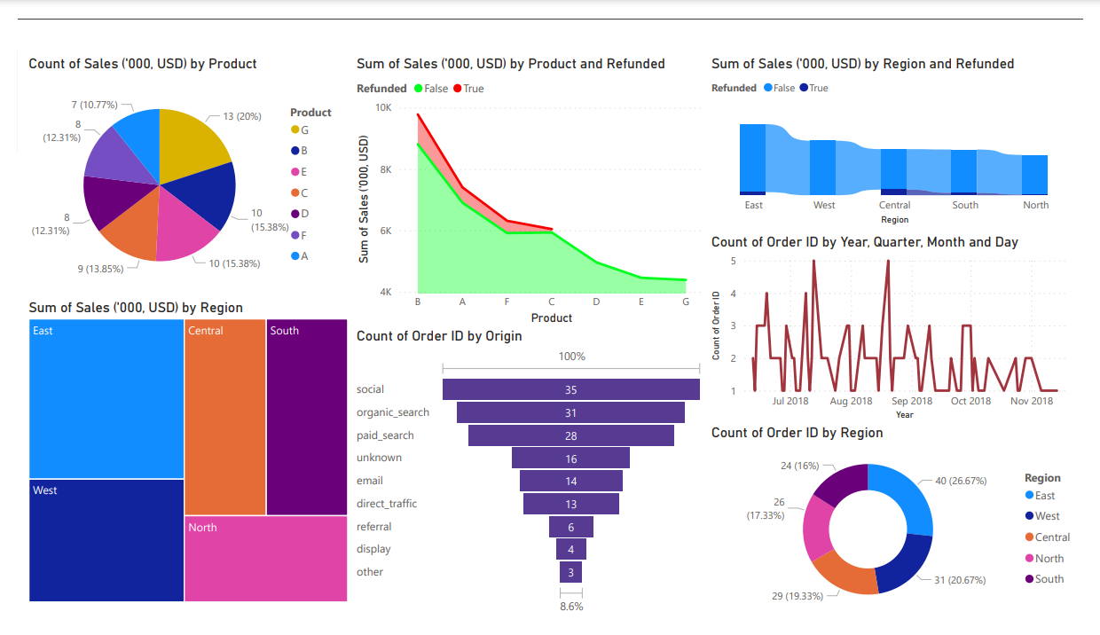

**Conclusion:**

In conclusion, the practical application of exploratory data analysis and visualization of social media data for business has significant potential to provide valuable insights and opportunities for businesses to improve their marketing and sales strategies. By using various visualization techniques and tools to analyze and understand social media data, businesses can identify patterns and trends in customer behavior, preferences, and sentiment towards their brand, products, or services.