FR. CONCEICAO RODRIGUES COLLEGE OF ENGINEERING

Department of Computer Engineering

Course, Subject & Experiment Details

|  |  |
| --- | --- |
| Practical No: | 7 |
| Title: | Develop a dashboard and reporting tool based on real time social media data. |
| Name of the Student: | Warren Fernandes |
| Roll No: | 8940 |
| Date of Performance: | 07/03/2023 |
| Date of Submission: | 14/03/2023 |

Evaluation:

|  |  |  |
| --- | --- | --- |
| Sr. No. | Rubric | Grade |
| 1 | On time submission/completion (2) |  |
| 2 | Preparedness (2) |  |
| 3 | Skill (4) |  |
| 4 | Output (2) |  |

Signature of the Teacher

To create a request in Postman using Twitter's user_timeline developer API request with OAuth 1.0 authentication and using name and screen_name as query parameters, you can follow these steps:

1. Open Postman and create a new request.
2. Select the "GET" method and enter the API endpoint URL for the user_timeline request. This will be in the format of <https://api.twitter.com/1.1/statuses/user_timeline.json>.
3. Click on the "Params" tab and enter "name" and "screen_name" as query parameters, along with their corresponding values. For example, you can set "name" to "testing" and "screen_name" to "NASA".

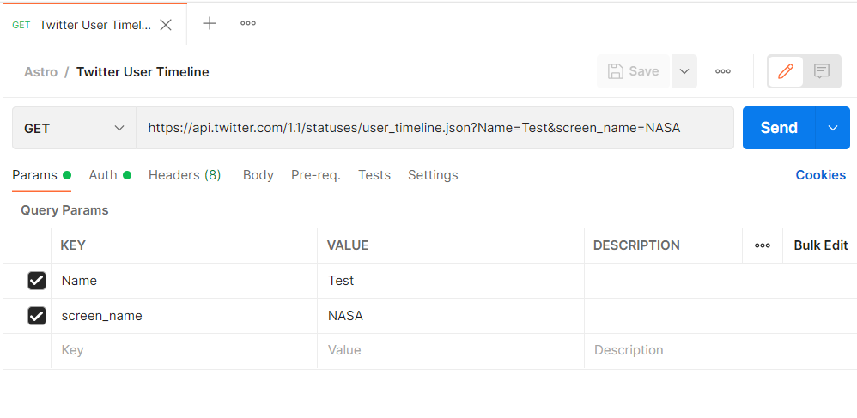

1. Click on the "Authorization" tab and select "OAuth 1.0" from the dropdown menu.
2. Enter your consumer key and consumer secret into the corresponding fields. These keys can be obtained from your Twitter Developer account.

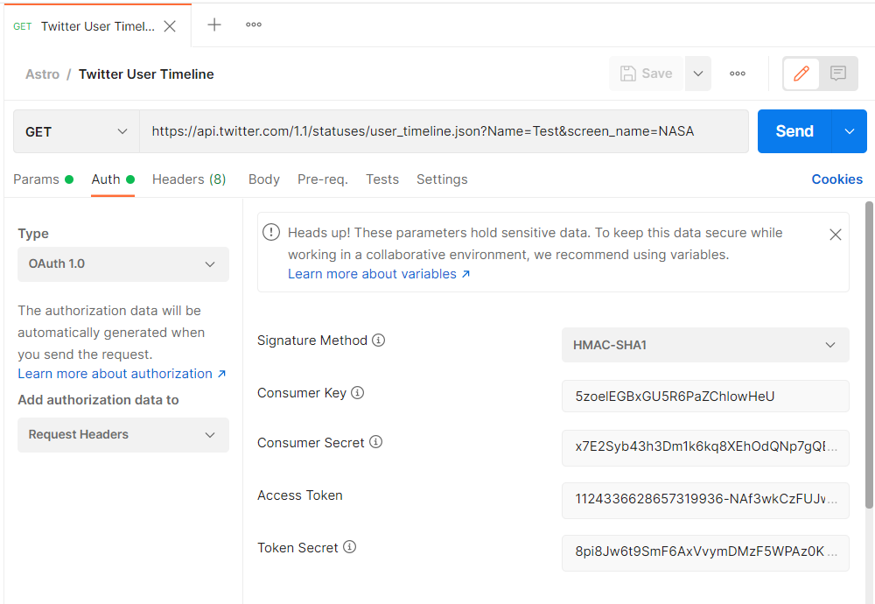

1. Click on the "Send" button to make the request.

Once the request is sent, Postman will display the response from the API in the "Body" tab. The response will be in JSON format and will contain the user's most recent tweets that match the provided name and screen_name parameters, along with information about each tweet such as the tweet ID, text, and creation time. You can use this information to analyze the user's tweets and perform further analysis or processing as needed.

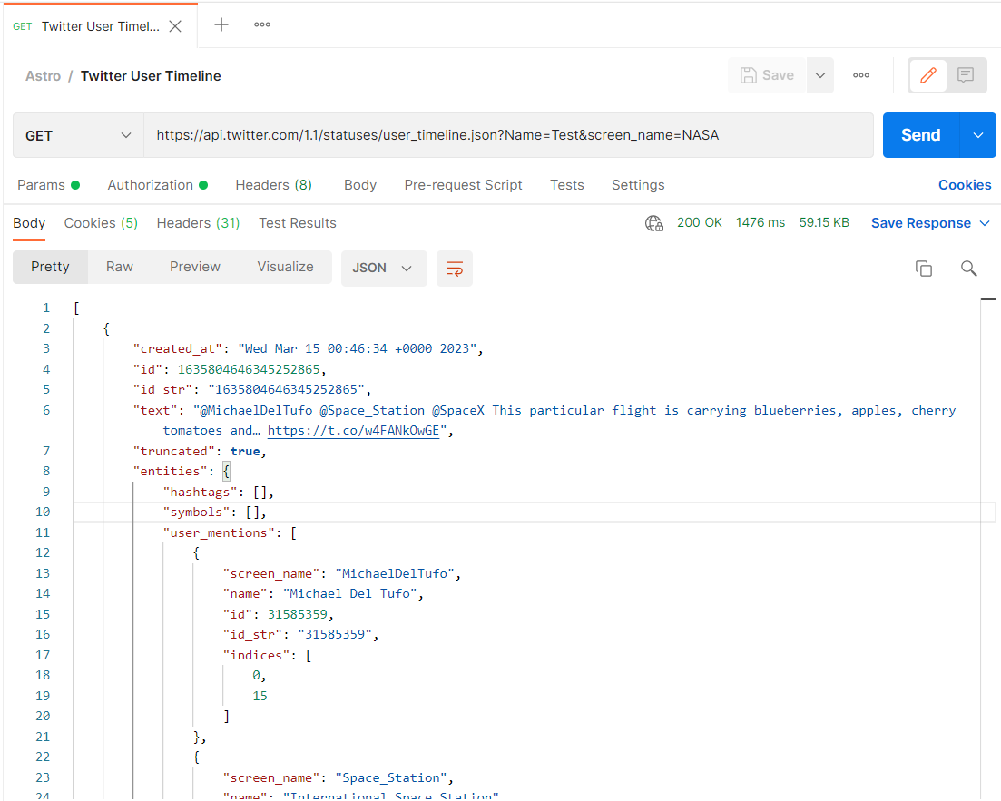

To display real-time data in Power BI, we can use the "Web Data" option and follow the steps you have described:

1. From the Power BI Home tab, select "Get Data" and choose "Web" as the data source.

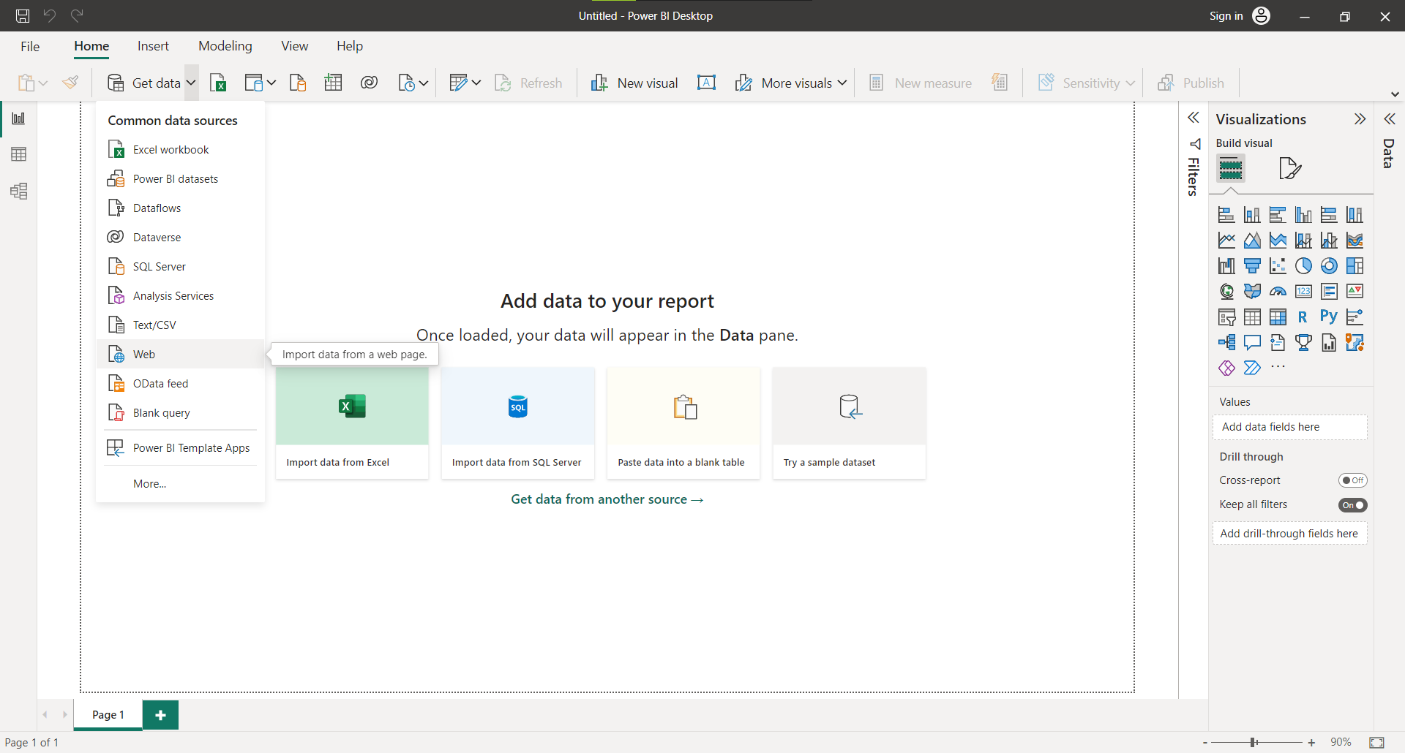

1. In the "From Web" dialog box, select "Advanced" and paste the API endpoint URL in the "URL Parts" section.
2. In the "Headers" section, add the Authorization header with the required token or key.
3. Click on OK to import the data as a JSON file.

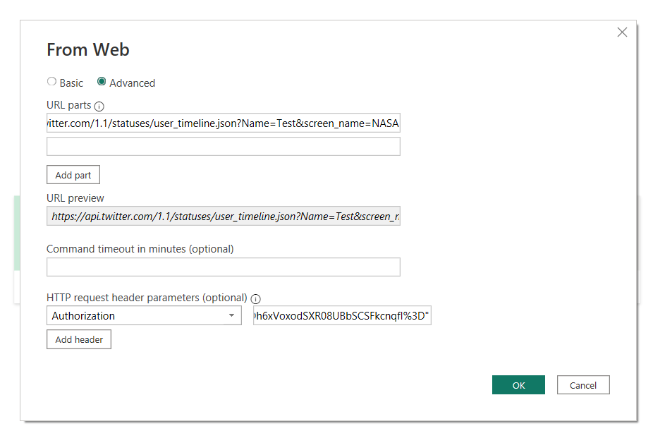

1. In the Power Query Editor, transform the data by clicking on "To Table" or other options available, as per the data format.

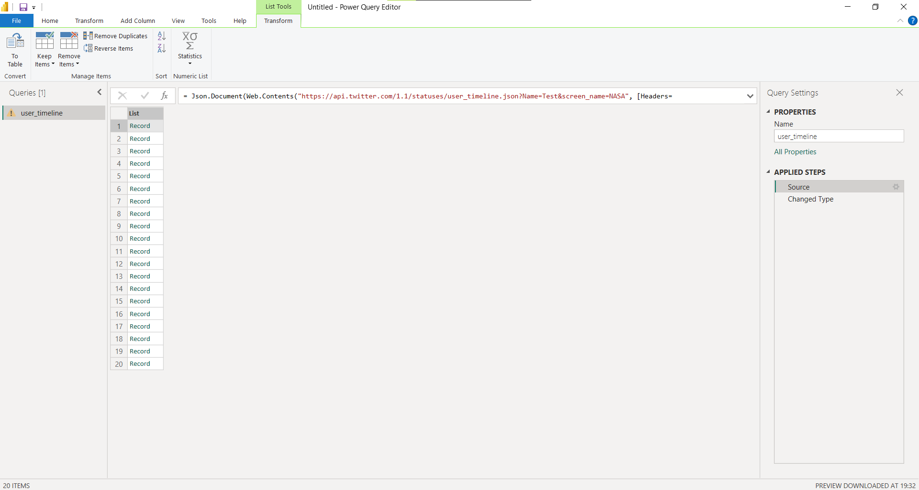

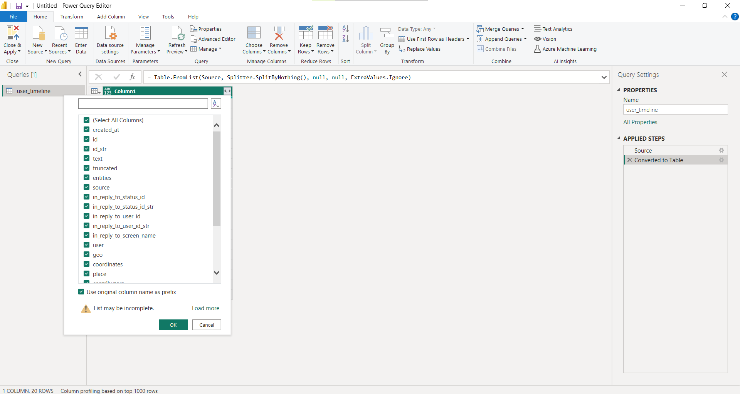

1. Rename the columns and change the data types as required.

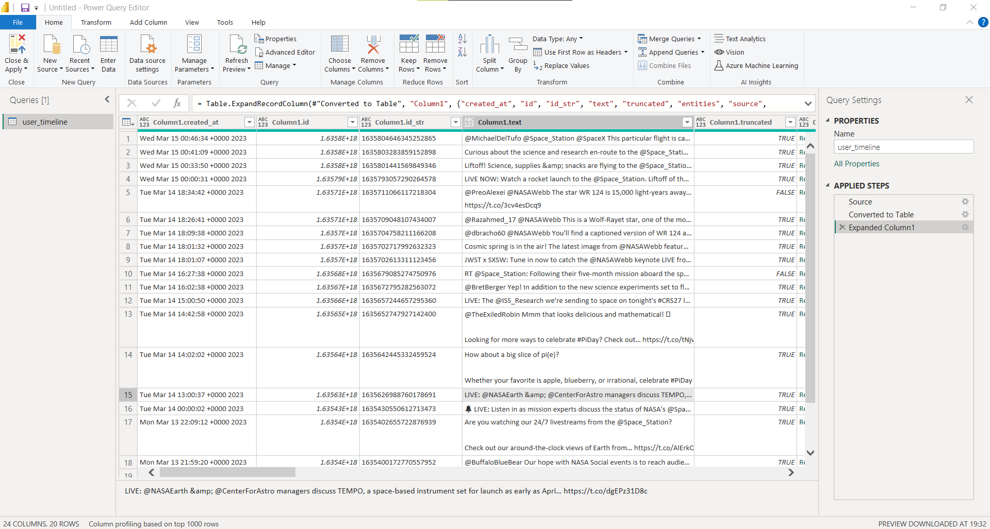

1. Load the data into the report view and create visualizations using the available visuals and options.

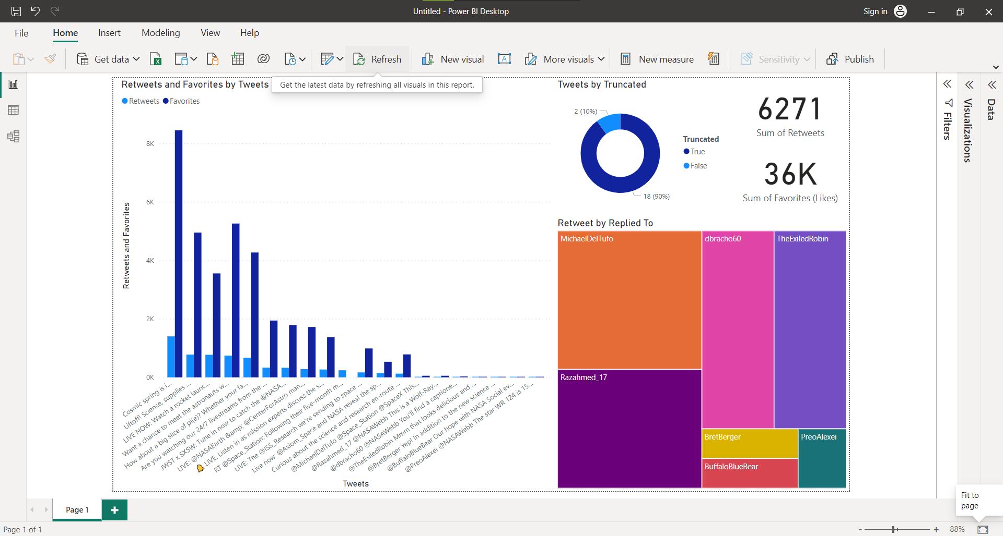

1. To refresh the data, click on the "Refresh data" button or schedule automatic refresh as per your requirement.

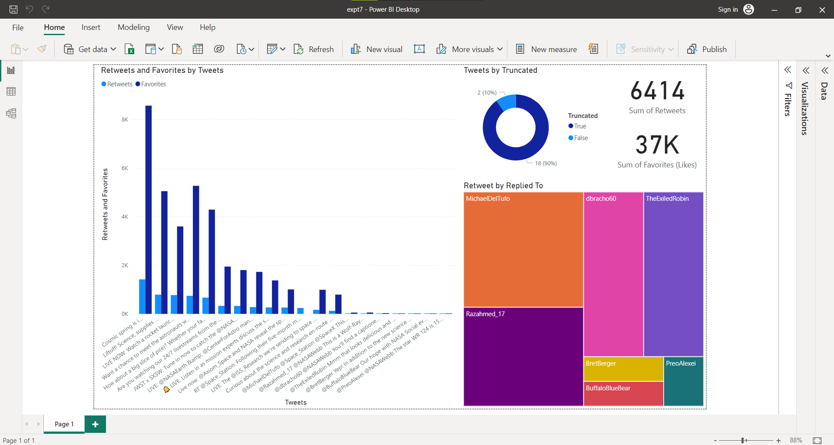

**Conclusion:**

Developing a Power BI dashboard and reporting tool based on real-time social media data from the Twitter API can be a valuable experiment for businesses. By analysing Twitter data in real-time, businesses can gain insights into customer sentiment, identify trends, and make data-driven decisions. To carry out this experiment, businesses can follow several steps. Firstly, they can obtain access to the Twitter API by creating a developer account and obtaining the required access keys. Next, they can use Power BI to import the data from the Twitter API by using the "Web Data" option and adding the API endpoint URL and authentication headers. Once the data is imported, businesses can use Power Query Editor to transform the data into a suitable format and create relevant visualizations using Power BI visuals. They can also schedule automatic data refreshes or manually refresh the data to ensure that the dashboard is updated with real-time data. Overall, developing a Power BI dashboard and reporting tool based on real-time Twitter data can provide businesses with valuable insights into customer behaviour and sentiment, enabling them to make data-driven decisions and stay ahead of the competition.