FR. CONCEICAO RODRIGUES COLLEGE OF ENGINEERING

Department of Computer Engineering

Course, Subject & Experiment Details

|  |  |
| --- | --- |
| Practical No: | 9 |
| Title: | Analyse competitor activities using social media data. |
| Name of the Student: | Warren Fernandes |
| Roll No: | 8940 |
| Date of Performance: | 04/04/2023 |
| Date of Submission: | 11/04/2023 |

Evaluation:

|  |  |  |
| --- | --- | --- |
| Sr. No. | Rubric | Grade |
| 1 | On time submission/completion (2) |  |
| 2 | Preparedness (2) |  |
| 3 | Skill (4) |  |
| 4 | Output (2) |  |

Signature of the Teacher

**Aim:** Analyse competitor activities using social media data.

**Objective:**

* Use social media post like facebook and Instagram post you can check activities as well as their comments and share.
* Use brand24 application you can check activities and analytics.
* Use Similarweb.com to check activites

**Steps:**

**LinkedIn Analytics**

LinkedIn competitor analytics can be a powerful tool for social media analysis practicals, as it provides valuable insights into how your competitors are performing on the platform. Here are some tips for using LinkedIn competitor analytics effectively:

1. Identify your competitors: Before you can use LinkedIn competitor analytics, you need to know who your competitors are. Identify the companies or individuals that you are competing with on LinkedIn.
2. Analyze their profiles: Once you have identified your competitors, analyze their LinkedIn profiles. Look at their content, connections, and engagement levels to get a sense of their social media strategy.
3. Use LinkedIn Analytics: LinkedIn Analytics provides a wealth of information about your competitors' performance on the platform. You can see how many followers they have, their engagement rate, and their most popular content.
4. Compare performance: Use the data from LinkedIn Analytics to compare your performance to your competitors. Look for areas where you are outperforming them and areas where you can improve.
5. Adjust your strategy: Based on the insights you gather from LinkedIn competitor analytics, adjust your social media strategy accordingly. Focus on creating content that resonates with your target audience and engages them on the platform.

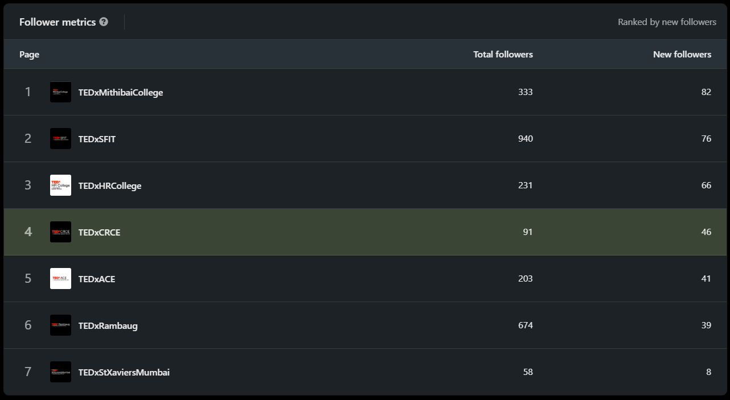

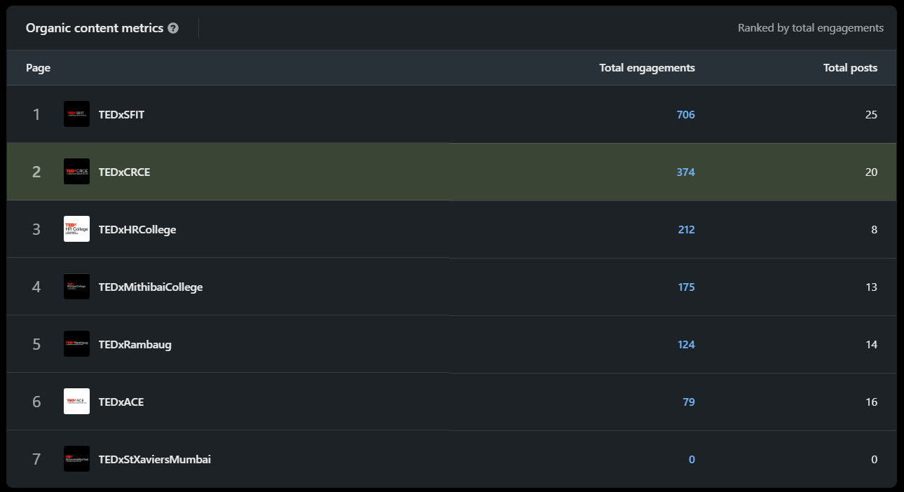

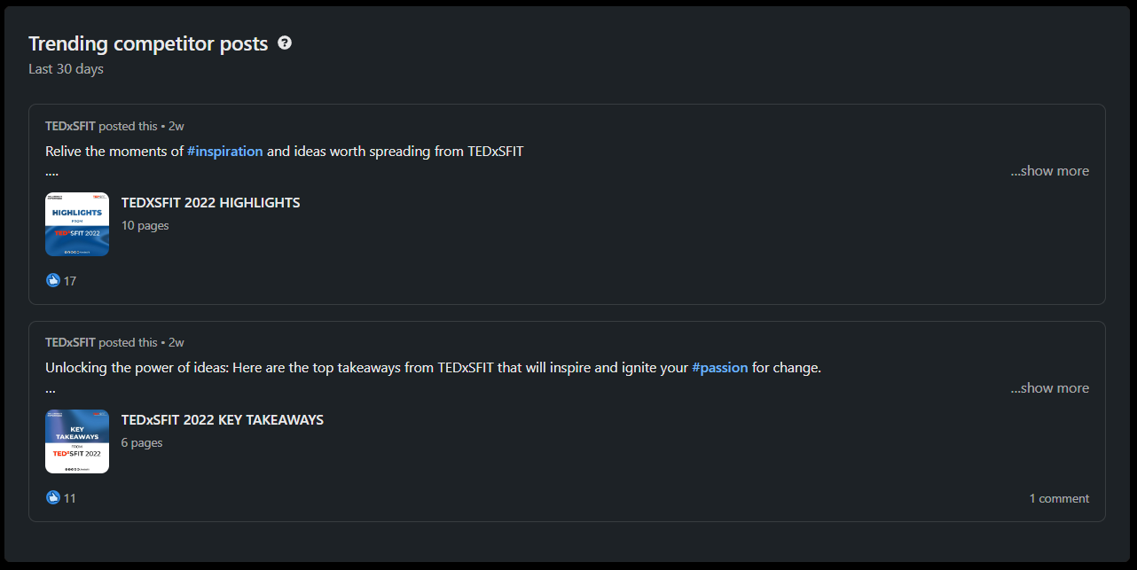

Overall, using LinkedIn competitor analytics can help you stay ahead of the competition on the platform and improve your social media performance**.**

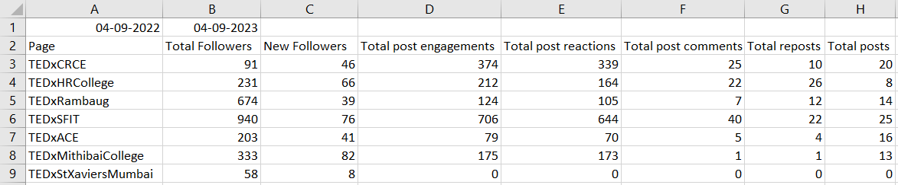

**Brand24**

Brand24 is a powerful social media analysis tool that can provide valuable insights for social media analysis practical. Here are some tips for using Brand24 effectively:

1. Monitor brand mentions: Brand24 can monitor brand mentions across social media platforms, including Twitter, Facebook, Instagram, and more. Use this feature to track how often your brand is being mentioned and what people are saying about it.
2. Analyze sentiment: Brand24 can analyze the sentiment of brand mentions, classifying them as positive, negative, or neutral. Use this feature to get a sense of how people feel about your brand.
3. Track competitors: Brand24 can also track the social media activity of your competitors. Use this feature to see how they are performing on social media and what strategies they are using.
4. Identify influencers: Brand24 can help you identify influencers who are talking about your brand or your competitors. Use this information to build relationships with influencers and leverage their influence to promote your brand.

Here we will be comparing the organizations TEDxCRCE with TEDxGateway

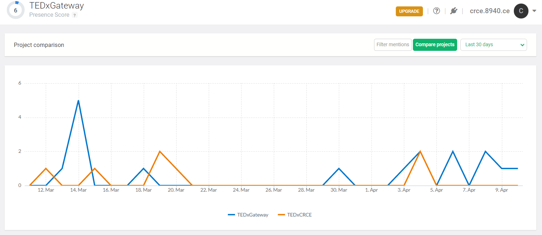

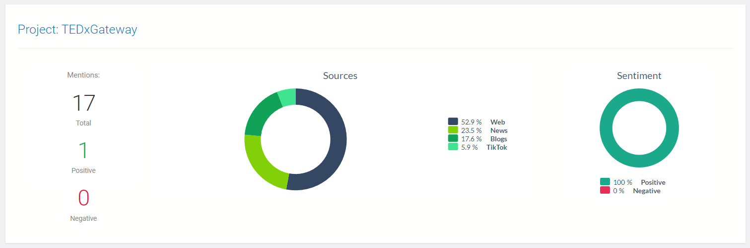

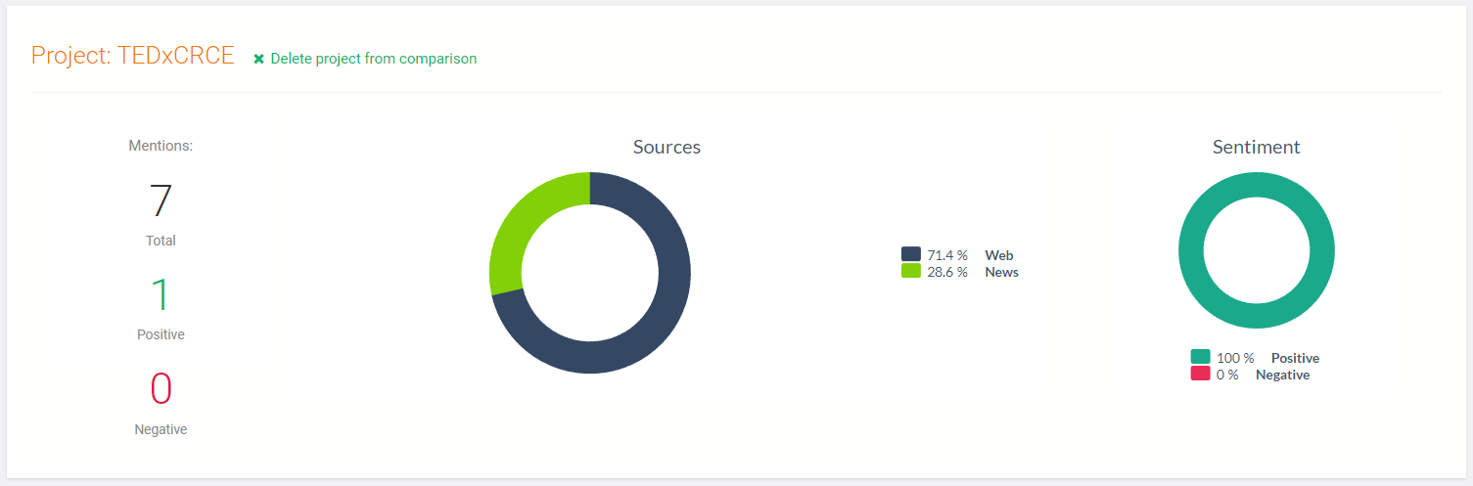

**SimilarWeb.com**

SimilarWeb.com is a website that provides competitive analysis for websites and mobile apps. Here are some tips for using SimilarWeb.com for social media analysis practical:

1. Analyze website traffic: SimilarWeb.com can provide insights into website traffic, including the number of visits, pageviews, and time spent on the website. Use this information to see how your website traffic compares to your competitors'.
2. Track referral traffic: SimilarWeb.com can also track referral traffic, showing you where your website traffic is coming from. Use this information to identify social media platforms that are driving traffic to your website.
3. Analyze social media traffic: SimilarWeb.com can track social media traffic to your website, showing you how much traffic is coming from each social media platform. Use this information to identify which social media platforms are driving the most traffic to your website.

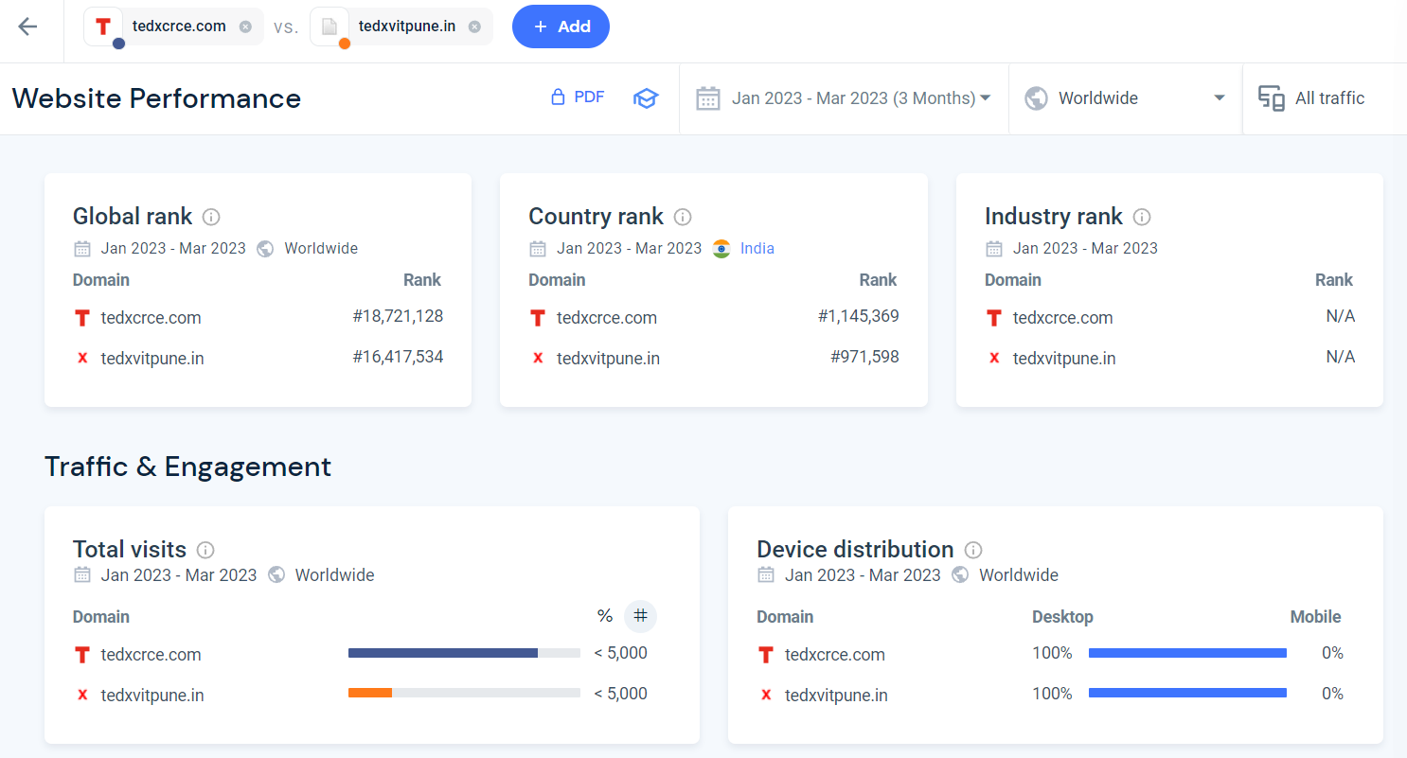

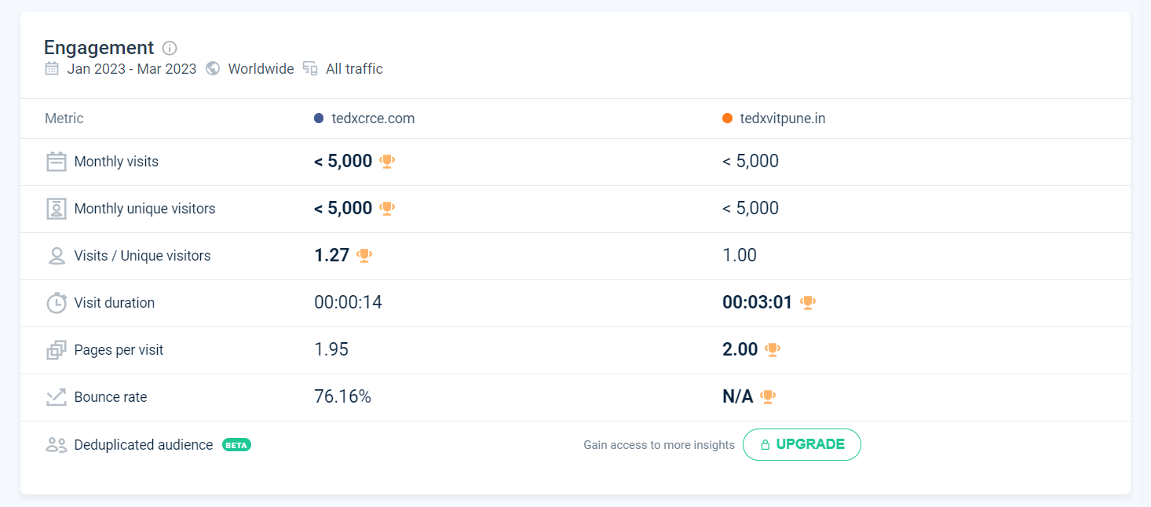

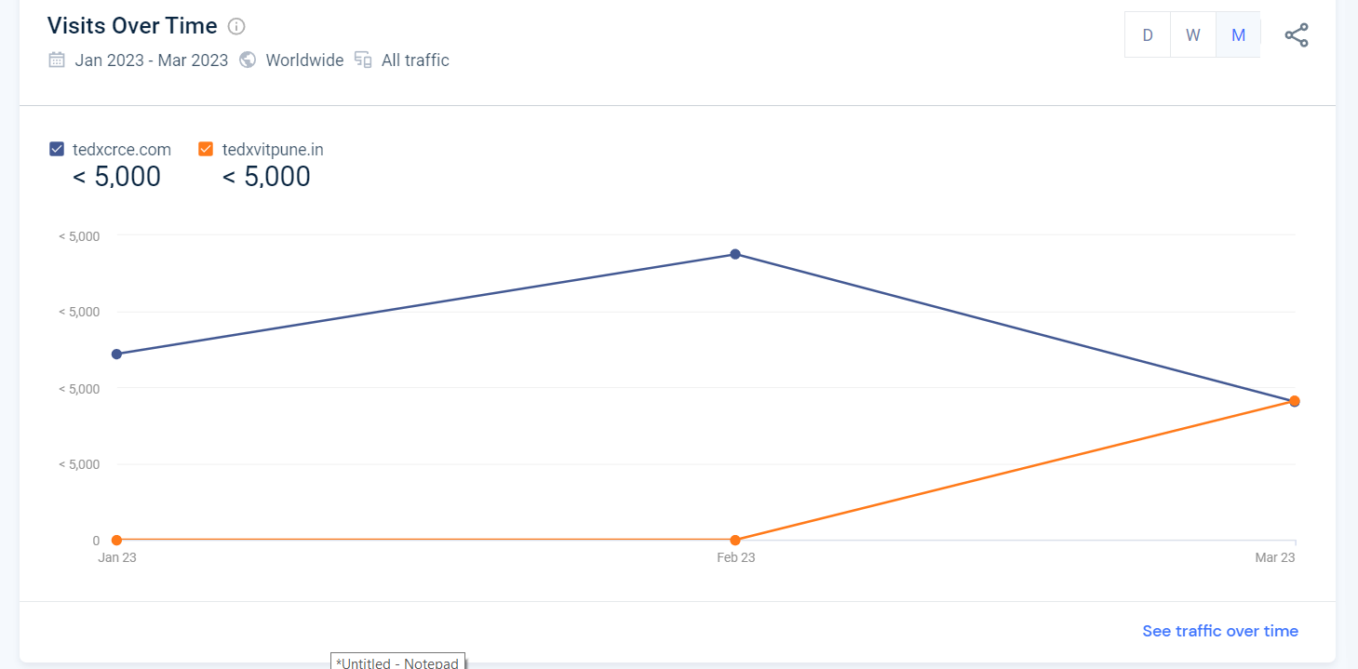

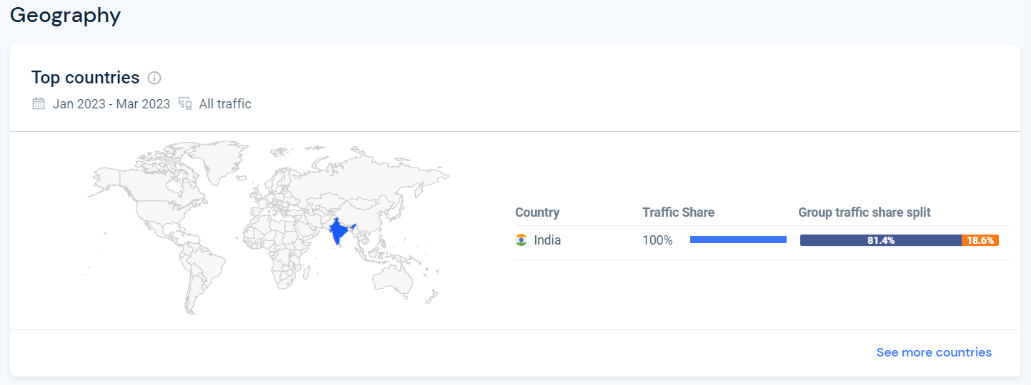

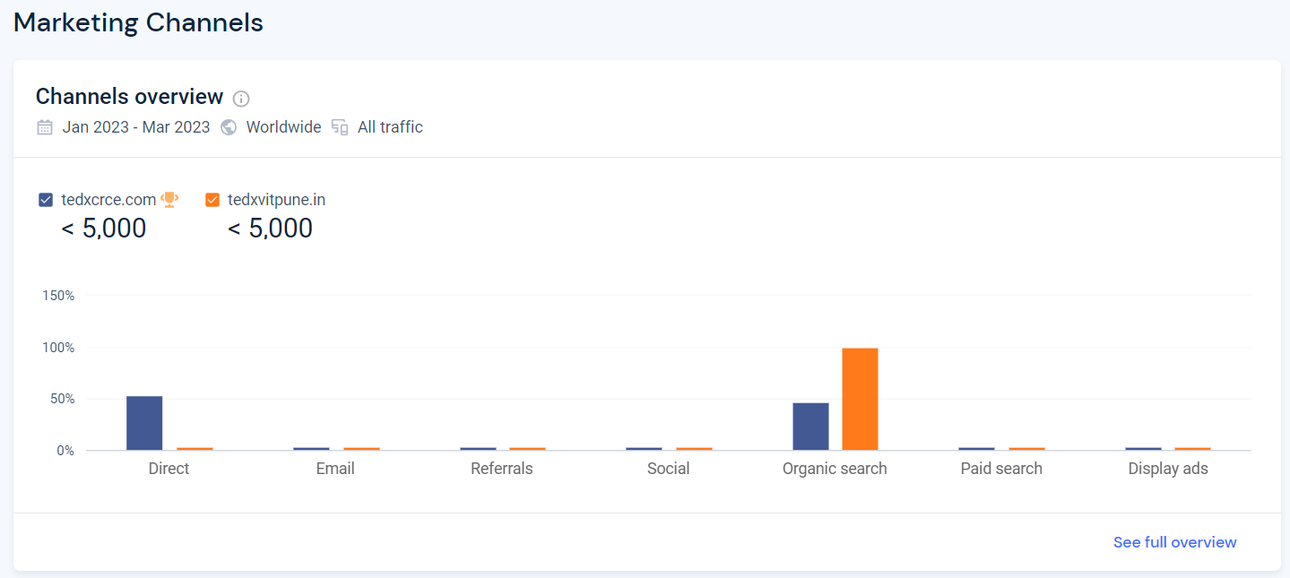

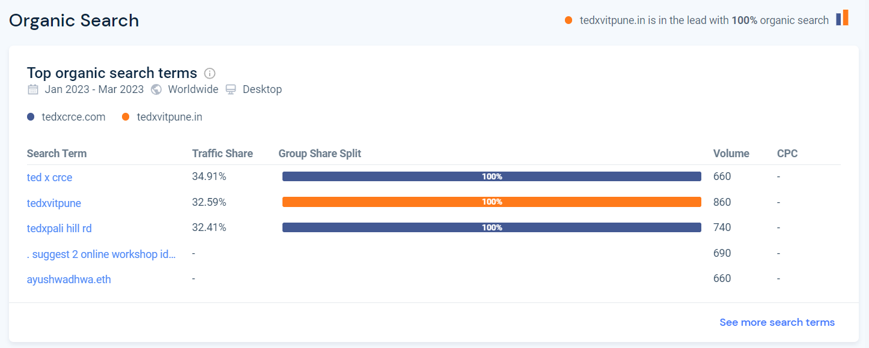

**Conclusion:**

In conclusion, analyzing competitor activities using social media data is a valuable exercise for any business looking to stay ahead of the competition. By monitoring your competitors' social media activity, you can gain insights into their social media strategy, identify areas where they are outperforming you, and make data-driven decisions to improve your own social media performance.

There are a variety of tools available for analyzing competitor activities on social media, including LinkedIn competitor analytics, Brand24, and SimilarWeb.com. These tools can provide valuable insights into brand mentions, sentiment analysis, competitor activity, and more.

By using these tools, businesses can gain a deeper understanding of their competitors' social media activity and leverage this information to refine their own social media strategy. Ultimately, analyzing competitor activities using social media data is an ongoing process that can help businesses stay competitive in a constantly evolving social media landscape.