**Microprocessor**

**Experiment 1**

Name – Warren Fernandes

Roll No – 8940

1. **8 bit Addition**

.8086

.model small

.data

num1 db 07h

num2 db 0ah

result db ?

.code

start:

mov ax,@data

mov ds,ax

mov al,num1

add al,num2

mov result,al

mov ah,4ch

int 21h

end start

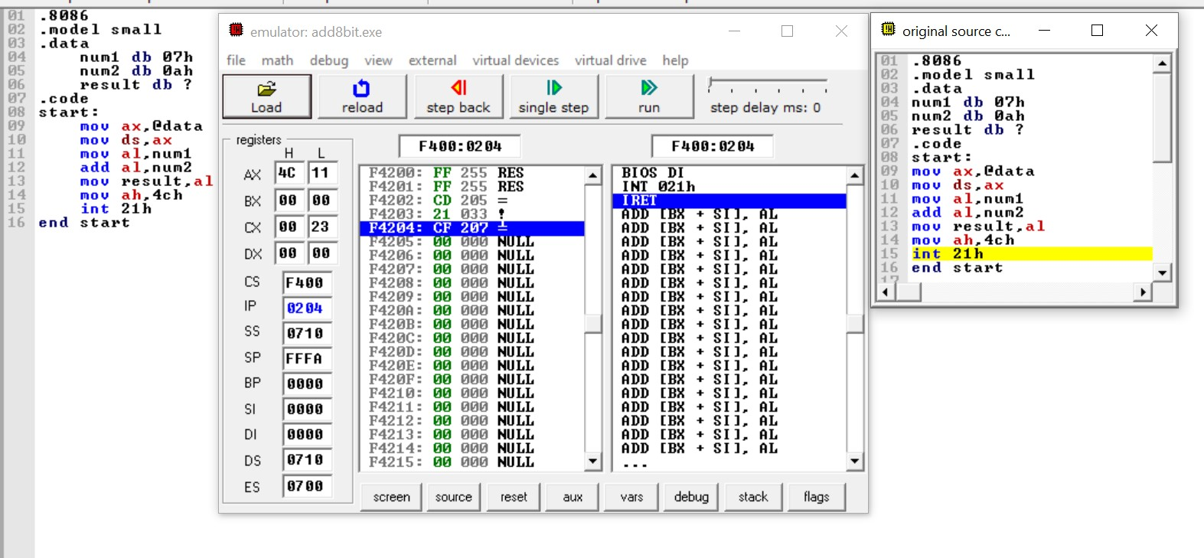

1. **8 bit Subtraction**

.8086

.model small

.data

num1 db 07h

num2 db 0ah

result db ?

.code

start:

mov ax,@data

mov ds,ax

mov al,num2

sub al,num1

mov result,al

mov ah,4ch

int 21h

end start

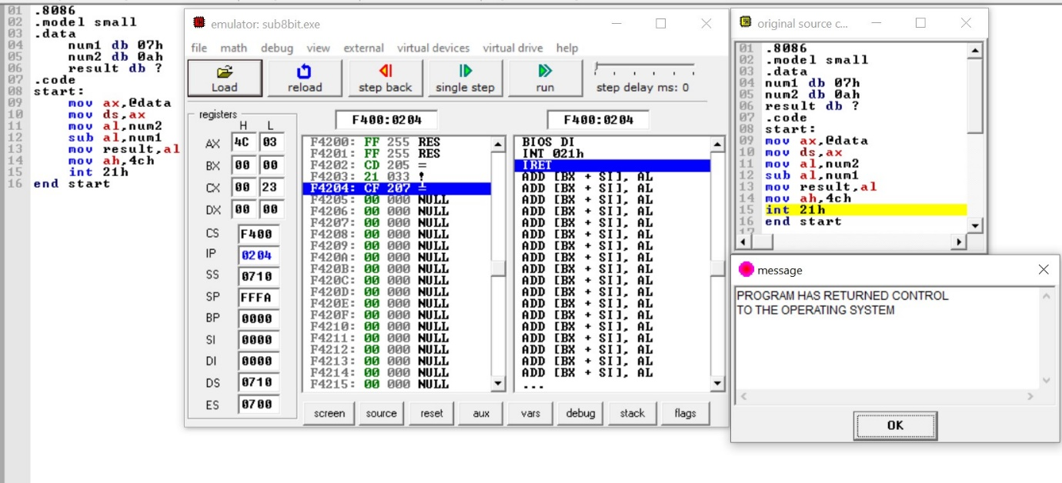

1. **8 bit Multiplication**

.8086

.model small

.data

num1 db 07h

num2 db 0ah

result db ?

.code

start:

mov ax,@data

mov ds,ax

mov al,num1

mov bl,num2

mul bl

mov ah,4ch

int 21h

end start

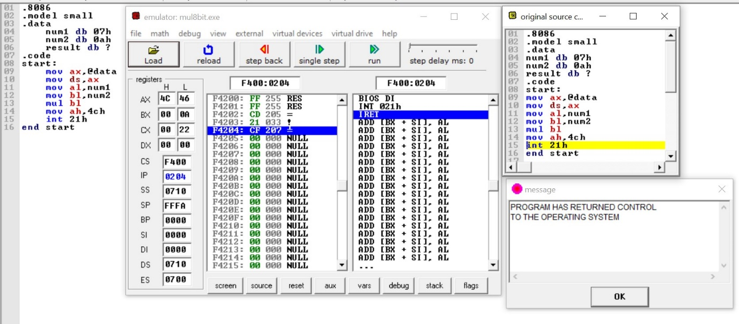

1. **8 bit Division**

.8086

.model small

.data

num1 db 28h

num2 db 02h

result db ?

.code

start:

mov ax,data

mov ds,ax

mov ax,00h

mov bx,00h

mov al,num1

div num2

mov result,ax

int 21h

end start

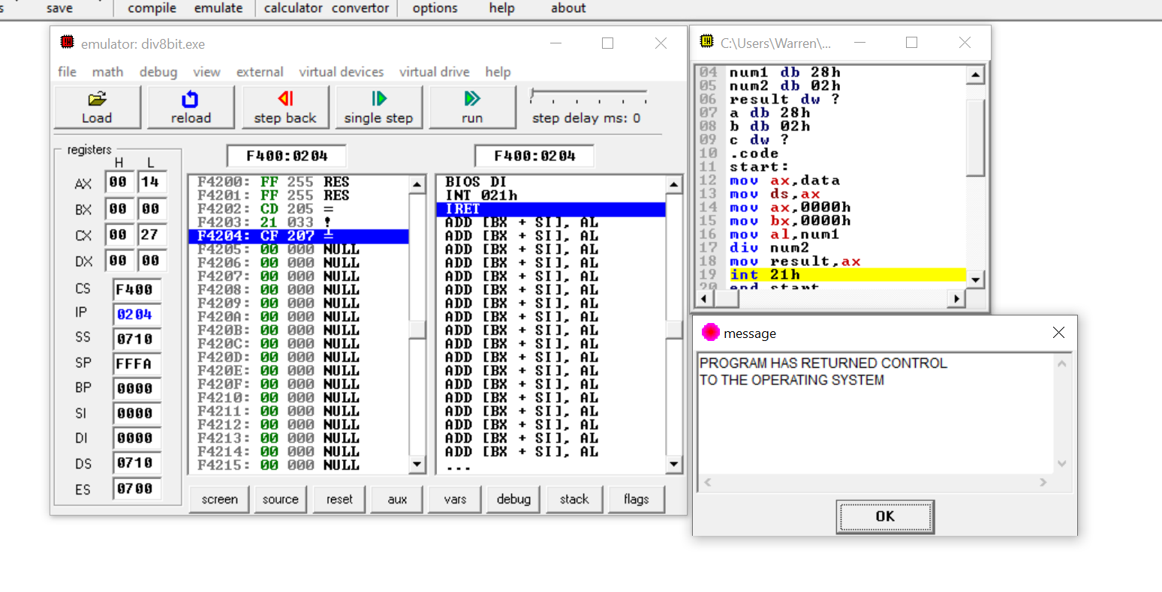

**POSTLAB:**

