**MICROPROCESSOR – EXPT 2**

**WARREN FERNANDES 8940**

**CODE:**

data segment

num1 dw 4444h

num2 dw 0002h

result dw ?

quo dw ?

rem dw ?

msg db 'Enter option: $'

msg1 db '1)ADD $'

msg2 db '2)SUB $'

msg3 db '3)MUL $'

msg4 db '4)DIV $'

code segment

assume ds:data, cs:code

start:

mov ax,data

mov ds,ax

lea dx,msg

mov ah,09h

int 21h

lea dx,msg1

mov ah,09h

int 21h

lea dx,msg2

mov ah,09h

int 21h

lea dx,msg3

mov ah,09h

int 21h

lea dx,msg4

mov ah,09h

int 21h

mov ah,08h

int 21h

cmp al,31h

jnz next1

mov ax,num1

add ax,num2

mov result,ax

next1:

cmp al,32h

jnz next2

mov ax,num1

sub ax,num2

mov result,ax

next2:

cmp al,33h

jnz next3

mov ax,num1

mov bx,num2

mul bx

mov result,ax

next3:

cmp al,34h

jnz next4

mov ax,0000h

mov dx,0000h

mov ax,num1

div num2

mov quo,ax

mov rem,dx

next4:

end start

**16 Bit Addition**

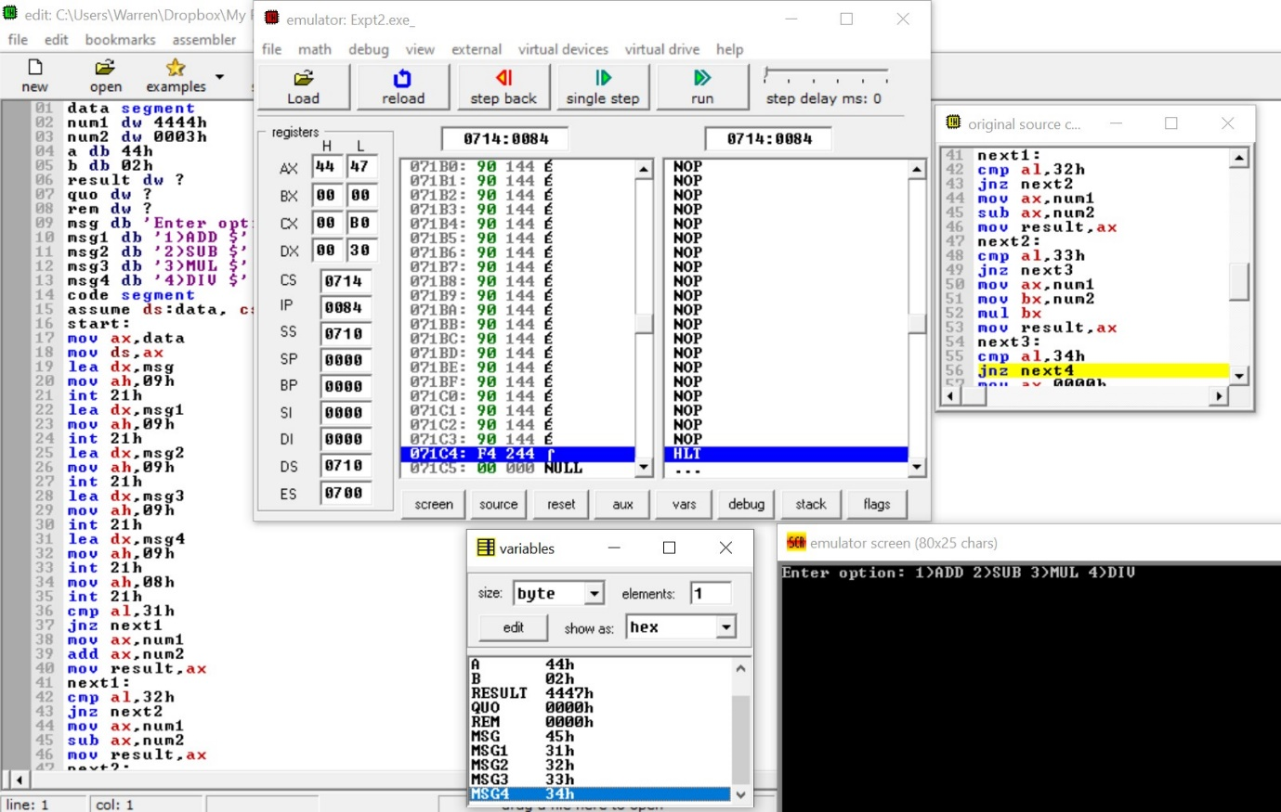

**16 Bit Subtraction**

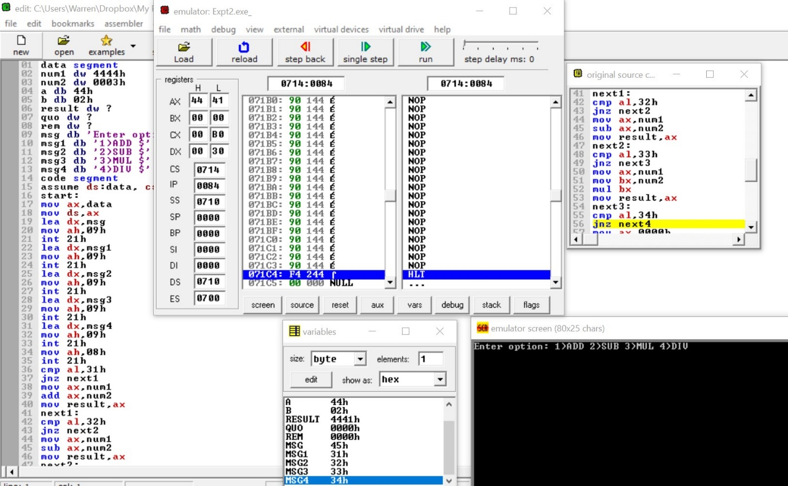

**16 Bit Multiplication**

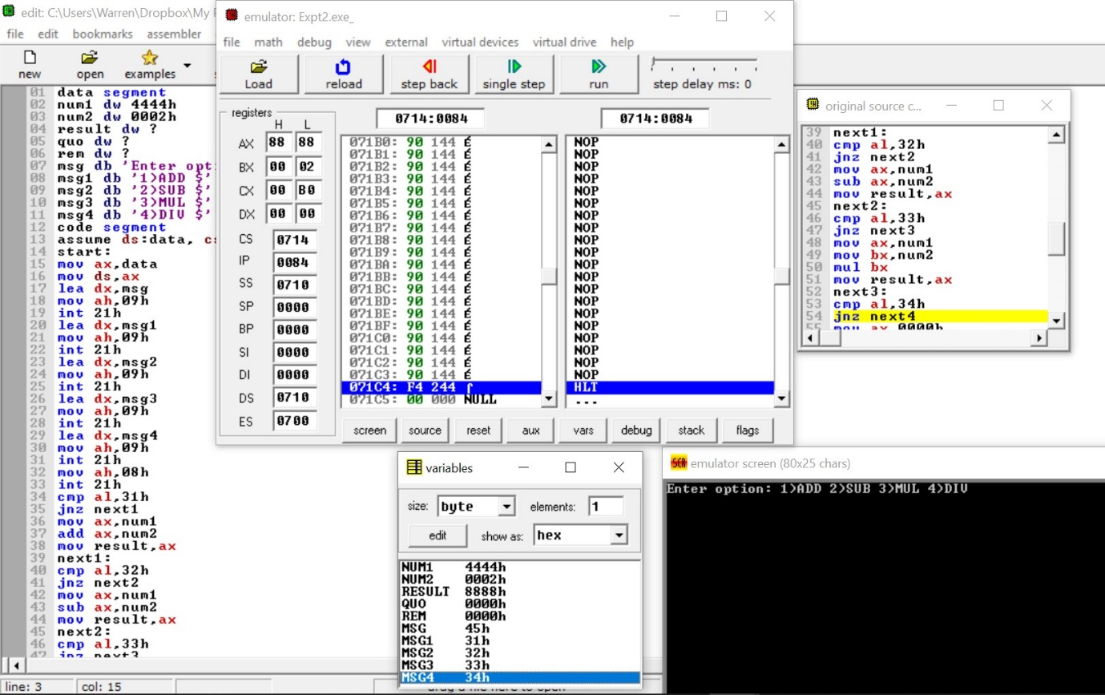

**16 Bit Division**

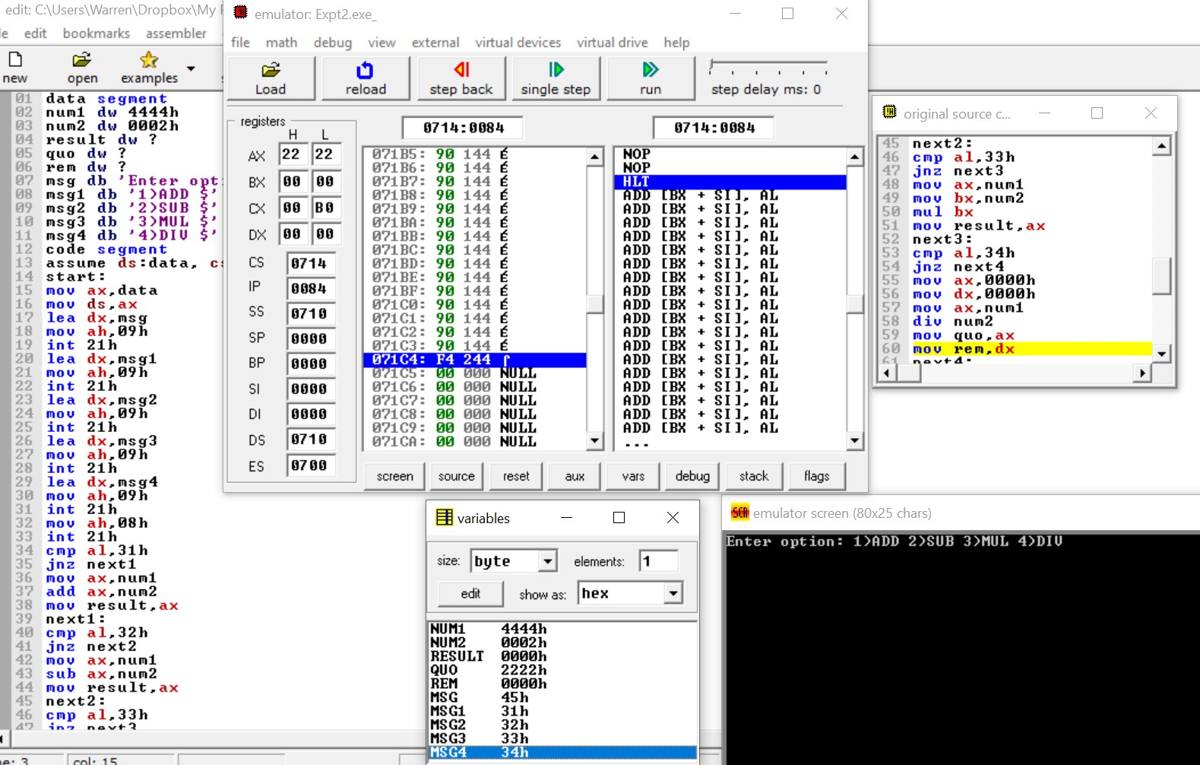

**POSTLAB:**

