**Experiment 9**

Title: Write a program to find LCM and GCD of two numbers

**8940 Warren Fernandes SE-COMPS-B**

8086 Program to find LCM

data segment

num dw 05,04

lcm dw 2 dup(0)

data ends

code segment

assume cs:code,ds:data

start: mov ax,data

mov ds,ax

mov dx,0h

mov ax,num

mov bx,num+2

up: push ax

push dx

div bx

cmp dx,0

je exit

pop dx

pop ax

add ax,num

jnc down

inc dx

down: jmp up

exit: pop lcm+2

pop lcm

mov ah,4ch

int 21h

code ends

end start

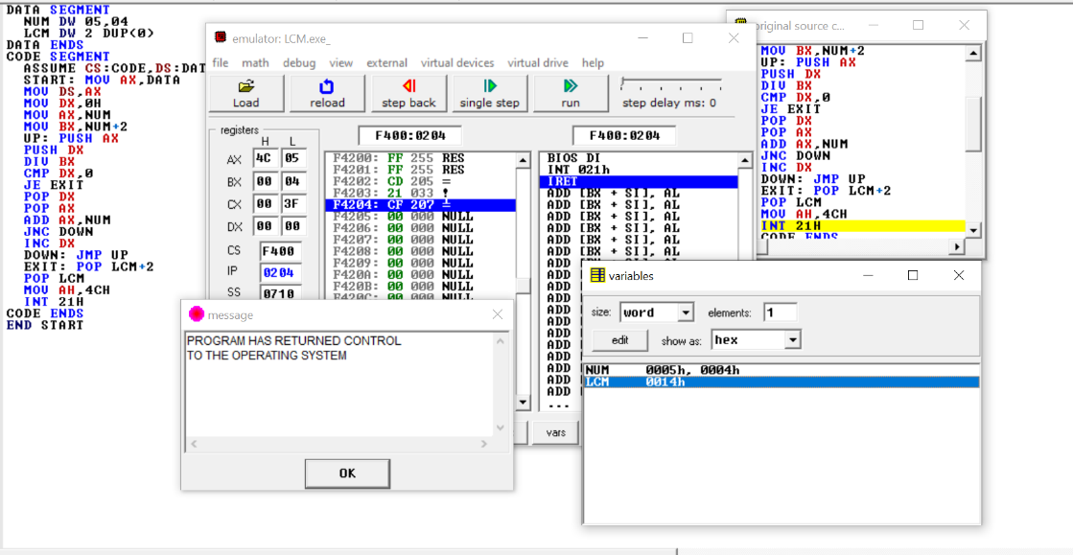

8086 Program to find GCD

data SEGMENT

n1 DB 8

n2 DB 22

rez DB ?

ENDS

stack SEGMENT

DB 128 dup(0)

ENDS

code SEGMENT

nzd PROC

POP CX

POP BX

ciklus:

CMP BL, 0d

JE done

MOV AL, BH

MOV AH, 0d

DIV BL

MOV BH, BL

MOV BL, AH

JMP ciklus

done:

PUSH BX

PUSH CX

RET

nzd ENDP

start:

MOV AX, data

MOV DS, AX

MOV ES, AX

MOV AX, stack

MOV SS, AX

MOV BH, [n1]

MOV BL, [n2]

PUSH BX

CALL nzd

POP BX

MOV [rez], BH

exit:

MOV AH, 4ch

INT 21h

ENDS

END start

