# GPCW: Gaussian Process Model for Critical Window Estimation

## GPCW_Example

[1] Simulate data from the proposed model:

* Setting the reproducibility seed and initializing packages for data simulation:

set.seed(8453)  
  
library(GPCW)   
library(mnormt) #Multivariate normal distribution  
library(boot) #Inverse logit transformation

* Setting the global data values:

n<-5000 #Sample size  
m<-36 #Number of exposure time periods  
x<-matrix(1,   
 nrow=n,   
 ncol=1) #Covariate design matrix  
z<-matrix(rnorm(n=(n*m)),   
 nrow=n,   
 ncol=m) #Exposure design matrix  
  
for(j in 1:m){  
 z[,j]<-(z[,j] - median(z[,j]))/IQR(z[,j]) #Data standardization (interquartile range)  
 }

* Setting the values for the statistical model parameters:

beta_true<- -0.30  
sigma2_theta_true<-0.50  
phi_true<-0.01  
Sigma_true<-sigma2_theta_true*chol2inv(chol(temporal_corr_fun(m,   
 phi_true)[[1]]))  
theta_true<-rmnorm(n=1,   
 mean=rep(0, times=m),   
 varcov=Sigma_true)  
theta_true<-theta_true - mean(theta_true)  
logit_p_true<-x%*%beta_true +   
 z%*%theta_true  
probs_true<-inv.logit(logit_p_true)  
hist(probs_true)

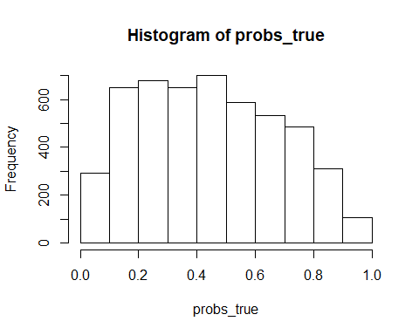

* Simulating the analysis dataset:

y<-rbinom(n=n,   
 size=1,   
 prob=probs_true)

[2] Fit GPCW to estimate critical windows of susceptibility:

results<-GPCW(mcmc_samples = 10000,  
 y = y, x = x, z = z,  
 metrop_var_phi_trans = 1.15)

## Progress: 10%  
## phi Acceptance: 27%  
## *******************  
## Progress: 20%  
## phi Acceptance: 27%  
## *******************  
## Progress: 30%  
## phi Acceptance: 28%  
## *******************  
## Progress: 40%  
## phi Acceptance: 28%  
## *******************  
## Progress: 50%  
## phi Acceptance: 29%  
## *******************  
## Progress: 60%  
## phi Acceptance: 28%  
## *******************  
## Progress: 70%  
## phi Acceptance: 28%  
## *******************  
## Progress: 80%  
## phi Acceptance: 28%  
## *******************  
## Progress: 90%  
## phi Acceptance: 28%  
## *******************  
## Progress: 100%  
## phi Acceptance: 28%  
## *******************

[3] Analyzing Output:

par(mfrow=c(2,2))  
plot(results$beta[1, 1001:10000],   
 type="l",  
 ylab="beta",  
 xlab="Sample")  
abline(h=beta_true,  
 col="red",  
 lwd=2) #True value  
plot(results$sigma2_theta[1001:10000],  
 type="l",  
 ylab="sigma2_theta",  
 xlab="Sample")  
abline(h=sigma2_theta_true,  
 col="red",  
 lwd=2) #True value  
plot(results$phi[1001:10000],  
 type="l",  
 ylab="phi",  
 xlab="Sample")  
abline(h=phi_true,   
 col="red",  
 lwd=2) #True value  
plot(rowMeans(results$theta[,1001:10000]),   
 pch=16,  
 ylab="theta",  
 xlab="Time")  
points(theta_true,   
 pch=16,   
 col="red") #True values

