SRResNet [1]

SRResNet is the generative network for the SRGAN.

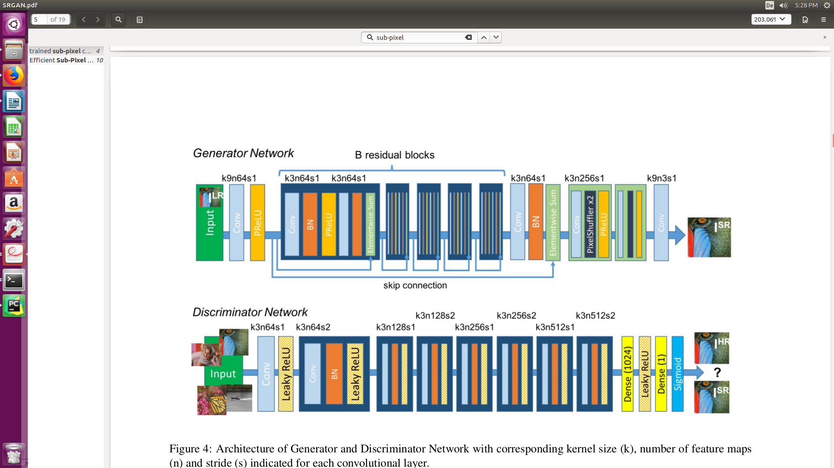

- 16 residual blocks
- omits the Relu in the original resnet after addition [2]
- use Prelu instead of relu
- two trained sub-pixel convolution layers for increasing the resolution of the input image[3]
- trained using the cost function based on MSE and VGG22. SRResNet-MSE get good results on the PSNR test.

Result: removal of a 4-pixel wide strip from each border
4x PSNR SSIM
Set5 32.05 0.9019
Set14 28.49 0.8184
BSD100 27.58 0.7620

Training details:
-training set: random sample of 350 thousand images from ImageNet
- batch: 16 images, 96 x 96 HR sub images of distinct images.
-size: input 24x24 label 96x96
- feature scaling: LR [0,1], HR[-1, 1]
-learning rate: 10**-4, no decay mentioned
-iterations: 10**6
-optimizer: Adam beta1 = 0.9

VDSR [4]

ideas:
- Depth is helpful for increasing the receptive field for large image context
- residual learning allows high learning rate and faster convergence 0.1, also better performance can be used in SR case, input and output are similar
- gradient clipping: clip the gradients to [-theta/gamma, theta/gamma], makes the convergence much faster (4 hours) theta range, gamma learning rate

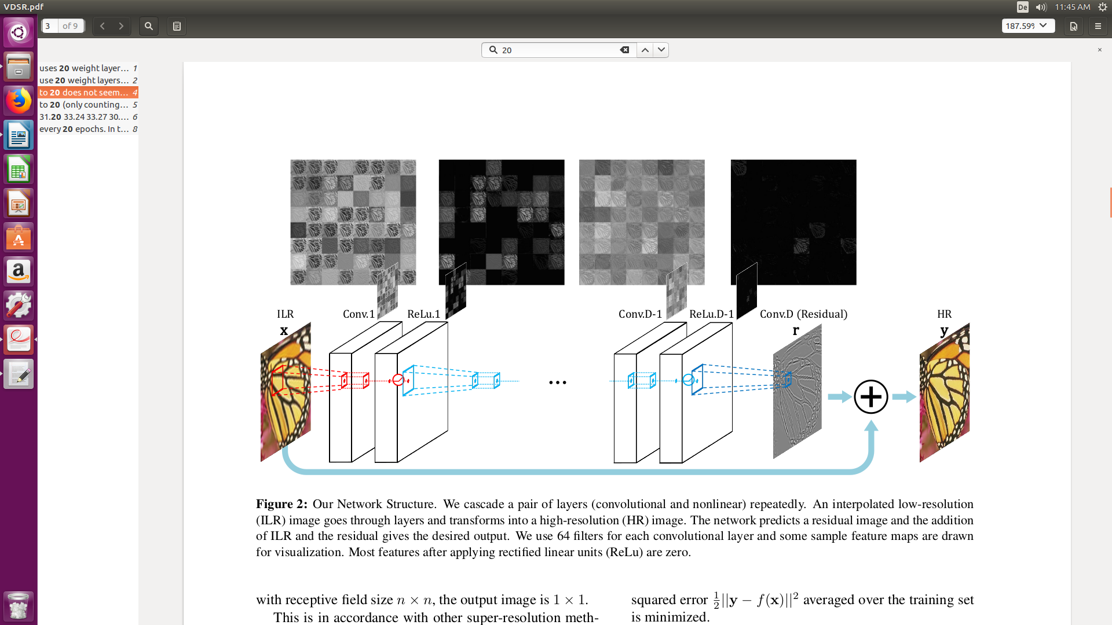
- In the experiment, 20 weighted layers (conv layers)
- batch norm not mentioned
- filter 3*3*64
- activation: relu
-cost func: MSE

Training details:
-training set: use 291 images as in [5] for benchmark with other
methods in this section
-optimizer: mini batch gradient descent with momentum 0.9
-regularization: L2 * 0.0001
- learning rate: was initially set to 0.1 and then decreased by a factor of 10 every 20 epochs, 3 times in total
- batch size: 64 sub-images, where sub-images from different scales can be in the same batch.
- Input size: equal to the size of the receptive field, related to length 41 * 41
- feature scaling: not mentioned
- iterations: 80 epochs (9960 iterations)
- data augmentation: rotation and flop

Results:

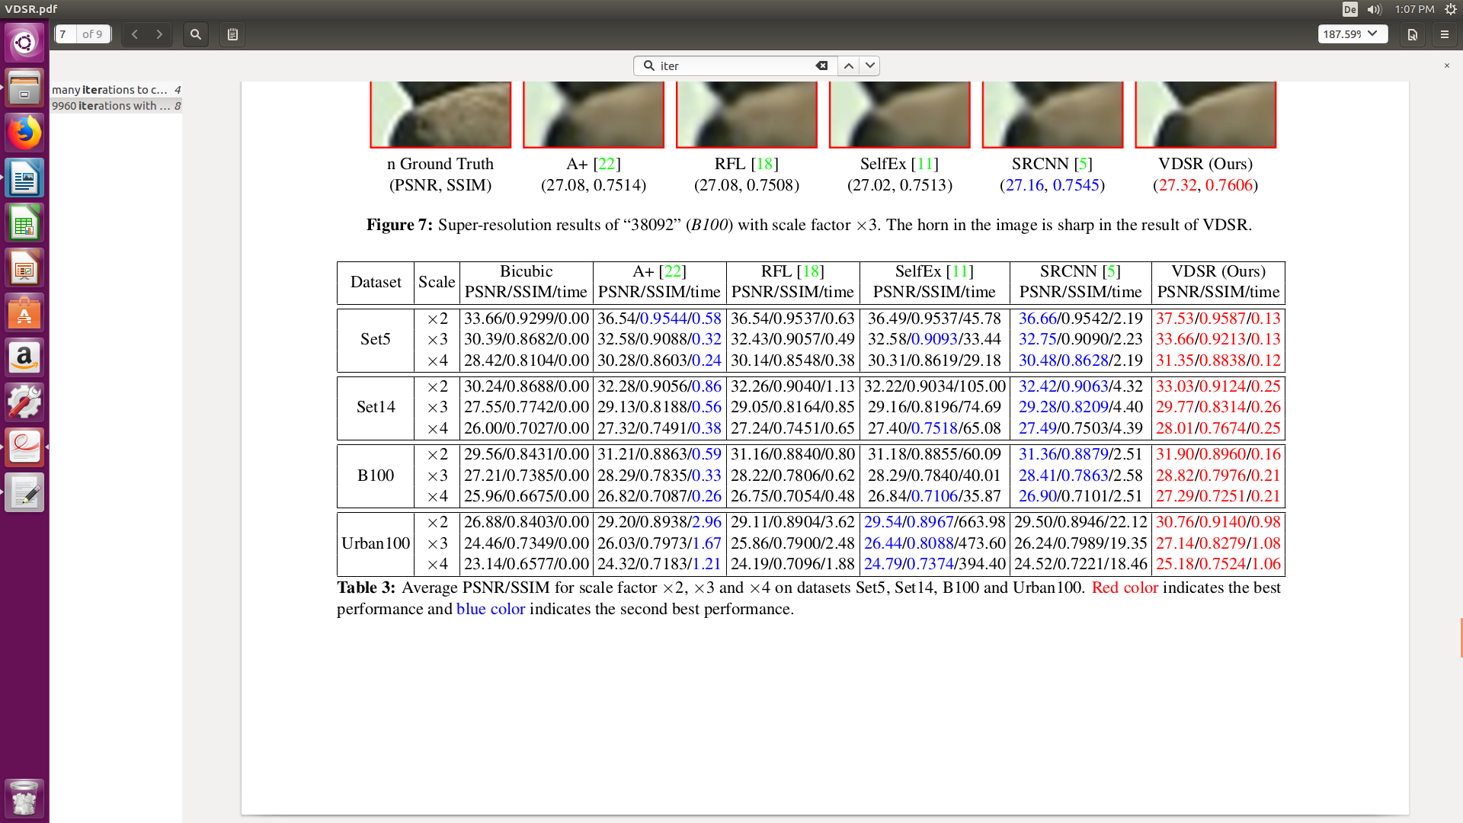

DRRN (Image Super-Resolution via Deep Recursive Residual Network) [6]

ideas:
- The deeper the better
- fewer parameters 2×, 6×, and 14× fewer parameters than VDSR, DRCN, and
RED30, respectively
- global residual learning + local residual learning
- recursive learning , proposed in DRCN [6]

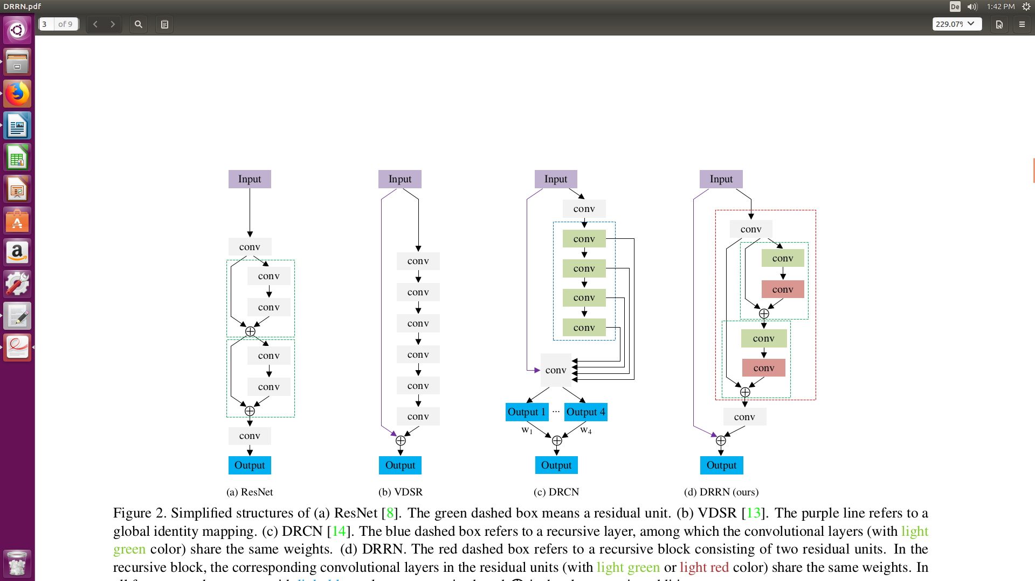
Structure:

- residual block: green box
- recursive block: red box, concatenate connection, more recursions are performed in the recursive layer
- The red dashed box refers to a recursive block consisting of two residual units. In the
recursive block, the corresponding convolutional layers in the residual units (with light green or light red color) share the same weights
- activation: BN + Relu, pre-activation before weight layer, same as Resnet
- chain model(a) vs multi-path(d): multi-path is less prone to overfitting
- loss func: MSE
- global residual learning
- in experiment B = 1 (number of recursive block), U = 25 (number of residual blocks)

training details:
-gradient clipping [-0.01/gamma, 0.01/gamma] gamma is learning rate
- training set: 291 images, where 91 images are from Yang et al. [7] and other
200 images are from Berkeley Segmentation Dataset [8].
-data augmentation: flipped and rotated, 90 ◦ , 180 ◦ , 270 ◦ and flip
them horizontally
-scale augmentation included *2 *3 *4 in a single model
- patch size: 31 × 31 patches, with the stride of 21
- optimizer: mini-batch size of SGD to 128, momentum parameter to 0.9, and weight decay to 10 −4
- filter size: 3 *3 * 128
- learning rate: 0.1 and then decreased to half every 10 epochs
- initialization: same as [9]
- iterations: not mentioned
- feature scaling: not mentioned

Result:
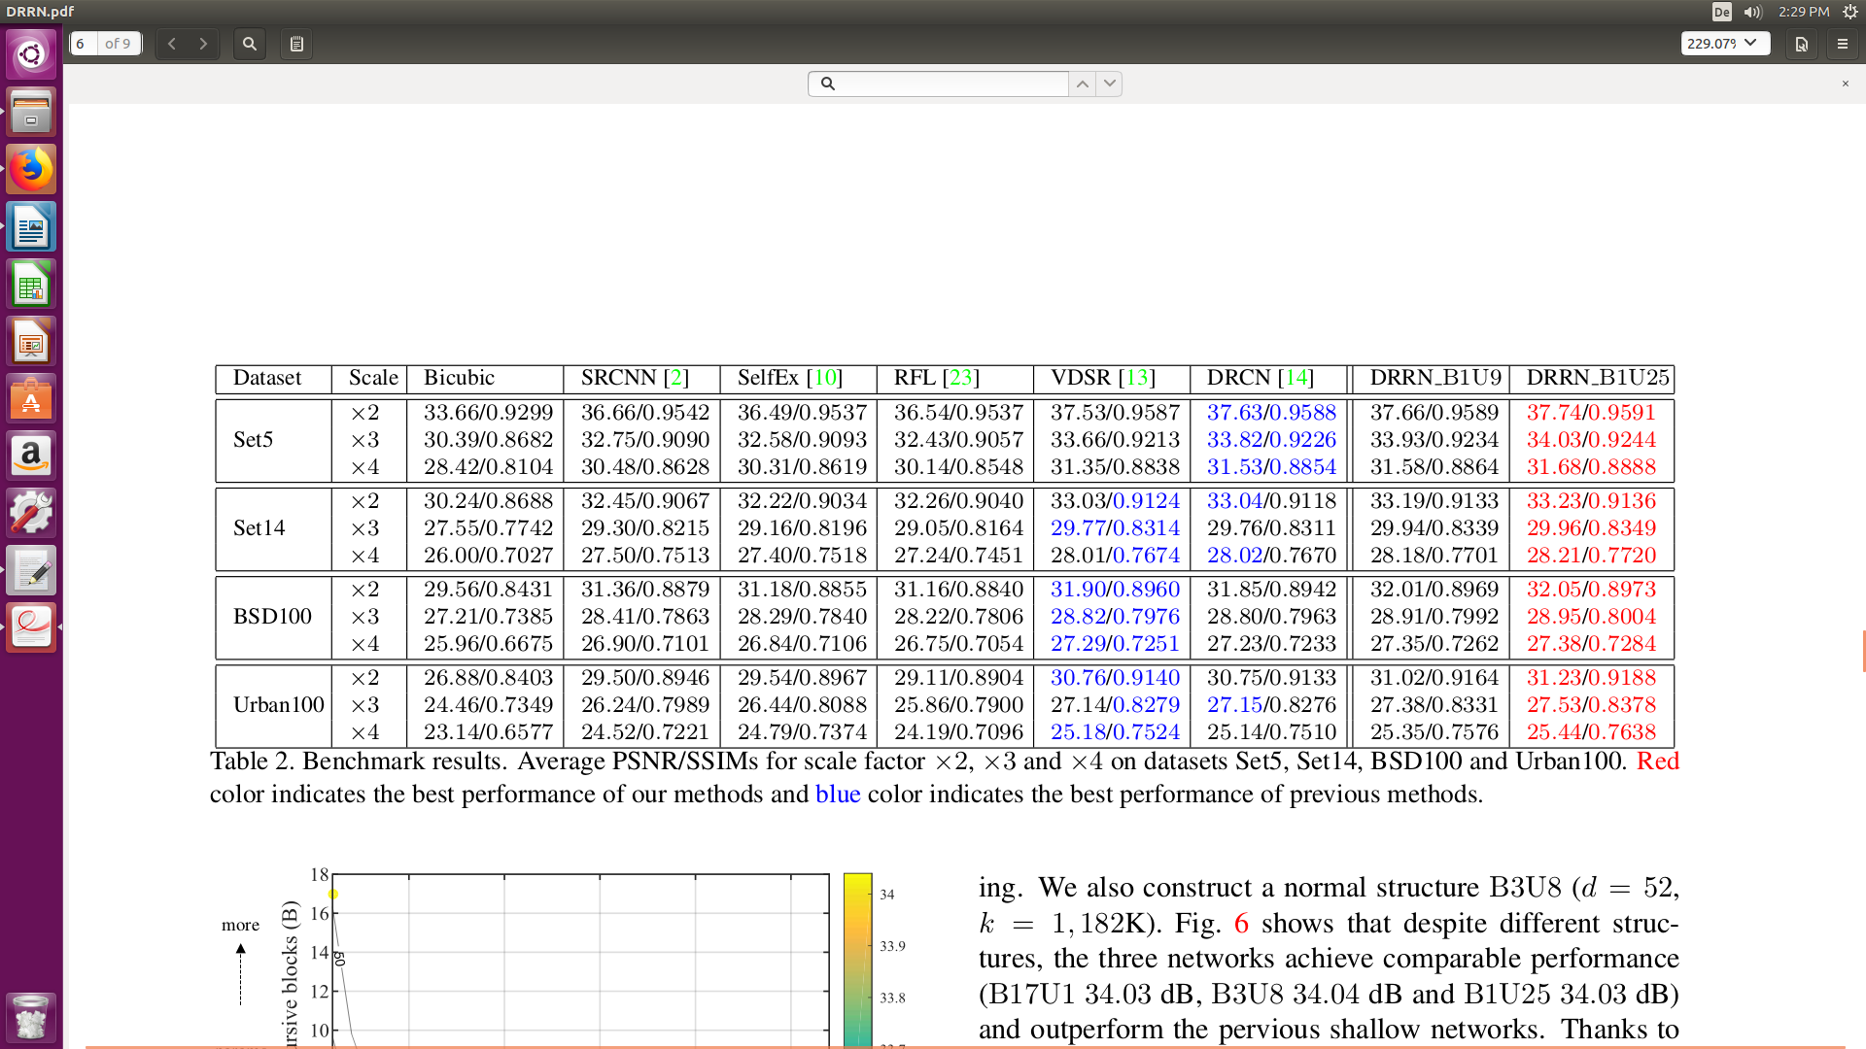

another metric proposed: Information Fidelity Criterion [10]

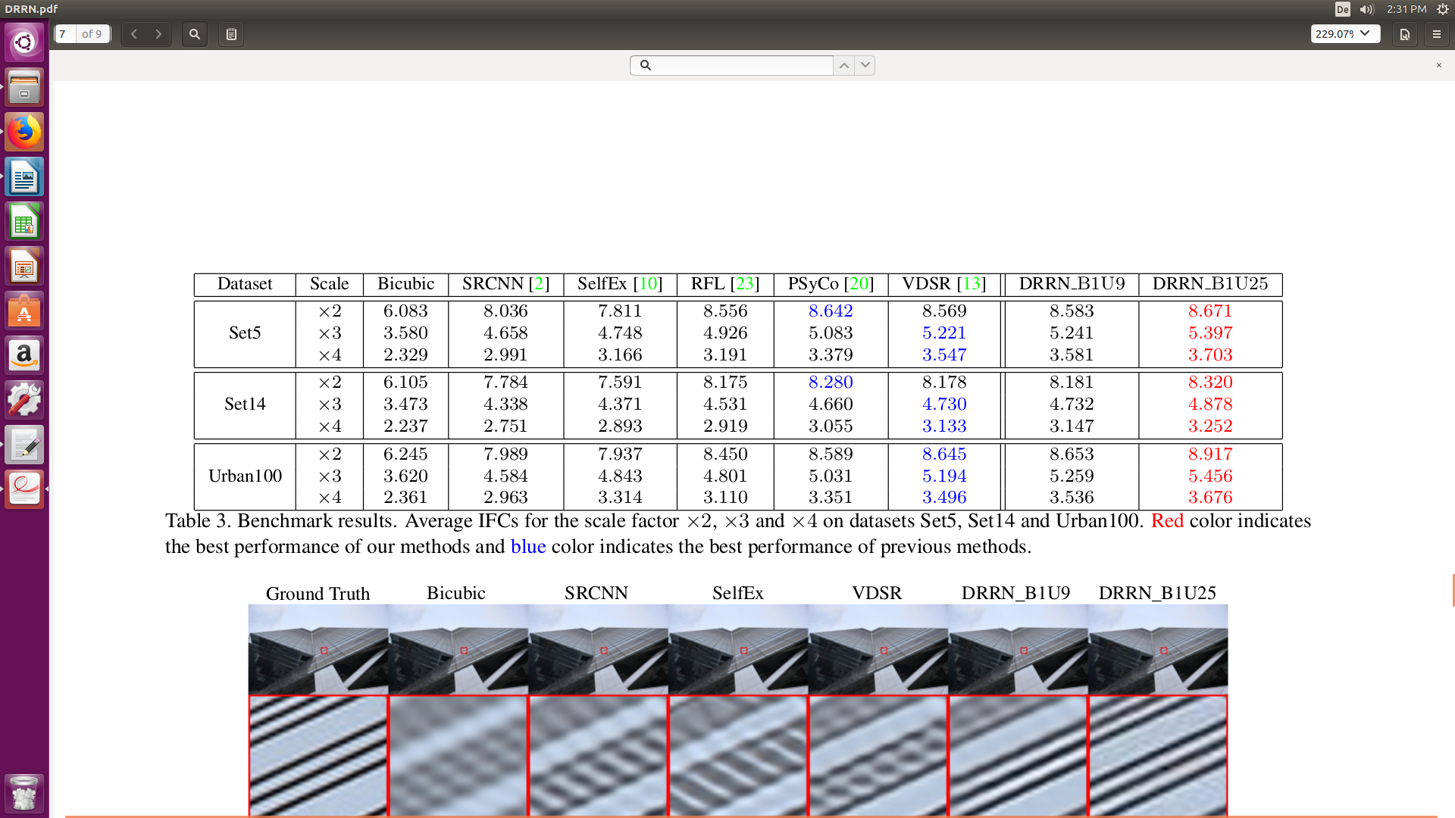
claims to have the highest correlation with perceptual scores for SR evaluation

PS: also a study about the depth: number of B,U, same depth will lead to comparable results

*Deep image prior:
idea:
- the structure of a generator network is sufficient to capture a great deal of low-level image statistics prior to any learning.
- a great deal of image statistics are captured by the structure of a convolutional image generator rather than by any learned capability
- randomly-initialized generative network can be used to sample realistic images from a random distribution
- using am encoder-decorder “hourglass” architecture with as many as two mil-
lion parameters θ
- In terms of (1), the prior R(x) defined by (2) is an in-
dicator function R(x) = 0 for all images that can be pro-
duced from z by a deep ConvNet of a certain architecture,
and R(x) = +∞ for all other signals
- for most applications, restrict the number of iterations in the optimization process
(2) to a certain number of iterations.

Result:
While our method is still outper-
formed by learning-based approaches, it does considerably
better than bicubic upsampling. Visually, it seems to close
most of the gap between bicubic and state-of-the-art trained
ConvNets

[1] Photo-Realistic Single Image Super-Resolution Using a Generative Adversarial Network.
[2] S. Gross and M. Wilber. Training and investigating residual nets, on-
line at http://torch.ch/blog/2016/02/04/resnets.
Html.
[3] W. Shi, J. Caballero, F. Huszar, J. Totz, A. P. Aitken, R. Bishop,
D. Rueckert, and Z. Wang. Real-Time Single Image and Video
Super-Resolution Using an Efficient Sub-Pixel Convolutional Neural
Network. In IEEE Conference on Computer Vision and Pattern
Recognition (CVPR), pages 1874–1883, 2016. 3, 4, 5, 6, 7, 8

[4] Accurate Image Super-Resolution Using Very Deep Convolutional Networks
[5] Fast and accurate image upscaling with super-resolution forests.
[6] Deeply-Recursive Convolutional Network for Image Super-Resolution
[7] Image super-resolution via sparse representation.
[8] A database of human segmented natural images and its application to
evaluating segmentation algorithms and measuring ecologi-
cal statistics.
[9] Delving deep into rectifiers: Surpassing human-level performance on ImageNet
classification.
[10] Single image super-resolution from transformed self-exemplars

