1. Database

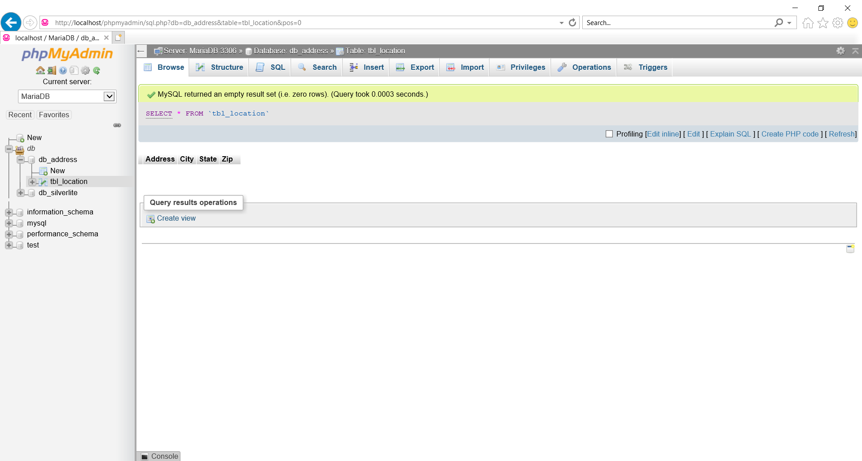

1. API to add Address Details in a SQL Table named Location – which have Address, City, State

and Zip.

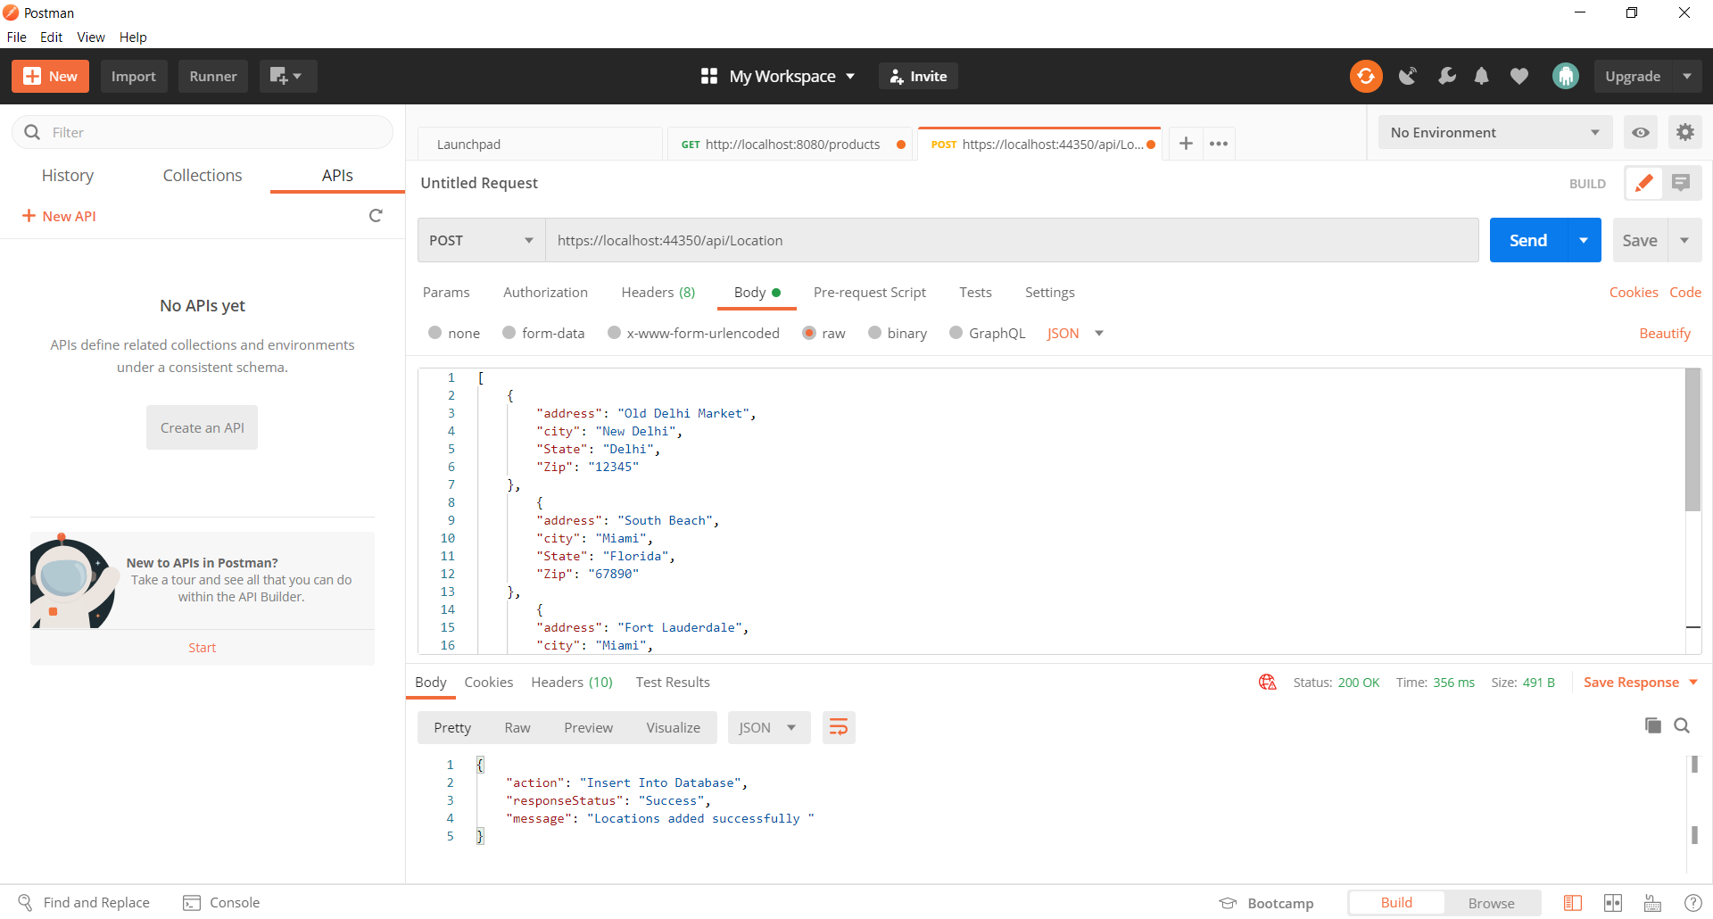

[

    {

        "address": "Old Delhi Market",

        "city": "New Delhi",

        "State": "Delhi",

        "Zip": "12345"

    },

        {

        "address": "South Beach",

        "city": "Miami",

        "State": "Florida",

        "Zip": "67890"

    },

        {

        "address": "Fort Lauderdale",

        "city": "Miami",

        "State": "Florida",

        "Zip": "24680"

    },

        {

        "address": "Fort Worth",

        "city": "Dallas",

        "State": "Texas",

        "Zip": "13579"

    },

        {

        "address": "North Fort",

        "city": "Miami Beach",

        "State": "Florida",

        "Zip": "66666"

    }

]

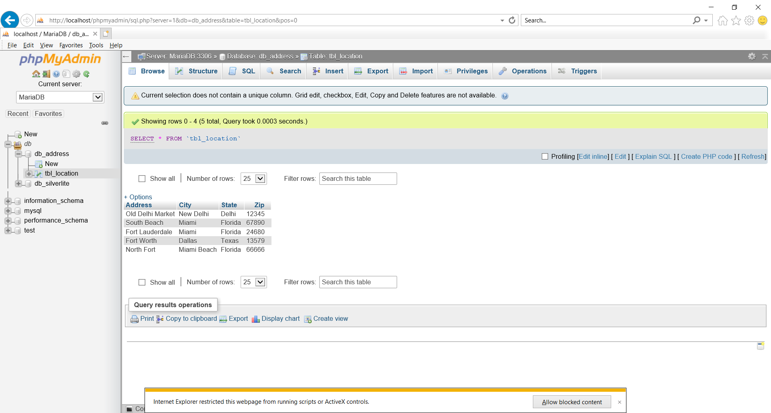

1. Search for Address
2. User can start the search, only when 3 or more letters are provided. If not, then throw an error. User can search for a keyword, which should match across address, City and state, all at once. Which means, if user has Searched for ‘Tex’ then select the records in the list of matched addresses, where either street address, or city, or State has that keyword and display them distinctively.

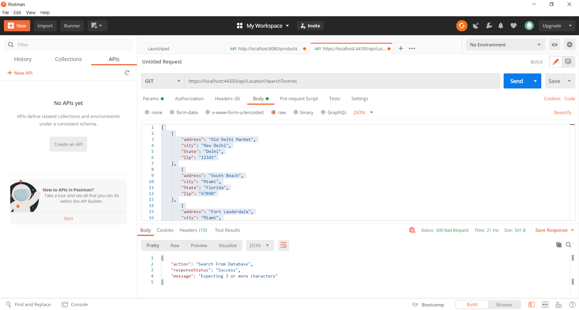

1. Search based on frequency

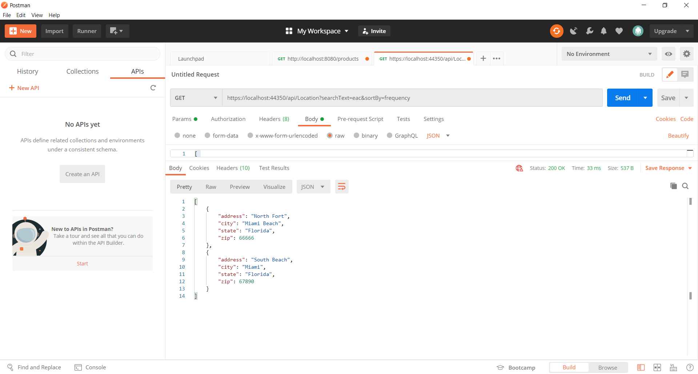

1. Default as alpha

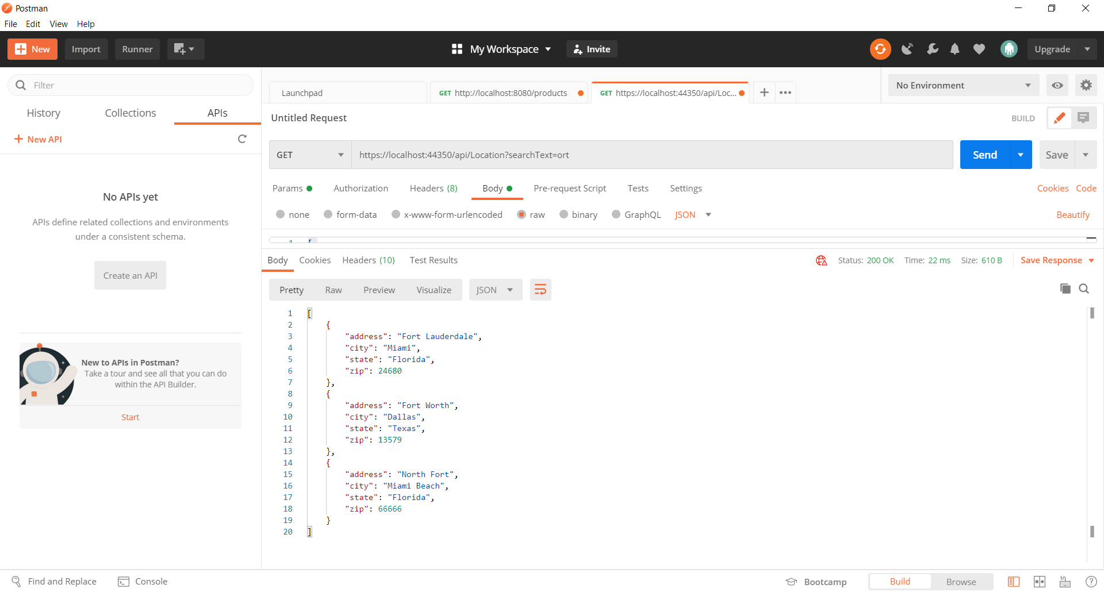

Other Validations:

1. If there are no records matching the search text

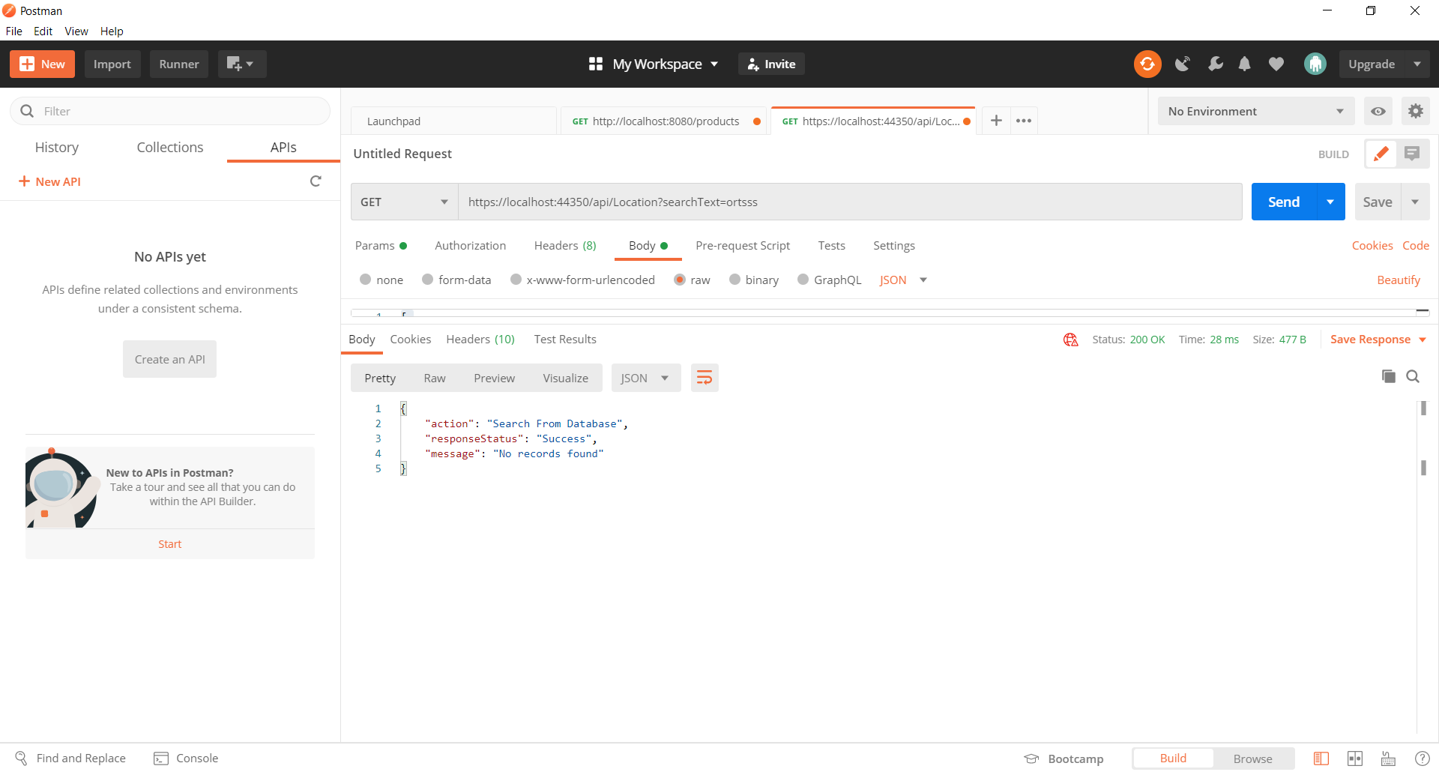

1. If the request is not appropriate

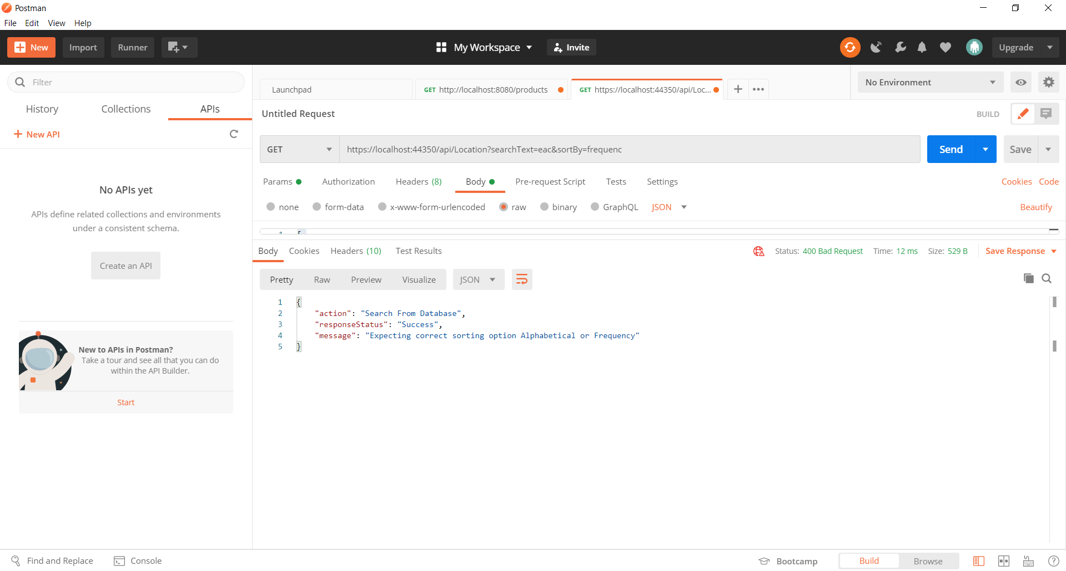

1. If there is issue with database connection

