**EMP191 Rocket Lab 1**

Warren Yuan

18 September 2018

Abstract:

In this Lab, students investigated the effects of changing the amplitude of a signal on the appearance of the wave on the oscilloscope. Students used Matlab to analyze the data collected and draw inferences.

Introduction:

Students were expected to become familiar with the lab equipment while also investigating the differences between the amplitudes and their subsequent appearances. Students changed the amplitudes of the signal frequency generator and recorded graphs.

Measurement procedure:

Aside from brief backtrack in order to double-check that the correct measurements were taken, the procedure was followed through as written.

Plots of data:

Figure 1 Figure 2

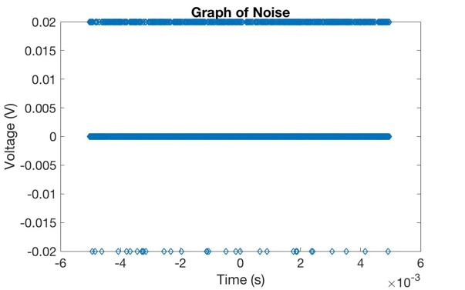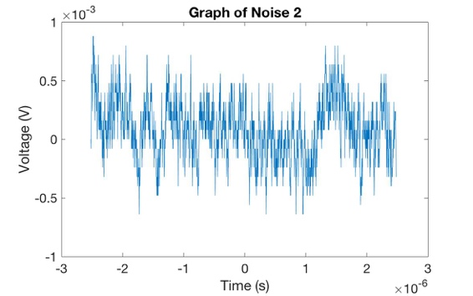

Figure 3 Figure 4

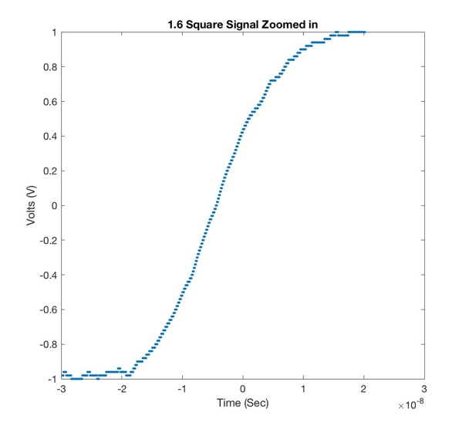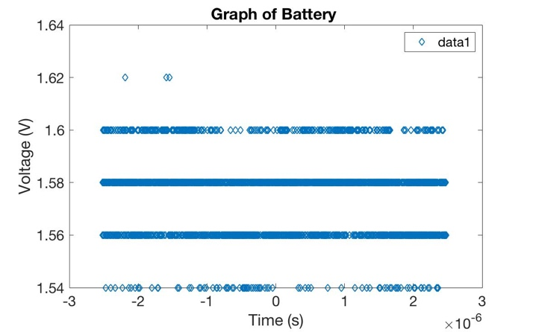

Analysis results:

1. The noise was approximately 0.0092kHz (the standard deviation of the signal data) for figure 1, and 2.5131*10^(-5) kHz for figure 2. The two graphs are different in that figure 2 displays distinctive spikes in data whereas the figure 1 shows three separate, constant levels of frequency.
2. The rise time is finite about 8*10^-7sec (see figure 3) so it is not a perfect square wave, rather a trapezoidal wave. The rise time doesn’t depend on the frequency of the square wave, only the change over time.
3. Given Figure 4 above, the Battery Voltage is close to 1.56-1.58V. When nothing was plugged in, the Voltage was fluctuating between .02 and 0V.

Conclusions:

Not only have I understood better the nature of the equipment which we will be using, I have also seen some of the programs (such as Matlab and LaTeX) we should be using, and now have some reasons to experiment with them. Because I had some issues with remembering which plots were which and also had some confusion about the measurements taken, I will be more descriptive with my labelling of data, and pay more attention to the details of the procedure.